3D Mechanism Replacement Operation Guide
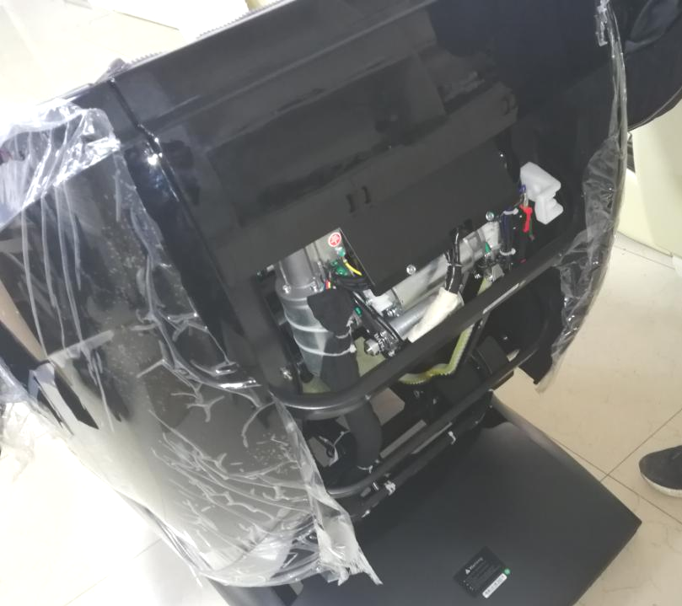
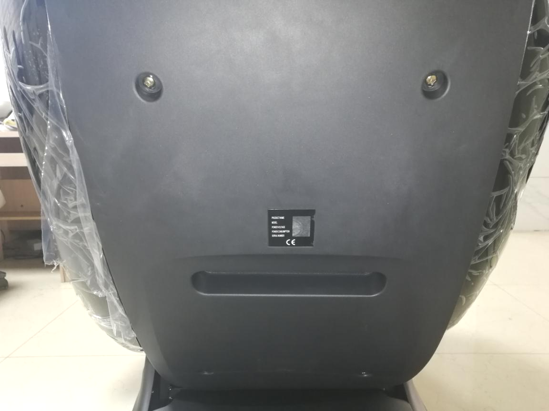

Remove 4 screws at the back plastic cover

Remove the back plastic cover

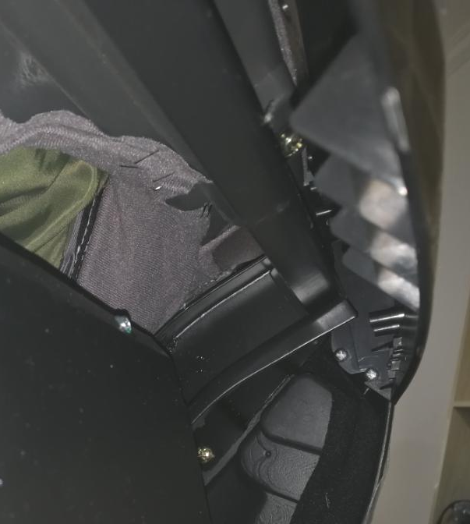

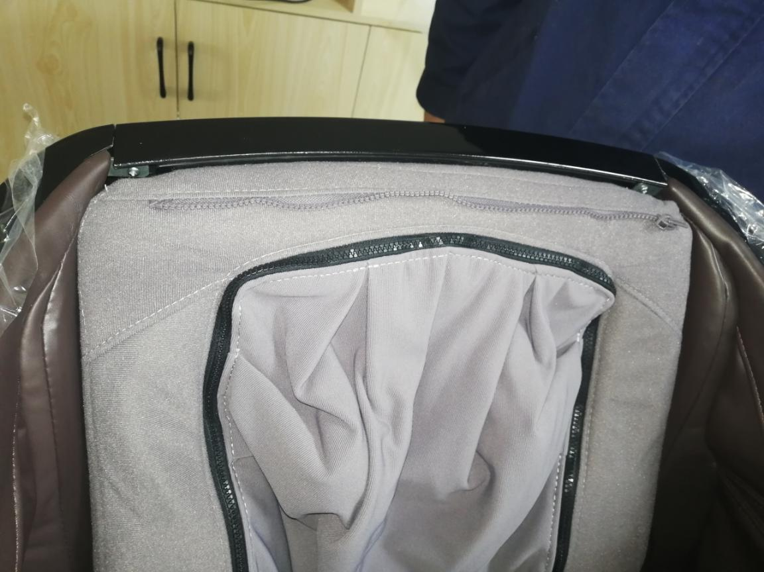

4. Remove 2 screws on the top of the armrest middle connecting part

3. Remove 4 screws (left 2/right 2) of armrest middle connecting part at the inside back cover

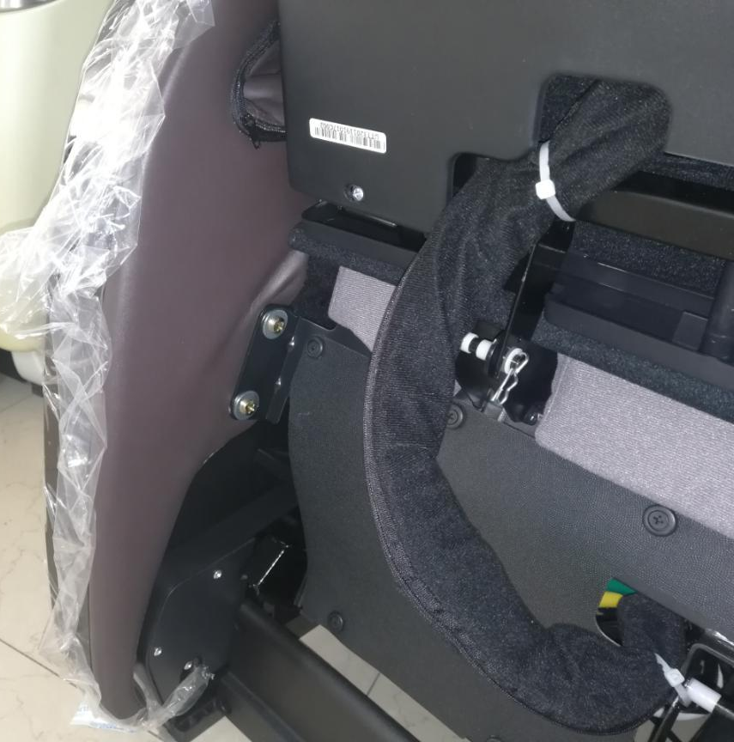
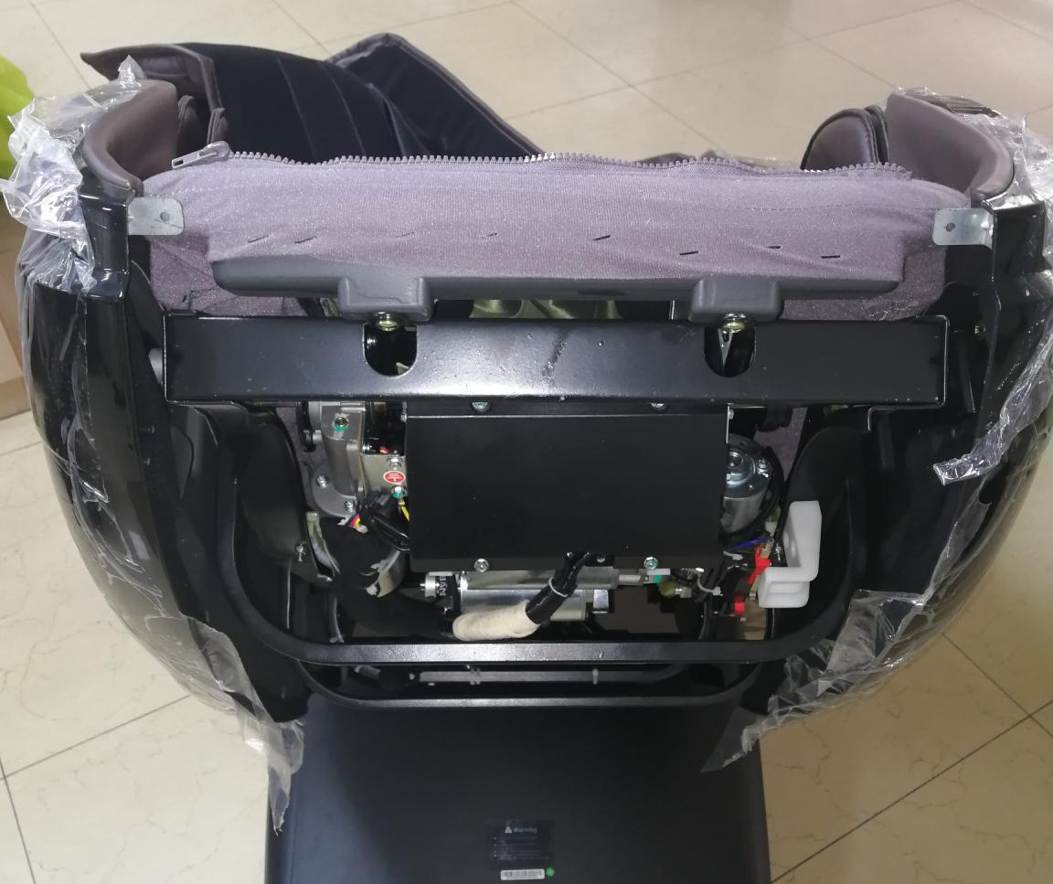

6. Turn up the leg and foot assembly, and then remove 4 screws(left 2/right 2) for fixing the armrest

5.Remove the armrest middle connecting part

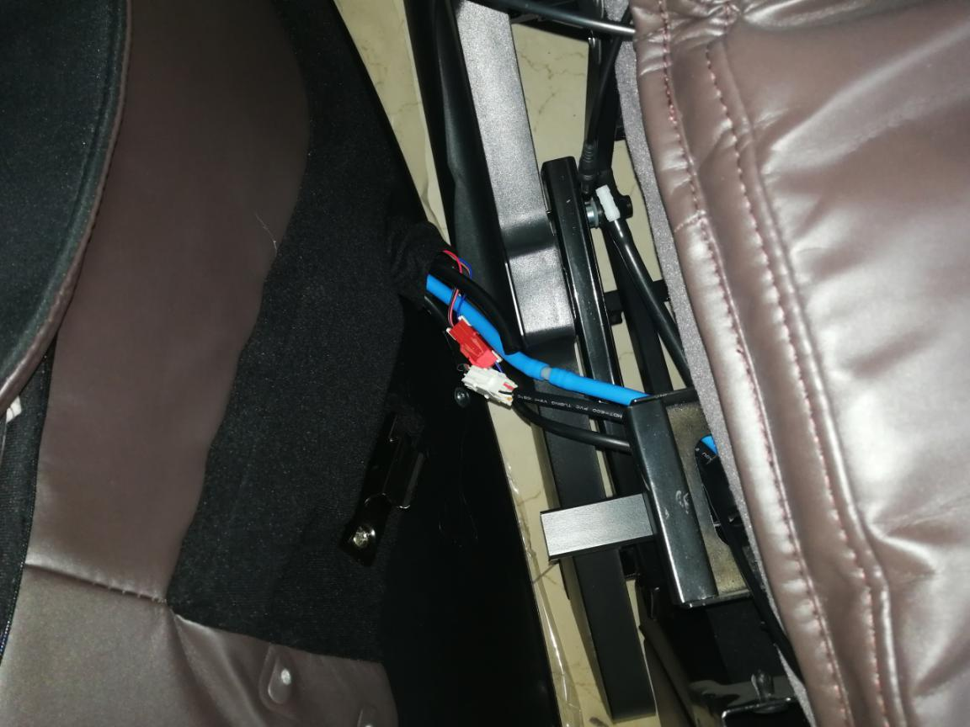
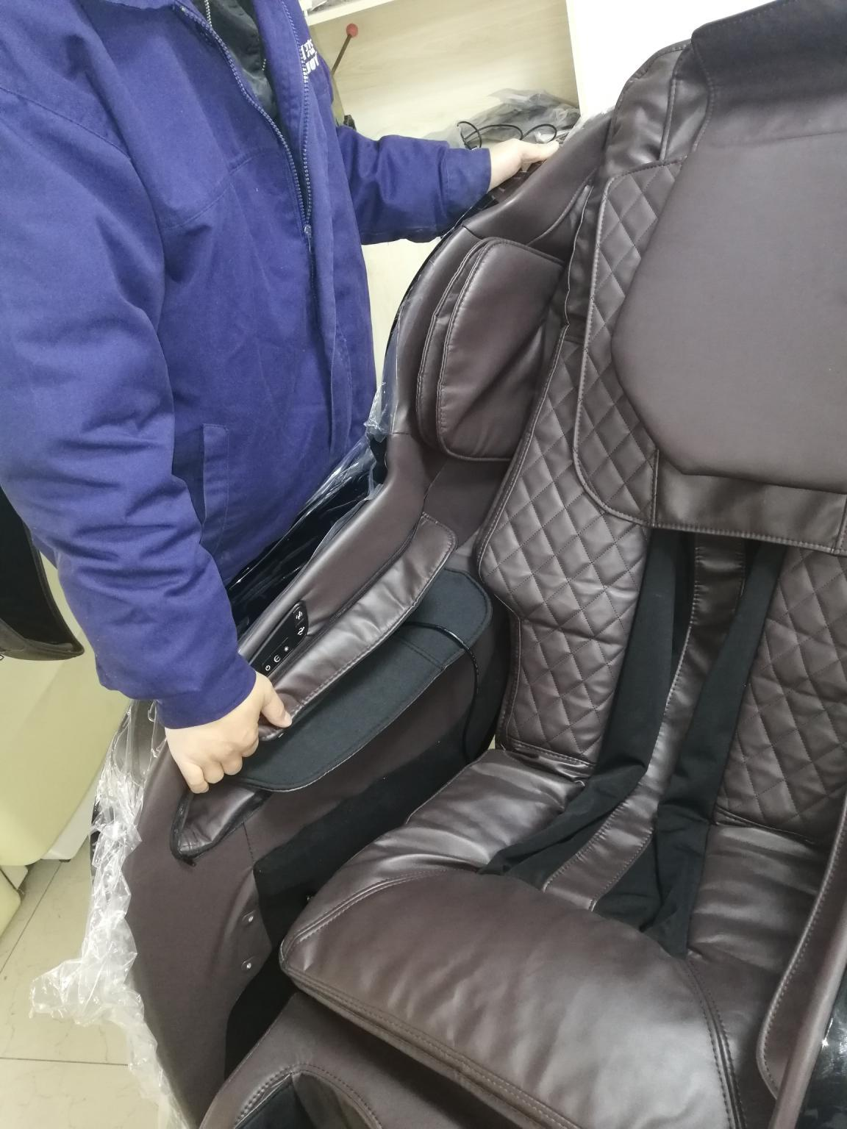

8. Plug off air tube and terminal on the armrest

Lift up the front of the armrest

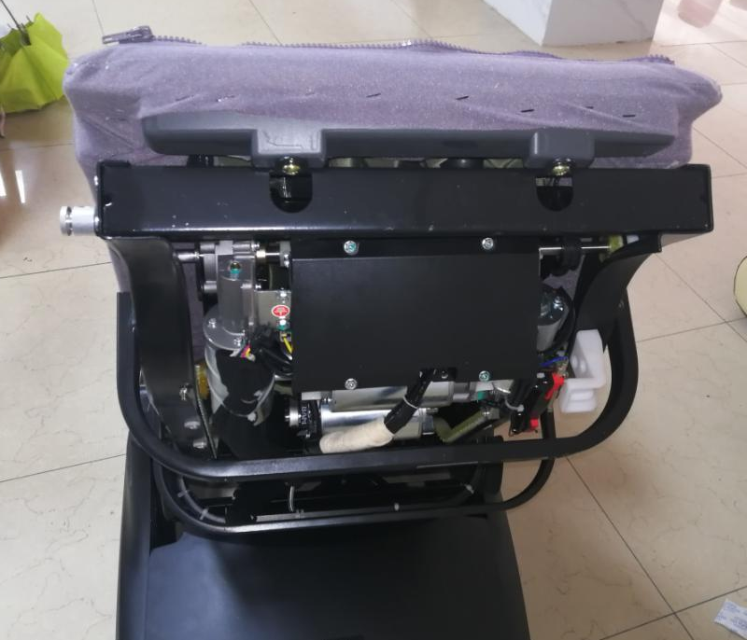
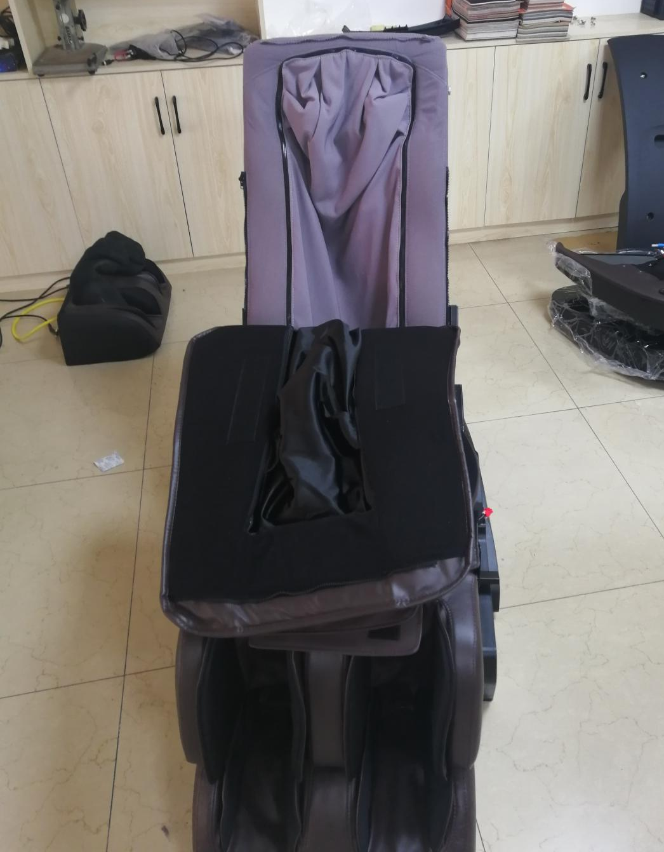

9.Remove the two side armrest

10. Remove 2 screws on the top of backrest frame

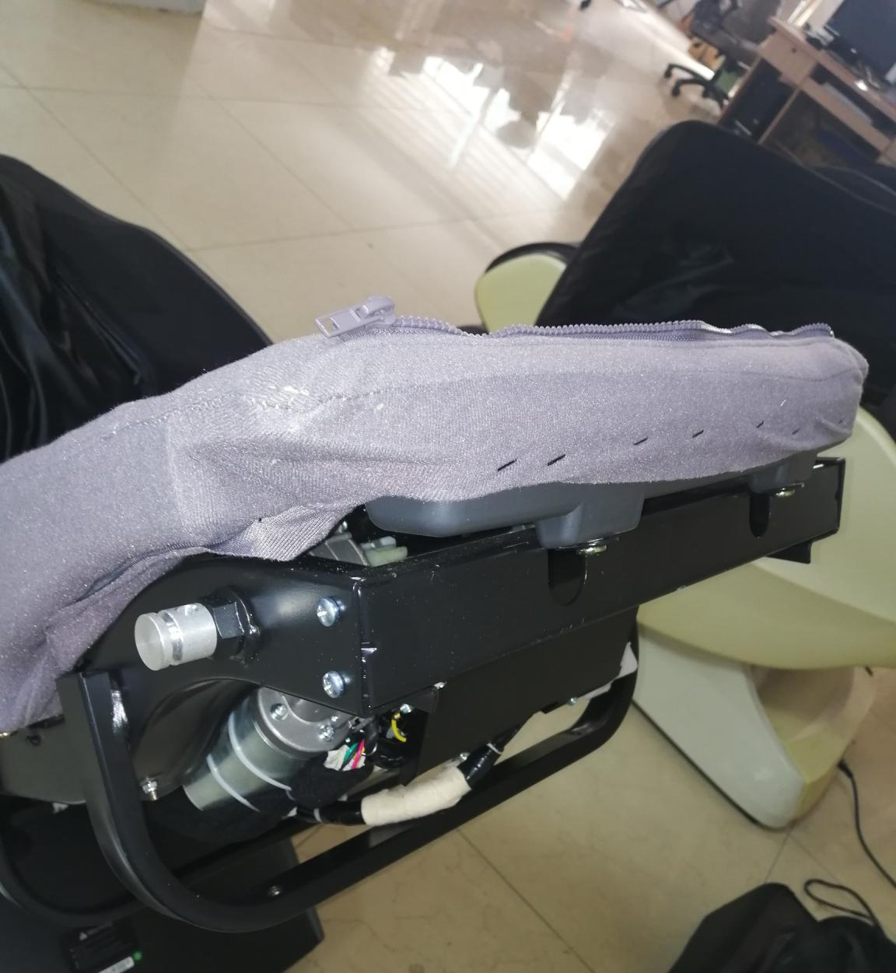
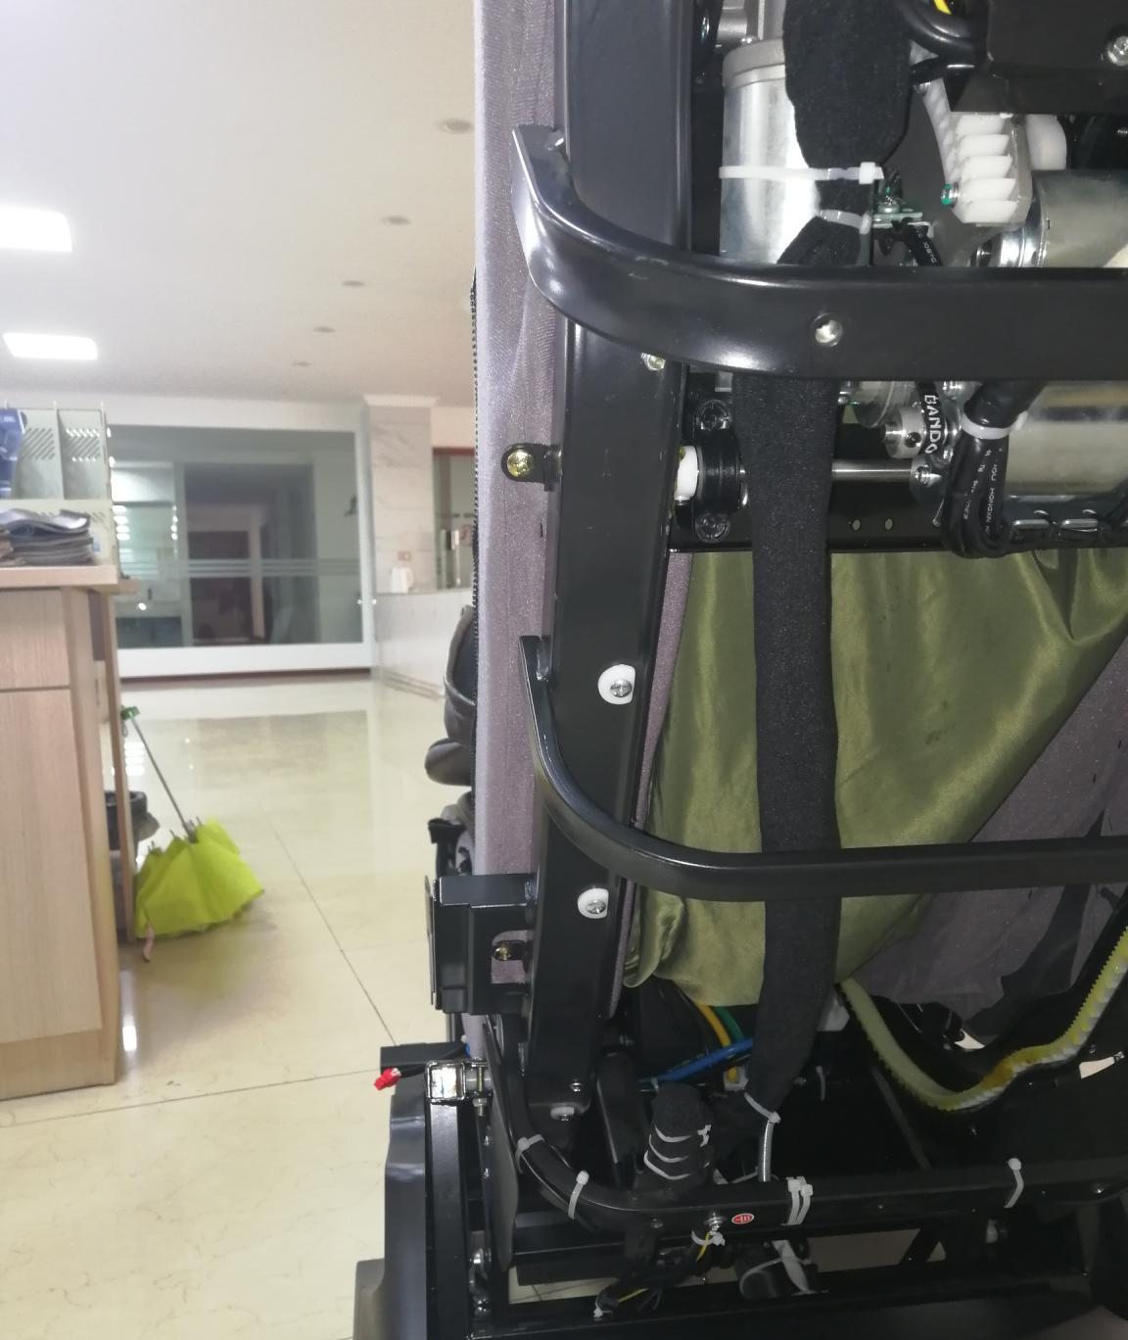
12. Remove 4 screws (left 2/right 2) on the track connecting plate

Remove 4 screws (left 2/right 2) in the middle of backrest frame

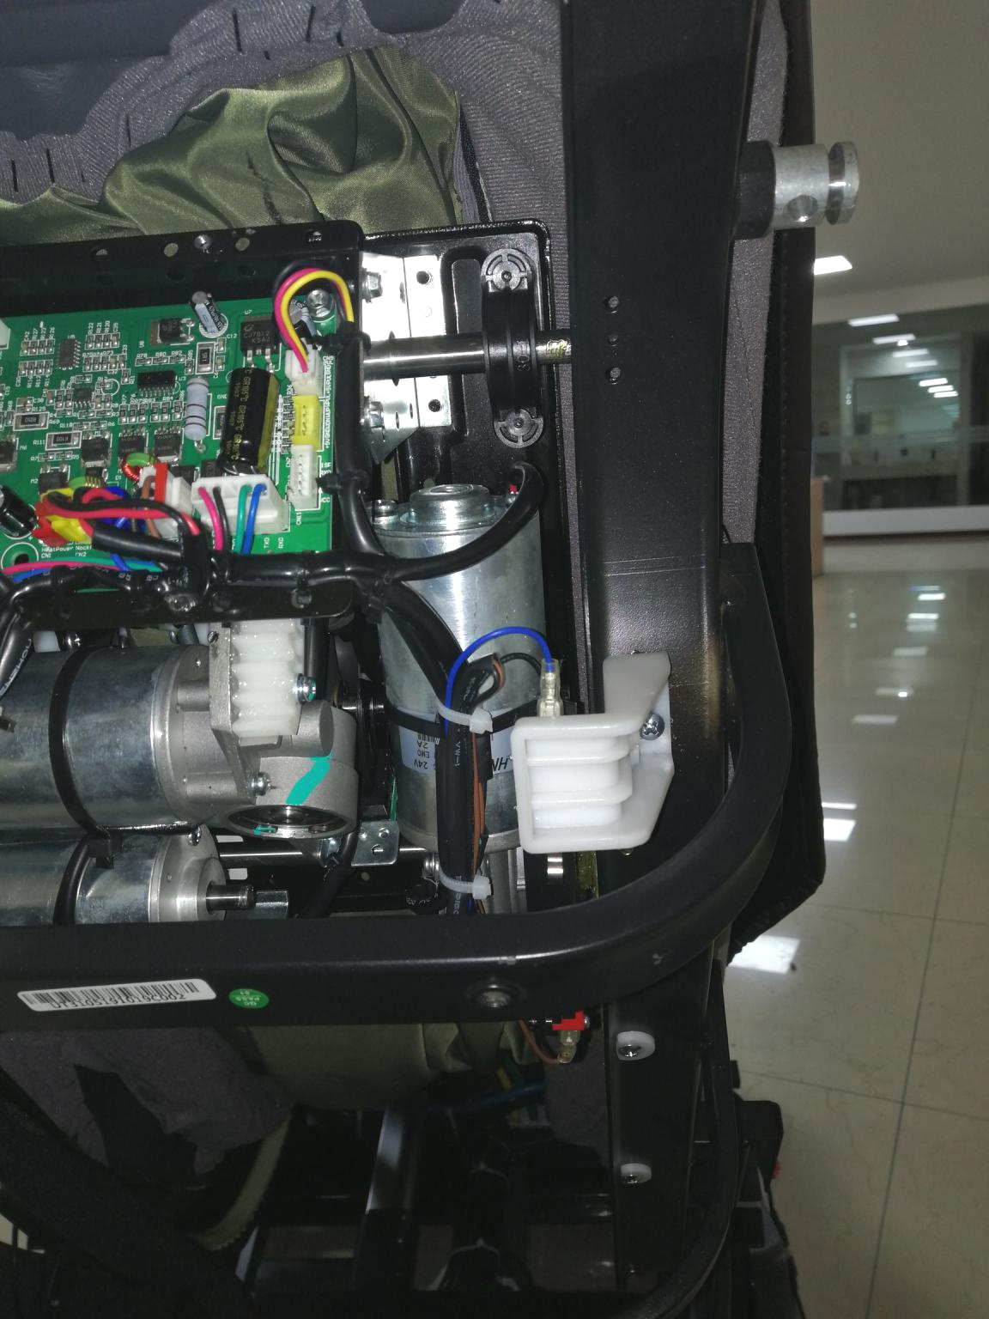
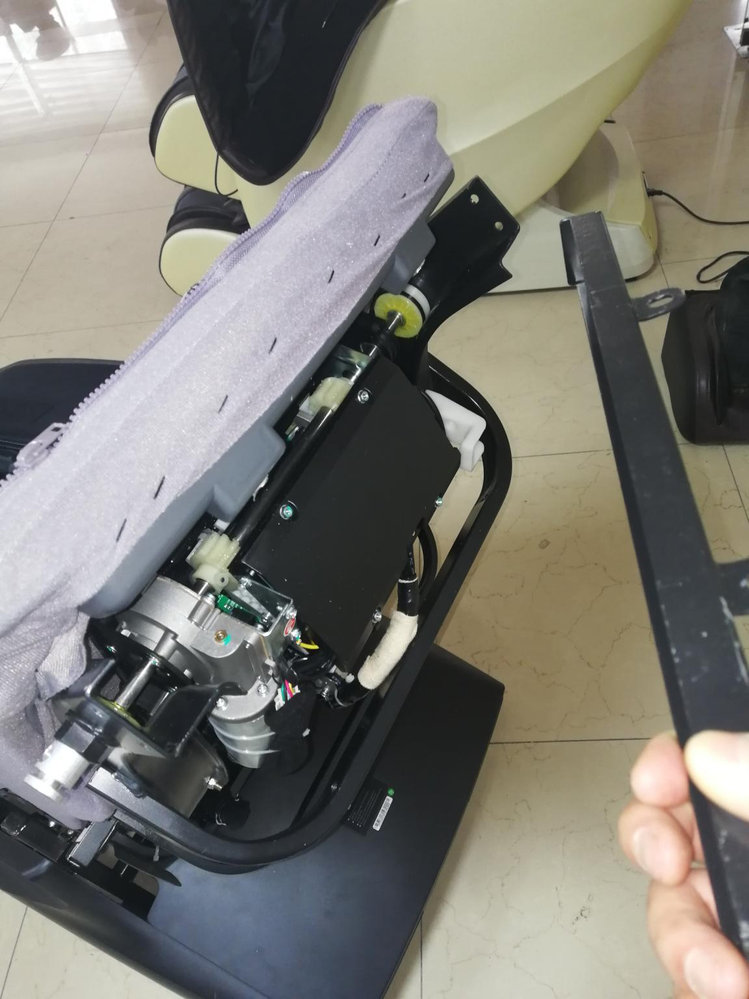

Remove the base

13.Remove track connecting plate

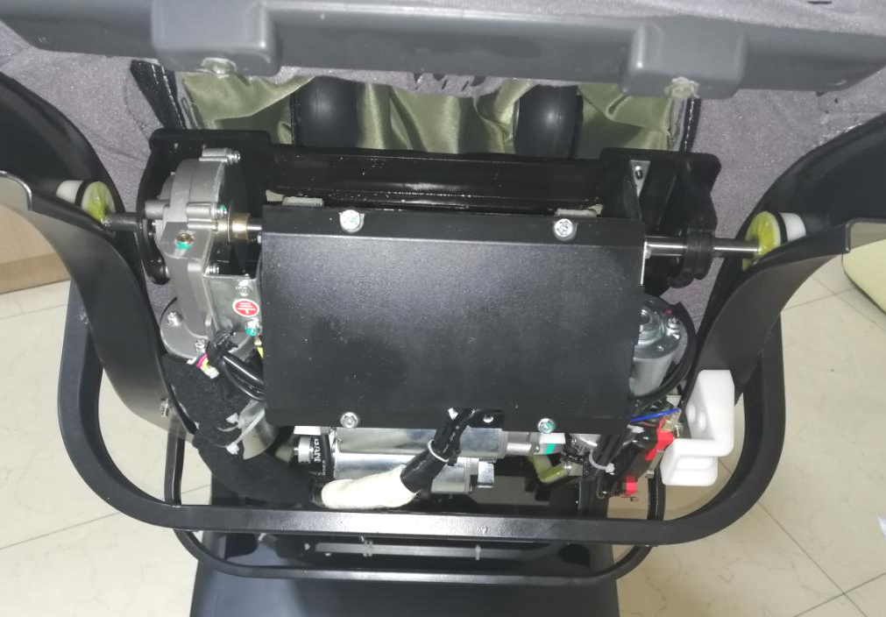
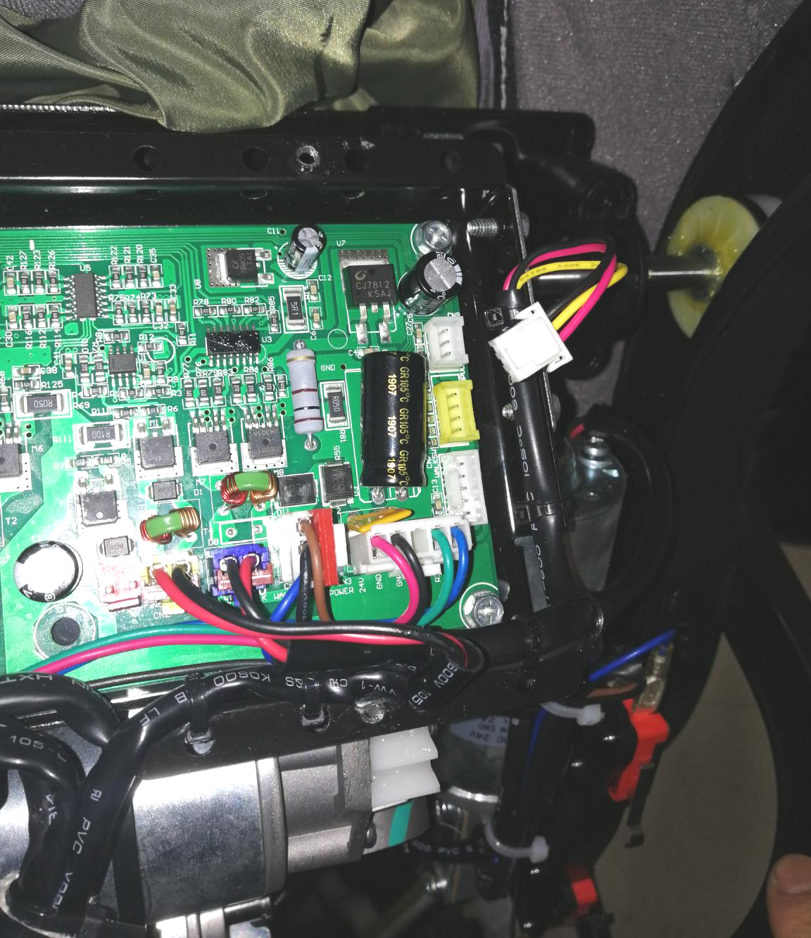

16.Plug off counting line terminal as shown

15. Remove 4 screws on the mechanism cover, then remove the cover

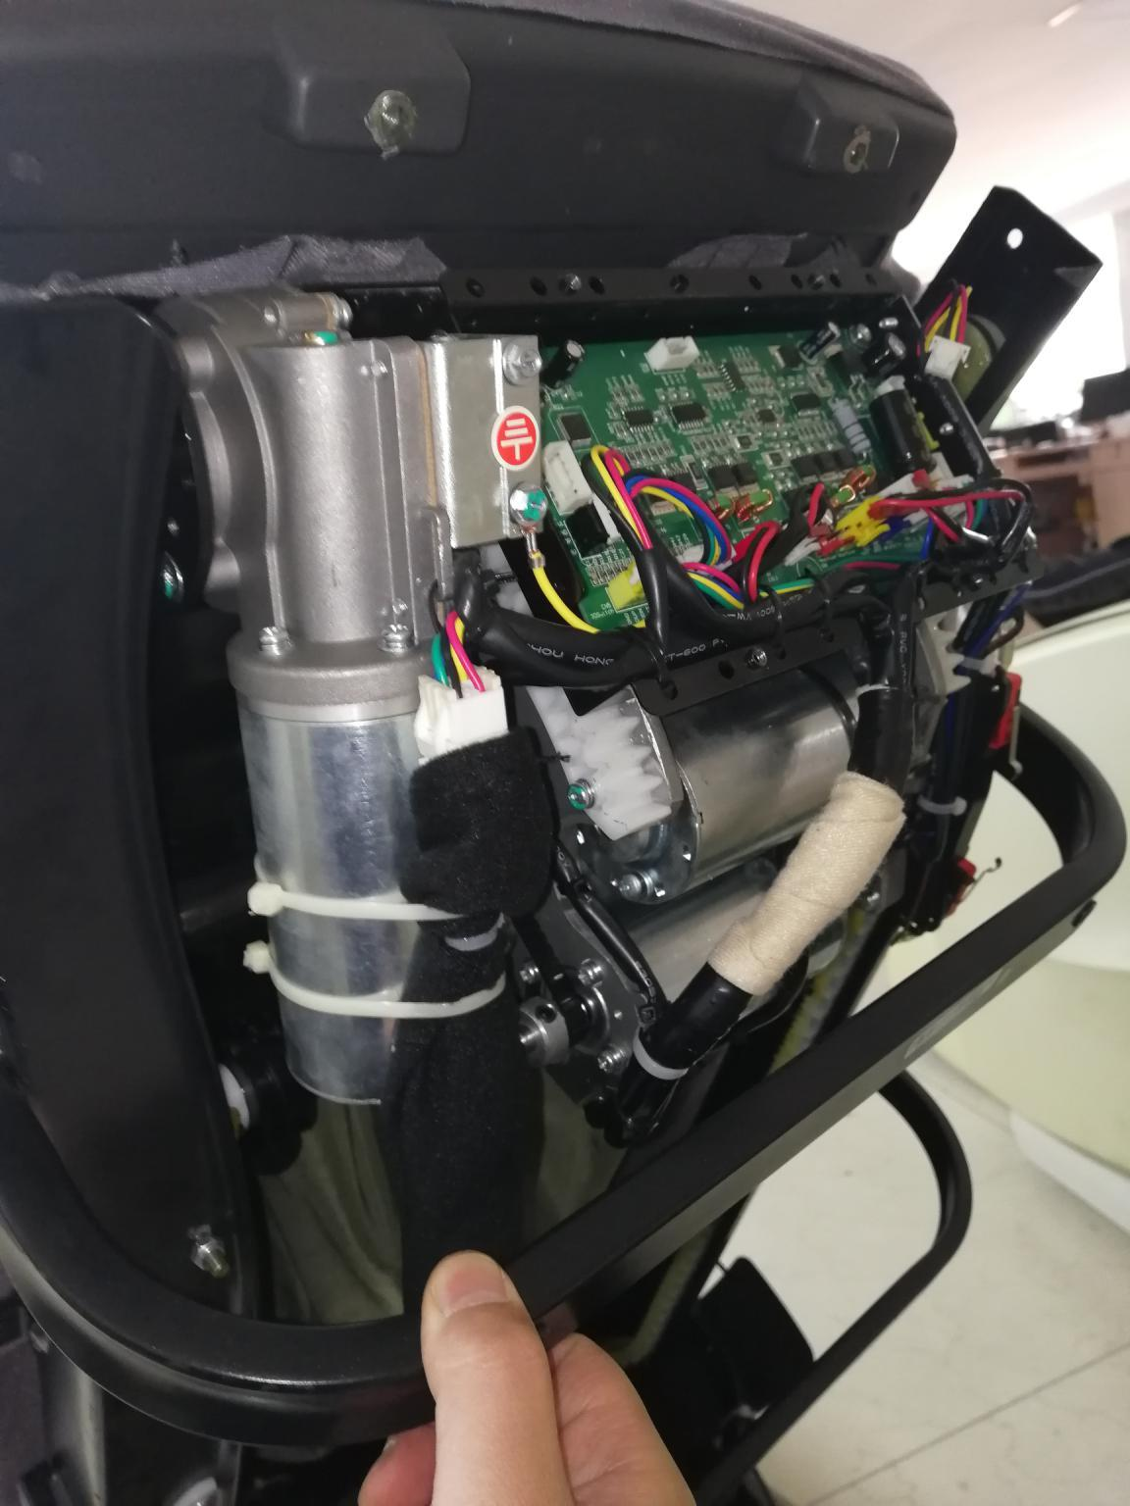
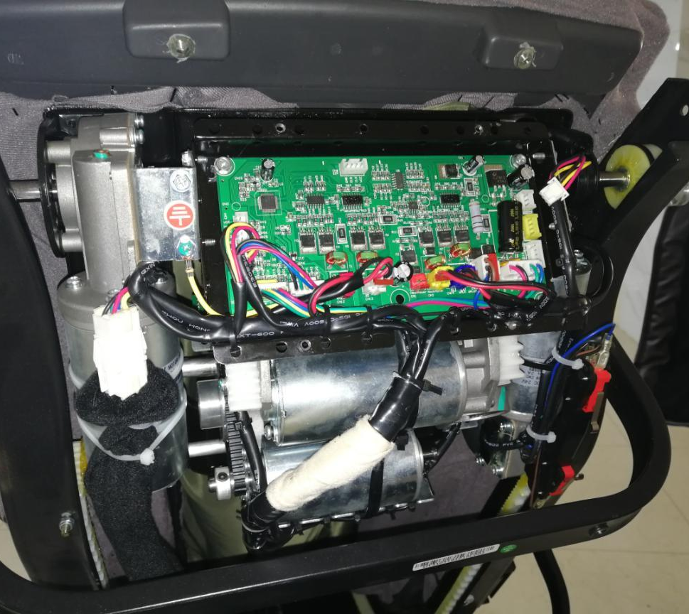

Cut off the cable tie at the mechanism wire position

17.Adjust the controller to manual mode, move up the mechanism and out of the rack.

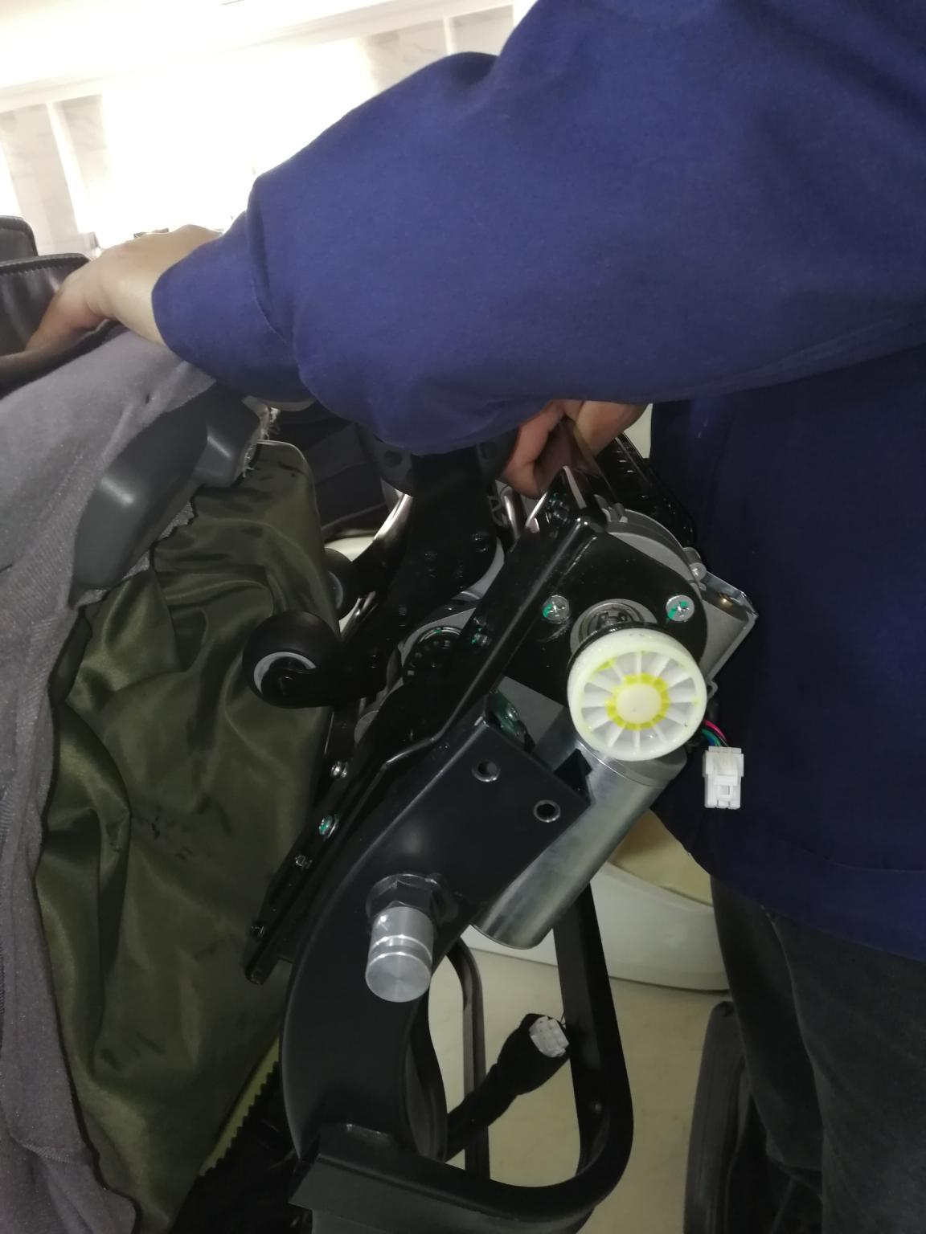
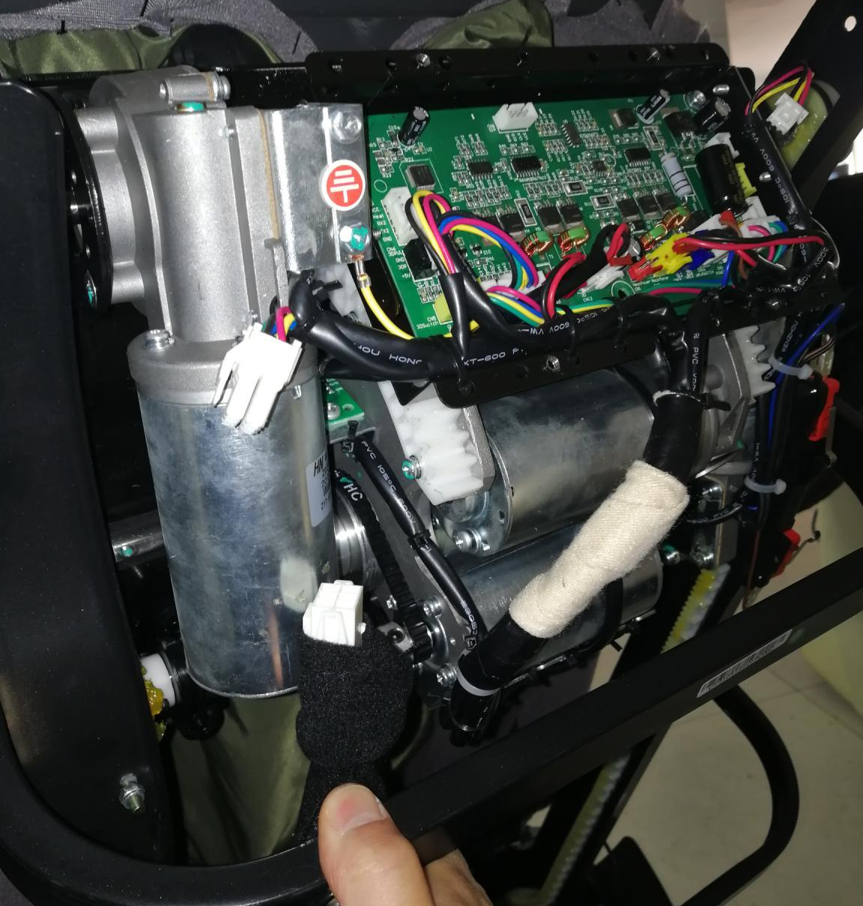

Plug off the mechanism wire connecting terminal

20.Lift up the backrest frame slightly, and then take out the mechanism and replace it

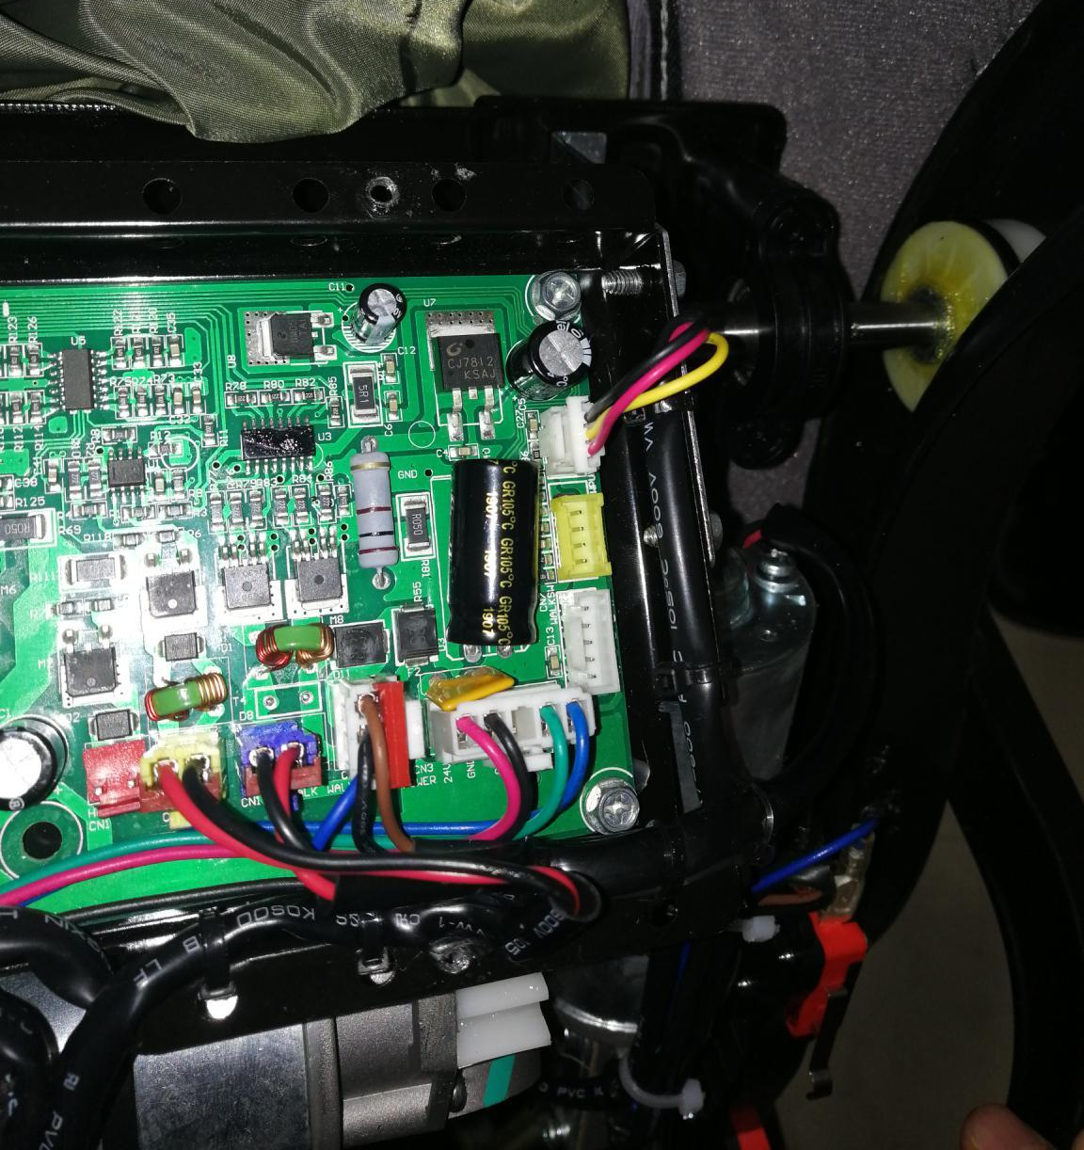
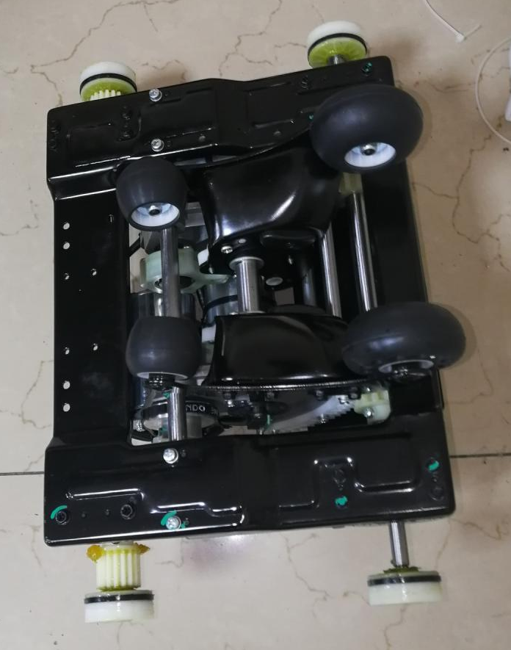

21.Mechanism removal completed

After replacing the mechanism, connect the terminal and adjust controller to manual mode, move down the mechanism, and then connect the counting wire

Reinstall the base, power off the chair, then power on and let the mechanism walk through the whole process.

