Replace accessories in power box
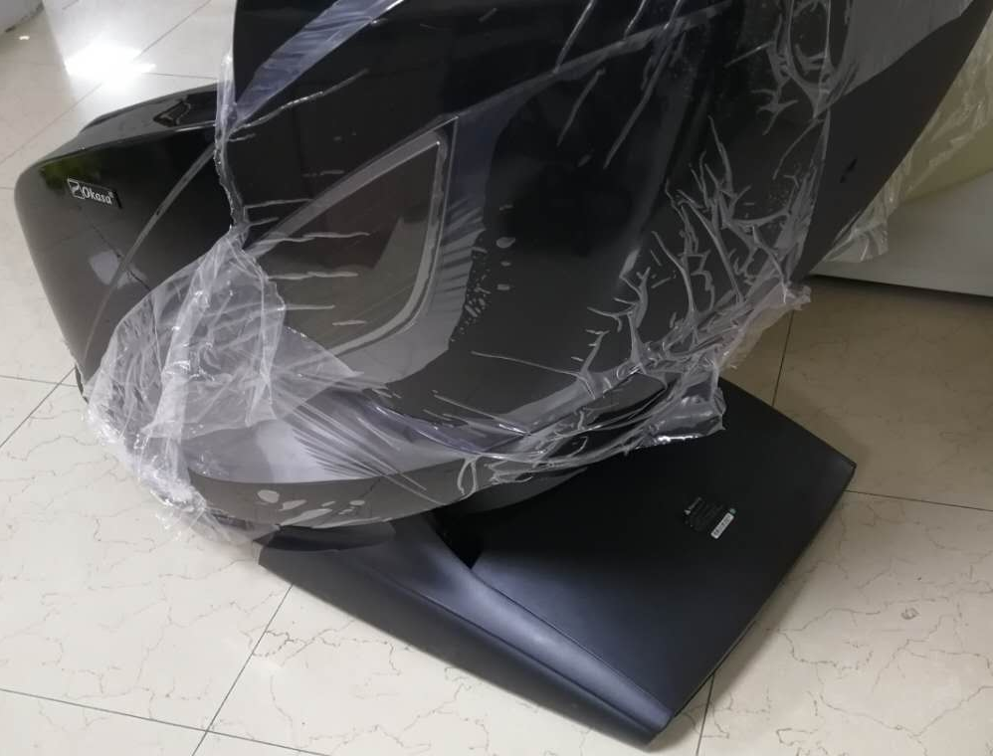
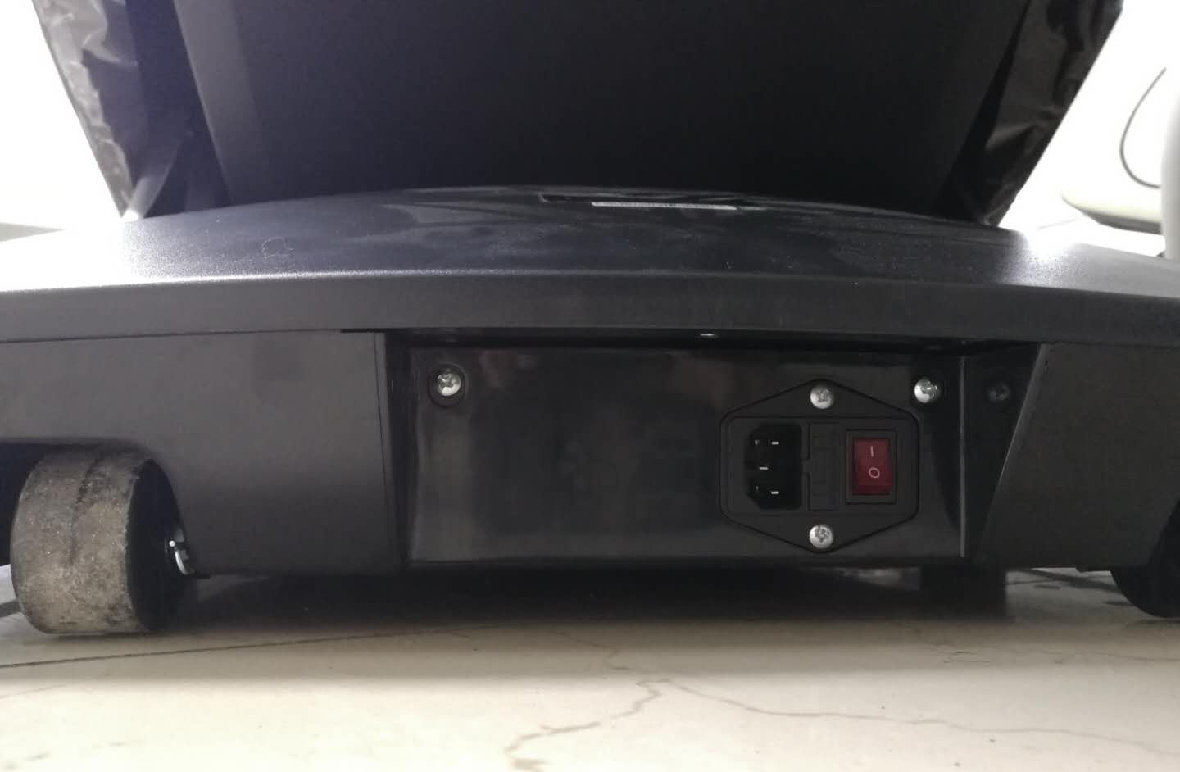
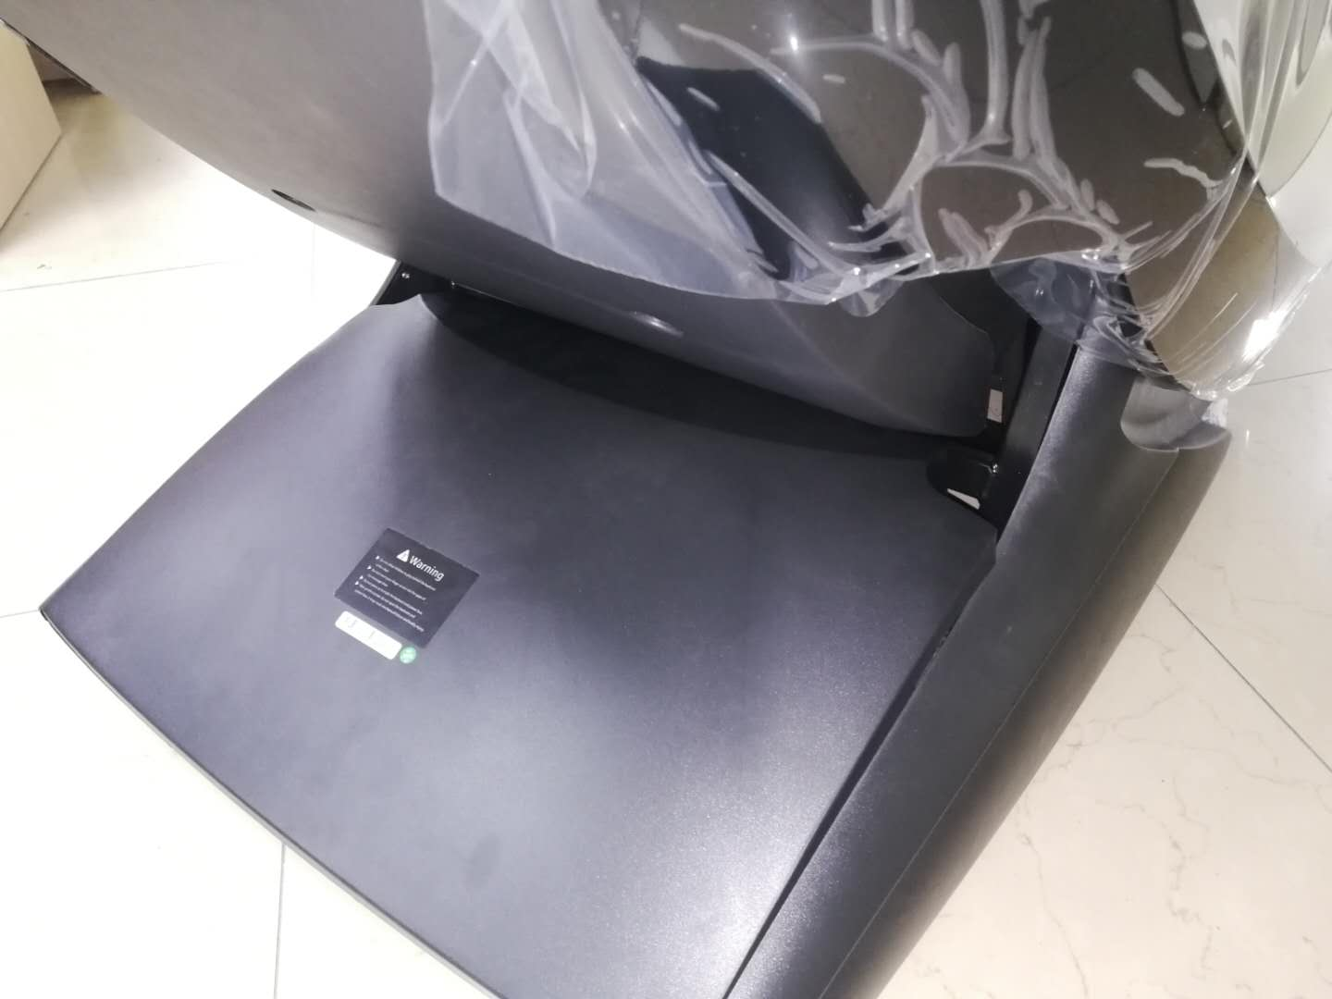

Disassemble the upper cover of power box
Remove the two screws that lock the cover of the power box

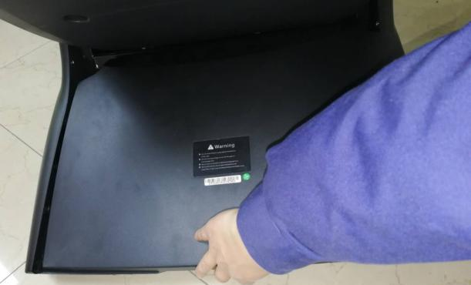

Then pull up the switch position by hand to open the power box
After removing the screws, please pull up the position of the cover of the power box left and right by hand

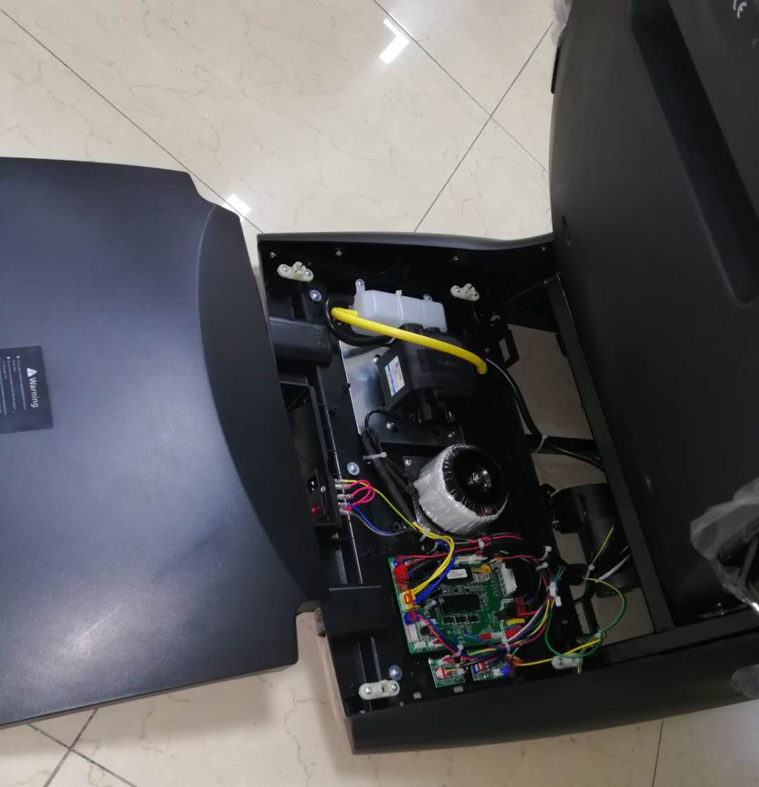
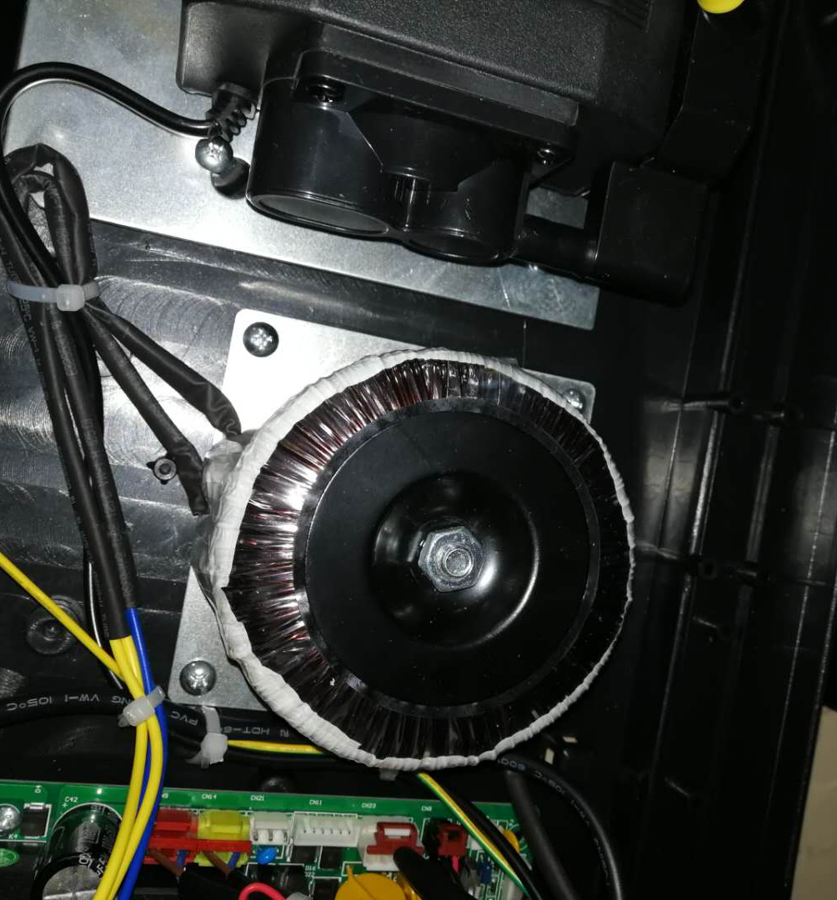

Disassemble the upper cover of power box

Change the transformer：Removing the 4pcs screws and unplug the terminal

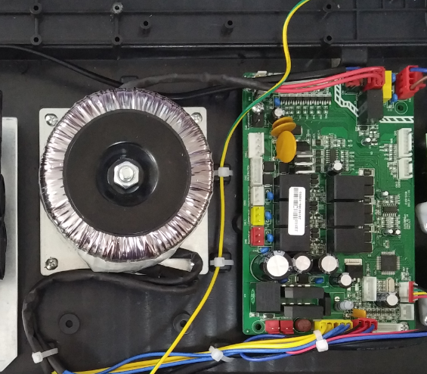
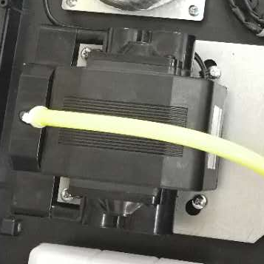
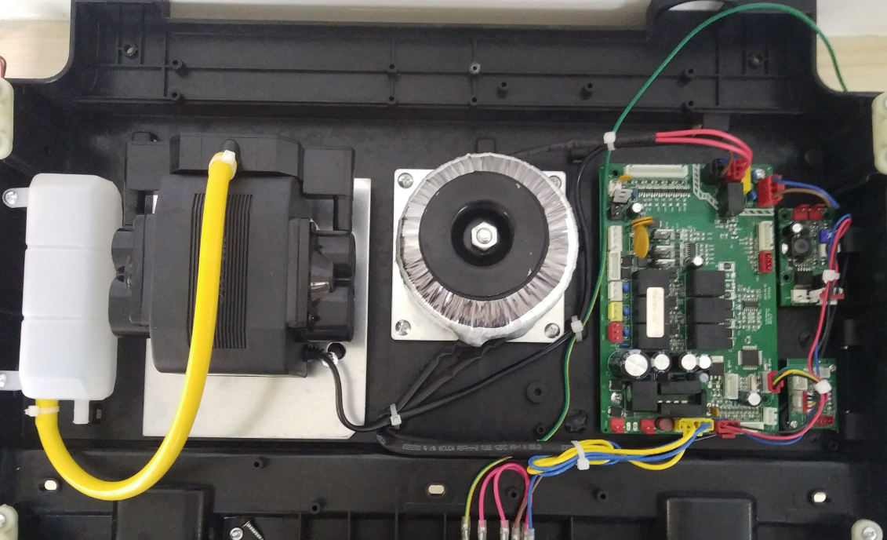
Red wire of the transformer must be above transformer

Red wire of the transfomer must be above transformer

Change the air pump：Removing the 4pcs screws and unplug the terminal

After changing the air pump, the cable tie should be reserved in radians, which cannot be tightened, otherwise it will cause abnormal noise of the air pump
Change the PCB:Unplug all plugs，then removing 2pcs screws

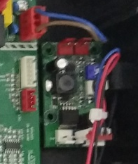

Change the pcb of controller:Unplug the terminal and removing screws
Change the stabilizing&charge board:Unplug the terminal and removing screws

Interface of air pump
Interface of transfomer(Red wire)

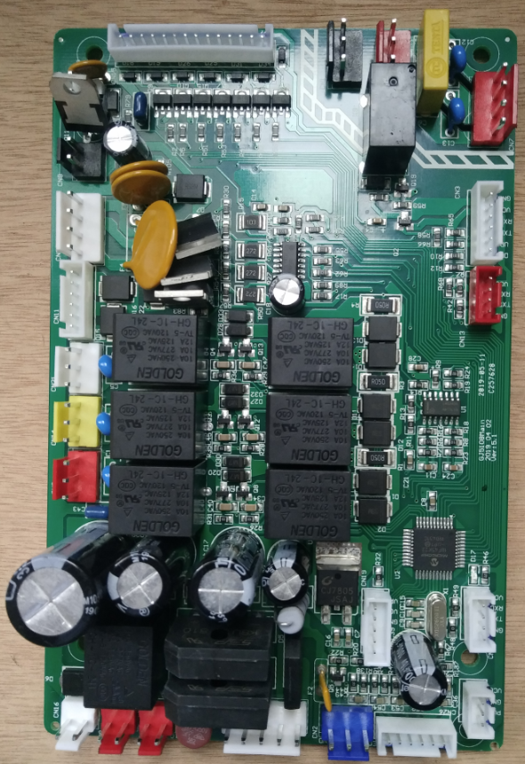
Interface of power switch

Interface of foot roller

Interface of calf motor

Interface of backrest motor

Interface of pcb of controller

Interface of mechanism

Interface of two heating
Interface stabilizing light board

Interface of transformer(Yellow and blue)

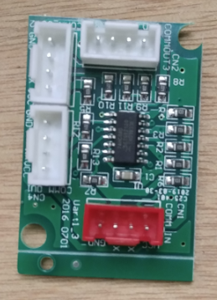
PCB of controller
Interface of small controller

Interface of mechanism signal

Interface of controller

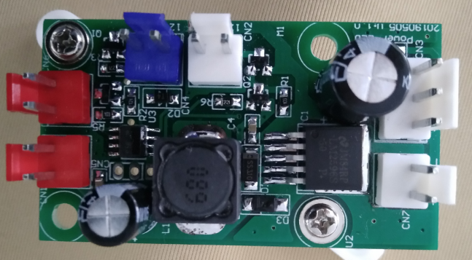
Interface of USB
Interface of light

Stabilizing &Charge board

