RK8900 Maintenance manual
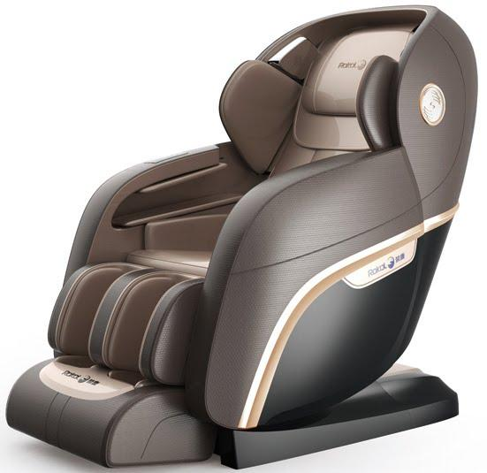

Contents

Preface……………………………………………………………………………………………1
Contents……………………………………………………………2
一、 Mechanical components diagram …………………………………3
（一）RK8900 Explosion diagram……………………………………………………3
（二）Components Introduction……………………………………………………5
二、Failure & Troubleshooting……………………………………………………………7
1. Chair can’t start, remote controller doesn’t work…………………………………………………7
2. Massage machine and actuators elevating function failure, massage techniques and remote control work well ……………………………8
3. Massage machine elevating function failure ……………………………8
4. .Kneading function failure………………………………………9
5. Knocking function failure………………………………………………9
6.3D massage machine forward function failure…………………………………9
7. Leg-rest extension and retraction failure……………….…………………………………10
8 Massage machine heating function failure…………………………………10
9.Leg-rest heating function failure ………..……………………10
10. Music Player Function Failure………………………………………10
11. Air Press Function Failure, massage function is good………………11
12. Back actuator doesn’t work……………………………………………………11
13. Leg-rest actuator doesn’t work……………………………………………11
14. Seat actuator doesn’t work……………………………………………………11
15. Foot roller doesn’t work……………………………………………………12
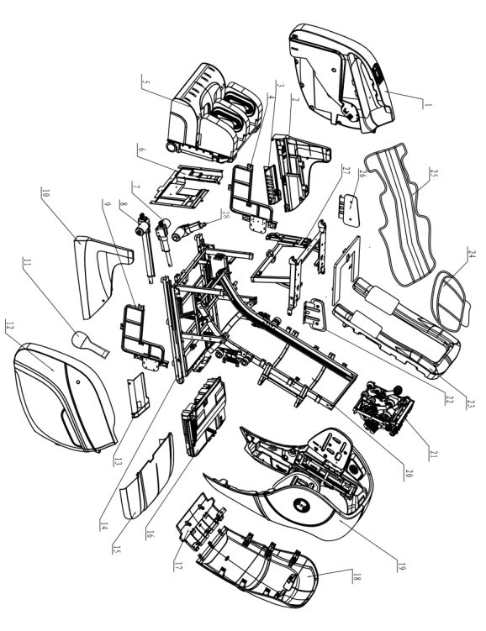
三、System connection diagram ………..……………………………………………12
四、Mechanical Failure & Troubleshooting ……………………………………………………………13
1. Massage machine failure……………………………………………………………13
2. Armrest failure……………………………………………………………………15
3. Shoulder failure ………………………………………………………………………20
4. Legrest failure ………………………………………………………………………23
5. Whole chair can’t work…………………………………………………………………26
一、Mechanical components diagram：
（一）RK8900 Explosion diagram

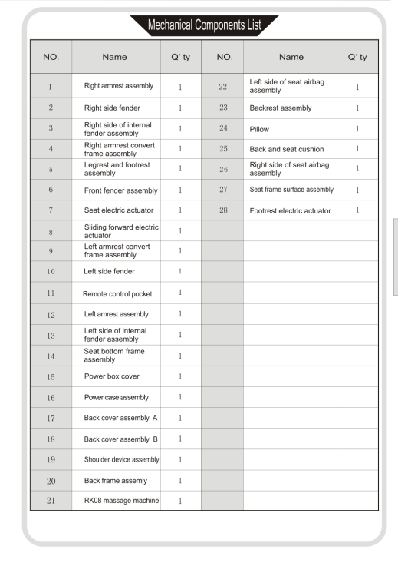

（二）Components Introduction

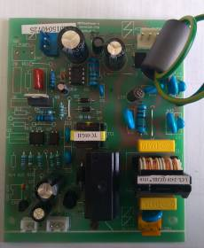

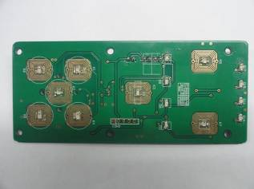

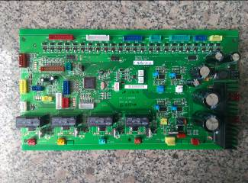

Main PCB Assay Power Board Assay Remote control board assay

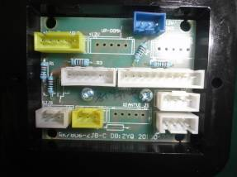

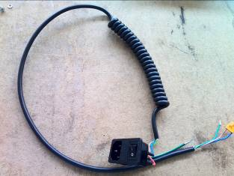

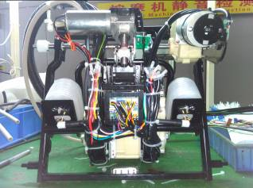

Power Input Assay Massage machine adapter board assay Massage machine assay

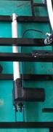

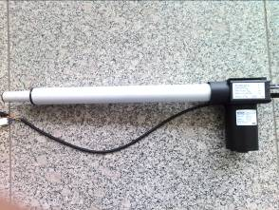

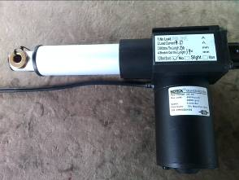

Seat Actuator Back Actuator Leg Actuator

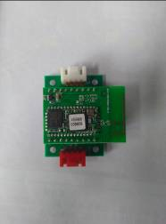

Bluetooth Module Assay

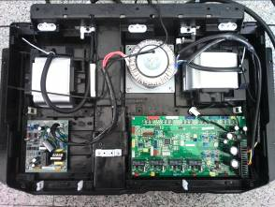

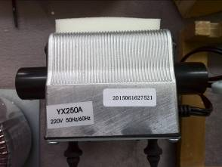

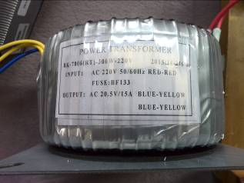

Circular transformer Air pump Power Supply Box

二． Failure & Troubleshooting
2 . Circular transformer

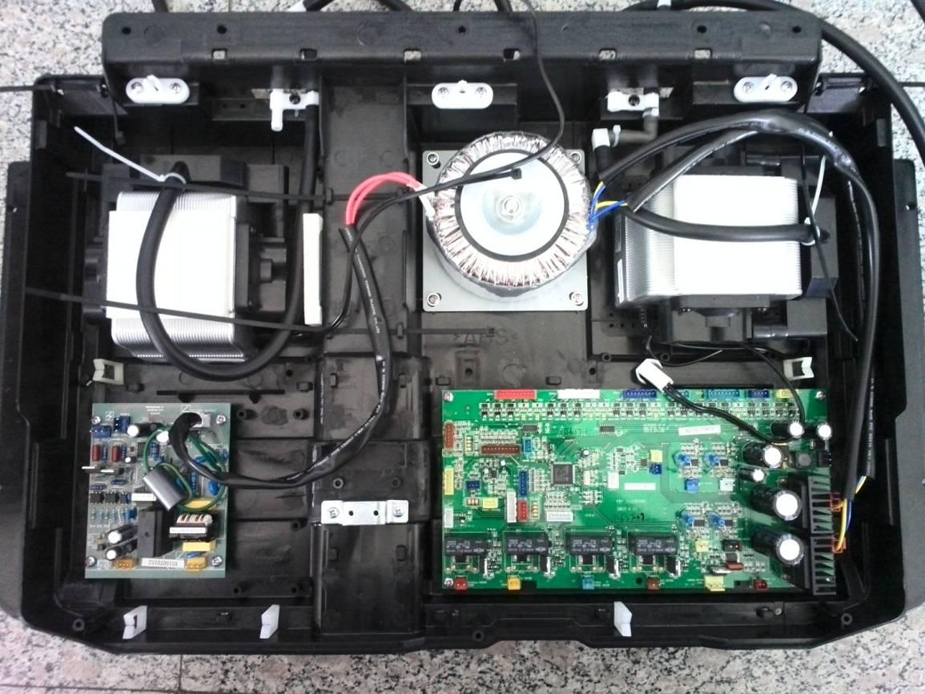
3 .AC220V Air pump

5. Main PCB Assay

Power Supply Box

1.AC220V Air pump

Circuit connection diagram
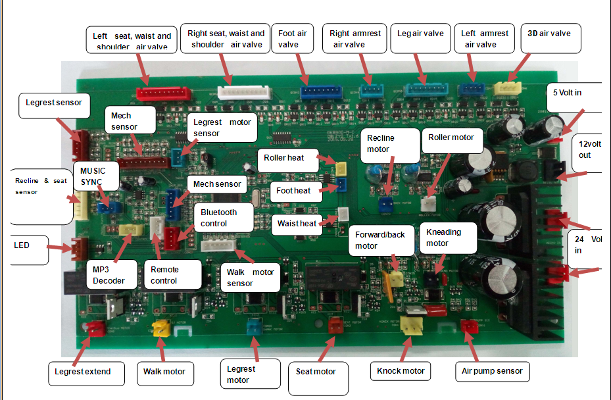
Main PCB Front view

Power Board
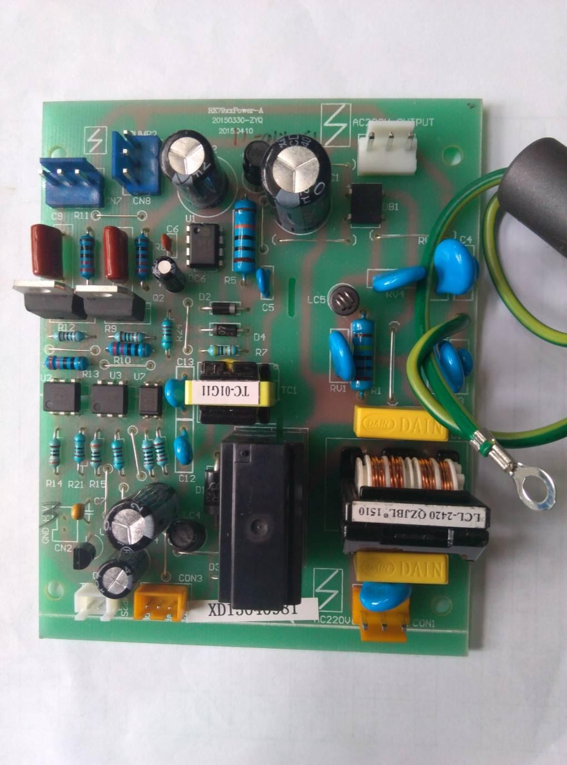
Pump signal

electric input

5V

Transformer input

pump（AC）

1.The massage chair stop working as well as the remote control.
1.1 First make sure the power is ok, turning on the power switch and check the fuse, if the fuse burned then need to change it.
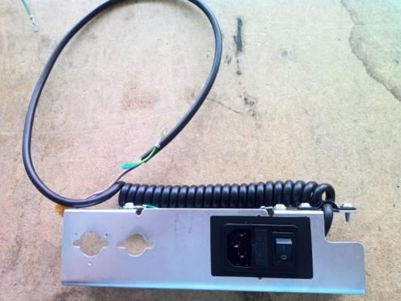
fuse

1.2 Check the 220V voltage the electric input CN1 on power panel and the circle transformer input CN6 with the AC on AVO meter, the power panel is damaged if without voltage; if With the voltage, then need to check the AC24V on input CON17, if without the AC24V then the transformer damaged,if with the AC24V, then power panel broken.
1.3 Check the CON3 voltage on the 5V part of power panel by AVO meter, and need to change the power panel if without voltage.
1.4 Check the remote control wire is loose or not.
2. The massage machine, actuator can’t move up & down, but others and remote control work well.
2.1 Check the 12V power CN3 voltage DC12V on pc-board by AVO meter, the pc-board broken if without voltage(check the LM1 LM2576T-12 usually), it will work well after changing.
3. moving problem with massage machine
3.1 Open the remote control and operate to move up & down, check the connector CON3 voltage 24V on two sides of the up & down motor by DC of AVO meter, need to change the pc-board if without voltage or the up & down motor conversely.(see. 3.3)
3.2 Make it move up & down, if it stuck on top or bottom, then the limit signal panel of up & down motor or the counter board need to be changed.
3.3 Check the up & down motor is good or not if the pc board voltage is ok. (usual ohm is 5-30Ω)
4. Kneading problem
4.1 Operate it on knead, and check the connector voltage 24V on two sides on the CON24 part of knead motor by DC of AVO meter, need to change the pc-board if without voltage or the knead motor conversely. (re. 4.2)
4.2 Check the knead motor if the pc board voltage is ok. (usual ohm is 5-30Ω)
5. Knocking problem
5.1 Operate it in knocking method, check the voltage on the both sides of connector by DC AVO meter, need to change the damaged pc board damaged if without any voltage.
5.2 Operate it to knocking and choose the width adjust, without any action then the problem lies in width adjust signal failure(J2), and need to check whether the connector falls off, or the variation of high-low LEV on sensor, need to change the width counter board if without variation.
5.4 Knocking well but tapping abnormal, then need to change the knocking counter board.
5.5 Check the knocking motor if the pc board voltage is ok. (usual ohm is 5-30Ω)
6. Forward pushing dysfunction
6.1 Shutdown condition puts multimeter DC gear, pens and placed in the front drive motor CON24 mouth, open the total moment multimeter to electricity power observation whether there is voltage.
6.2 If there is voltage output, the former push three count plate can be normal after the change
6.3 If no voltage output, then need to change the main board.
6.4 Test mechanism board wire and main board mechanism signal J1, J2 interface whether plug is reliable.

7. Leg extension failure
7.1 In the boot state and in leg length adjustment, measure the board CON5 legs extend motor, if there is the DC24V output or not.
7.2 If there is no output voltage, the motherboard is bad, replace it.
7.3 If there is voltage, extend motor is faulted, replace it.
7.4 Feet long detection board failure, replace it.

8. Abnormal heating function of massage machine
8.1 After turning on the heating function, measure the heating port CON3, if there is the DC24V output or not.
8.2 If no voltage, then need to change the main board.
8.3 If there is voltage, PTC heating element failure in massage rocking arm, after the replacement fault can be solved (PTC resistance 20-50 ohm)

9. Abnormal legrest heating function
9.1 After turning on the heating function, measure the heating port CON4, if there is the DC24V output or not.
9.2 If no voltage, then need to change the mainboard.
9.3 If there is voltage, foot heating element failure, after the replacement fault can be excluded.

10. Music decoding failure
10.1 After Start up, measure with a multimeter DC12V CN3 is normal or not.
10.2 If there is no output voltage, the motherboard is bad, replace it.
10.3 If there is voltage, the decoding board is bad, replace it.

11. The machine does not inflate or a certain way is not inflated.
11.1 If the machine is not inflated, after startup, with a AVO meter AC voltage, measuring the power board CN8 pump whether there is voltage, if there is voltage, the pump may be bad, if there is no voltage output power supply board is bad.
11.2 Above are not bad, check whether the tubes off.
11.3 If one way is not inflated, with a multimeter measuring the voltage DC a corresponding port in a DC24V voltage output, or turn off, measure with a multimeter this way corresponding solenoid valve with resistance or not (resistance is 165 (+ 10%) Omega).

12. Back actuator is not action
12.1 The multimeter is placed in the DC voltage, the two probes in CON23 blue connector terminal, operate the backrest up and down, observe the multimeter if there is a DC24V output, if there is voltage, the actuator is bad, if there is no ,bad motherboard, replace it.

13. Legrest actuator is not action
13.1 The multimeter is placed in the DC voltage, the two probes in CON10 green connector terminal , operate the legrest up and down, observe the multimeter if there is a DC24V output, if there is voltage, the actuator is bad, if there is no ,bad motherboard, replace it.

14. Seat actuator is not action
14.1 The multimeter is placed in the DC voltage, the two probes in CON2 Brown connector terminal , operate the Seat up and down, observe the multimeter if there is a DC24V output, if there is voltage, the actuator is bad, if there is no ,bad motherboard, replace it.

15. The foot rollers problem
15.1 Turn on rolling function, Without action , choose the DC on AVO meter and test the voltage of connector terminal on PC board CON20 roller part, the PC board damaged without voltage, the foot roller motor broken conversely.
3．Terminal list

Pc board terminal
terminal | marking | function
CON1 | KONCK MOTOR | Knocking motor
CON2 | SEAT MOTOR | Seat actuator
CON3 |  | Massage machine heating
CON4 |  | Legrest heating
CON5 | extend-retract MOTOR | Legrest motor
CON6 | TJ SIG | Legrest signal
CON7 | SHANK SIG | signal of leg actuator
CON8 | BACK&SEAT SIG | signal of BACK&SEAT actuator
CON9 | SJ MOTOR | Up&down motor
CON10 | SHANK MOTOR | Legrest actuator
CON11 | WD SIG | Signal of temperature
CON15 | MUSIC CONTROL | Decoders COM
CON16 | PUMP SIG | Pump control signal
CON17 | AC24V IN | 7 AC24V input
CON20 | ROLLER MOTOR | Roller motor
CON21 | HAND CONTORLLER | Simple controller
CON23 | BACK MOTOR | Back actuator
CON24 | KNEAD MOTOR | Kneading motor
CON25 | QT MOTOR | Forwarding motor
CON26 | AC24V IN | 7 AC24V input
CON27 | +5V POWER | 5V power
QCON1 |  | left part valve
QCON2 |  | right part valve
QCON3 |  | Foot valve
QCON4 |  | Right arm valve
QCON5 |  | Calf valve
QCON6 |  | Machine valve
QCON7 |  | Left arm valve
LCON2 | COM5V | Bluetooth control
J1 | CHIP SIG | Machine signal
J2 | CHIP SIG | Machine signal
J3 | UP AND DOWN SIG | Up&down limit
CN1 | MUSIC SYNCHR ONOUS | Music synchronous
CN2 | LED | LED light
CN3 | DC12V OUT | - decoding deck  12V power

Power panel port
port | Marking | function
CON1 | AC220V | input
CON3 |  | 5V and standby signal port
CN4 |  | Pump signal
CN6 | AC220V OUTPUT | 220V transformer input
CN7 | PUMP1 | Pump 1
CN8 | PUMP2 | Pump 2

Decoding deck
port | marking | function
J1 | 12V IN | 12V input
J2 |  | Music sampling
J4 | RPH | Right horn
J5 | LPH | Left horn
P1 |  | Music communication
4 The machinery problem and solution
1. Massage machine part
1.1Up&down motor noise or broken, change the motor assy.
1.1.1 Cut down the pack thread and the motor wire helmet by Oblique mouth pliers

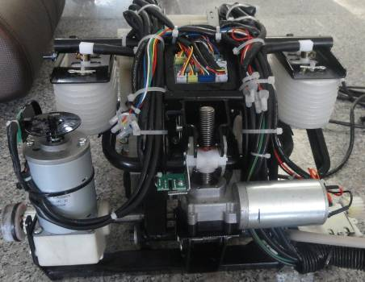

1.1.2 Take down the 4 pieces screw by screwdriver
and take off the motor assy.
Up&down motor assy

Install the machine assy by operate conversely.
Notice：
- Add some shell grease on worm of up&down
motor before installing.

2. When connecting the up and down wire harness. ensure safety helmet's installation is firm
3. Ensure without Interference phenomenon between the Counter wheel of up and down motor and light coupling of counter board
up and down counter board

1.2 up and down counter board is broken, please replace

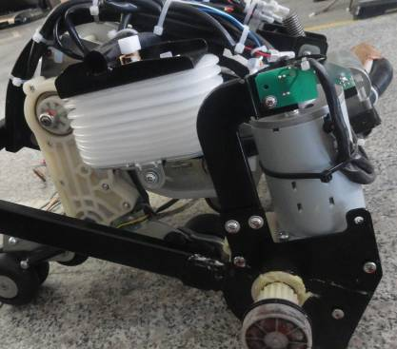

Up and down counter assembly.
1.2.1 use the Cross screwdriver to remove the screw
which fixed the up and down Counter board, remove the up
and down counter board;
1.2.2 With oblique mouth pliers or scissors to cut off
the Nylon cable tie off which strap up and down motor
Wiring harness. Cut the safe cap of connecting wire.

According to the above opposite counting steps with the new change of up and down counter assembly
Note: when installation to ensure up and down motor counting wheel and plate light coupling without interference phenomenon.

1.3 Electromagnetic valve is bad, replace solenoid valve assembly
1.3.1 With oblique mouth pliers or scissors to cut off the Nylon cable which fixed the up/down motor’s wire, unplug corresponding plug-in from the connecting plate.
1.3.2 Cut off the ribbon which fixed the

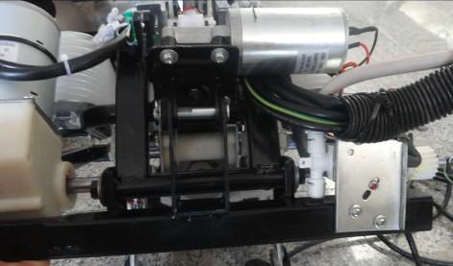

Electromagnetic valve, take off the pipe
from Gas solenoid valve’s mouth.
Electric valve assembly

1.3.3 use the screwdriver to remove the two
Screws which fixed the Solenkoid valve
Assembly, take off the Solenoid valve
Assembly.

According to the above opposite counting steps with the new change of Solenoid valve
Assembly.

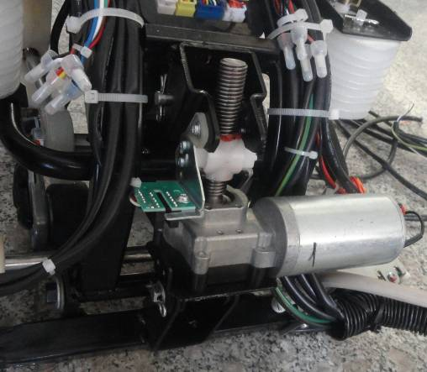

1.4 Forward motor noise or forward motor broken.
Replace the forward motor.
1.4.1With oblique mouth pliers or scissors to cut
off the Nylon cable which fixed forward motor’s
Wire. Unplug the corresponding plug-in from the
Forward counter assembly

connecting plate

1.4.2 Take off the pin which fix motor’s

Bracket, upward Rotate the motor assembly, till
up/down nut is in the same level of the nut cover,
Take off the nut, remove the forward motor assembly.
Pin

1.4.3 use the screwdriver to remove the two
Forward counter assembly

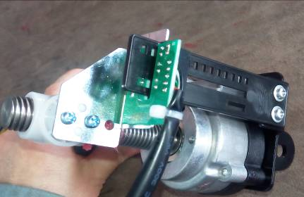

Screws which fixed forward displacement counter board,
Take away the forward displacement counter board,
1.4.4 use the screwdriver to remove the two
Screws which fixed forward counter assembly, take away
The forward counter assembly, According to the
above opposite counting steps with the new change of
Forward motor assembly.
forward displacement counter board

Pay attention to the installation：
Paint grease to forward nut and screw rod.
Without interference phenomenon between forward displacement counter board and optocoupler.

1.5 Forward counter board is broken, replace board.
Forward counter assembly

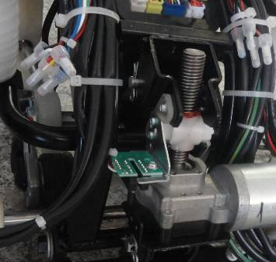

1.5.1 use the screwdriver to unplug the two
Screws which fixed forward displacement counter
Board, take away the counter board.

1.5.2 With oblique mouth pliers or scissors to cut
off the Nylon cable which fixed forward motor’s wire,
Unplug the corresponding plug-in from the
connecting plate.
According to the above opposite steps to install new up down motor counter assay
Pay attention to the installation：
Without interference phenomenon between forward displacement counter board and optocoupler.

2 Armrest part：
2.1 without air pressure on armrest，Installation the armrest, check if there is folding tube or tube falling off.
maintenance method: check if the air pipe is connecting or not, is there folding tube condition.
2.1.1 check the air pipe’s connection between armrest and main body is OK or not, For example: check Soft L pass is folding tube or not, As shown in the picture below
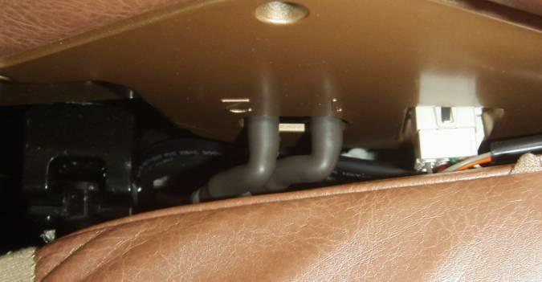

2.2 Magnetic valve function failure, replace an electromagnetic valve
2.2.1Dismantle the armrest assembly
Adjust the massage chair to recline the lowest state, loosen the screw which fixed the armrest through screwdriver, pull forward the armrest, unplug the air pipe which connect the armrest, use the screwdriver to open the connector, then the armrest could be taken off.
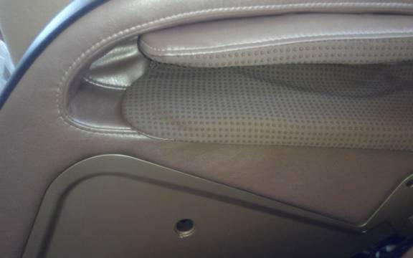
1 remove the screw foxed on armrest

2. Grab it and drag forward

2.2.2 Remove back cover A
Use cross screwdriver to remove 2 screws on Back cover A, take off back cover A with strength,(if can not take off back cover, zip off covering in front , and push the back coverA)
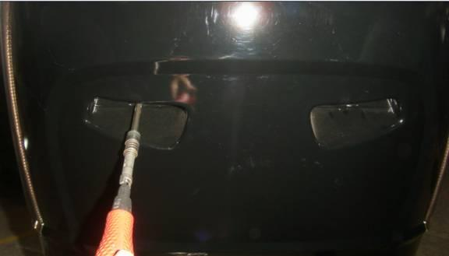
remove screws of back cover A

2.2.3 Remove back cover B
After take off back cover A, remove 4 screws on back cover B, then take off cover B.
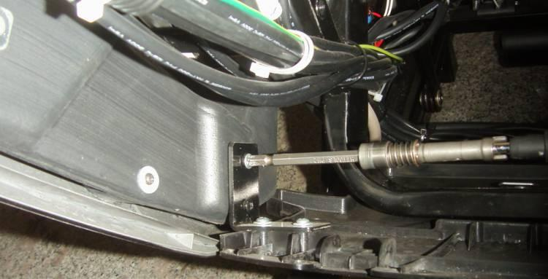
Remove screws fixed on back cover B, (2 screws each side)

2.2.4 Take off shoulders
Remove 8 screws on shoulders with cross screwdriver, (4 each side), and cut the fastener on loudspeaker cord, disconnect the connector, and disconnect shoulder LED connect on each side, lift up the shoulder, then you can take off shoulders.
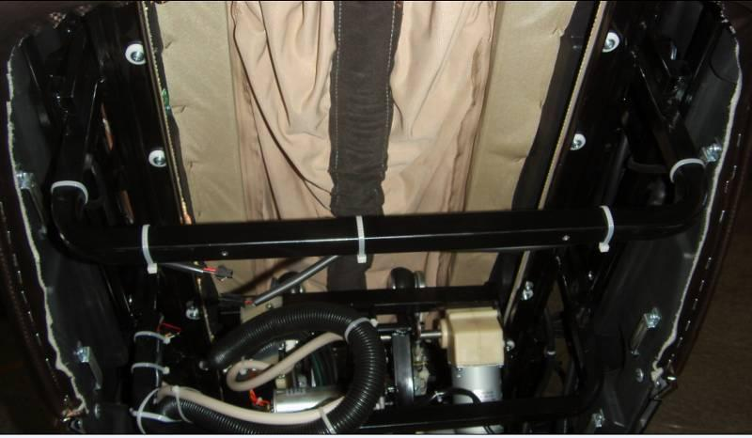
Remove screws on shoulder

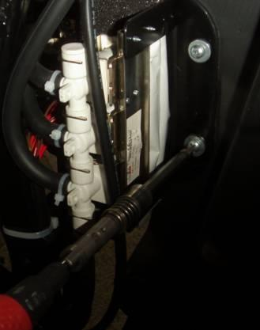
Cut the fastener on loudspeaker cord, disconnect the connector

2.2.5 Remove convert frame

- Use cross screwdriver, 13mm open wrench and 6mm Allen wrench to remove screws, self-locking nut, hexagon socket head cap screw, then take off convert frame from seat frame

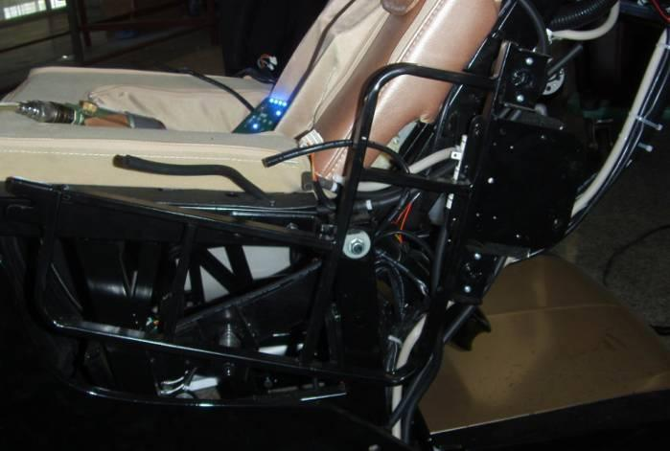
Take off screw

Use 6mm Allen wrench to remove it

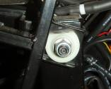

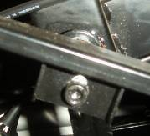

Use 13mm HYPERLINK "javascript:void(0);" open HYPERLINK "javascript:void(0);" spanner to remove it

2.2.6 Replace solenoid valve
Remove the screw of the fixed arm solenoid valve and replace the solenoid valve.
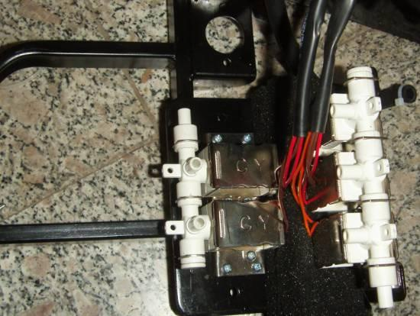
Remove the screw of the fixed arm solenoid valve and replace the solenoid valve.

2.3 Shoulder LED light is not bright, the handrail lamp connector is bad or bad light board.
Maintenance mode：Check whether the handrail connector plug in place, if the wiring harness is no problem , replace the light board
2.3.1 Dismantle the armrest assembly
According to 2.2.1 step to remove the arm assembly from the machine.
2.3.2 Remove the inner cover
After remove the armrest assembly, according to the following steps to remove the cover.
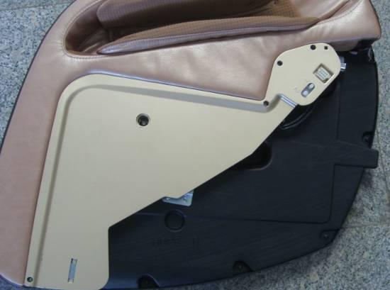
Use cross screwdriver to remove the screw cap

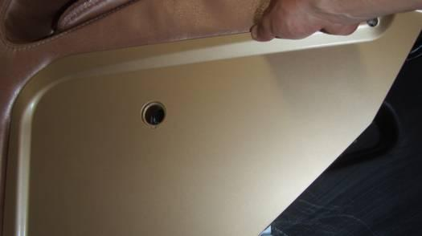
Put your fingers into the cover, push up the cover, break the connection in fixing the cover.

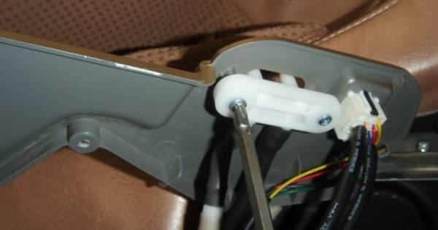
remove PP stick with a wallpaper knife after, unplug the connector.

Remove screws which fix double L connector

2.3.3 Remove the outer cover
Remove the inner cover, show screw which fixes the cover，remove the outer cover according to the following steps：
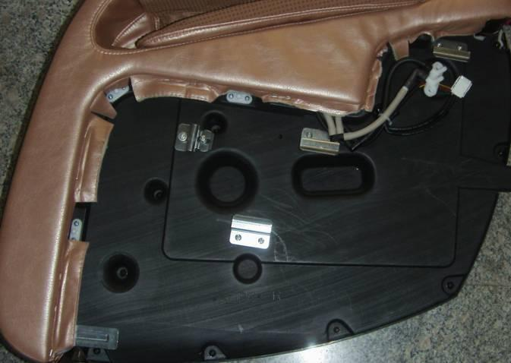
Remove the 9 screws of the fixed outer cover with a cross screwdriver.

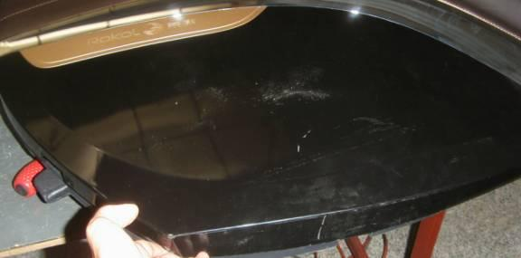
Flip the armrest，forcibly up from the bottom of the cover with the hand will cover fixed buckle broke off.

2.3.4 Check the wiring harness plug in place, there is no abnormal wiring
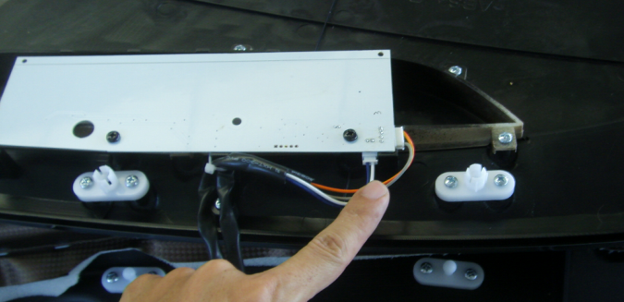
Check whether the plug connector in place

2.3.5 Replacement lamp plate
If check wiring harness is normal, need to replace the lamp board, remove the fixed lamp board of the two screws with a screwdriver, replace the new light board, as shown below:
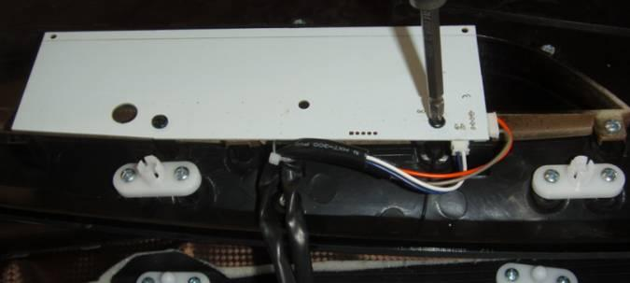
Remove screw fixing the lamp board, unplug the connector and replace the lamp board

2.4 Hand controller function failure, armrest wiring harness connection is bad.
Maintenance mode：Check if connector plug in place.
Check whether the plug connector in place

2.5 Hand controller function failure, manual control board failure.
Maintenance mode：Replace the manual board.
2.5.1 unistall hand control panel
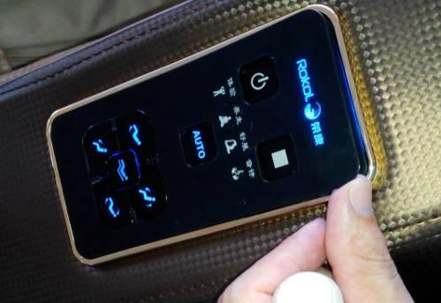
With wallpaper knife lift from a corner of the panel, and then hand in a corner of the panel to lift slowly.

2.5.2 Remove screws for fixed hand control
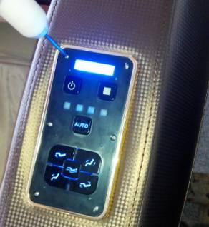
Remove the screws from the fixed hand controller with a small cross screwdriver.

2.5.3 Replace the manual device
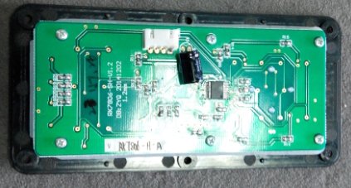
Using the small cross screwdriver to remove the screw of the fixed hand controller board (a total of 6), and replace the hand control panel.

3 The shoulder part
3.1 The horn does not ring, connector falling off or power amplifier board is bad.
Maintenance mode：Check if the connector is off or replace the power amplifier board.
3.1.1 Remove horn decoration cover
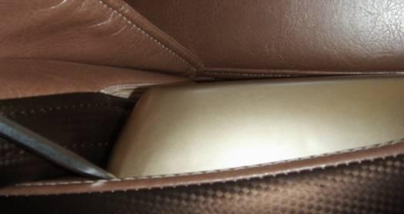
Use a flat-blade screwdriver to pry the audio cover away from the corner of the audio cover

3.1.2 Remove the audio base, replace the power amplifier board

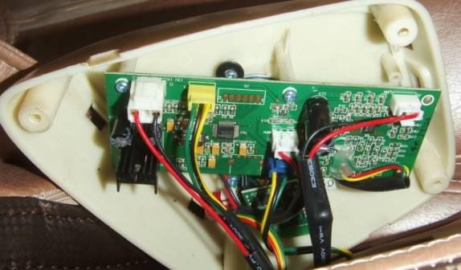
Check whether the connector has a peeling phenomenon
If there is no loose, you need to remove the fixed amplifier board screws to replace the power amplifier board

Remove the four screws securing the audio cover base

3.2 Bluetooth can not be connected, Bluetooth board off or function failure
Maintenance method: Check whether the Bluetooth board and connector is off or replace the Bluetooth board
3.2.1 Check that the Bluetooth board is disconnected after removing the audio base as described in 3.1.1 and 3.1.2
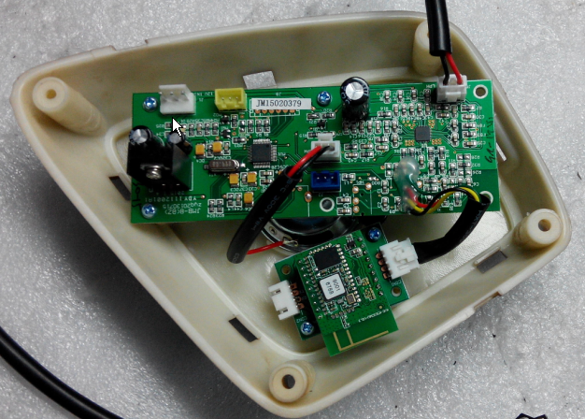
Check the connector connections

3.2.2 If there is no problem in checking the connection of the Bluetooth board, it may be that the Bluetooth board function is invalid, replace the Bluetooth board
·
Use the diagonal pliers to cut the thread clips and use a screwdriver to remove the screws that secure the bluetooth board
Replace the Bluetooth board

3.3 shoulder air bag is not inflated, the shoulder tube is folding
Maintenance: Check the shoulder tube is broken
3.3.1 Remove the shoulder air bag to see if it is fold
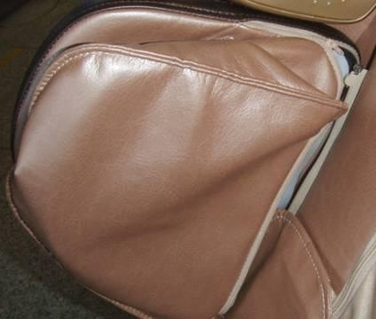

Pull the air bag zipper open

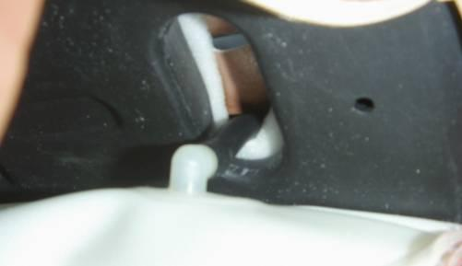
Check the tube is with a folding mark or not, , if there is a long trachea, pull off the tube, and cut off.

3.4 shoulder air bag is not inflated, the shoulder solenoid valve function failure
Maintenance: replace the shoulder solenoid valve
After removing the converter frame according to 2.2.1-2.2.6, remove the shoulder solenoid valve and replace it
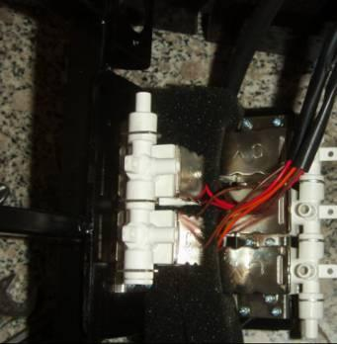
Remove the four screws that secure the solenoid valve. Replace the solenoid valve

3.5 shoulder LED lights do not shine, the shoulder light board bad
Maintenance: replace the shoulder LED light board
3.5.1 Remove the shoulder airbag fixing plate
Remove the shoulder airbag as described in section 3.3.1, and remove the airbag mounting plate as shown below.
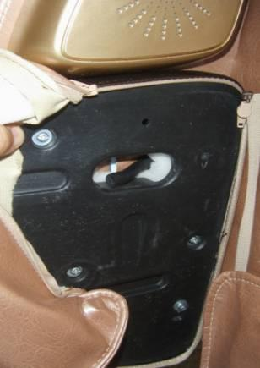
Remove the screws on the plate and remove the airbag fixing plate and remove the airbag

3.5.2 Replace the shoulder LED panel
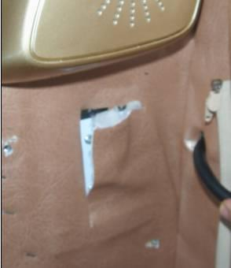
Cut the stitches with a paper knife or scissors to expose the screws that secure the LED board

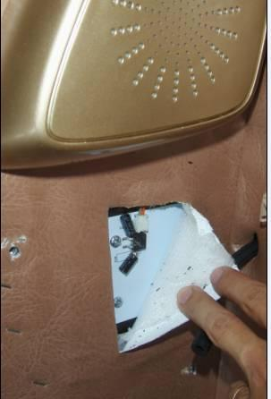
Use a Phillips screwdriver to remove the screws that secure the lamp panel and replace the LED board

4.Leg part

4.1 foot massage roller bad, replace the foot massage roller assembly::

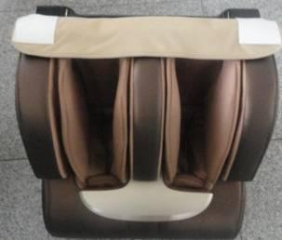
4.1.1 Disassemble Legrest assembly:
4.1.1.1

Use a Phillips screwdriver to remove the Legrest assembly and seat connections screw (left and right side of each one), turn the spindle plate upward, you can unload legrest assembly.
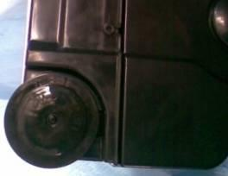
4.1.1.2；unplug the legrest harness and air pipe from the whole machine;
casters

4.1.2 Remove the rear leg shield

4.1.2.1
Disassemble the casters: Remove the mounting screws (circle position) at the center of the casters with a Phillips screwdriver to remove the casters and one of the left and right casters.
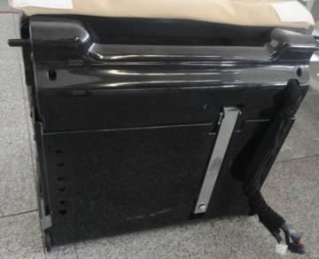
4.1.2.2
leg upper cover

。

Remove the legs upper and lower covers: Use a Phillips screwdriver to remove the eleven screws (rear eight,
Bottom side of the three), and finally removed the M10 screw, lift the legs and legs push tube, You can remove the legs upper and lower shield
4.1.3 disassemble feet assembly
4.1.3.1 Using a Phillips screwdriver, remove the five M6 screws that secure the foot assembly;
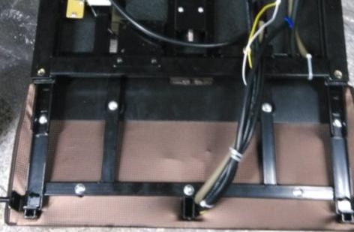
4.1.3.2

Unplug the foot of the total intake air pipes, pay attention to the total intake pipe spring should not be lost;
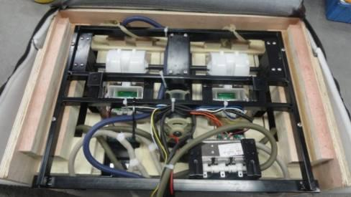
4.1.4 Disassemble the foot of wood products

4.1.4.1
Remove the foot of wood products: the foot sewing products on the zipper opened, remove the sewing products. Use a Phillips screwdriver to remove the four screws and two screws on the side to remove the wooden parts.

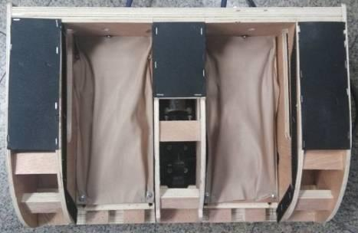
4.1.5 Demolition of foot roller:

4.1.5.1

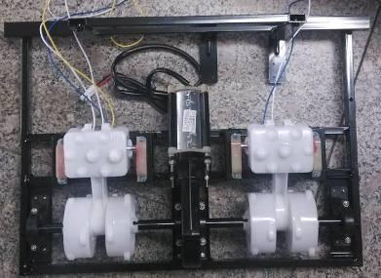
Remove the 20 screws on both sides and center of the fixed foot roller with a Phillips screwdriver and remove the motor wire of the wheel to remove the foot roller.
4.1.5.2

Replace the foot roller: Install the new one according to the reverse procedure above
Roller.

4.2 Foot electric valve is bad, change it.
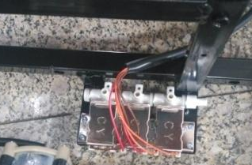
4.2.1 Disassemble legrest, see 1.1
4.2.2 Disassemble legrest back cover , see 1.2
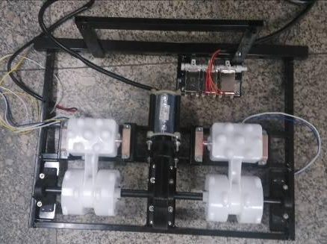
4.2.3 Disassemble legrest ,see 1.3

4.2.4 Disassemble foot wooden product,

See 1.4
4.2.5 Disassemble foot electric valve.
4.2.5.1 Remove valve connector, cut the wire harness, unplug the tube on valve, use cross screwdriver to remove 4 screws from valve, then take off valve.
4.2.5.2 Replace electric valve: take the opposite step
To change electric valve, make sure to connect tight, each
Tube position is same as before disassembling.
4.3 Leg electric valve is bad, change it.
4.3.1 Disassemble legrest, see 1.1
4.3.2 Disassemble legrest back cover , see 1.2

4.3.3 Disassemble legrest ,see 1.3

4.3.4 Disassemble legrest assembly
4.3.4.1 Use cross screwdriver to remove 4 screws in the circle,
Take off legrest

4.3.4.2 Disassemble electric valve: unzip the leg sewing product, take off the tube connected to electric valve, use cross screwdriver to remove 2 screws fixed on the valve assembling board, then take off the electric valve.
Notice: when taking off the tube, be careful not to break the air tap.
5、Whole chair
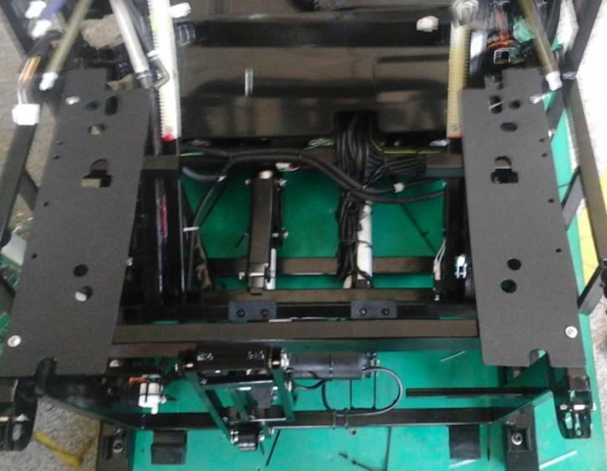
Leg Actuator

Slide Forward Actuator

Seat Actuator

5.1 Leg Actuator is broken, change the leg actuator.
Remove the leg-rest according to step 4.1.1.1 and 4.1.1.2, take down the back cushion, unzip the front back-rest clothing, cut down the ties binding actuator cords and unplug the connector and signal cord. Remove the pine leaf pin and pin roll on one end of actuator motor and seat frame, then the pin and pin roll on the other end of actuator. In this way, you can take down the actuator and replace a new one. Do not miss the original cap or washer.
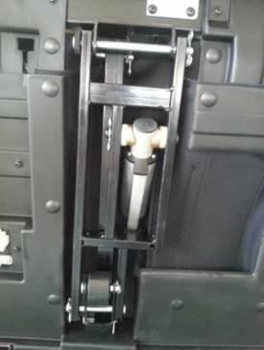
Leg Actuator

5.2 Seat actuator is broken, change the seat actuator.
Remove the leg-rest according to step 4.1.1.1 and 4.1.1.2, take down the back cushion, unzip the front back-rest clothing, cut down the ties binding actuator cords and unplug the connector and signal cord. Remove the pine leaf pin and pin roll on one end of actuator motor and seat frame, then the pin and pin roll on the other end of actuator. In this way, you can take down the actuator and replace a new one. Do not miss the original cap or washer.
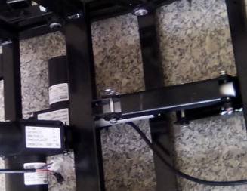

5.3 Sliding forward actuator is bad, change it

5.3.1 disassemble the back cover

Use cross screwdriver to disassemble the two screws at the bottom of back cover, there is a buckle in the front of both sides, unplug the buckle, the back cover can be disassembled.
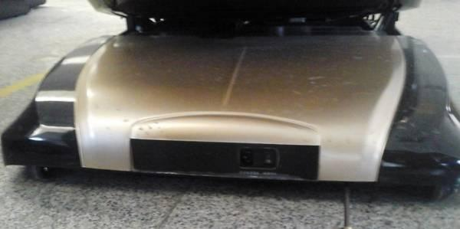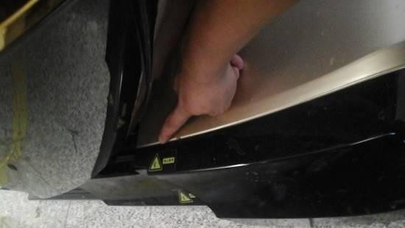

5.3.2 disassemble the power box

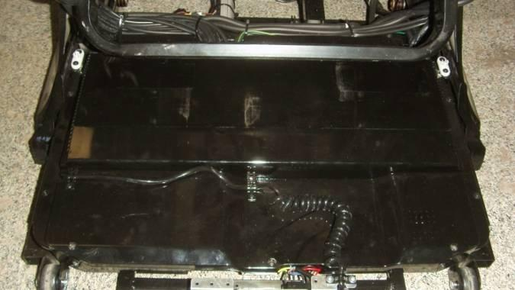

7 screws

According to 2.2.1 2.2.2 2.2.3 and 2.2.4 steps, disassemble the armrest, back cover A、B and shoulder. Cut off all of power box front line buckle, show the screws, use cross screwdriver to disassemble the fixed power box at the bottom of seven screws.

5.3.3 change forward slip electric actuator

According to 4.1.1.1 and 4.1.1.2 steps disassemble the leg-rest part. Disassemble back cushion, open front sewing cover zipper, take out strapping electric actuator wiring harness of cable tie, unplug the electric actuator’s connector and line connector. Put the power box lift up, show the fixed forward slip actuator head, disassemble the cotter, pull out pin, disassemble the actuator motor loose leaf pin and cotter, then can be disassembled the forward slip electric actuator. Change the electric actuator, pay attention to when changing, do not neglected install the original sheath, gasket, etc.

5.4 Air pump bad, change the air pump
5.4.1 disassemble the power box cover

Use cross screwdriver to disassemble the fixed power box cover three screws. there is a buckle in the front of power box cover, put the buckle unplug, then can see the air pump.

5.4.2 change pump
Unplug the air tube of air pump and take the rubber feet out of the lower case, take away the air pump and unplug the connectors. Thus you can change air pump.
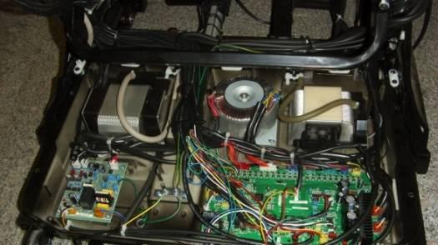
Air Supply of the Pump Left Air Pump: massage machine, left and right armrest two-valve magnetic valve group
Right Air Pump: legs and feet airbags, left and right shoulder, waist and seat three-valve magnetic valve group

5.5 Massage machine is broken, change the massage machine.
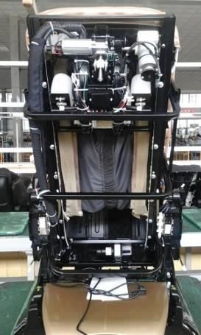
5.5.1 According to the steps of 5.3.1、2.2.1、2.2.2、2.2.3、2.2.4 and 5.4.1, take away the back cover, armrest, back-rest cover A and B, shoulder and power box cover. Cut down the connectors of massage machine by Diagonal Pliers and unplug the air tube. Remove the six screws fixing the back-rest front plastic part.

Six Screws Fixing the Back-rest Front Plastic Part.

Massage Machine Air Tube Connector

5.5.2 Remove the junction plate of back-rest
Remove the eight screws fixing the back-rest junction plate by cross screwdriver, then you can change the massage machine.
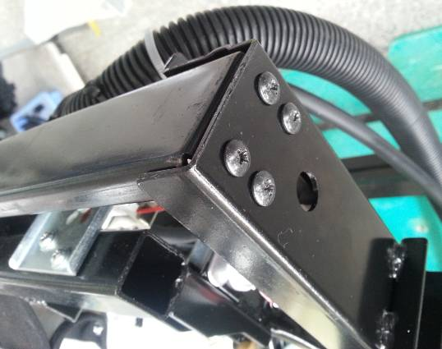
Eight Screws Fixing the Back-rest Junction Plate
Four on the Left and Four on the Right

