
HIGhpointeMassage chair
Maintenance instructions
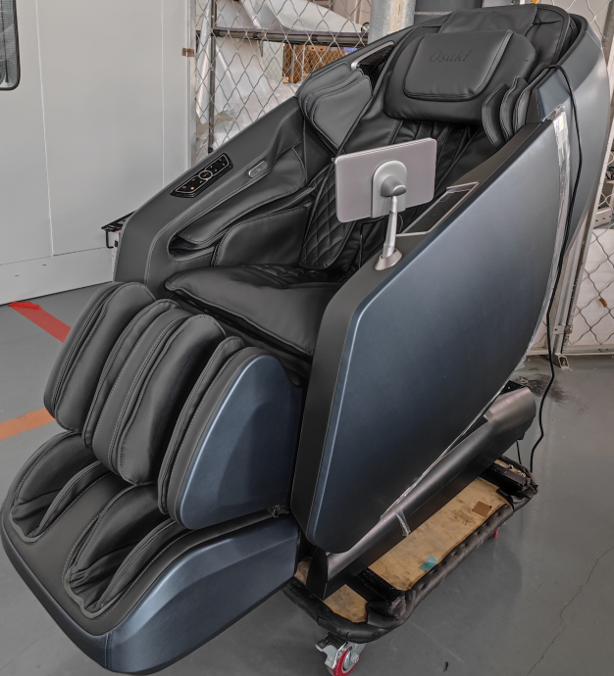

Shandong Kangtai Industrial Co., Ltd.

Thank you for choosing Rongkang massage chair!
It is our greatest honor for you to become a user of Shandong Kangtai Industrial Co., Ltd. I sincerely hope that Rongkang massage chair can become a good helper for your leisure and health care.
In order to facilitate the majority of dealers and customer service personnel to do a good job in the on-site maintenance of products, some common problems and fault solutions in the use of the massage chair are now summarized and sorted out for professional maintenance personnel..
Pour:Non-professional,Do not try.
After-sales service center telephone:(86) 400 -6582511
(86) 0535 -8243907
(86) 0535 -8243916
Http://www.kangtaigrouP.com

Shandong Kangtai Industrial Co., Ltd.

Catalogue
I. Product components: 1
(One) RK7602DStructure diagram 1
(Two) Introduction of key components 3
II. Common faults and solutions 4
1. The whole machine of the massage chair is not working, and the hand controller is not displayed. 5
2. The massage machine and pole do not move, other functions are normal, and the hand controller is displayed. 5
3. Abnormal lifting of the massage machine 5
4. The massage machine kneads abnormally. 8
5. The massage machine tapped abnormally. 8
6. The massage machine tilts forward abnormally. 9
7. The whole machine is not inflated or a certain road is not inflated, and the massage machine works normally. 10
8. The back pole does not move. 10
9. The leg pole does not move. 10
Ten. The screen of the hand controller is abnormal, and the key operation function is normal. 11
11. The sole roller does not work. 11
12. Leg rubbing motorDon't work 11
13. Abnormal operation of telescopic motor 12
14. KneeThe heating cloth does not work. 13
15. Chest plusHot cloth is not working. 13
16. The loudspeaker is not working 13
III. Mechanical faults and solutions: 14
1. Replace the massage machine 14
2. Remove the armrest assembly and shoulders 14
3. Front backrest plastic assembly 16
4. Unpack the power box assembly 16
5. Remove the legs and feet 17
IV. Layout diagram of the main circuit board components 21
V. System connection diagram 22

- Product components:
- RK7602DStructure diagram
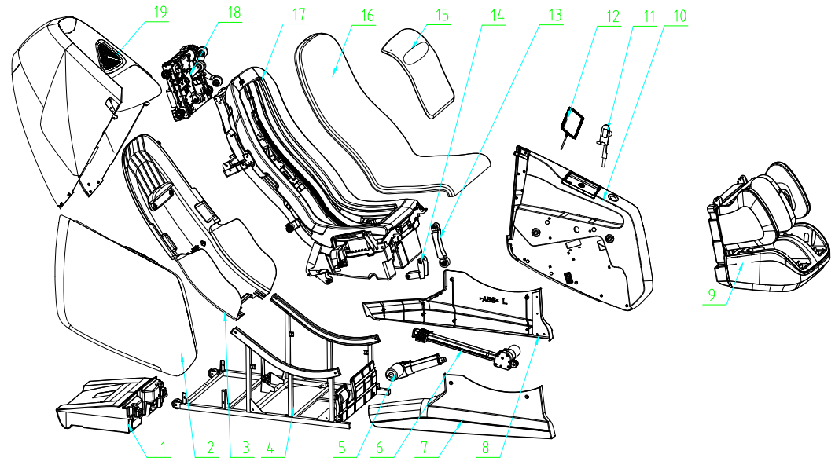

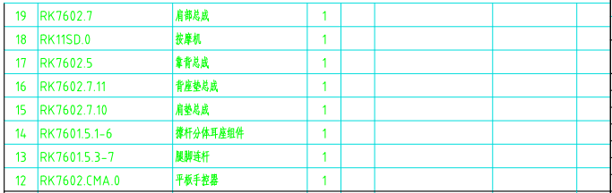
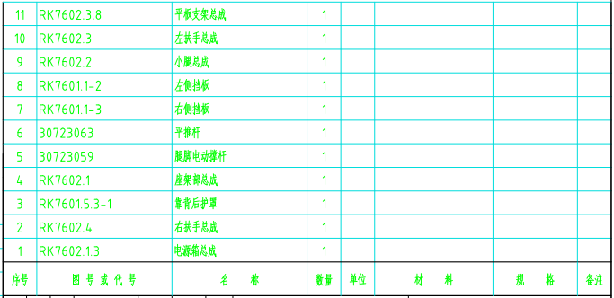

- Introduction of key components
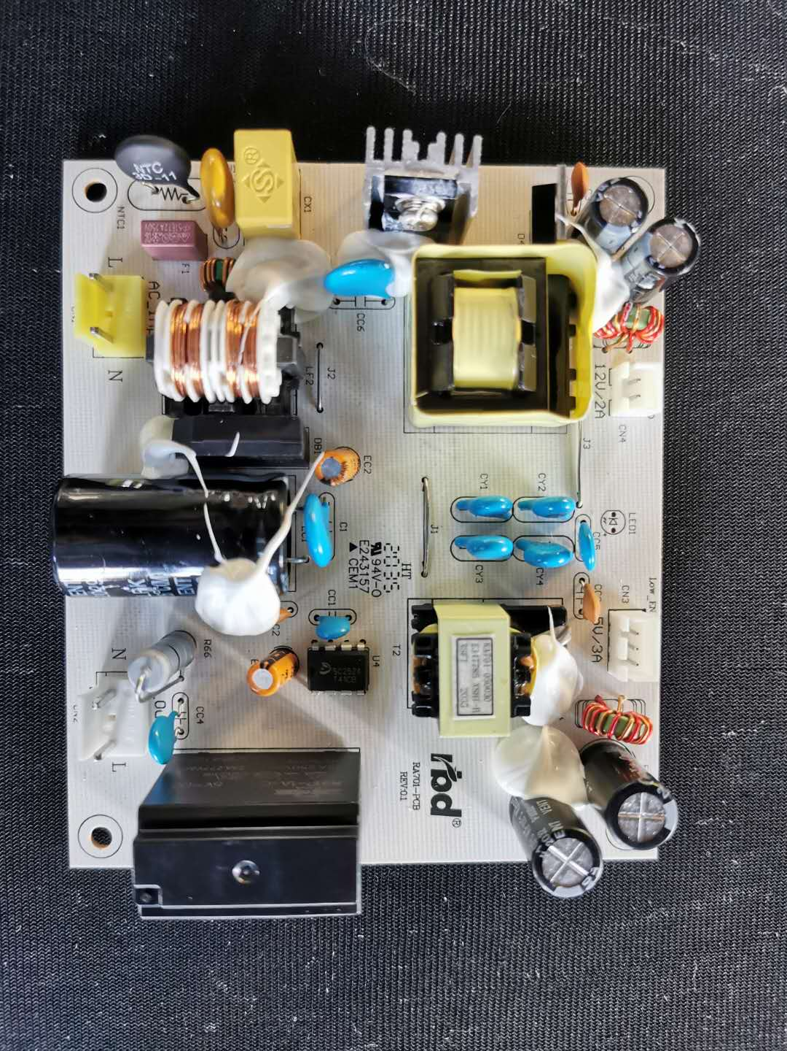
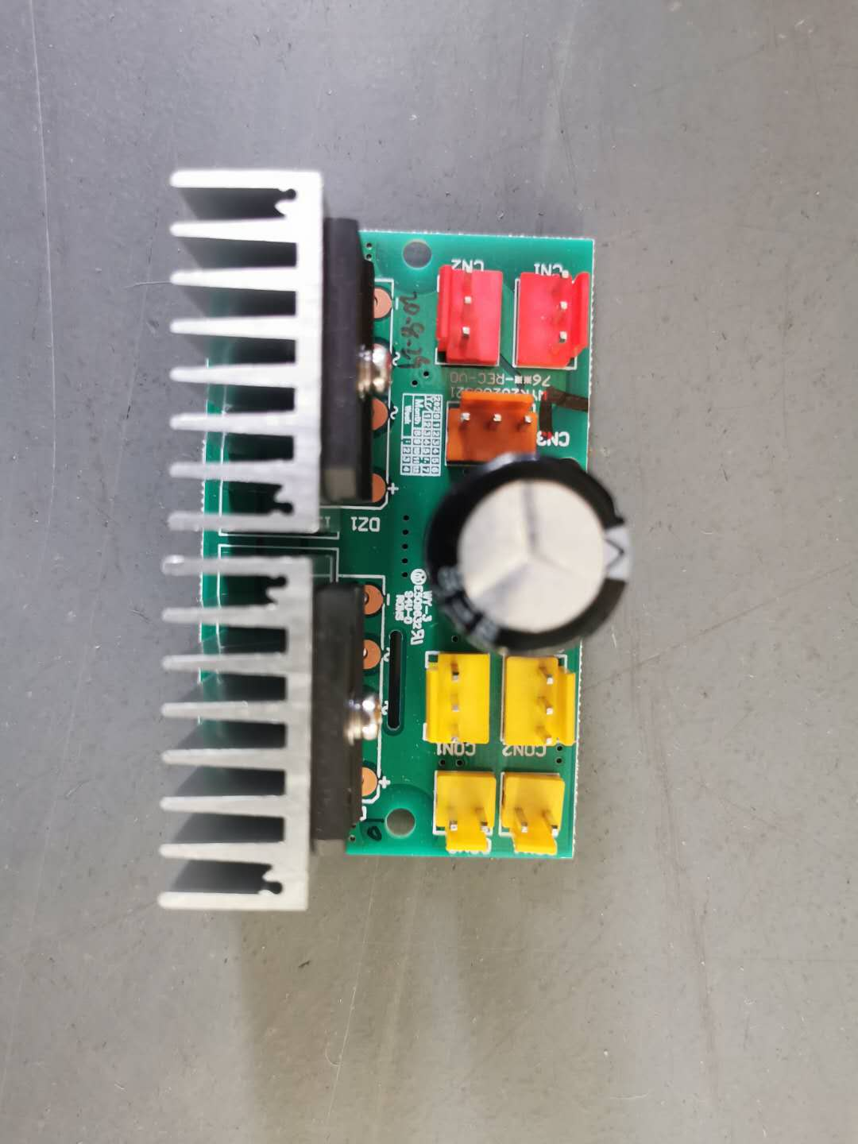
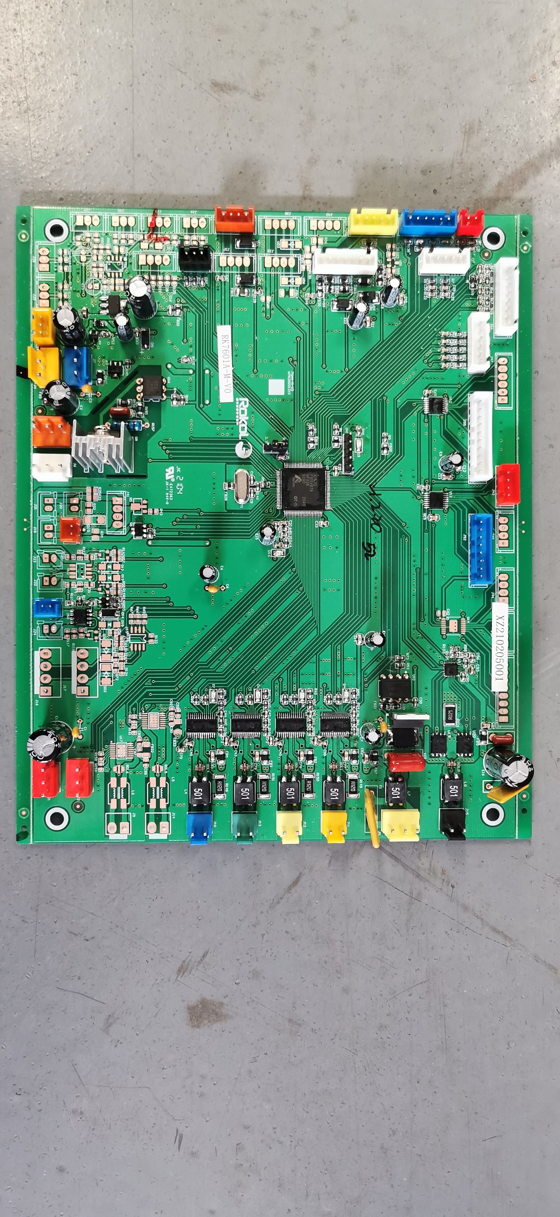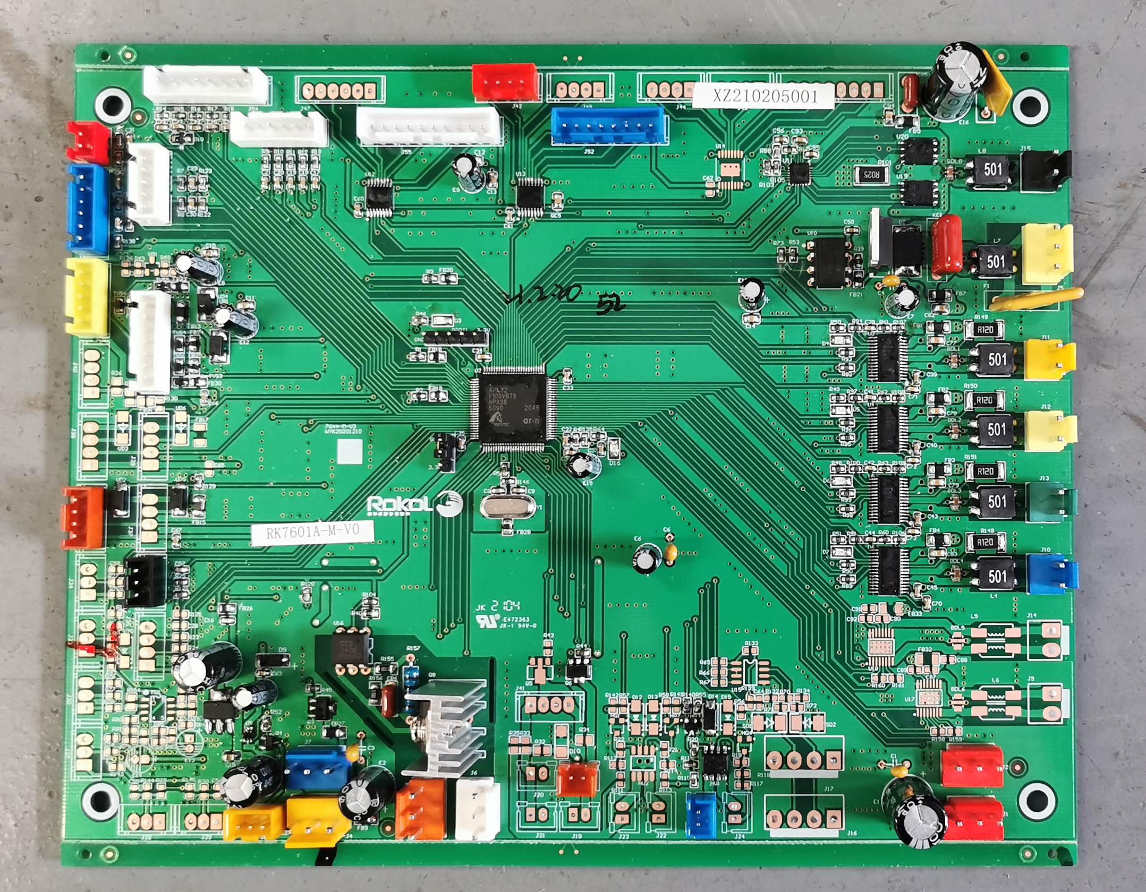

Main circuit board Power board Rectifier board
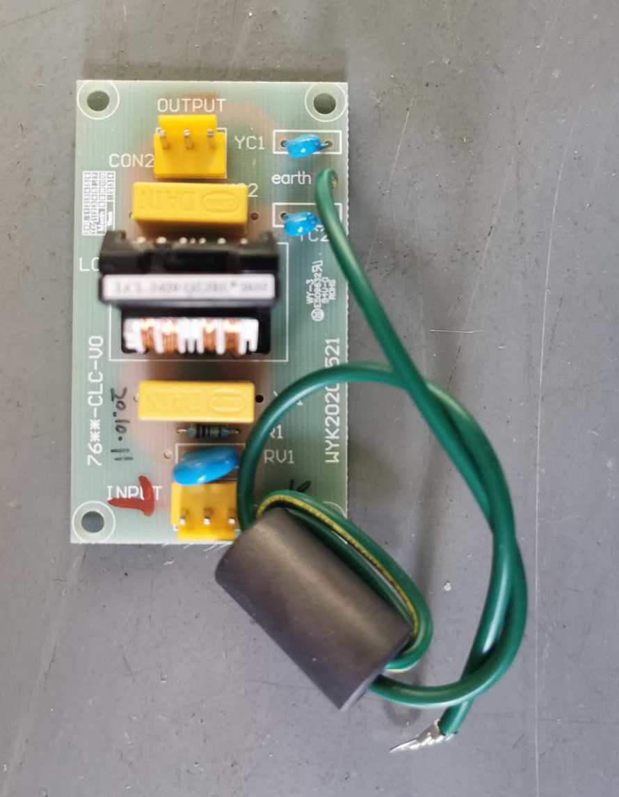
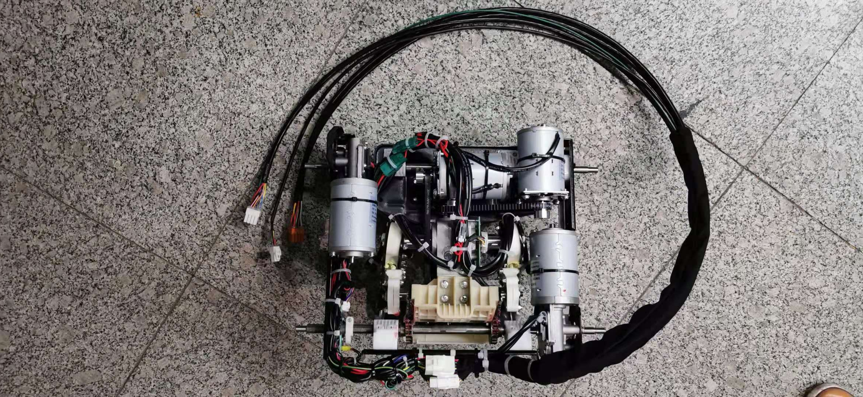
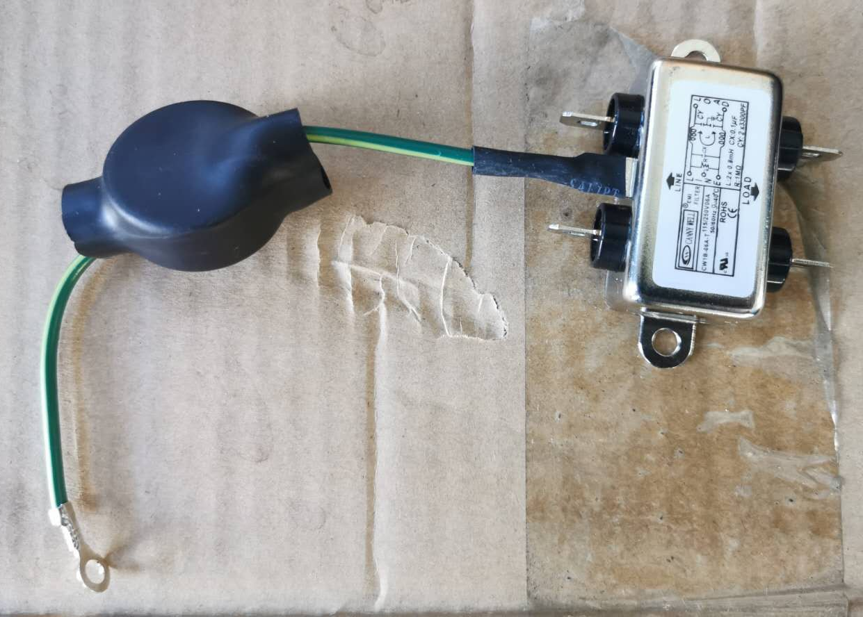

Filter Filter plate Massage machine
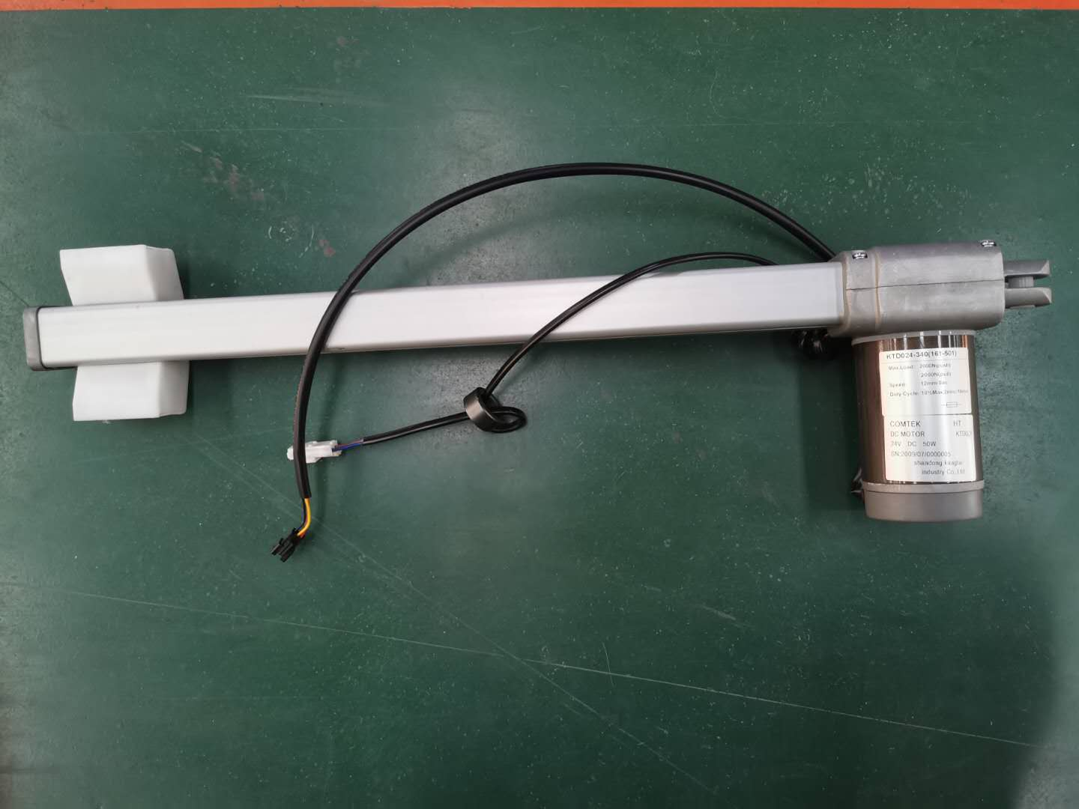
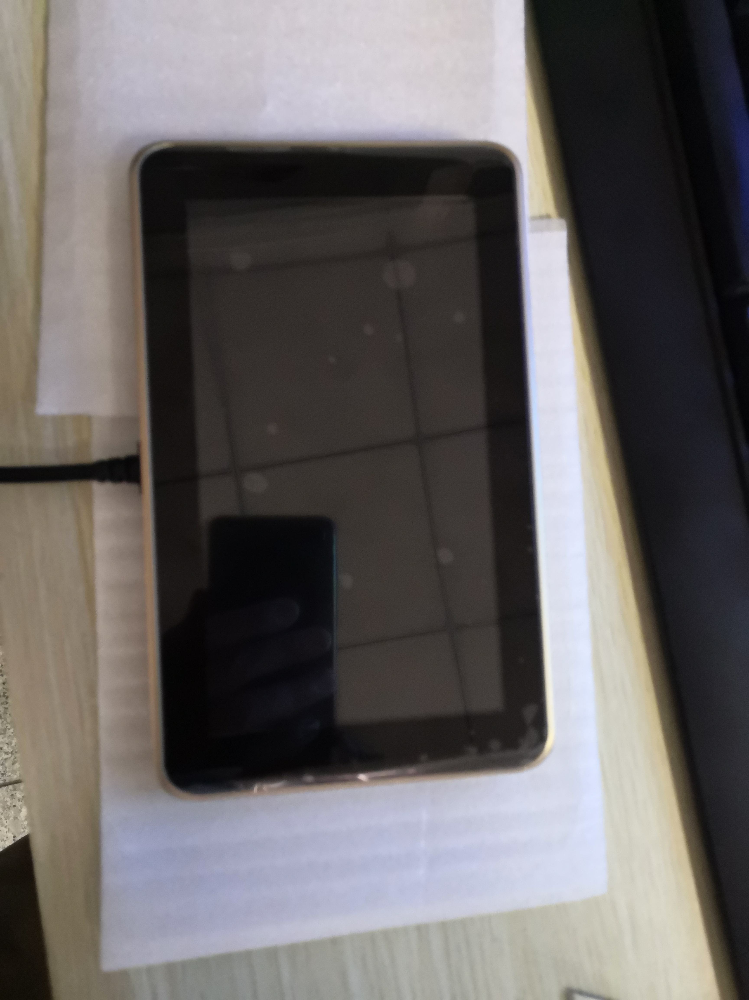
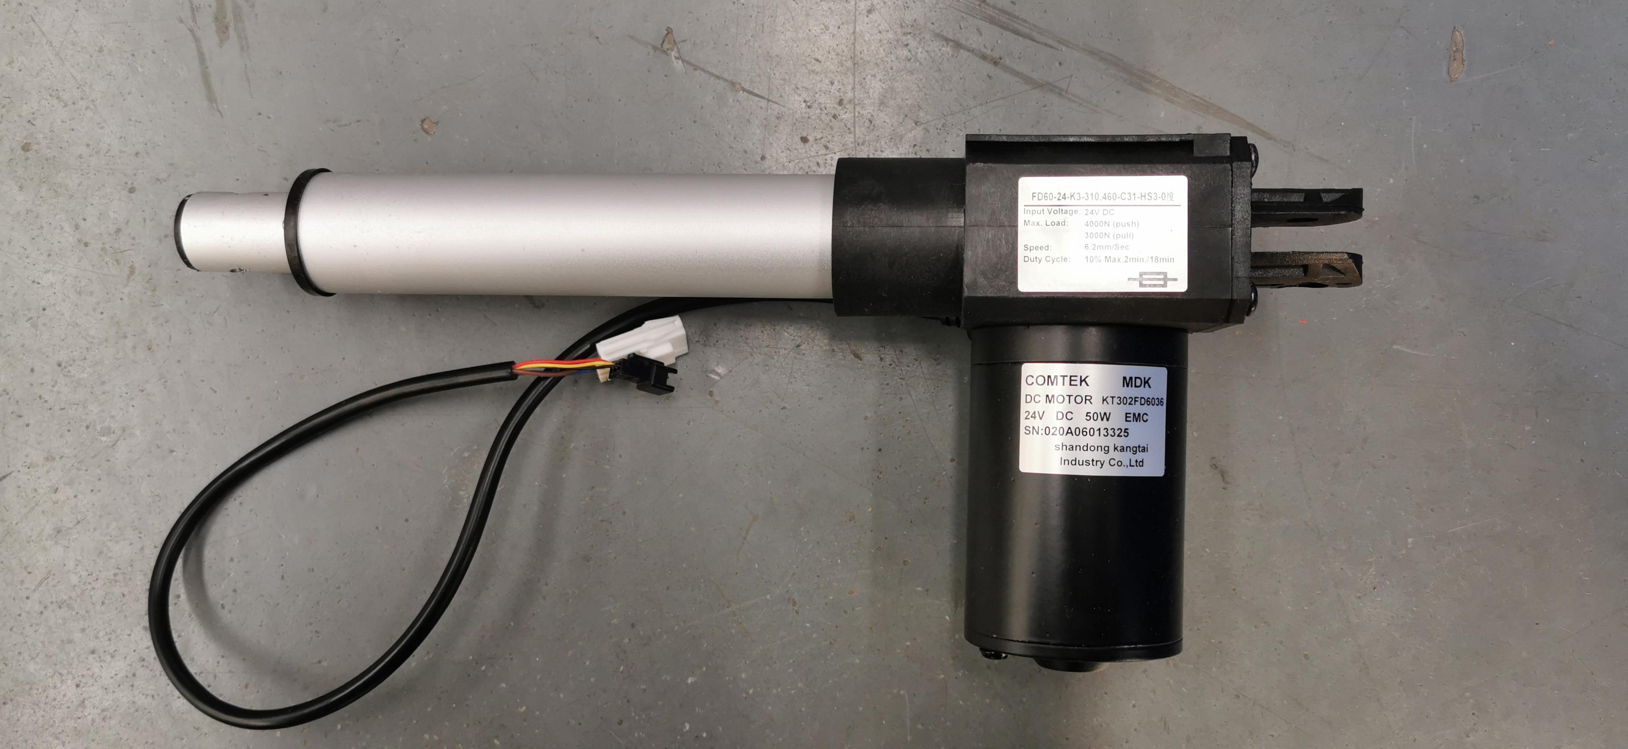

Back pole Leg pole Tablet assembly

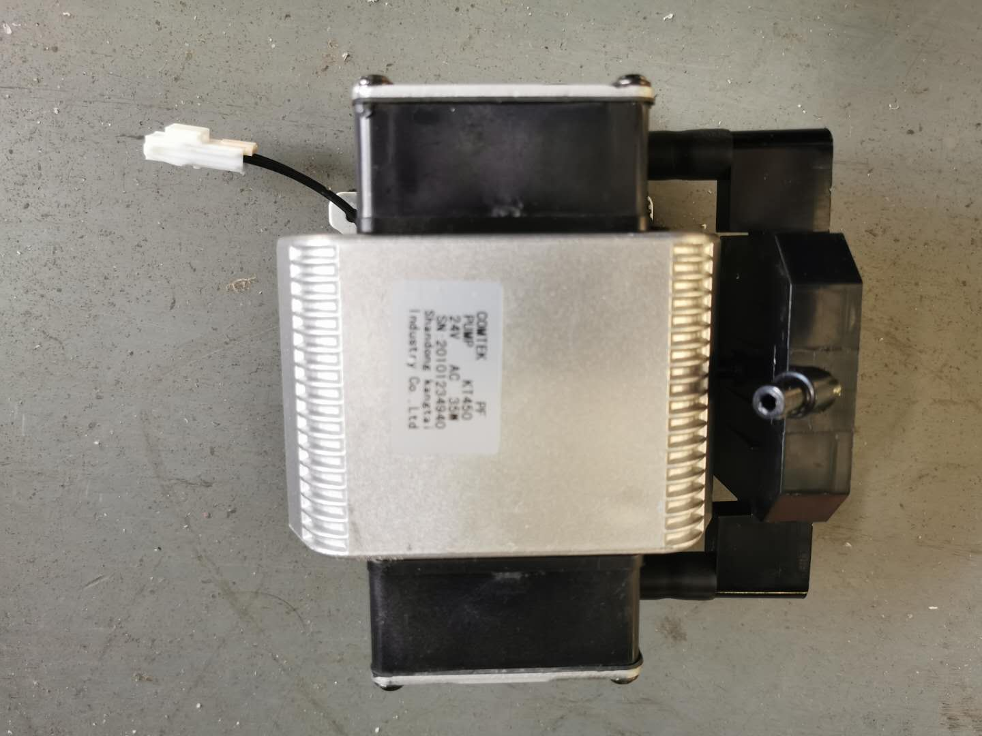

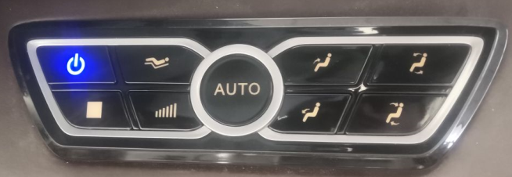
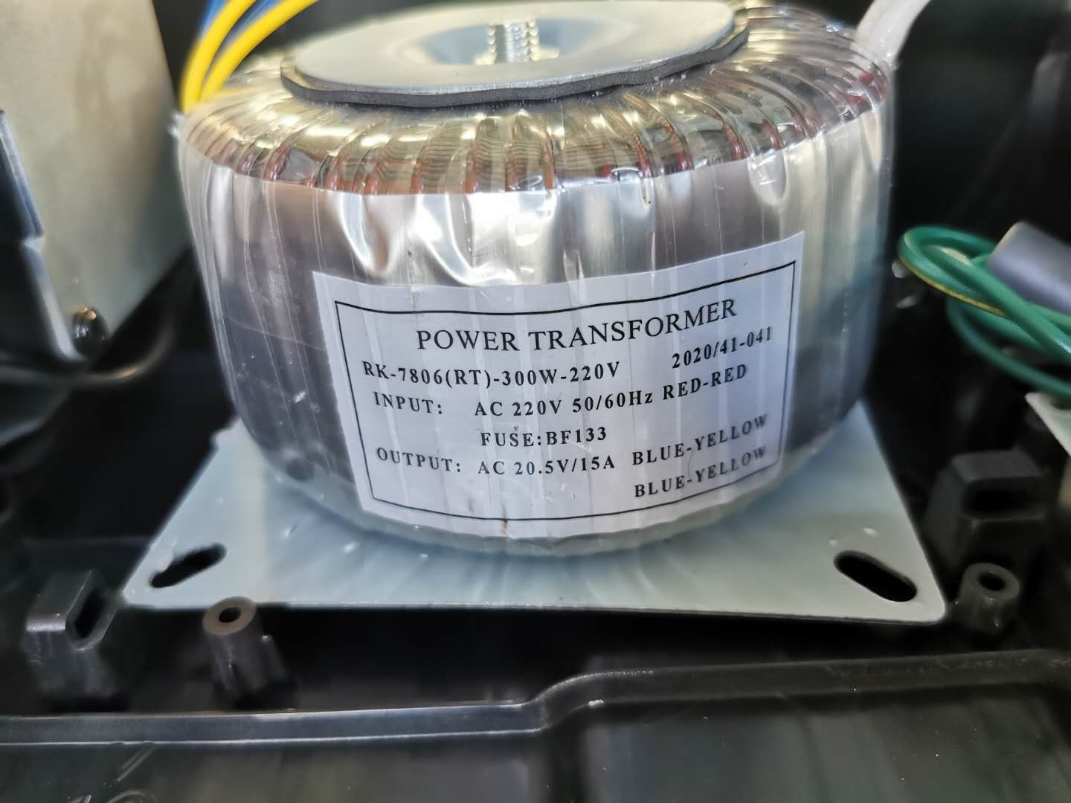

Ring transformer Air source box hand controller

- Common faults and solutions
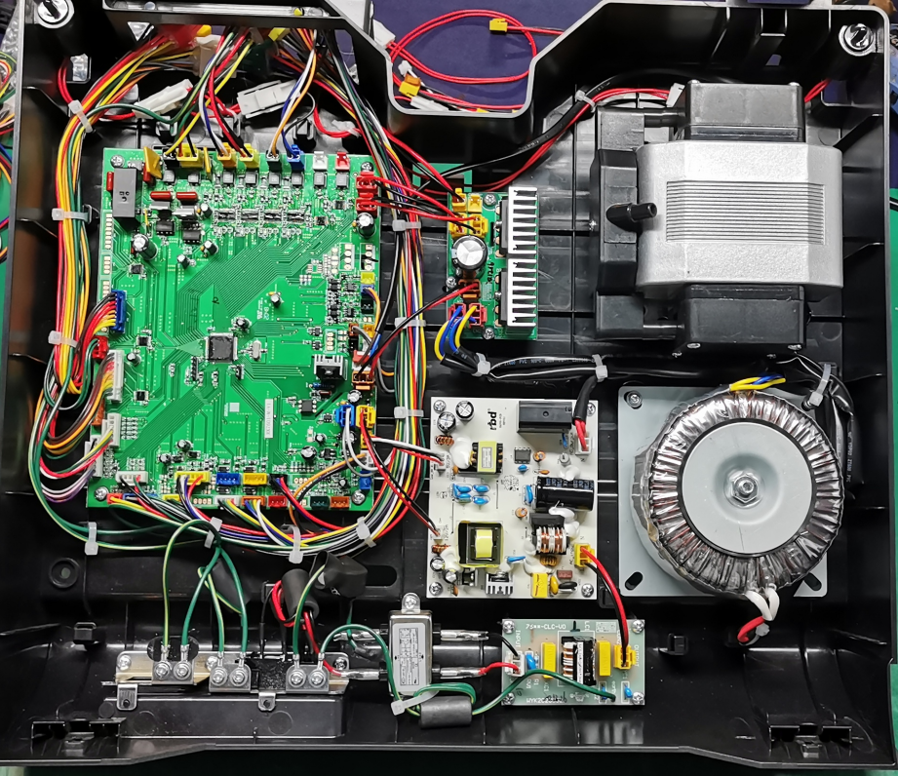
6 air pump(AC24V)

4 Transformer output(AC20.5V)

2 Power input(AC220V)

9 Standby,DC5V

7 Air pump power supply
11 movement signal
10 Solenoid valve(DC24V)

3 Transformer input(AC220V)

1 three-in-one switch
8 Power output(DC12V)

5 Output(DC24V)

Electrical connection diagram
Movement signal
Solenoid valve

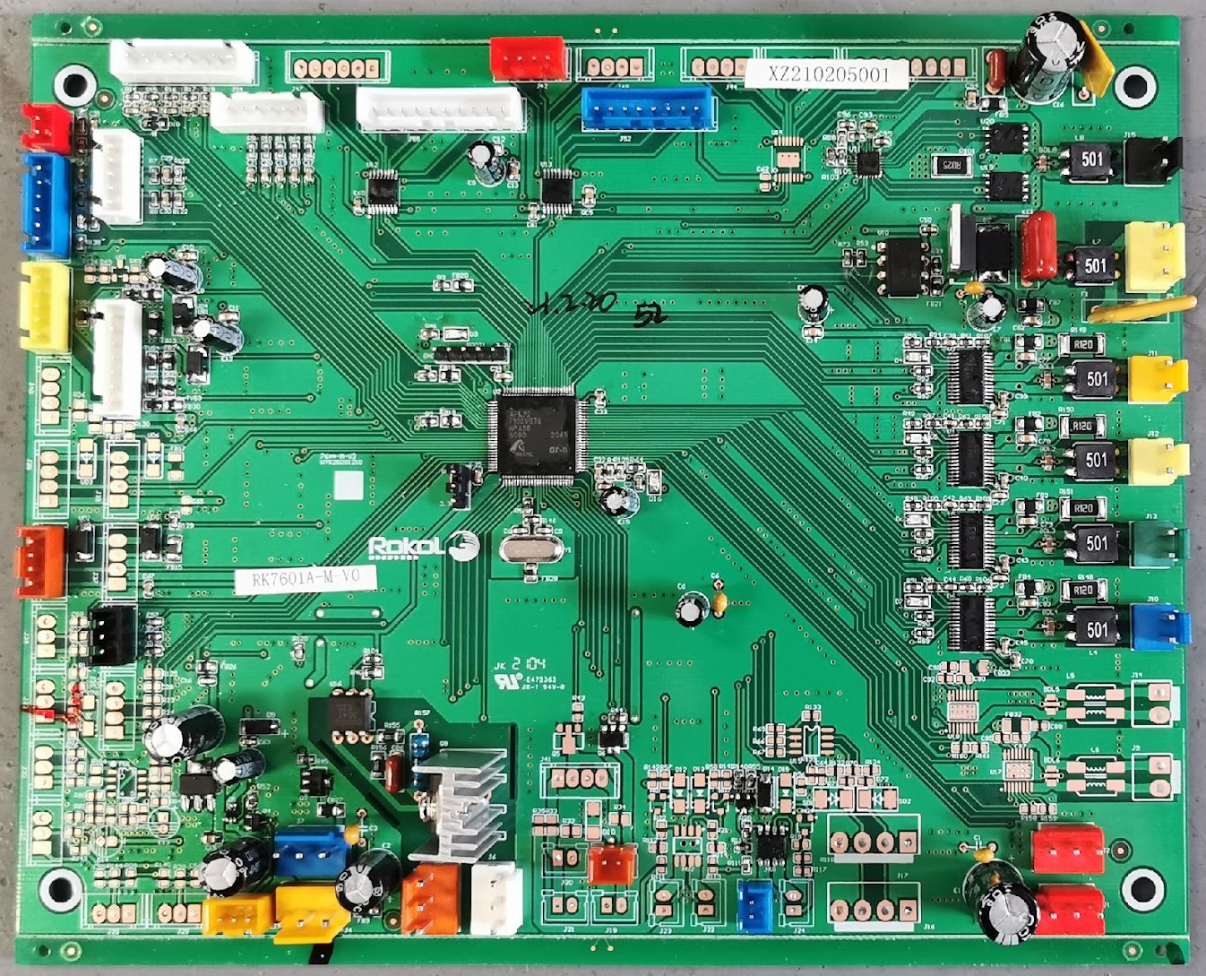
19Upper limit
Tablet hand controller
Leg and foot serial signal
16Tap the motor
13Leg pole(DC24)
12Back pole(DC24)
17Lifting motor
Pole counting signal
DC12V
Simple hand controller
15Knead the motor
20Lower limit
5VAnd standby signal
21Bluetooth power supply
AC24V
Air pump
14Waist heating
DC24VInput
18Forward tilting motor

- The whole machine of the massage chair is not working, and the hand controller is not displayed.
1.1First of all, check that the socket is charged, and the three-in-one switch is turned on. Determine whether the fuse of the 1 three-in-one switch in the figure is burned out. If the fuse is burned and replaced, it is normal.
1.2Use a mermACVoltage gear measurement 2 (AC220V), 4 (AC20.5V) Two voltages, if the 2 voltage is normal, and if there is no voltage in 4 places, the ring transformer will be broken, and it will be normal after replacement.
1.3Use a mermDCVoltage gear measurement 9 (DC5V) Is the voltage normal, if there is no voltage?,See if the connection cable between the power board and the motherboard is in good contact. If there is no problem, the power board should be broken and normal after replacement.
1.4Determine whether the hand controller cable has poor contact.If not, replace the hand controller..
- The massage machine and pole do not move, other functions are normal, and the hand controller is displayed.
2.1Use a mermDCLightningPressure measurement8Voltage (DC12V) Whether it is normal or not, if there is no voltage, the power board will be broken, and it will be normal after replacement.
3The lifting of the massage machine is abnormal.
3.1When the massage machine works in the up and down, the massage machine does not move; turn on the manual control.
Make the massage machine run the whole process, with a mermeter.DCVoltage gear measurement motherboard "17" Chu Lian
Whether the connector terminal voltage has an output (DC24V), if there is no voltage, the motherboard is broken, and it is positive after replacement.
Often; if the voltage of the motherboard is normal, use the multmeter buzzer to measure the lifting motor from the motherboard to the movement.
White three-core450BThe on-off of the white and blue lines of the connector, and check the motherboard to the machine.
Whether the plug-in connector of the core is reliable, whether the terminals are in good contact, and if they are connected, it means
If the lifting motor is broken, the movement needs to be replaced. If the two lines are not connected, the machine needs to be replaced.
The core wire is normal after replacement; to judge whether the lifting motor is damaged, you can put the multimeter in the resistance gear.
Measure whether there is resistance at both ends of the lifting motor connector.5-30Ω, if not, it will be damaged.
3.2When the massage machine works in the upper and lower rows, if there is a top or bottom phenomenon, it will rise and fall.
Motor upper and lower limit signal failure. First, check the motherboard.19",20"Connector and
Whether the connectors on the upper and lower limit boards have fallen off, and whether the connector terminals have come off. Second,
Check whether the lifting motor limit Hall element has a high and low level change (use magnet steel to approach or leave Huo)
Er element, measure the upper limit or lower limit connector2,3Feet), if there is no level change,
Replace the lifting limit plate. Third, unplug "19",20The connector at the place, use a mermeter.
The buzzer gear measures the on-off of the connector to the upper and lower limit lines. If they are all connected, it means that
If the motherboard is broken, the motherboard needs to be replaced; if it is not connected, replace the lifting limit signal line.
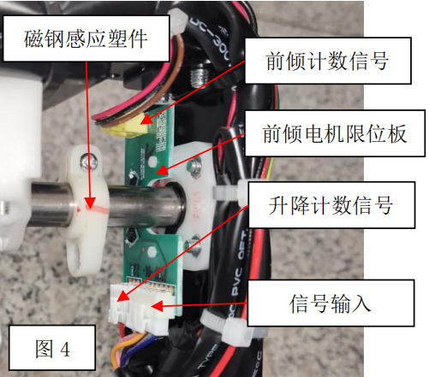
3.3If the massage machine does not work in a certain range of the back of the shoulder or waist, the massage machine runs throughout the whole process; then the motherboard11The signal of the movement fails. Check the motherboard to the movementWhether the plug-in connector has come off or not, and whether the terminal has come out. Unplug the picture4The signal input line on the forward motor limit plate measures the motherboard corresponding to brown, pink, orange, purple, gray and blue.If the red, pink, orange, purple, gray and black are turned off, replace the movement signal line. If they are all connected, the massage machine will work in the up and down state and use the mull-meter.DCVoltage gear measurement diagram4Is there a brown and blue line of signal input?5VVoltage, if there is no voltage, the motherboard is broken, if there is, the forward tilting motor limit plate is broken, and it is normal after replacement. During the maintenance process, do not adjust the position of the magnetic steel of the magnetic steel induction plastic part and the Hall element of the forward tilting motor limit plate, otherwise it will also cause the movement up and down or forward tilt counting failure.

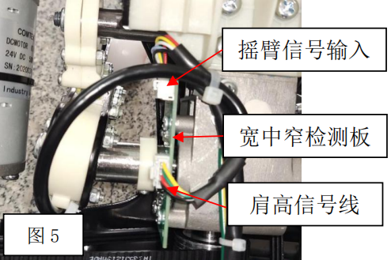
3.4StartEntering a program, the massage machine begins to carry out shoulder height detection. If the massage machine directly reaches the upper limit, it indicates the shoulder height detection failure. Check the motherboard11Whether the plug-in connector with the shoulder height signal of the movement is reliable and whether the terminal is in good contact. Measure the motherboard with the mulmeter buzzer file11Red, green, yellow, white, light blue, black to the picture5The on-off of the input end of the rocker arm signal. If it doesn't work, replace the movement signal line. If they are all connected, dial the mer toDCVoltage gear, insert the pen into the motherboard "11"Eight-core connector2,8Hole (light blue and black line), press and release the left rocker arm of the massage machine by hand to see if the voltage has changed. If there is any change, it means that the shoulder height signal line is normal, the wide and narrow detection board is damaged, and it is normal after replacement. If not, it means the motherboard, wide and narrow check.One of the measuring board and shoulder height signal lines is damaged or completely damaged. Judgment method: Replace the motherboard and turn it on for shoulder height detection. If it is normal, the original motherboard is broken. If it is not normal, insert a new shoulder-high signal line into the picture.5At the position of the shoulder height line, lean the infrared tube together, turn it on and let the massage machine carry out shoulder height detection. When it is above the waist, release the infrared tube and observe whether the massage machine stops.Sore. If you stop going up, it means that the original shoulder height detection line is damaged and needs to be replaced. If you continue to go up, it means that the wide and narrow detection board is damaged, and the wide and narrow detection board needs to be replaced. This step is slightly complicated, and the movement or motherboard can be replaced directly depending on the on-site situation during repair.

4.The kneading function of the massage machine is abnormal.
4.1The massage machine has no kneading action. Open manually.Control the massage machine to knead instructions, use ten thousand
Use the tableDCVoltage gear measurement motherboard "15Are there any terminals of the connector?DC24VVoltage output. If there is no voltage output, the motherboard will be broken and the motherboard will be replaced. If there is a voltage output, check15Whether the plug-in connector to the movement is secure and whether the terminals are in good contact. Then measure the motherboard connector with the mullmeter buzzer.15"Yellow and green lines to the black two-core of the movement450BIf the on-off situation at both ends of the connector is connected, it means that the kneading motor is broken and the movement needs to be replaced; if it does not work, the movement harness assembly needs to be replaced; the method of judging whether the kneading motor is damaged is the same as3.1Judgment method of lifting motor.
5.The tapping function of the massage machine is abnormal.
5.1There is no tapping action on the massage machine.Turn on the manual control and let the massage machine perform the tap command.
Use the table to put it inDCVoltage gear, measure the motherboard "16The voltage at both ends of the motor connector is
NoDC24VVoltage output, if there is no voltage, the motherboard is broken, and it is normal after replacement. If the voltage of the motherboard is normal, check whether the plug-in connector from the motherboard to the movement is reliable and whether the terminals are in good contact. Then measure the motherboard connector with the meter buzzer.16"ResideGo to the movement and tap the white two-core motor.450BThe connection and disconnection of the red and black lines of the connectors, if they are all connected, it means thatIf the tapping motor is broken, the movement needs to be replaced. If the two wires are not connected, the movement line needs to be replaced.,Normal after replacement; the method of judging whether the tapping motor is damaged is the same as3.1Judgment method of lifting motor.
5.2Turn on the hand controller to make it work in the tapping state. If you can't choose wide and narrow, the movement
Wide and narrow signal failure. Use a mermDCVoltage gear measurement motherboard "11The connector is red and black.
Is there a line?5V/DCOutput, if there is no output, the motherboard is broken, and it is normal after replacing the motherboard. If there is a voltage output, check the motherboard.11" to the movement diagram5Whether the connector of the "rocker arm signal input" is firmly plugged in, and whether the terminal has prolapsed. If it is normal, measure it with a munter buzzer."11Red, green, yellow, white, light blue, black to the picture5The on-off situation of the "rocker arm signal input" end. If it does not work, replace the movement signal line. If it is connected, it means that the wide and narrow detection board is damaged and normal after replacement.
6.The forward tilt function of the massage machine is abnormal.
6.1The massage machine leans forward without action. Turn on the manual control and let the massage machine carry out forward instructions.
Use the table to put it inDCVoltage gear, measure the motherboard "18The voltage at both ends of the forward tilt motor connector is
It is normal. If there is no voltage, the motherboard will be broken, and it will be normal after replacement. If the motherboard voltage is normal, check
Whether the plug-in connector from the motherboard to the movement is reliable and whether the terminals are in good contact. Then use it for all purposes.
Table buzzing file measurement motherboard "18"Red, black line to movement forward tilt motor black three-core450B
If the connection between the brown and blue lines of the connectors is connected, it means that the forward tilting motor is damaged and needs to be more
Change the movement. If it doesn't work, you need to replace the movement line, which is normal after replacement;
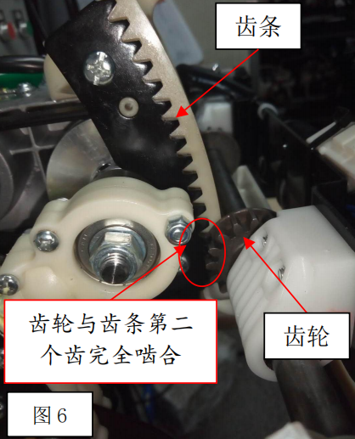
6.2The massage machine is not in place or exceeds the limit. Explain the forward plan.Number of failures. There are two kinds of situations, one is forward leaning.The counting board is faulty and is normal after replacement. One is a picture.4The position of "magnetic steel induction plastic parts" has changed. The solution is as follows:1As shown in the figure6As shown, make sure that the gear is completely meshed with the second tooth of the rack. If it is not completely meshed, adjust the forward tilting motor shaft until it meshes.

7.The whole machineIf it is not inflated or not inflated on a certain road, the massage machine works normally.
7.1If the whole machine does not inflate, use a malmeter after starting up.ACVoltage gear, measure whether the motherboard 7 connector hasAC24VLeft and right voltage, if there is, the air pump may be broken, and if there is no voltage output, the motherboard is broken.
7.2None of the above is bad. Check whether the trachea has fallen off.
7.3If a certain road is not inflatable, use a munmeter.DCThe voltage gear measures whether there is a corresponding port in this way.DC24VVoltage output, or shutdown, use the mulmeter ohm gear to measure the resistance value (resistance value) of the corresponding solenoid valve.For165(±10%)Ω). ( The corresponding solenoid valve is shown in the drawing of the replacement of the solenoid valve)
8.The back pole does not move.
8.1Put the mermer onDCVoltage gear, insert the two pens into the diagram.12In the blue connector terminal, operate the backrest lift button of the hand controller to observe whether the merometer is available.DC24VThe output, if the pole is broken, if the motherboard is not broken, it is normal after replacement.
8.2PerhapsUnplug the pole connector and check the resistance value between the two wires of the pole. If the pole is at the upper and lower limits, measure it with a diode gear and test forward and negative. It is better to pass the single guide, in the middle position.3-20ΩThat is to say, other circumstances prove that the electric pole motor is broken, and replacing the electric pole can be eliminated.
9.The leg pole does not move.
9.1Put the mermer onDCVoltage gear, insert the two pens into the green connector terminal at the 13 in the figure, operate the backrest lift button of the hand controller, and observe whether the mutmeter hasDC24VThe output, if the pole is broken, if the motherboard is not broken, it is normal after replacement.
9.2PerhapsUnplug the pole connector and check the resistance value between the two wires of the pole. If the pole is at the upper and lower limits, measure it with a diode gear and test forward and negative. It is better to pass the single guide, in the middle position.3-20ΩThat is to say, other circumstances prove that the electric pole motor is broken, and replacing the electric pole can be eliminated.
10.The screen of the hand controller is abnormal, and the key operation function is normal.
Ten.1The screen display is abnormal. Long press the switch key to restart to observe whether it returns to normal. If it is not normal, replace the hand controller assembly.
11.The sole roller does not work.
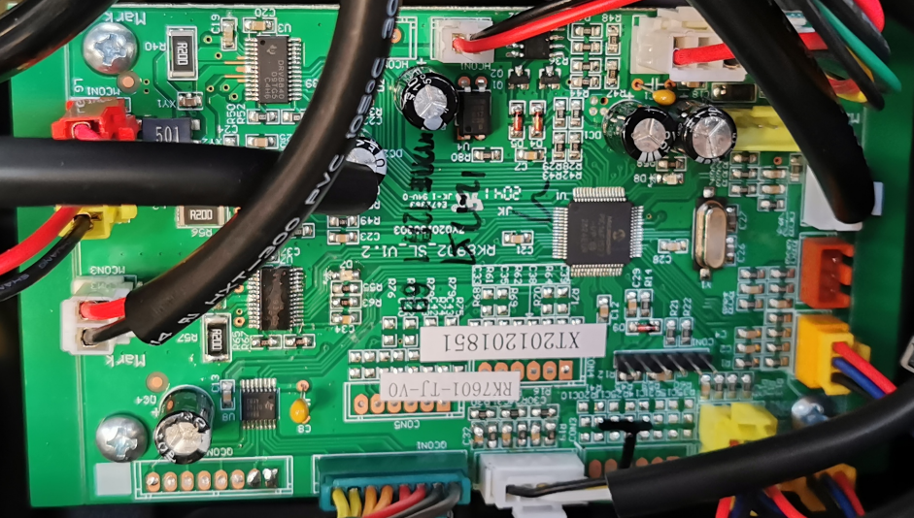
11.1Turn on the foot roller function(Leg and foot air pressure), don't work,Put the mermer onDCVoltage gear, insert the two pens into the picture.1ResideRoller motorIn the connector terminal, whether the output voltage is normal, and if there is no voltage, the leg plate is broken; if there is voltage output, use a mulmeter to measure the other end of the wire harness.450Is the voltage at both ends of the red and black lines of the connector?24VIf not, replace this wire harness assembly. If there is, the roller motor is generally broken. Just replace it.
Picture1
Telescopic motor
Roller motor
Heat
Rub your legsElectric machinery
12.The leg rubbing motor is not working.
12.1OpenLegsRoller function(Leg and foot air pressure), don't work,Put the mermer onDCVoltage gear, insert the two pens into the picture.1ResideLeg rubbing motorIn the connector terminal, whether the output voltage is normal, if there is no voltage, the leg and foot plate is broken; there is voltage output,Measure the other end of this wire harness with a malmeter.450Is the voltage at both ends of the red and black lines of the connector?24V,If there is no voltage,Replace this harness assembly,Otherwise, rub your legs.If the motor is broken, just replace it.

13.Abnormal operation of telescopic motor
13.1The telescopic motor is not working
13.1.1Check whether the motor connector is firmly plugged in, whether the connector is plugged in, and whether the terminal is detached;
13.1.2Put the mermer onDCVoltage gear, insert the two pens into the picture.1Telescopic motorIn the connector terminal, operate the hand controllerLeg expansionPress the button to see if there is a mutmeter.DC24VOutput, if notAbility to walkThe board is broken and normal after replacement.Unplug the telescopic wire harness and measure whether it is present or not.DC24VOutput, if not, the telescopic wire harness is damaged and can be replaced.
13.1.3ExamineTelescopic motorResistance between the two lines(Normal5-30Europe), no resistance or a large indication of motor failure, just replace it.
13.1.4Use a mermDCGear, measure the leg and foot plateCON2The voltage between the green, yellow, white and black lines of the telescopic counting signal harness respectively covers the photoelectric switch of the counting plate. Is there a level change? If there is a voltage change, replace the leg and foot plate. Check whether the connection harness is connected. If it doesn't work, just replace it. Otherwise, replace the counting board.
13.2The foot of the boot leg sticks out and checks whether the sole detection board is damaged. If the indicator light is always on, replace the sole detection board. Use the mulmeter buzzer to measure the length of the left and right feet to detect the red, blue and black wire harness. If it does not work, replace the wire harness. Use a mermDCGear measurement orange connector blue,The voltage between the black lines, press the soles of the feet with your hands. If there is a voltage change, the legs and feet will be broken and can be replaced. Otherwise, replace the sole detection board.
13.3Don't stretch your legs out, according to13.1After the inspection. Use a mermDCFile measurementSCON4Is there a voltage change between the blue and black lines? If not, replace the ground-touch test assembly; otherwise, replace the leg and foot plate.
13.4The legs will not shrink, according to13.1After the inspection. Check whether the anti-clip hand detection board is damaged. If the indicator light is always on, replace the anti-clip hand detection board. Use the mer buzzing file to measure the red, blue and black wire harnesses of the anti-clip hand. If it does not work, replace the wire harness. Use a mermDCFile measurementSCON5,6Is there a voltage change between the blue and black lines? If not, replace the anti-clip hand detection board assembly; otherwise, replace the leg and foot board.
14.KneeThe heating cloth does not work.
14.1Turn on the heating function,MeasurePicture1HeatIs the voltage at this place?DC24V;If there is no voltage output,Then it isAbility to walkDamaged board;If there is voltage output,Use a mi-meter to measure whether the heating line plug is available.DC24V,If there is no,Please replace the heating line.;If there is a voltage,Please replace the heating cloth.
15.The chest heating cloth does not work.
15.1Examine14Whether the connector is firmly plugged in and the terminal is released, and the seat is heated.DCWhether the plug is firmly plugged in; whether the internal heating line of the back cushion is firmly plugged in.
15.2Turn on the heating function,Put the mermer onDCVoltage gear, insert the two pens into the diagram.14ResideBlueInside the color connector terminalMeasure whether there isDC24V. If there is no voltage, the motherboard will be damaged and can be replaced; the heating line of the measuring seatDCDoes the head have it?DC24VOutput, if there is no voltage, the heating wiring harness is not good; measure the shawl heating extension cable inside the back pad.DCDoes the head have it?24VOutput, if there is no voltage, the heating extension cable will be damaged and can be replaced. If there is a voltage, the heating cloth is damaged and can be replaced.
16.The loudspeaker is not working
16.1Measuring connector21The voltage at the place,Whether it isDC12V;If there is no voltage output,The motherboard is damaged.;If there is voltage output,Measure the amplifier board with a mulmeterJ2,J3Is there a voltage?,If there is no,Replace the power amplifier board;If there is a voltage,After checking that there is no problem with the wiring harness,Please replace the speaker.

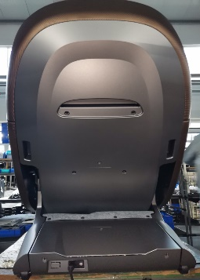

- Mechanical faults and solutions:
Screws fixed to the rear shield
1Replace the massage machine
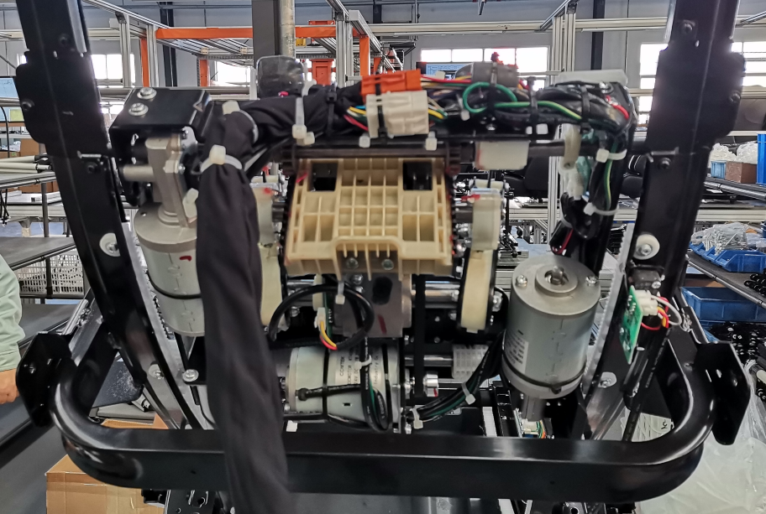
1.1As shown in the figure1As shown, use a cross-slot screwdriver to4ItemST4.2*16
Remove the screw and remove the shield on the back.
1.2As shown in the figure2As shown, use a cross-slot screwdriver to6Item
4*10Cross slotSmall sizeRemove the head of the cap.
1.3Unplug the movement wire harness connector and put the movement assembly.
Disassemble and take it out.
Picture1

Picture2
2, remove the armrest assembly, shoulder
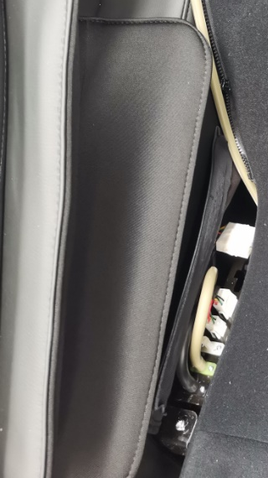
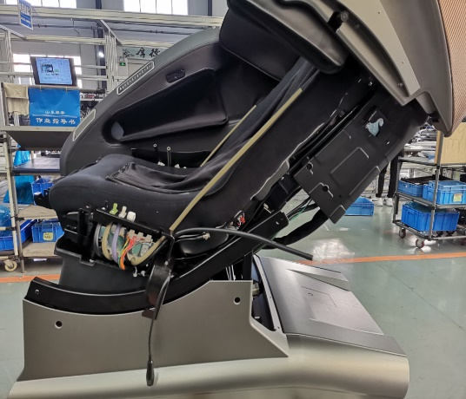
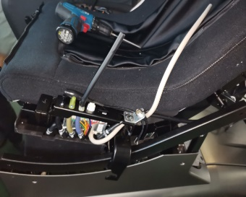
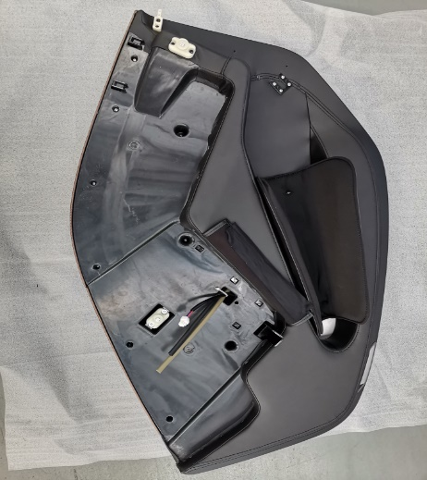
2.1Remove the armrest assembly
2.1.1As shown in the figure1,2,3As shown, firstM6*16Remove the cross-slot plate head screw, and then remove the armrest from the whole machine connector and the trachea.

Picture1

Picture2

Picture3

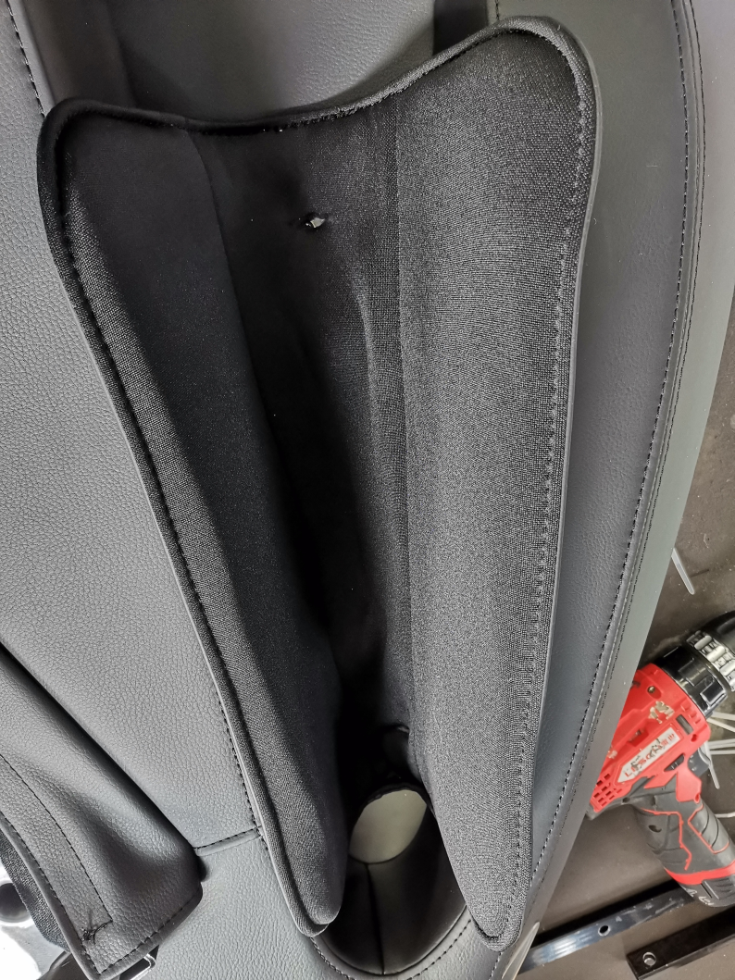
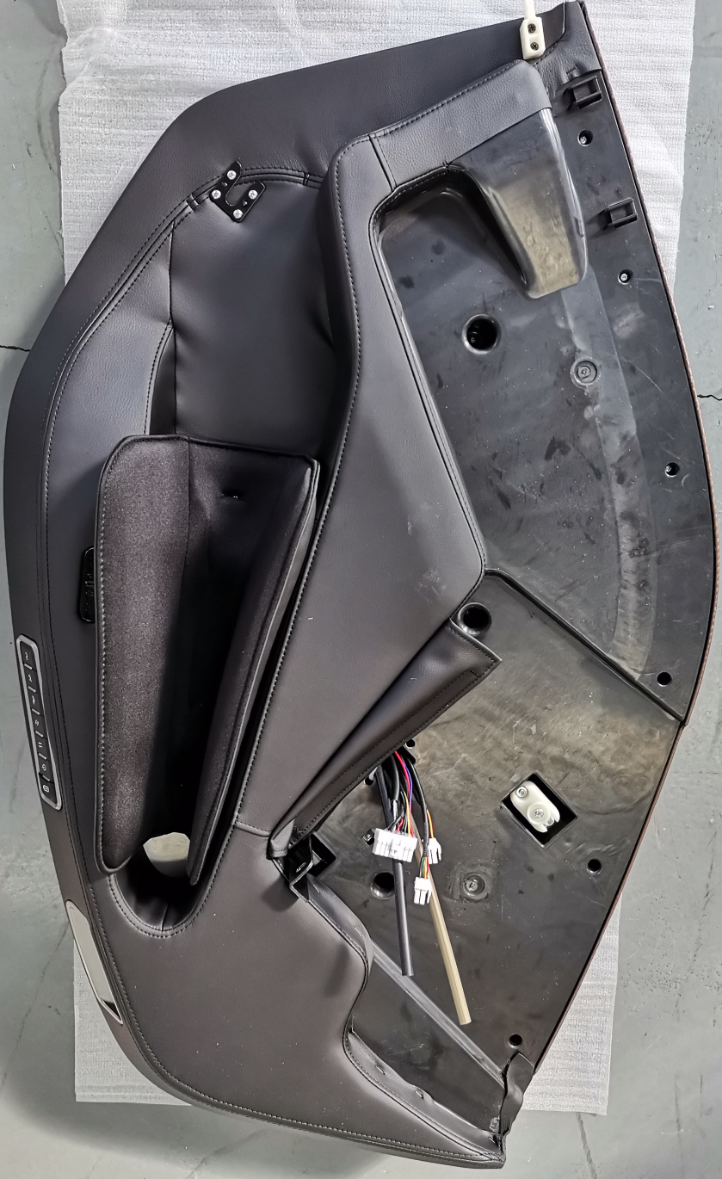
2.1.2Remove the armrest
2.1.2.1As shown in the figure, use tools to shape the handrail.18Remove the screw and split the inner shell of the armrest.
2.1.3Remove the armrest arm airbag
2.1.3.1Use tools to2Remove the screws and
Remove the armrest airbag trachea and split the arm.
Airbag.

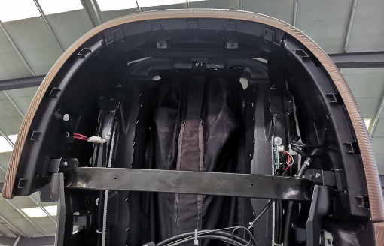

2.2Remove the shoulder assembly As shown in the figure, put the shoulder assembly above
6Remove the screw, then unplug the connecting trachea and replace it.
Shoulder assembly.
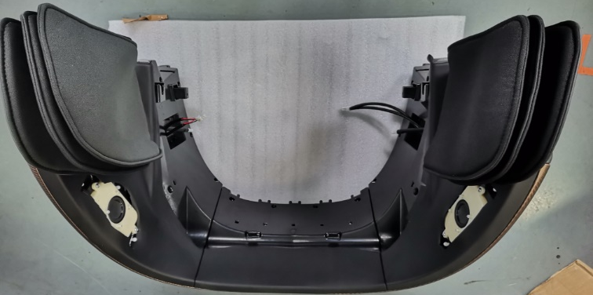
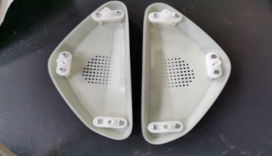
2.2.1Remove the shoulder horn : As shown in the figure below, pry down the speaker cover from the edge, butThe horn shell will be fixed later.2Remove the screw and replace the horn.

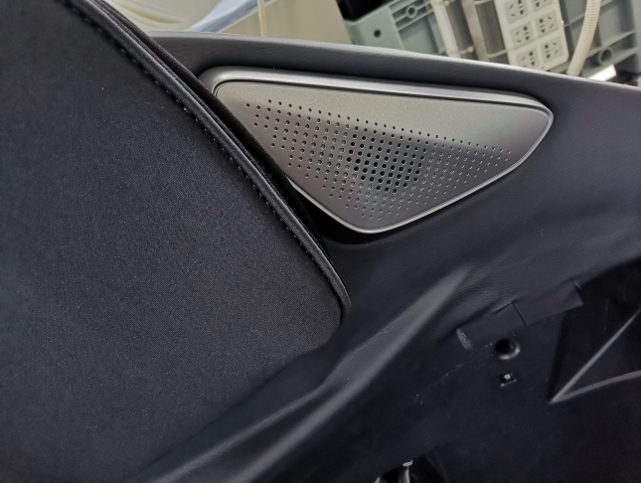

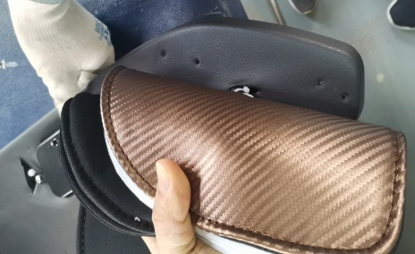
2.2.2Remove the shoulder airbag As shown in the figure, put your shoulders first.
Remove the screw under the airbag, and then the airbag.
Remove the lower screw and connect the airbag trachea.
Unplug and replace the shoulder airbag.

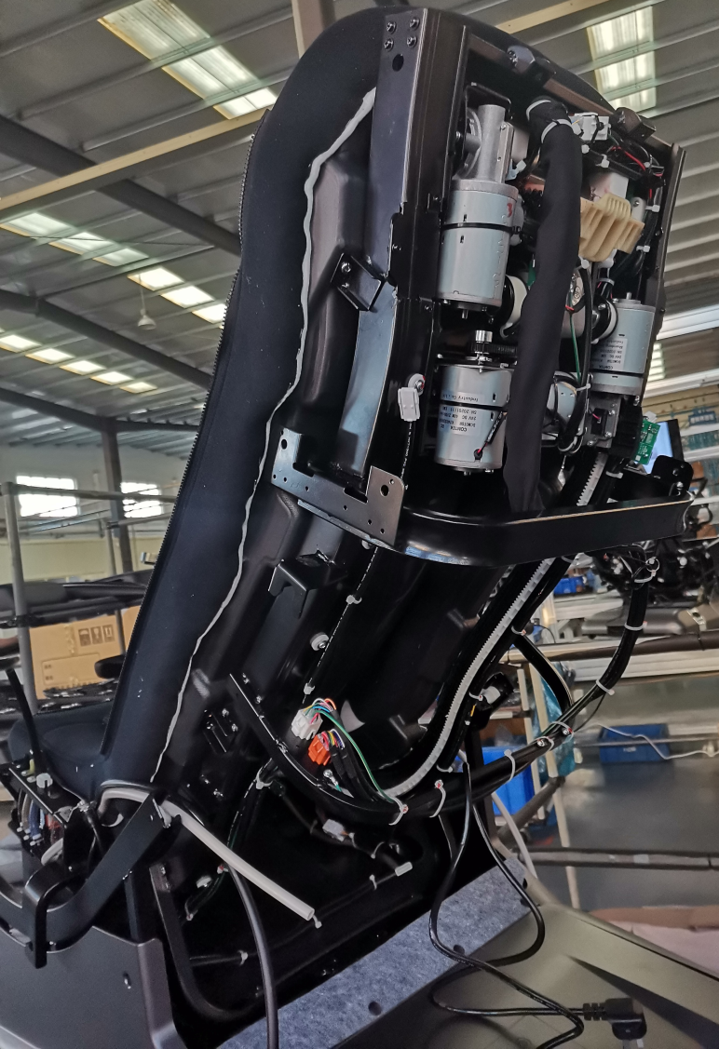
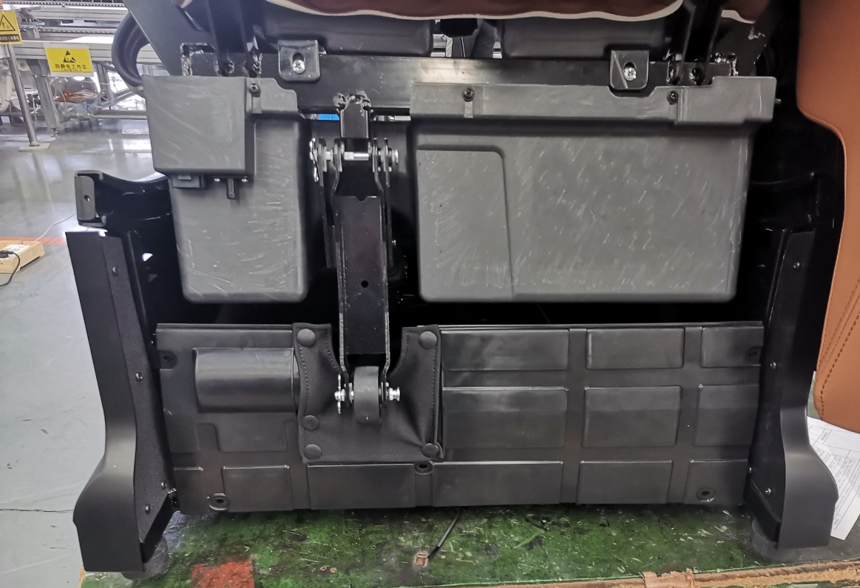
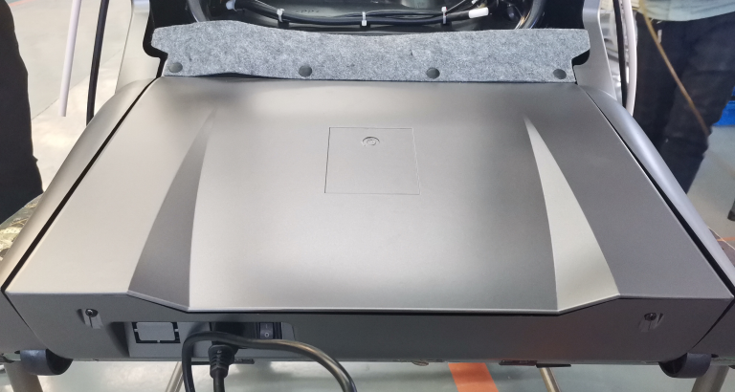
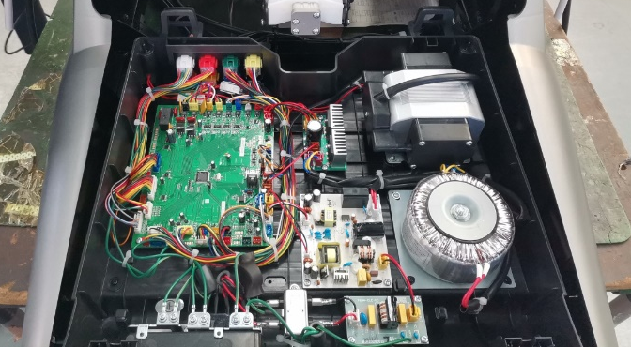
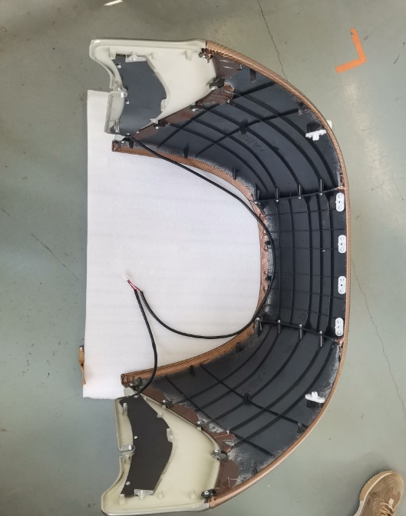
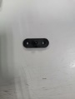
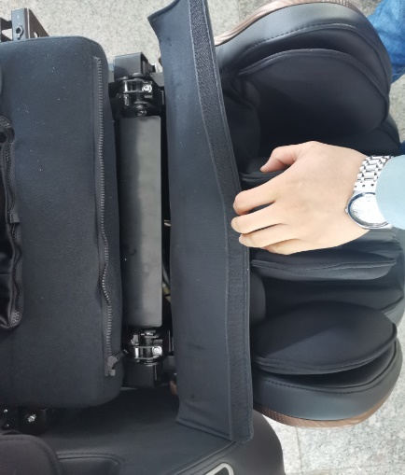
2.2.3Remove the inner shell of the shoulder As shown in the figure,
Under the shoulder airbag6After the screw is removed,
Then follow the position shown in the figure and make the shoulder assembly.
Up26Remove the screws and remove the inner shell of the shoulder.
Disassembly and replacement of internal wiring harnesses and partsPiece.
3, the front backrest plastic assembly
As shown in the figure, after removing the rear shield
Remove the screws on both sides of the position shown in the figure.
Then the front end2Remove the screws.
Replace the front backrest plastic assembly.
4, unpack the power box assembly
4.1As shown in the figure, follow the position shown in the figure.2Reside
Remove the screw, and then remove the top case of the power box.
Replace internal parts.
4.2As shown in the figure, the internal picture of the power box
Remove the position screw, and then remove the wire harness.
Unplug the plug and replace the power box assembly.

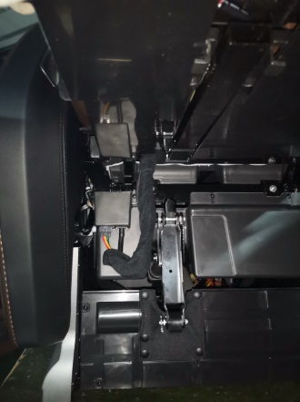
5Remove the legs and feet
As shown in the figure on the right, employment
It will connect the legs and feet.2
Remove the screws and put the legs.
Lift your feet and put the trachea and
Unplug the wire harness and replace the leg and foot assembly.

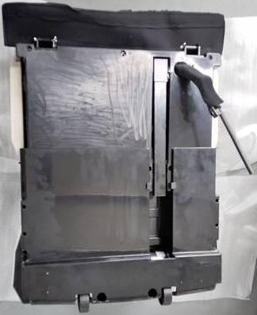
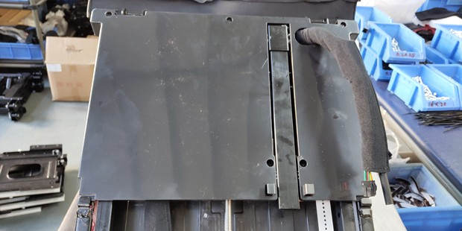
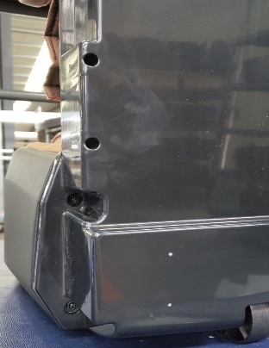
5.1Remove the foot assembly
5.1.1As shown in the figure below, use the tool to remove the position screw, then remove the rear shield of the legs and feet, replace the shield parts and repair the internal structure.

5.2Replace the foot assembly and solenoid valve.
5.2.1As shown in the figure below, first use a screwdriver to remove the screw shown in the figure, then unplug the wire harness and trachea in turn, and replace the foot assembly and solenoid valve assembly.
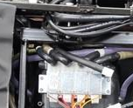
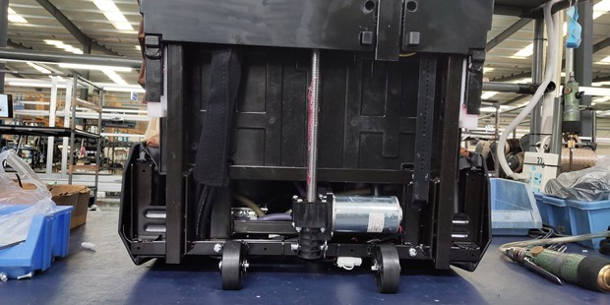

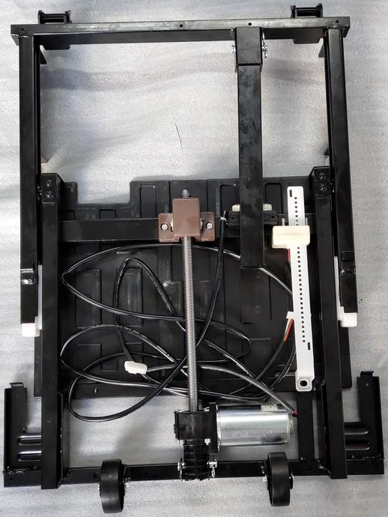
5.3Replace the leg and foot telescopic strut.
5.3.1As shown in the figure, use the tool to put it in the picture.2Hexagonal inside the piece

M6*12Screw
Pine leaf pin+Pin shaft
M6*12Remove the screw and then pin the pine leaves.+B8*40Melt
Remove the shaft, unplug the connecting wire harness, and replace the leg.
Foot telescopic pole.
5.4Remove the leg skeleton.
5.4.1As shown in the figure below, pull the sewing products away first.
The zipper then removes the airbag, removes the airbag from the sewing cloth sleeve, then removes the position screw in the picture, and replaces the leg skeleton and leg massage assembly.
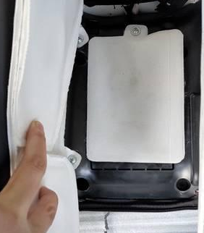
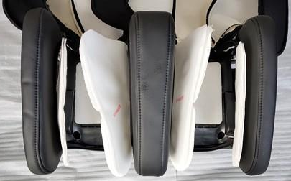
Remove the airbag
Sewing products and leg shaping assembly

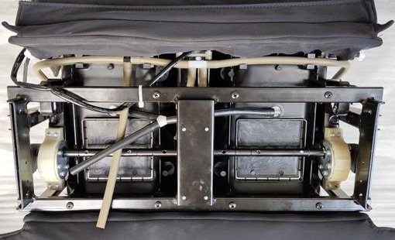
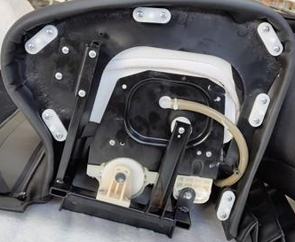

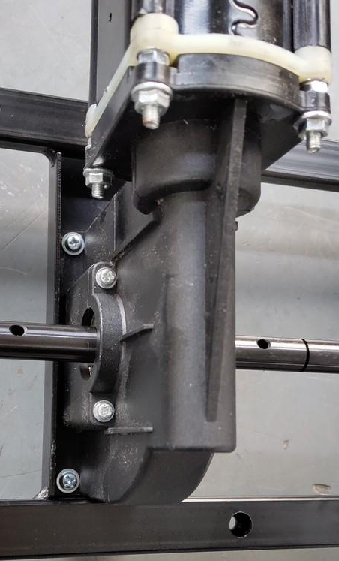
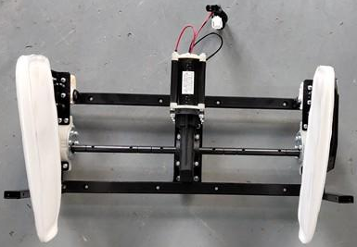
5.4.2Remove the leg motor
Show the position screw and
Remove the plug-in and replace it.
Leg massage motor.

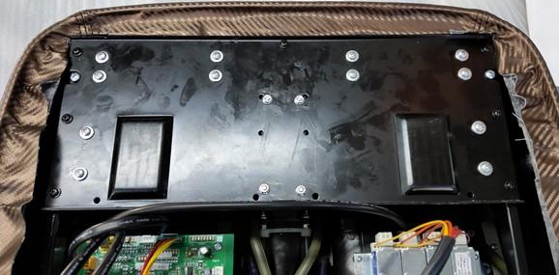
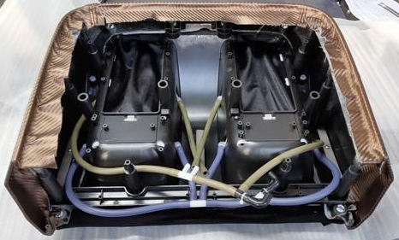
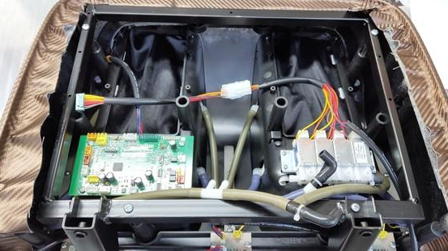
5.5Remove the foot roller
As shown in the figure, use the tool to screw the picture.
Remove and unplug the wire harness plug.
Then remove the foot massage assembly.
Replace the foot roller massage assembly.
5.6Remove the foot circuit board and solenoid valve.
As shown in the figure, put it on the circuit board4Self
Remove the screw, replace the circuit board, and
Solenoid valve4Remove the screw and replace it.
Solenoid valve assembly.
5.7Replace the foot clip.
According to the position shown in the figure, put the feet up and down.
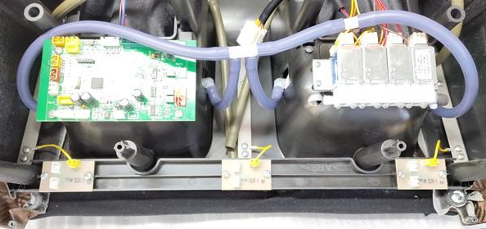
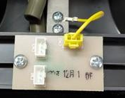
Remove it, and then put the foot anti-splint detection board.
Remove and replace.

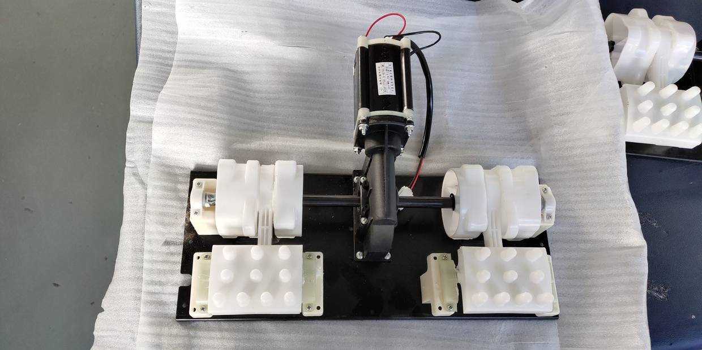
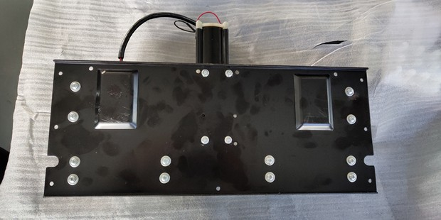
5.8Replace the foot massage machine.
As shown in the figure, each part will be shown.
Remove the screws and replace the soles of the feet.
Massage machine assembly.
5.9Replace the sole detection board
As shown in the figure, remove the cloth cover on the soles of the feet first.

2Item
ST3.9*12.7
4Straight chute
ST3*10
3Item
ST3.9*9.5
, and then fix the foot pads.
2Remove the screws and finally replace the soles of the feet.
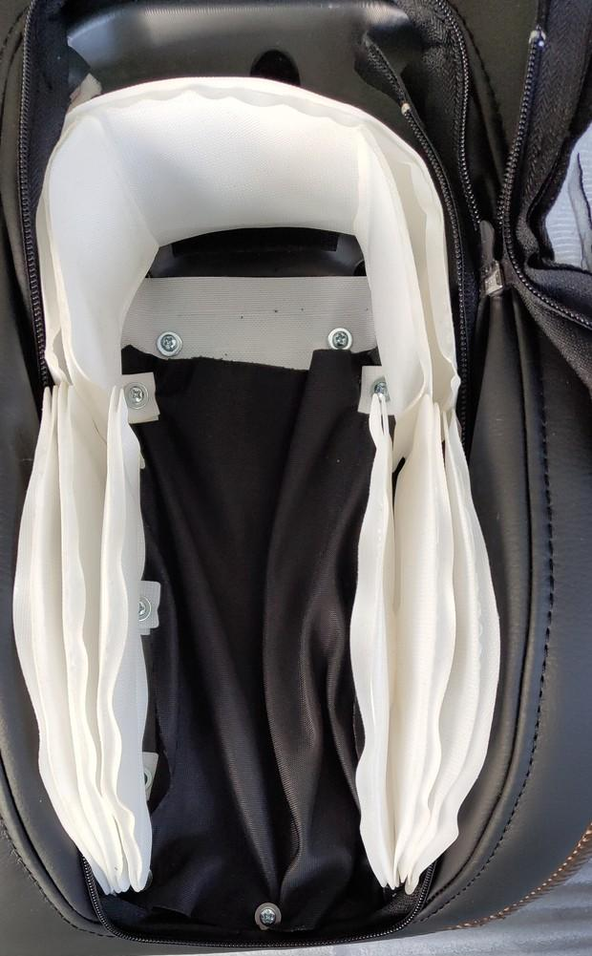
Test board.
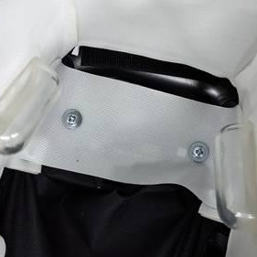
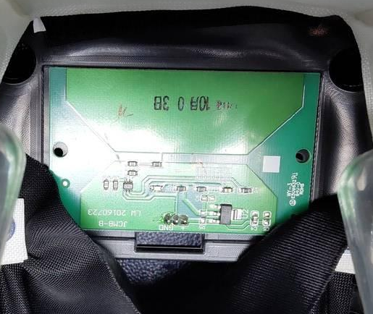

IV. Layout diagram of the main circuit board components

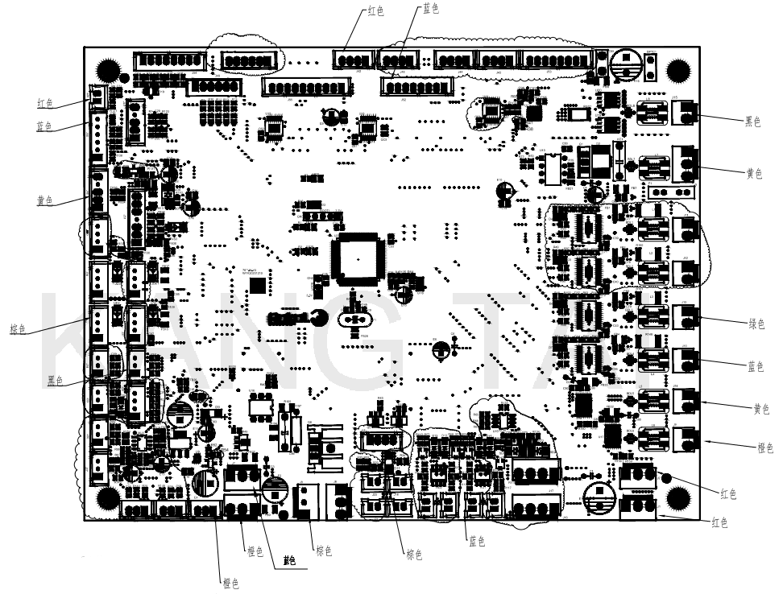

V. System connection diagram
