Removing the foot roller assembly
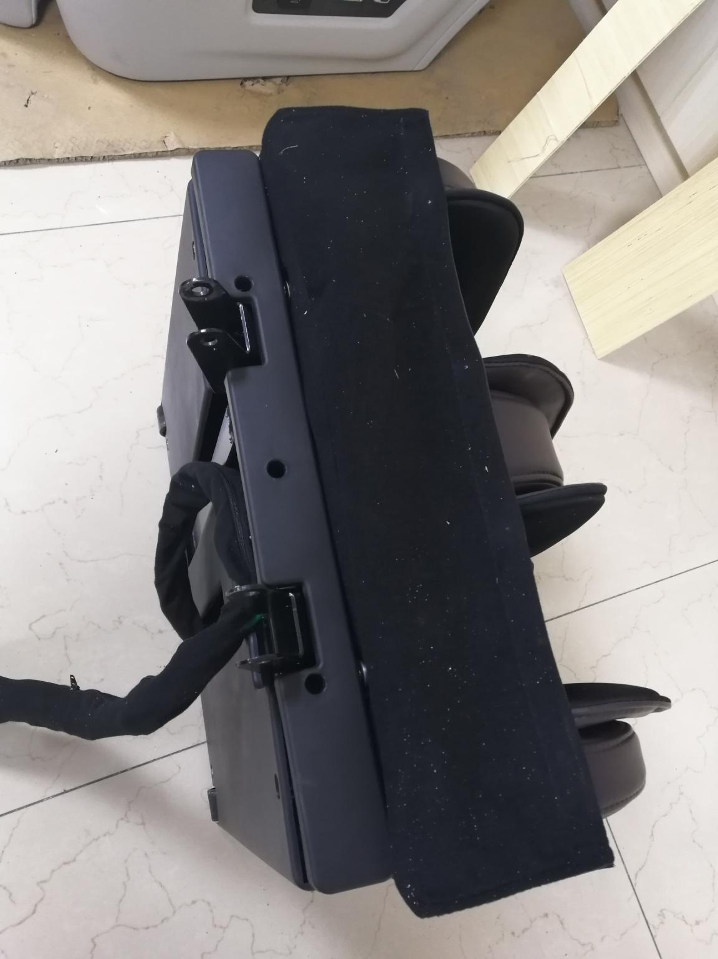
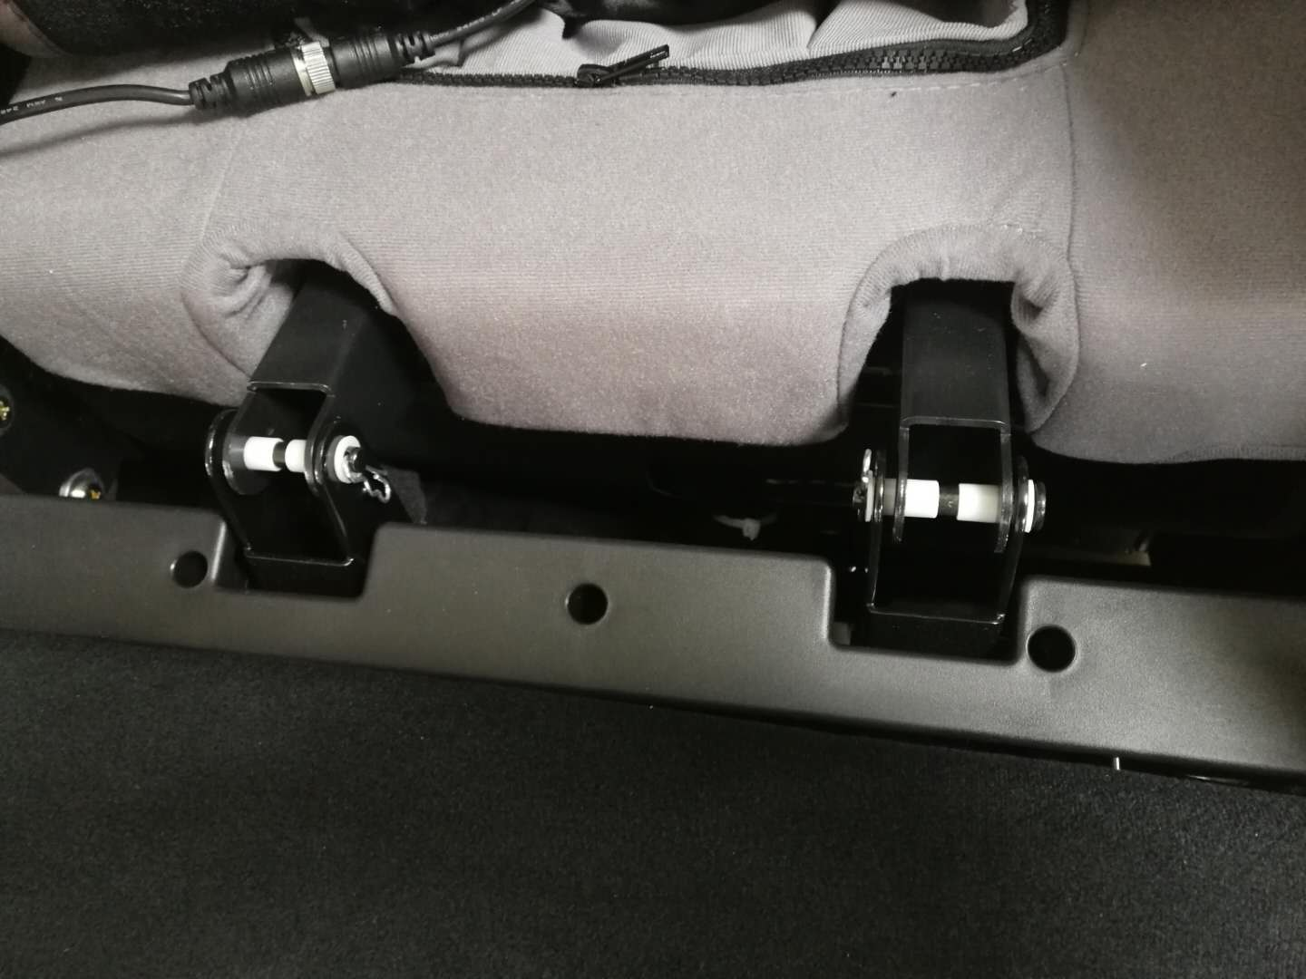
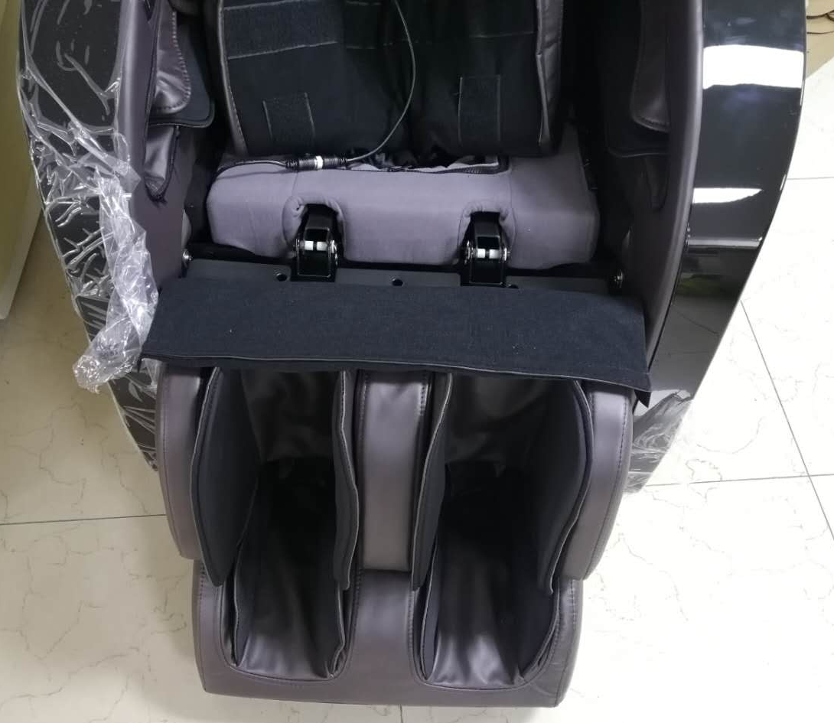

Remove the leg and foot assembly
Remove the two pins of the fixed leg assembly

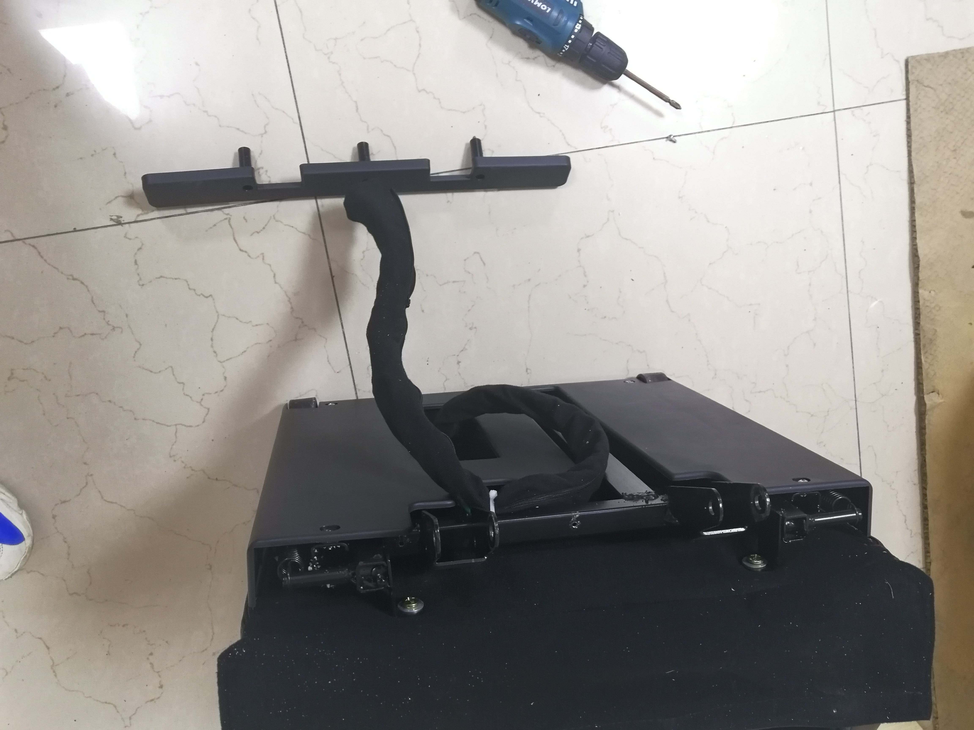

Remove that 3PCS screws
Remove the protective cover and the baffle

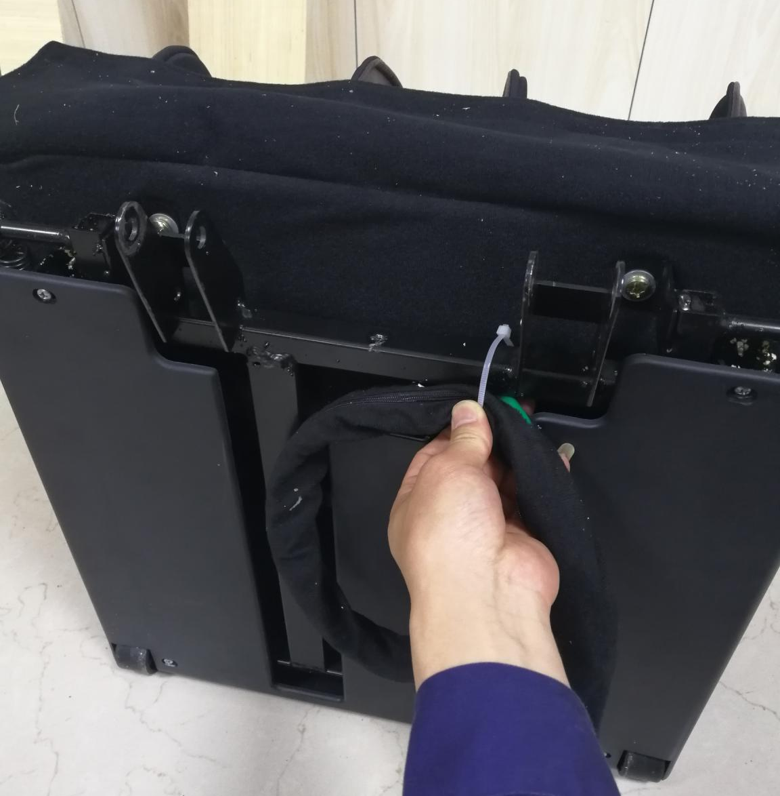
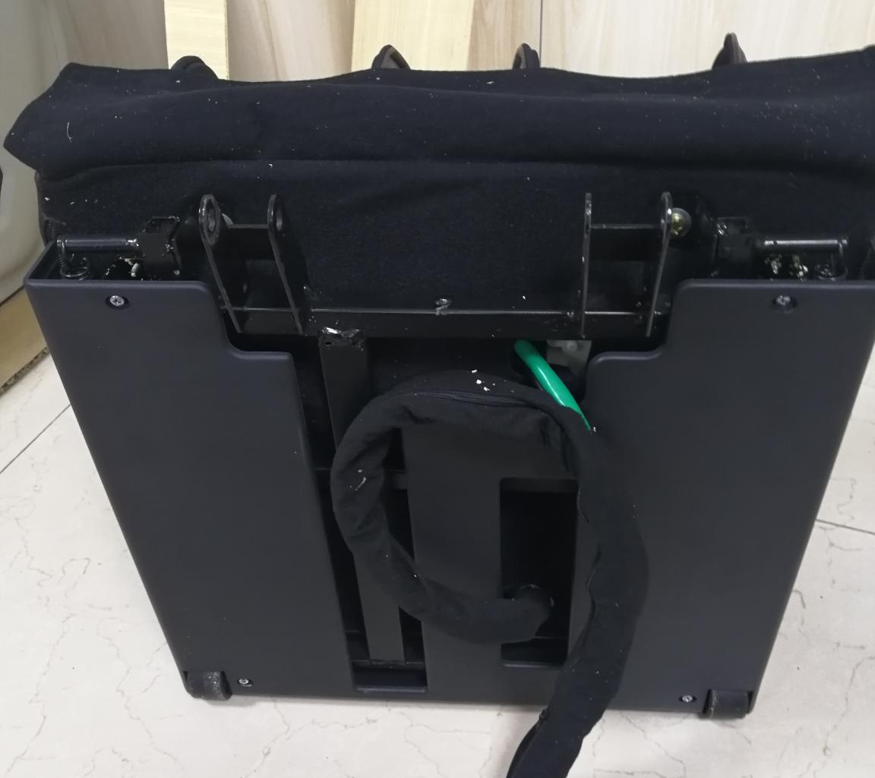

Remove the cable tie
Remove the 4PCS screw

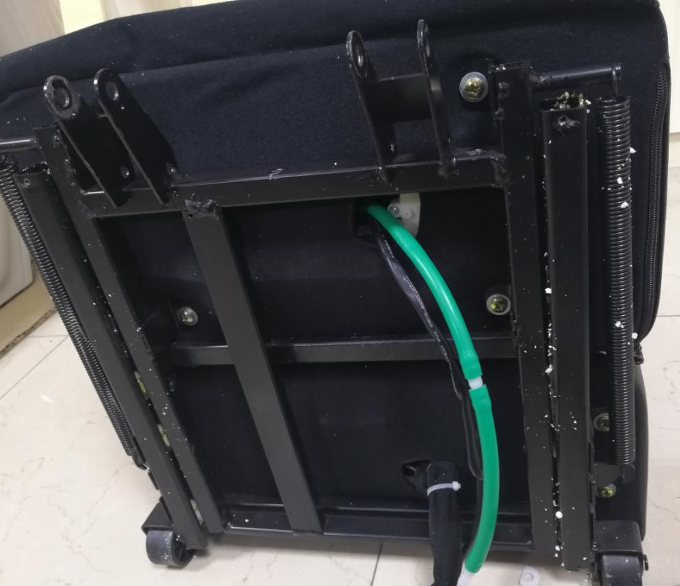
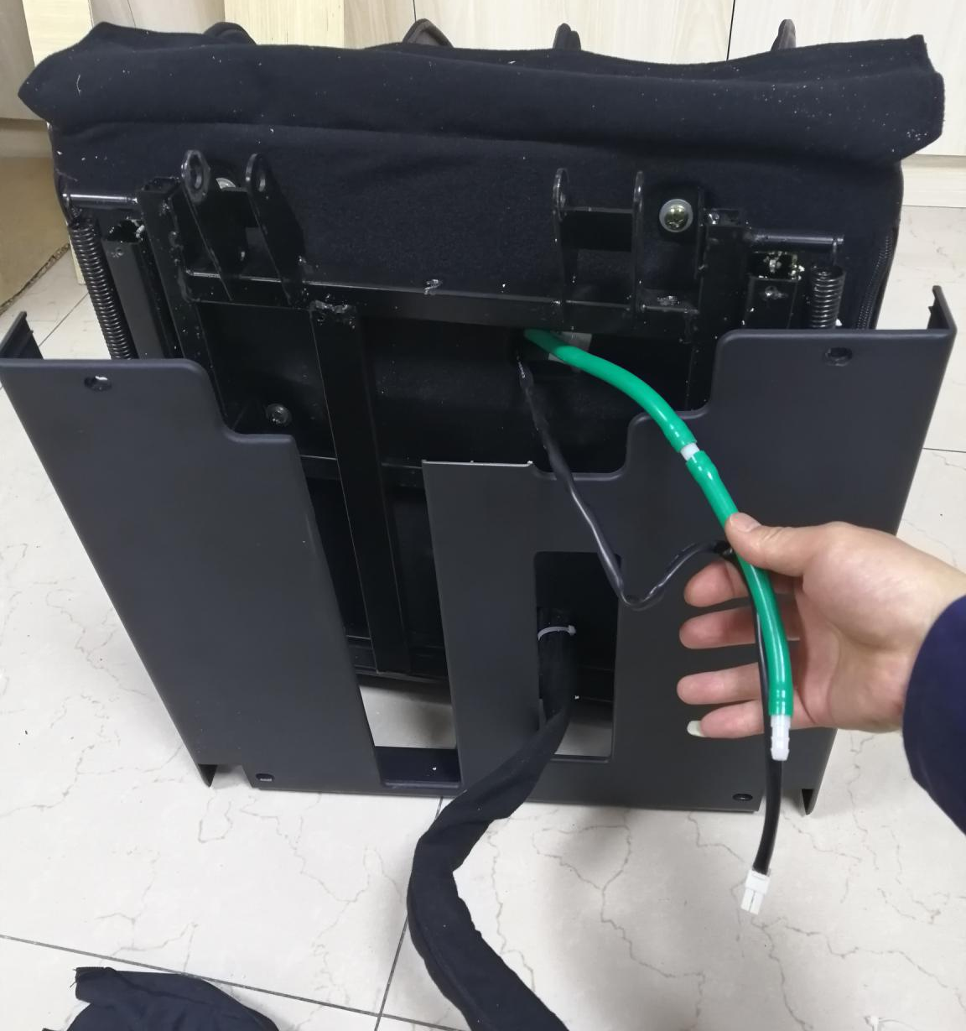

Remove the calf protective cover
Remove the 8PCS screws that lock the legs and feet

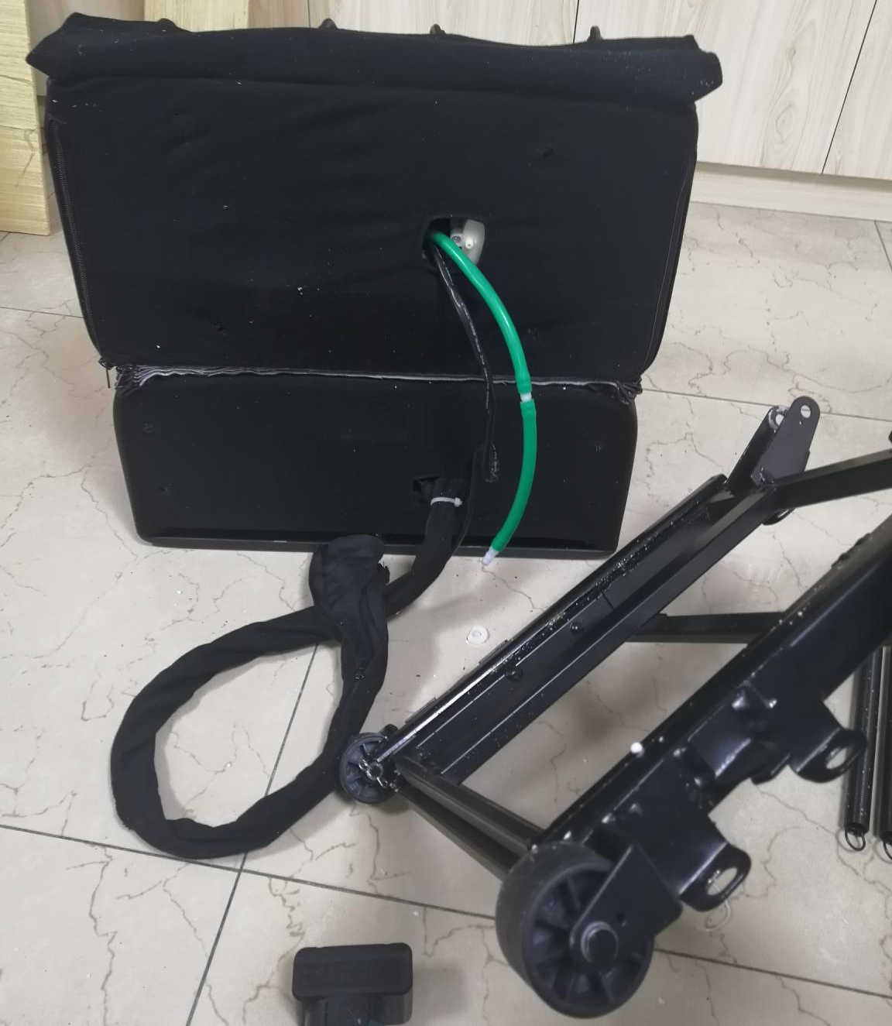
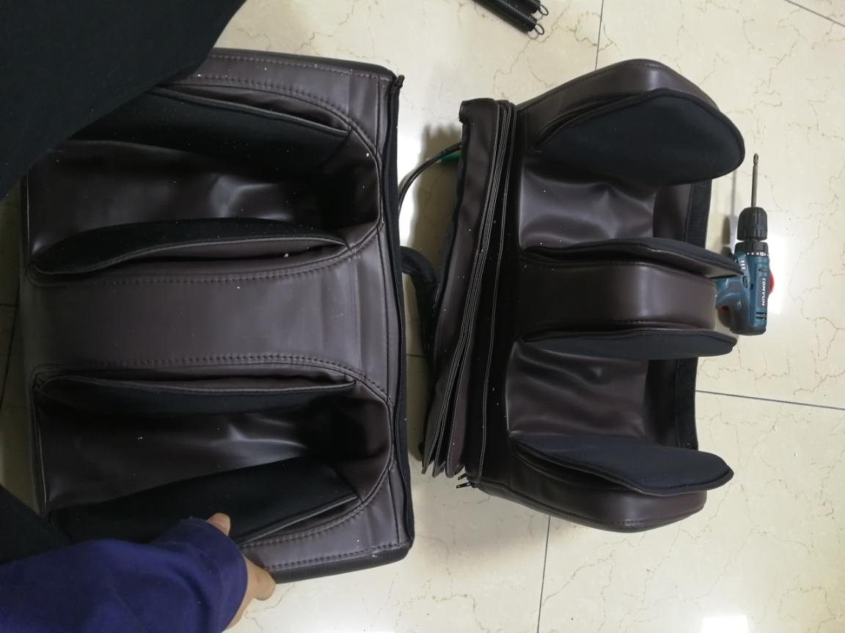

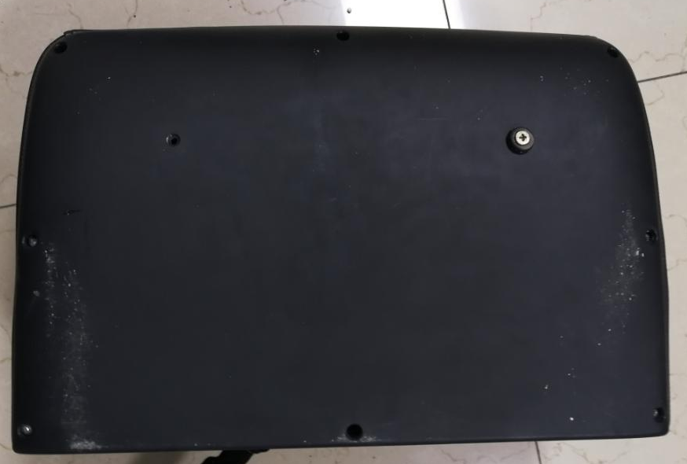

Remove the screws, then remove the foot bottom cover
Remove the leg and foot fixing cover
Unzip it, separate the leg and foot

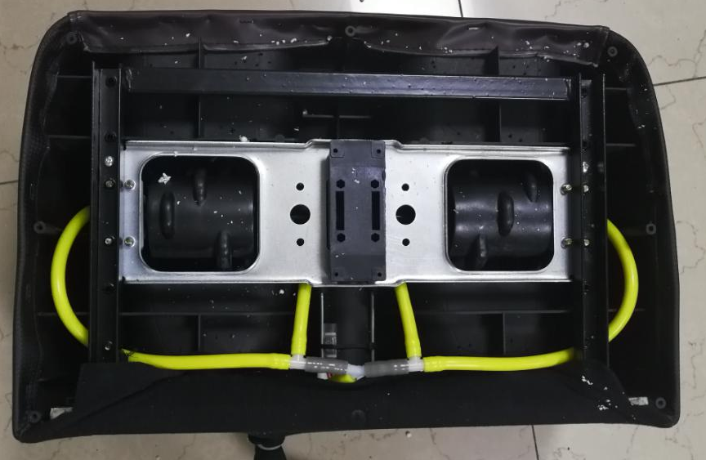
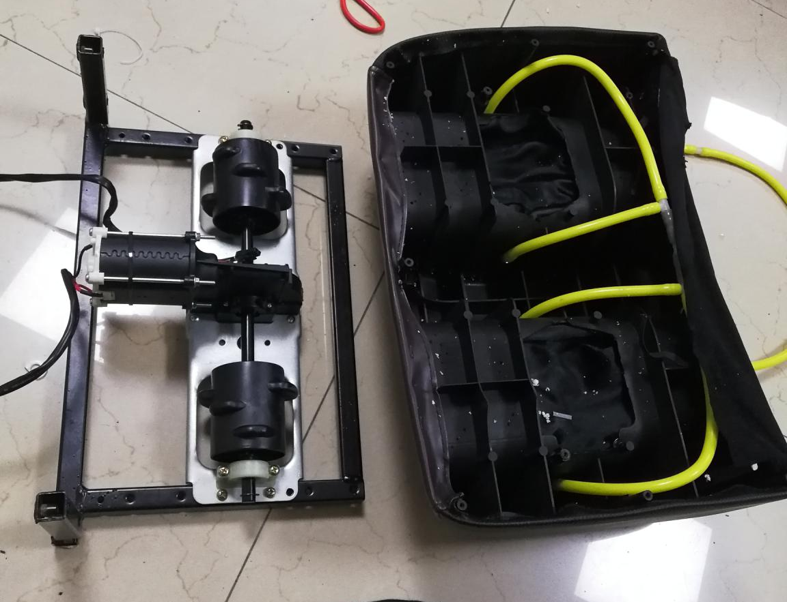
Remove the 4PCS screws
After removing the foot roller,it can be replaced

Removing the leg kneading assembly
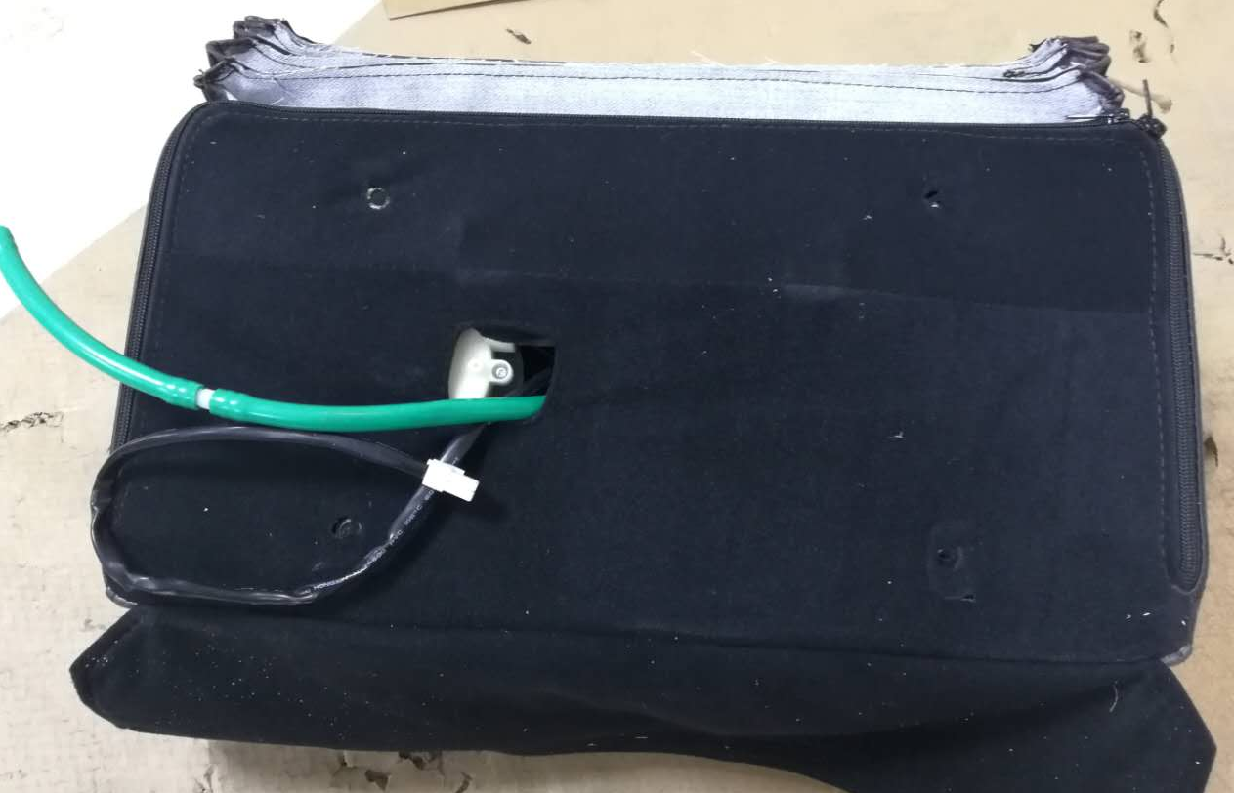
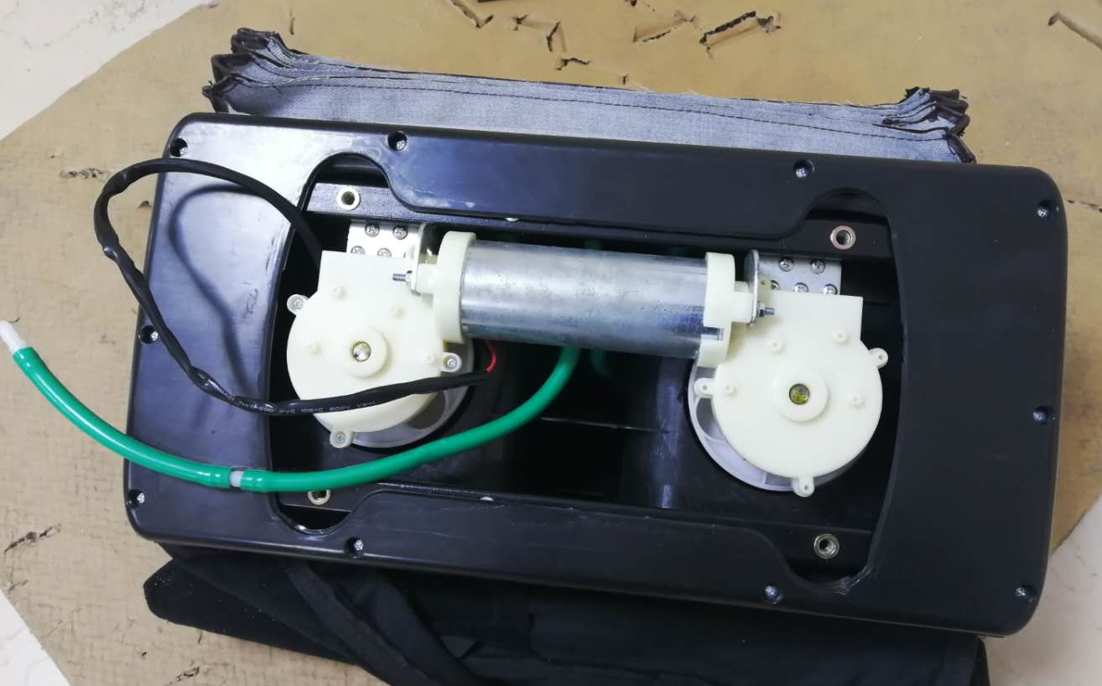
Turn the calf to the bottom and unzip

Open the zipper, pull down the holster to expose the back cover, and then remove the screws

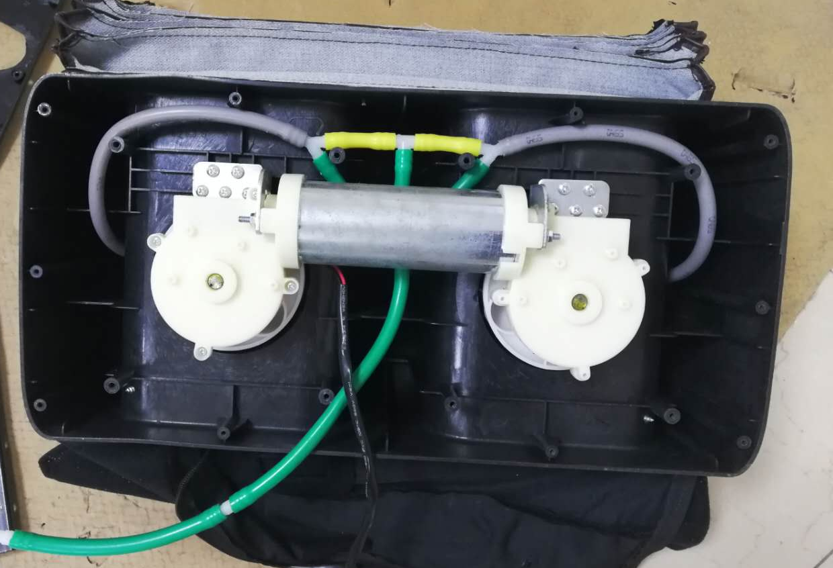
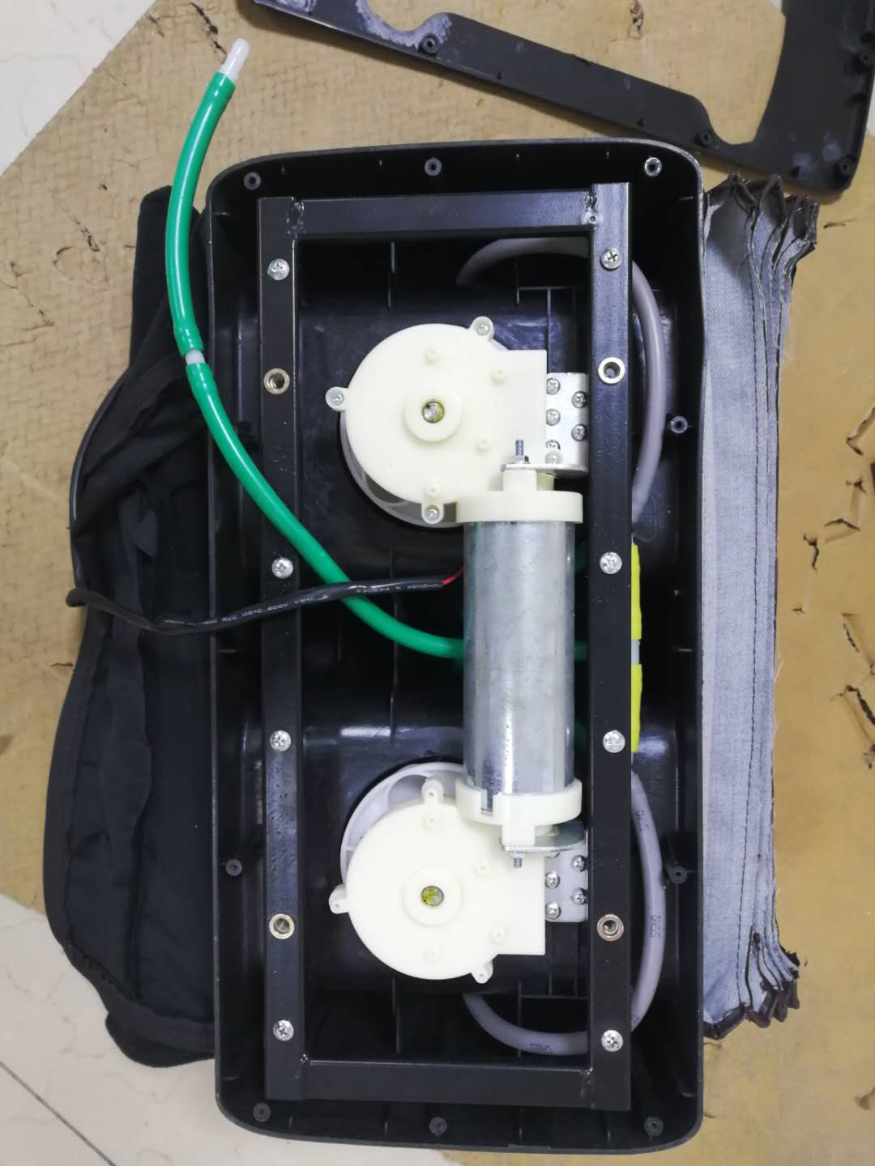

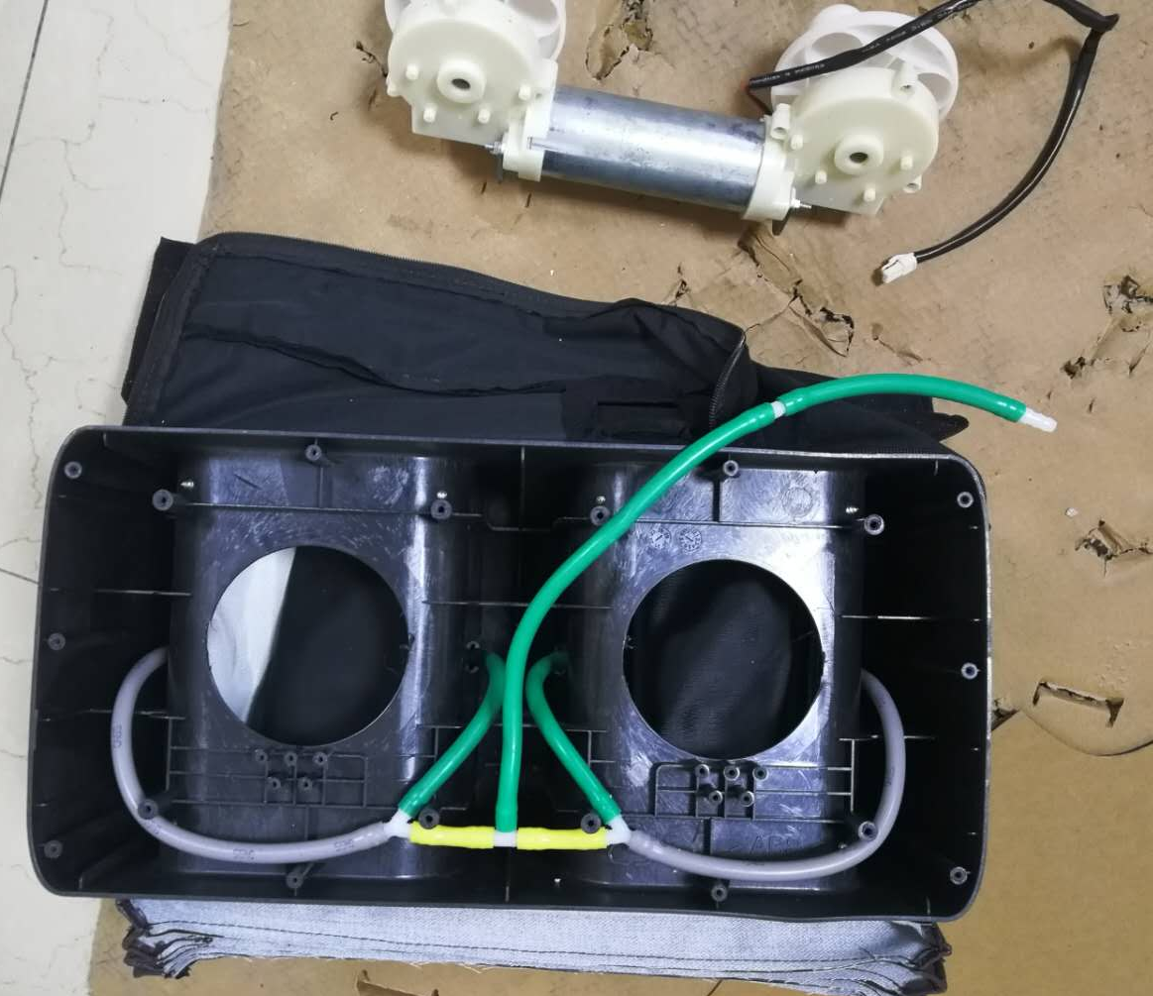
After removing the leg kneading assembly,please install new one

Remove the back cover and continue to remove the screws of the leg holder
Remove the leg holder, then continue to remove screws of the leg kneading assembly

