By Echo, 20131216
Step 1: To enter engineering mode:

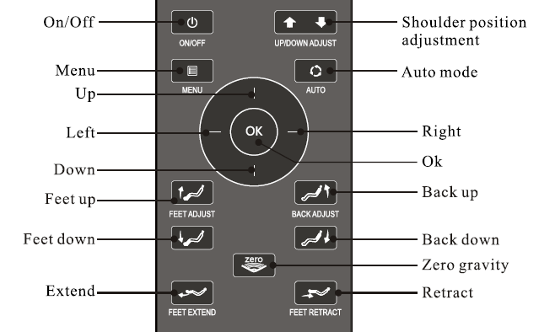
Keep pressing the button “UP” and turn on the main
power switch of the chair to enter the main menu of
engineering mode.

Layout of main menu:
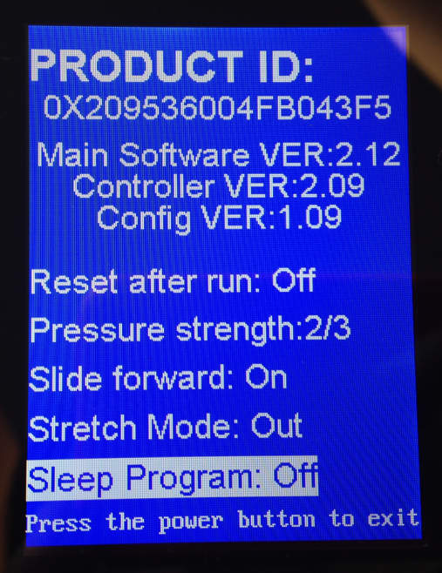
:
a.ID of thechair
e. After massage come back to normal position or not ：on/off
b. Program version of the main PCB is：2.12
c. Program version of the remote controller is:2.09

d.Internal testing program version is:1.09

h. Stretch Mode: Out/Down (out means stretch by extending your body, Down means pull down your lower body. It’s only applicable under Extent Auto massage mode.
f. Air pressure： total to 3 levels

g. Slide function：on/off

i. Sleep Program: on/off, if choose on, the Relax auto program change to Sleep Program.

To change e, f, g,h,i :
Press button Up/Down to choose the menu you want to change, and then press button
Left/Right to change the set.
For example, if you want to change the Slide forward from On to Off, first please press Down to “Slide forward:Open” and then press button Right to change to Off.

Step 2: To enter main part testing mode:
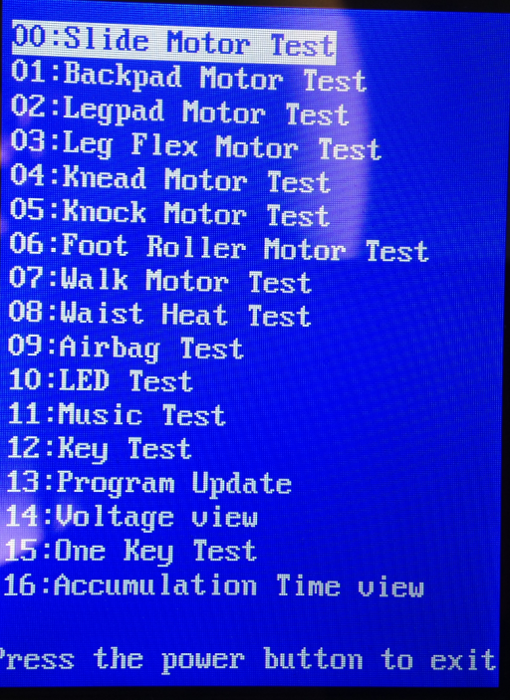
Keep pressing Menu and AUTO at the same time for 3-5 seconds to enter the main part testing mode.
00：Slide Motor Test 滑动电动缸测试
01：Back pad Motor Test 靠背电动缸测试
02：Leg pad Motor Test 小腿电动缸测试
03：Leg Flex Motor Test 小腿伸缩测试
04：Knead Motor Test 揉捏电机测试
05：Knock Motor Test 敲打电机测试
06：Foot Roller Motor Test 脚底滚轮测试
07：Walk Motor Test 行走电机测试
08：Waist Heat Test 腰部加热测试
09：Airbag Test 安全气囊测试
10：Led Test 彩灯测试
11：Music Test 音乐测试
12：Key Test 按键测试
13：Program Update 程序更新
14：Voltage View 电压数值
15: One Key Test 一键测试
16: Accumulation Time View 累计工作时间查看

Explanation:
00：Slide Motor Test
Press OK to enter the testing layout for slide motor as follows:
Forward Switch Off
Backward Switch On

Keep pressing UP, the chair slide forwards to the maximum, it display:
Forward Switch On
Backward Switch Off
Keep pressing Down, the chair slide backwards to the maximum, it display:
Forward Switch Off
Backward Switch On

If the chair slide and display as above, means the slide motor is ok.
Press Menu to exit.

01：Back pad Motor Test
Press Down to “01：Back pad Motor Test” and press OK to enter the testing layout of back pad motor as follows:
Back up Switch On
Back down Off

Keep pressing UP, the chair backrest rise to the maximum, it display:
Back up Switch on
Back down Off
Keep pressing Down, the chair backrest decline to the maximum, it display:
Back up Switch Off
Back down Switch On

Important Note:
When you test this part, please make sure there has at least 50cm distance between backrest and wall, because in this test mode, the chair won’t slide forwards when you decline the backrest.
Press Menu to exit.

02：Leg pad Motor Test
Press Down to “02：Leg pad Motor Test” and press OK to enter the testing layout of leg pad motor as follows:
Leg up Switch Off
Leg down Switch On
Flex Angle Switch On
Flex Ground Switch Off

Keep pressing UP, the chair legrest rise to the maximum, it display:
Leg up Switch On
Leg down Switch Off
Flex Angle Switch Off
Flex Ground Switch Off

Keep pressing Down, the chair legrest decline to the maximum, it display:
Leg up Switch Off
Leg down Switch On
Flex Angle Switch On
Flex Ground Switch Off

Press Menu to exit.

03：Leg Flex Motor Test
Before entering the 03: Leg Flex Motor Test, please enter to 02: Legpad Motor Test to rise the legrest to highest position and then enter to 01: Backpad Motor Test to recline the backrest down to the lowest position.
Press Down to “03：Leg Flex Motor Test” and press OK to enter the testing layout of leg flex motor as follows:
Flex out Switch Off
Flex In Switch On
Flex Angle Switch Off
Flex Ground Switch Off
Flex Foot Switch Off

Keep pressing UP, the chair legrest extend to the maximum, it display:
Flex out Switch On
Flex In Switch Off
Flex Angle Switch Off
Flex Ground Switch Off
Flex Foot Switch Off

Keep pressing Down, the chair legrest come back to the maximum ,it display:
Flex out Switch Off
Flex In Switch On
Flex Angle Switch Off
Flex Ground Switch Off
Flex Foot Switch Off

Press Menu to exit.

04：Knead Motor Test
Press Down to “04：Knead Motor Test” and press OK to enter the testing layout of kneading motor as follows:
Knead Speed 0
Knead Phase 0 --this is kneading direction(clockwise/anti-clockwise)
Knead Position 0 –this is kneading width(wide/medium/narrow)
Press UP continuously, back mechanism start to knead and speed change from 0-6, it doesn’t work at 0, it display: Knead Speed 0-6
Press Down continuously, back mechanism start to knead and speed change from 6-0, it doesn’t work at 0, it display: Knead Speed 6-0
Press left/right to adjust the kneading direction, Knead Phase 0 means knead clockwise, Knead Phase 1 means knead anti-clockwise.
Knead Position means the width of mechanism, it changes automatically from in 1-3, 1 means narrow, 2 means medium, 3 means wide.

Press Menu to exit.

05: Knock Motor Test
Press Down to “05: Knock Motor Test” and press OK to enter the testing layout of Knocking motor as follows:
Knock Speed 0 -------it is knock speed
Knock Phase 0 ------it is knock direction

Press UP continuously, back mechanism start to knock and the speed changes in 0-6, it doesn’t work at 0, it display: Knock Speed 0-6
Press Down continuously, back mechanism start to knock and the speed changes in 6-0, it doesn’t work at 0, it display: Knock Speed 6-0
Press left/right, the Knock Phase changes in 0-1, but actually there is no change.
Press Menu to exit.

06: Foot Roller Test
Press Down to “06: Foot Roller Test” and press OK to enter the testing layout of Foot Roller Test as follows:
Roller Speed 0----------it’s roller rotating speed
Roller Phase 0----------it’s roller rotating direction

Press UP continuously, Roller start to work and speed changes from 0 to 3, it doesn’t work at 0, it display: Roller Speed 0-3
Press Down continuously, Roller start to work and speed changes from 3-0, it doesn’t work at 0, it display: Roller Speed 3-0
Press left/right to change the roller rotating direction.

Press Menu to exit.

07: Walk motor Test
Press Down to “07: Walk motor Test” and press OK to enter the testing layout of Walk Motor Test as follows:
Walk Up Switch Off
Walk Down Switch Off
Shoulder Switch Off
Position: 0

Keep pressing Down, the back mechanism goes to the lowest position, remote controller display:
Walk Up Switch Off
Walk Down Switch On
Shoulder Switch On
Position: 0

Keep pressing UP, the back mechanism goes to the highest position, remote controller display:
Walk Up Switch On
Walk Down Switch Off
Shoulder Switch Off
Position 424

Press Menu to exit.

08: Waist Heat Test
Press Down to “08: Waist Heat Test” and press OK to enter the testing layout of Waist Heat Test as follows:
The display screen change to yellow from blue to start heat test, press OK again to finish the test.

Press Menu to exit.

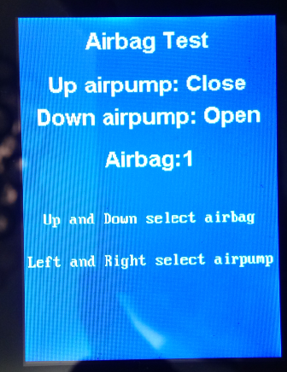
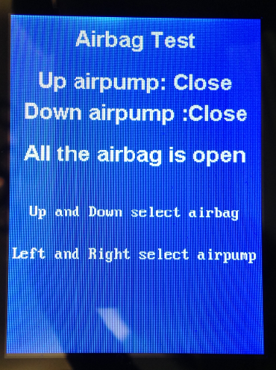
09: Airbag Tes
Press Down to “09: Airbag Test”, it display:
Up airpump: Open/Close
Down airpump: Open/Close
Airbag: 1-24/ All the airbag is open

Press left/right to switch the Up airpump and Down airpump between Open and Close
Press OK to change the Airbag:1-24 to “All the airbag is open.”
Press up/down to change the “All the airbag is open ” to “Airbag:1-24” and switch among Airbag:1, Airbag:2, ……..Airbag:24.
Airbag:1,Airbag:2,…..,Airbag:24 means different position, here is the explanation:
Airbag:1 , the airbag of right side of back is working
Airbag 2, the airbag of right side of waist is working.
Airbag 3, the airbag of left side of thigh is working
Airbag 4, the airbag of right side of thigh is working
Airbag 5, the airbag of left side of shoulder is working
Airbag 7, the airbag of left side of back is working
Airbag 8, the airbag of right side of shoulder is working
Airbag 9, the front airbags of right arm are working(both upper and lower)
Airbag 10, the middle airbags of right arm are working(both upper and lower)
Airbag 11, the rear airbags of right arm are working(both upper and lower)
Airbag 12, none if airbags works
Airbag 13, the front airbags of left arm are working(both upper and lower)
Airbag 14, the middle airbags of left arm are working(both upper and lower)
Airbag 15, the rear airbags of left arm are working(both upper and lower)
Airbag 16, none if airbags works
Airbag 17, airbags at outer side of left feet and inner side of right feet are working
Airbag 18, airbags at inner side of left feet and outer side of right feet are working
Airbag 19, the airbags at both heels are working
Airbag 20, none if airbags works
Airbag 21, lower back airbags of both calves are working
Airbag 22, both sides airbags(outer side and inner side) of both calves are working
Airbag 23, upper back airbag of both calves are working
Airbag 24, the calves assisting airbags(outer side of both claves) are working
Press Menu to exit.

10: Led Test
Press Down to “10: Led Test” and press OK continuously, both controller screen and LED light color changed among red-green-blue.
Press Menu to exit.

11：Music Test
Press Down to “11: Music Test” : not applicable at present
Press Menu to exit.

12: Key Test
Press Down to “12: Key Test” and press OK to enter the testing layout of Key Test as follows:
Key Code:[0*(a figure)]---Press the keys in turn and the figure for each key are as follows:
ON/OFF: Key Code [0*46]
UP ADJUST: Key Code [0*47]
DOWN ADJUST: Key Code [0*48]
MENU: Key Code [0*4f]
AUTO：Key Code [0*50]
OK：Key Code [0*45]
UP：Key Code [0*41]
DOWN：Key Code [0*42]
LEFT：Key Code [0*43]
RIGHT：Key Code [0*44]
FEET UP：Key Code [0*4b]
FEET DOWN：Key Code [0*49]
BACK UP：Key Code [0*4c]
BACK DOWN：Key Code [0*4a]
FEET EXTEND：Key Code [0*4e]
FEET RETRACT：Key Code [0*4d]
ZERO：Key Code [0*11]
Press power switch to exit the testing

13：Program Update
For updating the program, please refer to the program updating instruction.

14: Voltage View
Press Down to “14: Voltage View”, and press OK to enter the testing layout of Voltage View as follows:
Signal Voltage：5±5% V
Motor Voltage(transformer main voltage): 25-35V
Valve Voltage(transformer assist voltage): 23-33V(depends on loading马达不开的话电压会高一点)
CPU temperature(主板的主芯片)：比室温稍高，或同室温

Signal Voltage：normal range: 5±5% V
Motor Voltage(transformer main voltage to motor): normal range 25-35V
Valve Voltage(transformer secondary voltage to air valve): 23-33V(depends on the loading, if motor is off, the voltage to valve is high, if motor is on, the voltage to valve is lower)
CPU temperature(chip in main PCB)：same as room temperature or a little bit higher than room temperature.

15: One Key Test
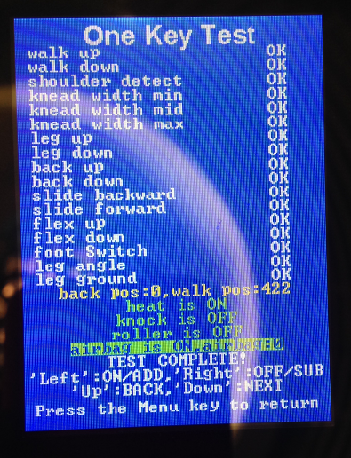
Press Down to “5: One Key Test”, it starts to test all functions automatically, please touch the back mechanism when it’s going to shoulder position and the heel sensor, all test result change to OK means everything is ok.

16: Accumulation Time View
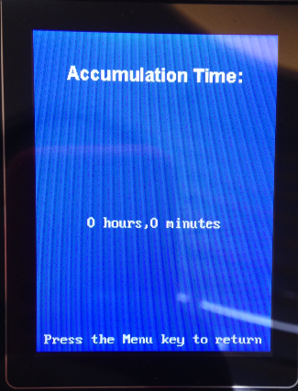
Check how much time the chair has worked. It starts to accumulate after the chair at least worked for five minutes.

第一步：长按手控器向上键（右图中的Up）不放，同时开启电源，进入主菜单(下左图)：

工程模式主菜单介绍：
产品ID号
当前驱动板程序版本号为：2.12

当前手控器程序版本号为：2.09

运行后复位：Off(关闭)/On(打开),按Left/Right键切换Off/On

当前内部测试程序版本为：1.09

气压强度：图示处于2档（共3档）,按摩Left/Right键切换档位
拉伸方式(Out(向前拉)/Down(向下拉))（仅在舒展按摩下有拉伸程序）按Left/Right键切换Out/Down

睡眠程序(Off(关闭)/On(开启))，如选On, 则Relax变为睡眠程序。按Left/Right键切换Off/On
滑动功能：open（打开）/close(关闭)
按Left/Right键切换Off/On

第二步：长按菜单键和自动键（或长按靠背上升键和靠背下降键）进入工程模式
00：Slide Motor Test 滑动电动缸测试
01：Backpad Motor Test 靠背电动缸测试
02：Legpad Motor Test 小腿电动缸测试
03：Leg Flex Motor Test 小腿伸缩测试
04：Knead Motor Test 揉捏电机测试
05：Knock Motor Test 敲打电机测试
06：Foot Roller Motor Test 脚底滚轮测试
07：Walk Motor Test 行走电机测试
08：Waist Heat Test 腰部加热测试
09：Airbag Test 安全气囊测试
10：LED Test 彩灯测试
11：Music Test 音乐测试
12：Key Test 按键测试
13：Program Update 程序更新
14：Voltage View 电压数值查看
15: One Key Test 一键测试
16: Accumulation Time View 累计工作时间查看

Explanation:
00：Slide Motor Test 滑动电动缸测试
选择进入滑动电动缸测试后画面显示：Forward Switch Off 向前滑动开关关闭
Backward Switch On 向后滑动开关打开
按手控器向上键，向前滑行至最长距离时，手控器画面显示：Forward Switch On
Backward Switch Off
按手控器向下键，向后滑行至最长距离时，手控器画面显示：Forward Switch Off
Backward Switch On
按菜单键退出测试

01：Back pad Motor Test 靠背电动缸测试
选择进入靠背电动缸测试后画面显示：Back up Switch On 靠背向上开关打开
Back down Off 靠背下躺开关关闭
按手控器向上键，靠背上升到最高时，手控器画面显示：Back up Switch on
Back down Off
按手控器向下键，靠背下躺到最低时，手控器画面显示：Back up Switch Off
Back down Switch On

重要提示：
测试此项时，请确认靠背与墙面有50CM距离，因为在此测试模式中，仅仅是测试靠背下躺上升功能，椅子不会前移。

按菜单键退出测试

02：Leg pad Motor Test 小腿电动缸测试
选择进入小腿电动缸测试后画面显示：Leg up Switch Off 小腿上升开关关闭
Leg down Switch On 小腿下降开关打开
按手控器向上键，小腿升至最高时，手控器画面显示：Leg up Switch On
Leg down Off
按手控器向下键，小腿升至最低时，手控器画面显示：Leg up Switch Off
Leg down Switch On
按菜单键退出测试

进入03: Leg Flex Motor Test测试前，请进入02: Legpad Motor Test将小腿升至最高，然后进入01: Backpad Motor Test将靠背降至最低，然后进入03: Leg Flex Motor Test测试，否则无法测试小腿伸缩。因为此项仅测试小腿伸缩功能，如无空间供小腿伸出来，则会将靠背顶下损坏电动缸。或者将椅子放在架台上，小腿是架空状态也可以测试。
03：Leg Flex Motor Test 小腿伸缩测试
选择进入小腿伸缩测试后画面显示：Flex out Switch Off 延伸开关关闭
Flex In Switch On 缩回开关打开
Flex Angle Switch On 角度开关打开
Flex Ground Off 触底开关关闭
按手控器向上键，小腿伸出时，手控器画面显示：Flex out Switch On
Flex In Off
Flex Angle Off
Flex Ground Switch On
按手控器向下键，小腿缩回时，手控器画面显示：Flex out Switch Off
Flex In Switch On
Flex Angle Switch On
Flex Ground Off
按菜单键退出测试

04：Knead Motor Test 揉捏电机测试
选择进入揉捏电机测试后画面显示：Knead Speed 0 揉捏速度
Knead Phase 0 揉捏方向（正反）
Knead Position 0 揉捏的位置（宽中窄）
按手控器向上键，机芯开始揉捏，手控器画面显示：Knead Speed 揉捏速度从0到6档，再按手控器向下键，揉捏的速度从6档到0档,显示0揉捏电机不工作
按手控器左键（或右键），开始调节揉捏的正反向：Knead Phase 0 正转
Knead Phase 1 反转
Knead Position 揉捏的宽中窄自动调节，从1—2—3档
按菜单键退出测试

05：Knock Motor Test 敲打电机测试
选择进入敲打电机测试后画面显示：Knock Speed 0 敲打速度
Knock Phase 0 敲打方向
按手控器向上键，敲打速度从1档到6档进行工作
按手控器向下键，敲打速度从6档到1档进行工作
按左键（或右键），敲打方向Knock Phase 0或Knock Phase 1 无变化
按菜单键退出测试

06：Foot Roller Motor 脚底滚轮电机测试
选择进入脚底滚轮电机测试后画面显示：Roller Speed 0 滚轮速度
Roller Phase 0 滚轮转动方向
按手控器向上键，滚轮速度从1档到3档，按向下键，滚轮速度从3档到1档
按手控器左键（右键），Roller Phase 0 滚轮反转Roller Phase 1 滚轮正转
按菜单键退出测试

07：Walk Motor Test 行走电机测试
选择进入行走电机测试后画面显示：Walk Up Switch Off 向上行走开关关闭
Walk Down Switch Off 向下行走开关关闭
Shoulder Switch Off
Position: 0 行走距离
按手控器向下键，行走电机向下行走至最低点，手控器显示：
Walk Up Switch Off
Walk Down Switch On
Shoulder Switch On
Position: 0

按手控器向上键，行走电机向上行走至最高点，手控器显示
Walk Up Switch On
Walk Down Switch Off
Shoulder Switch Off
Position 424
按菜单键退出测试

08：Waist Heat Test 腰部加热测试
选择进入腰部加热测试后，按OK键显示屏画面由蓝变黄，开启加热测试，再按OK键关闭加热测试
按菜单键退出测试

09：Airbag Test 气囊测试
选择进入气囊测试后，手控器画面显示：Up airpump: Open/Close
Down airpump: Open/Close
Airbag 1-24/All the airbag is open
按OK键显示 All the airbag is open 所有气囊充气，按上下键可以选择测试气囊位置,按左右键选择Up airpump: Open或Close，Down airpump: Open或Close。

按向上键第1次 显示：Airbag 1右侧背部充气
第2次 显示：Airbag 2右侧腰部充气
第3次 显示：Airbag 3左侧大腿充气
第4次 显示：Airbag 4右侧大腿充气
第5次 显示：Airbag 5左侧肩部充气
第6次 显示：Airbag 6左侧腰部充气
第7次 显示：Airbag 7左侧背部充气
第8次 显示：Airbag 8右侧肩部充气
第9次 显示：Airbag 9右侧扶手前气囊充气(both upper and lower)
第10次显示：Airbag 10右侧扶手中间气囊充气 (both upper and lower)
第11次显示：Airbag 11右侧扶手后气囊充气(both upper and lower)
第12次显示：Airbag 12 不充气（空挡）
第13次显示：Airbag 13左侧扶手前气囊充气(both upper and lower)
第14次显示：Airbag 14左侧扶手中间气囊充气(both upper and lower)
第15次显示：Airbag 15左侧扶手后气囊充气(both upper and lower)
第16次显示：Airbag 16不充气（空挡）
第17次显示：Airbag 17左脚外侧和右脚内侧
第18次显示：Airbag 18左脚内侧和右脚外侧
第19次显示：Airbag 19 两脚脚后跟气囊充气
第20次显示：Airbag 20不充气（空挡）
第21次显示：Airbag 21小腿后侧下气囊充气
第22次显示：Airbag 22小腿全部侧气囊充气(左小腿两侧和右小腿两侧)
第23次显示：Airbag 23小腿后侧上气囊充气
第24次显示：Airbag 24小腿辅助气囊（左右脚外侧（非翼气囊））
按菜单键退出测试

10：Led Test 彩灯测试
连续按OK键,彩灯及遥控器屏幕由红—绿—蓝 相互切换

11：Music Test 音乐测试
暂无 需更换新的用户接口板方可测试

12：Key Test 按键测试
进入按键测试后画面显示：Key Code:[0*(a figure)],依次按手控板的按键测试数值如下
电源: Key Code [0*46] 肩部：上Key Code [0*47] 下Key Code [0*48]
菜单：Key Code [0*4f] 自动：Key Code [0*50] OK键：Key Code [0*45]
向上键：Key Code [0*41] 向下键：Key Code [0*42]
左键：Key Code [0*43] 右键：Key Code [0*44]
小腿上升键：Key Code [0*4b] 小腿下降键：Key Code [0*49]
靠背上升键：Key Code [0*4c] 靠背下降键：Key Code [0*4a]
小腿伸出键：Key Code [0*4e] 小腿缩回键：Key Code [0*4d] 零重力键：Key Code [0*11]
关闭电源开关退出测试

13：Program Update 程序更新
For updating the program, please refer to the program updating instruction.
14：Voltage View 电压数值查看
选择进入后画面显示：Signal Voltage 信号电压 Valve Voltage 电磁阀电压
Motor Voltage 电机电压 CPU temperature 芯片温度

15: One Key Test
肩部位置检测时和脚后跟触地检测需要手动触碰一下方会测试OK。
Press Down to “5: One Key Test”, it starts to test all functions automatically, please touch the back mechanism when it’s going to shoulder position and the heel sensor, all test result change to OK means everything is ok.

16: Accumulation Time View(工作时间超过五分钟才会累计时间)
Check how much time the chair has worked. It starts to accumulate after the chair at least worked for five minutes.

