OPPO 3D Luxury Massage Chair Maintenance Manual

Wenzhou Guojie Healthcare Appliance Co.,Ltd
SEP 25,2020

Preface
In order to facilitate customer service staff to do field product maintenance and give on-site technical guidance for maintenance personnel, Maintenance Manual summarizes some common problems and faults which are easy to appear in the use of products for professional maintenance personnel to consult and refer to. As the compilation of materials may not be comprehensive enough, more maintenance methods also need to be accumulated by all maintenance personnel and summarized during the field maintenance process, which can be supplemented on the basis of Maintenance Manual.
Warning: This manual is only for professional maintenance personnel.

Wenzhou Guojie Healthcare Appliance Co.,Ltd
SEP 25,2020
Content
- Main PCB Port Function Description Diagram
  - Main PCB Diagram
  - Main PCB Port Function Description
- Detecting Board Port Function Description Diagram
  - Width Detecting Board Connection Port Function Description
  - Shoulder Position Detecting Board Connection Port Function Description
  - Walking Detecting Board Connection Port Function Description
  - Hall Detecting Board Connection Port Description
  - Bluetooth Board Connection Port Description
- Power Transformer Lead Diagram
- Common Faults of Massage Chair and Elimination Methods
    - The fuse blows as the power switch is turned on
    - The power indictor is on, but main PCB is not energized
    - Backrest cannot be supine, or leg cannot move up or down
    - The controller cannot be turned on or operated
    - No kneading or knocking
    - Manipulator cannot walk up or down
    - Some airbags are not inflated
    - All airbags are not inflated
    - Manipulator rushes to the top (bottom)
    - Foot roller does not work
- ●Main PCB Diagram

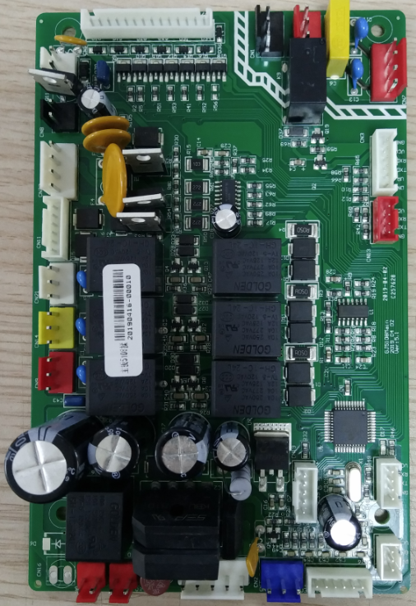
5

23

12

11

10

9

6/7

4

3

2

8

1

22

15

21

19/20

17/18

16

14

13

●Main PCB Port Description

1.Foot Roller Port 2.Back Electric Pushrod Port
3. Leg and Foot Electric Pushrod Port 4. Walking Motor Port
5.Spare Port 6.Kneading Motor Port
7.Knocking Motor Port 8.Leg Roller Port
9.Solenoid Value Connection Port 10.AC110VAir Pump Port
11.Transformer Input Port 12.Power Input Port
13.Controller Port 14.Walking Counting Detecting Board Connection Port
15.Mechanism Signal Wire Connection Port 16.12V Output/ Light Signal
17.AC12VTransformer Output Port 18.AC24V Transformer Output Port
19/20.Waist/Leg and Foot Heating Port 21.Program Input Port
22. Hall Detecting Board Connection Port
①The red wire frame is the high voltage part of the power supply. Please be careful during maintenance after disconnecting the power supply to prevent electric shock.
②When substituting, please pay attention to whether the port is correct and whether the terminal direction is consistent with the socket to prevent wrong insertion.

3D PCB Diagram
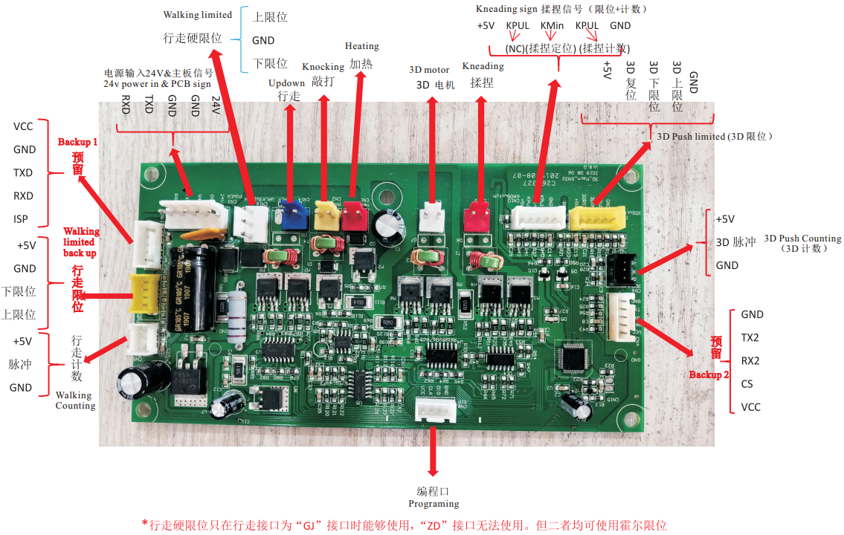
3D Machanism Diagram
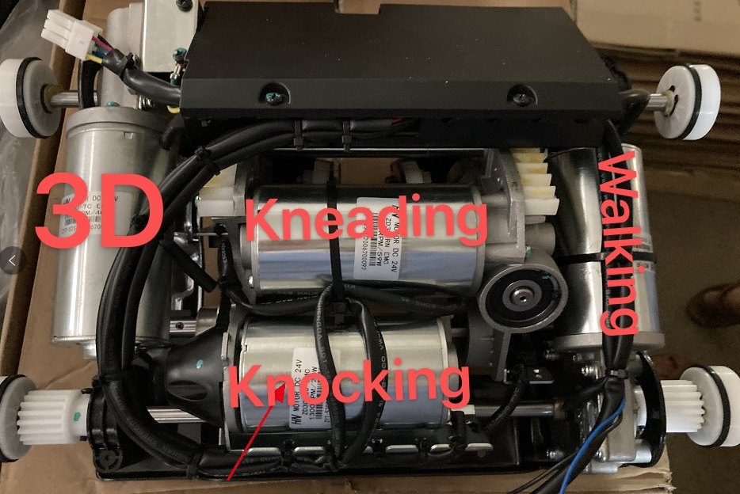

- ●Detecting Board Diagram and Port Description
Width Detecting Board
VCC
GND
GND
SHD
Shoulder Position Detecting Port

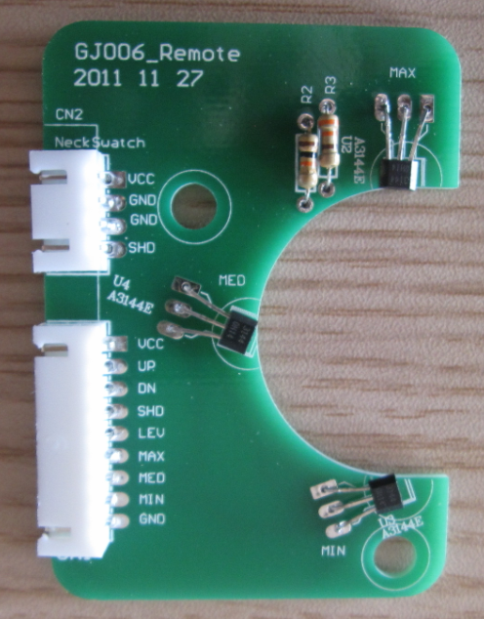

Narrow Hall Element

VCC Voltage Circuit
UP
DN
SHD Shoulder Position Detecting Signal Wire
LEV
MAX Manipulator Narrow Signal Wire
MED Manipulator Middle Signal Wire
MIN Manipulator Wide Signal Wire
GND Ground
Mechanism Signal Port

Middle Hall Element

Wide Hall Element

Shoulder Position Detecting Board
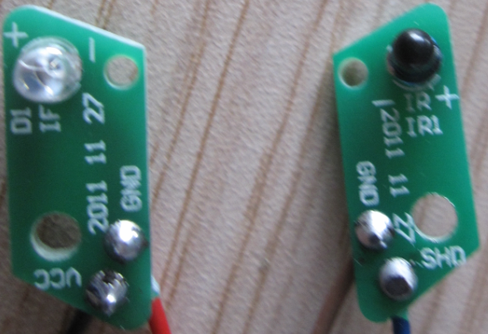
Signal Receiving Tube

Signal Transmitter Tube

VCC
GND

GND
SHD

Walking Counting Detecting Board
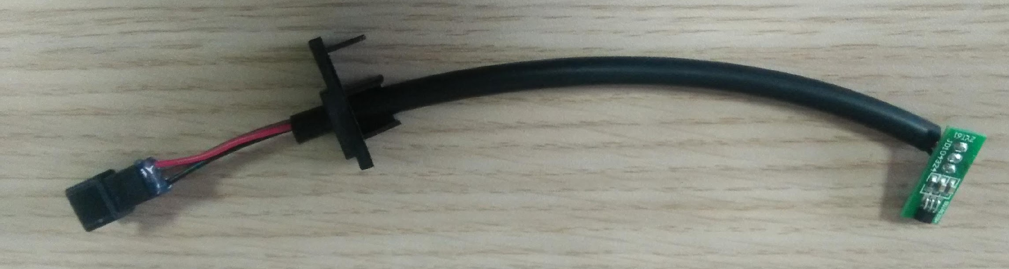

Docking Plug-in

Hall Detecting Board
Walking Signal Wire Port

Walking Motor Docking Port

Main PCB DC24V Voltage Drive Port

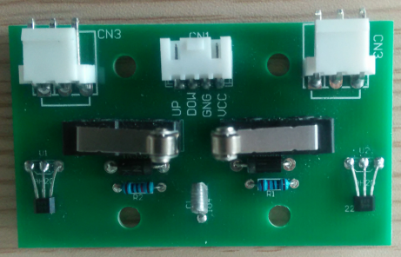

Up Hall Detecting

Down Hall Detecting

Down
Microswitch

Down
Microswitch

- Power Transformer Lead Diagram
AC110V Transformer Input Terminal

Transformer Transformer

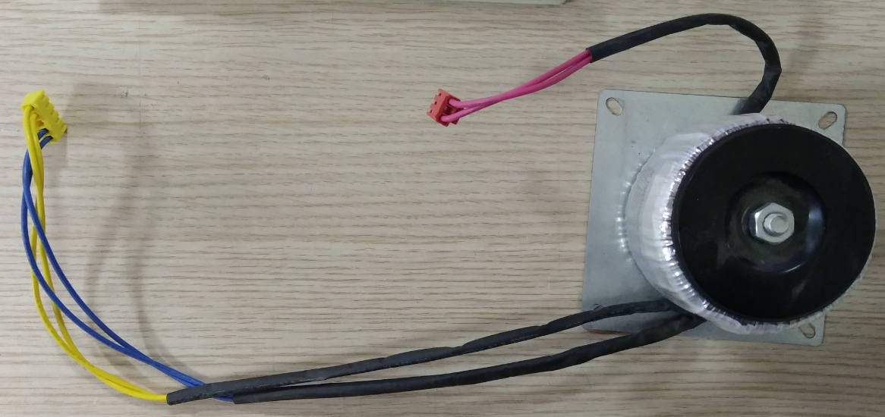
AC20V AC10V Transformer Output Terminal

5102Z adopts 110V ring transformer
- Common Faults and Elimination Methods
①. The fuse blows as the power switch is turned on
1.1 Causes Analysis:
A. Overcurrent protection caused by grid voltage fluctuation
B. Short circuit caused by high temperature and humidity environment
C. Power load short circuit
1.2 Solutions:
A. Overcurrent protection caused by grid voltage fluctuation—Replace with same type of fuse
B. Short circuit caused by high temperature and humidity environment—The cover of the electrical box should be opened. Firstly, check whether there is short circuit at AC220V input line terminal after unplugging transformer. Secondly, measure on-off to confirm whether the fuse in transformer is blown. If abnormal phenomena are found in the above-mentioned examinations, it is only necessary to repair them. If there is a short circuit in the main PCB or transformer, the corresponding parts will have obvious burning marks and can be replaced.
C. Power load short circuit—It is mainly because the dust and iron filings enter into the main PCB in the chassis, which results in partial short circuit. The solution is to clean up or change the main PCB.
D. After completing all maintenance operations, it is necessary to check the connection status of the circuit parts, and ensure the correct connection of the circuit and the normal operation of mechanical parts.
②. The power indictor is on, but main PCB is not energized
2.1 Causes Analysis:
A. Switch board lead wire falls off B. Transformer burnout
C. Damage of PCB
2.2 Solutions:
A. Turn off the power supply, check the connection of the lead wire at the switch, and repair it if it is found to fall off.
B. If the wiring harness is connected properly, the main PCB is still unable to be energized. Check whether the transformer voltage is normal, and replace the transformer if it is abnormal.
C. If switch board lead wire and transformer are normal, it must be short circuit or burnout of main PCB. Then replace it with the same type of main PCB.
D. After completing all maintenance operations, it is necessary to check the connection status of the circuit parts, and ensure the correct connection of the circuit and the normal operation of mechanical parts.
③. Backrest cannot be supine, or leg cannot move up or down
3.1 Causes Analysis:
A. Plug-in has loosened or fallen off
B. No driving voltage at main PCB pushrod plug-in
C. Damage of electric pushrod
3.2 Solutions:
A. Open the sleeve, and check whether the pushrod docking plug has loosened or fallen off. If so, repair it. If the docking plug in the sleeve is well connected, check the plug-in which connects main PCB and pushrod loosened or fallen off. If so, repair it.
B. If the pushrod connection wire is normal, it may be that there is no 24V driving voltage on the leg pushrod on main PCB. Detect pushrod port on main PCB by the direct voltage at multimeter, and press up down and reset button. If there is no 24V voltage displayed at multimeter, it may be the damage of pushrod power drive, then repair or replace main PCB.
C. If the pushrod connection wire and driving voltage at main PCB pushrod plug-in are normal, it must be the damage of pushrod, and then change it.
④. The controller cannot be turned on or operated
4.1 Causes Analysis:
A. Controller wire falls off B. Deviation of controller docking hole
C. Damage of controller PCB D. Controller terminal on main PCB falls off
4.2 Solutions:
A. Open the controller shell and reconnect the wire.

B. Arrows should be consistent to prevent deviation when docking
C. Replace it with a new controller
D. Reinsert controller terminal into controller port on main PCB
⑤. No kneading or knocking
5.1 Causes Analysis:
A. Damage of kneading or knocking motor
B. Kneading motor connection wire, plug or plug-in falls off
C. No 24V control power
5.2 Solutions:
Open the back cover and check whether the plug falls off or is not firmly connected. If not, exchange kneading terminal and knocking terminal, then turn on the power and operate knocking function under manual condition. After exchange, if kneading function is normal, it shows that kneading motor is not damaged. If not, it shows that kneading motor is damaged, and then replace it. If all the above conditions are normal, detect whether the 24V driving voltage of knocking port is normal by the direct voltage at multimeter, and then repair or replace main PCB if it is abnormal which means that there is something wrong with main PCB control circuit (detection method for no kneading and no knocking are same).
⑥. Manipulator cannot walk up or down
6.1 Causes Analysis:
A. Walking motor wire is disconnected or plug-in falls off
B. Damage of walking motor C. No 24V driving voltage on main PCB
D. Damage of Hall detecting board
6.2 Solutions:
A. Open the electrical box cover and check whether the wire is broken or the terminal is off.
B. Detect main PCB port by the direct voltage at multimeter, and press up down button of controller under manual condition .If there is driving voltage, it shows the motor is damage, and then replace it.
C. Unplug walking port and Hall detecting signal wire port, then detect whether there is driving voltage. If not, change main PCB.
D. If there is driving voltage and mechanism still does not work, change Hall detecting board.
⑦. Some airbags are not inflated
7.1 Causes Analysis:
A. Air tube bending B Air tube which connects solenoid value falls off
C. Solenoid value plug-in is not firmly connected
7.2 Solutions:
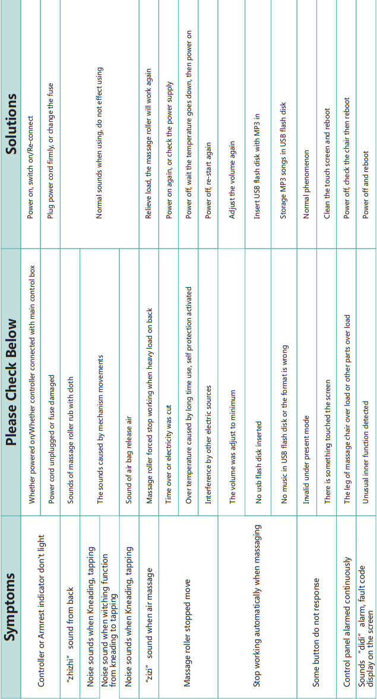
- Firstly, check whether the air tube bends, if so, repair it to the original state.
B. Open the electrical box cover, lift leg and foot assembly, and check whether air tube which connects solenoid value falls off.
C. Check whether solenoid value plug-in on main PCB is firmly connected, if so, plug it in.
⑧. All airbags are not inflated
8.1 Causes Analysis:
A. Damage of pump
B. Damage of connection wire between pump and main PCB
C. Damage of main PCB control circuit
D. Damage of solenoid valve or pump falls off
8.2 Solution:
A. Check the main PCB port and pump docking plug-in, reinsert plug-in into port if it falls off. If plug-in is normal, unplug air tube which connects pump and solenoid valve. If there is outflow of air, check whether the solenoid valve is damaged or the solenoid valve port is firmly connected. If not, check whether there is driving voltage on main PCB connection port by AC 750V at the multimeter and voltage value is about 220V, replace main port if there is no driving voltage; replace pump if there is driving voltage.
⑨. Manipulator rushes to the top (bottom)
9.1 Causes Analysis:
A. Hall detecting board signal wire falls off
B. Damage of Hall detecting board or magnet base
C. Damage of main PCB related travel detection circuit which results in failure to receive the walking detecting signal normally.
9.2 Solutions:
A. Firstly, check whether the wire or main PCB port is firmly connected, and repair it if so.
B. Replace it with new Hall detecting board
C. If Hall detecting board signal wire, Hall detecting board and magnet base are normal，replace main PCB.
⑩. Foot roller does not work
10.1 Causes Analysis:
A. Damage of motor B. Docking wire falls off
C. Damage of main PCB circuit
10.2 Solution:
A. Check whether the leg docking falls off, and detect whether there is driving voltage on main PCB port. If so, it shows the motor is damage and replace it. If not, replace main PCB.

