**Titan Pro Ace II &**

**Titan Pro Commander**

**Maintenance Manual**

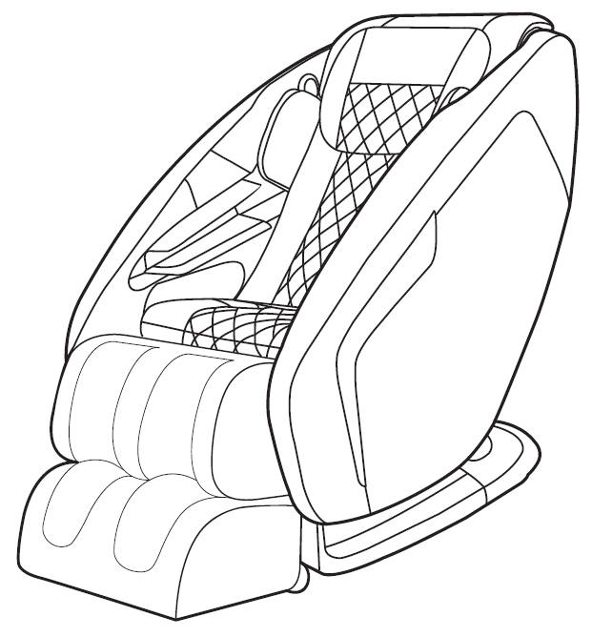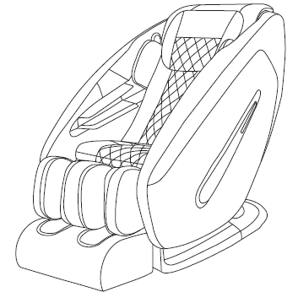

目录 Table of contents

1．产品预防措施进行检查和维修Precautions for inspection and repair 3

2. 产品规格说明 Product specification 4

3．布线图 Wiring diagram 4

4．按摩椅电机 Massage chair motors 5

5．气压按摩 Air massage 10

6．气压气路图解 Air valve diagram 11

7．按摩椅故障检测表 Massage chair trouble lists 12

8．更换零部件注意事项Replacement parts notes 16

8.1更换A板注意事项Precautions for Replacing the “A” Board (Massage mechanism PCB) 16

8.2更换B板注意事项 Precautions for Replacing the “B” Board（Bottom box PCB/Main board） 19

8.3更换手控注意事项 Precaution for remote control replacement 22

8.4更换气泵注意事项 Precaution for air pump replacement 23

8.5更换变压器注意事项 Precaution for transformer replacement 24

8.6更换气阀注意事项 Precaution for air valve replacement 25

8.7拆后盖方法 Precaution for backrest rear cover disassemble 26

8.8更换靠背、美腿电动推杆注意事项 Precautions for backrest actuator and footrest actuator. 28

8.9更换美腿注意事项 Legrest (Footrest )replacement precautions 30

8.10维修用的工具包 REPAIR KIT 31

8.11工具清单 Tool lists 31

# 1．产品预防措施进行检查和维修Precautions for inspection and repair

**检查：Inspection**

* 确认机器的电源线是连接好的

Verify that the power cord is tightly connected on the machine.

* 小心避免电击

Be careful to avoid electric shock.

**维修：Repair**

* 维修前需先关闭电源供电

Power off the supply before repair work begins.

* 维修过程中保持整洁

Keep things tidy and in order during repair work.

* 当更换多个部件时，确定损坏的部件和重新使用的部件

When changing more than one part, identify the parts that are damaged and re­use the serviceable parts.

* 在拆除装配过程中，不损坏其他部件和PCB

During the dismantling or assembling process, do not damage other parts and PCB.

* 小心提防松动或断开连接的连接器再进行修理

Be on the alert for loose or disconnected connectors during repair.

* 装配完成后不要留下螺丝或其他部件

Do not leave any screws or other foreign objects in the unit after it is assembled.

* 维修完成后，确认产品是否恢复正常工作

Carry out test operation of the machine after the repair work is done.

* 维修工作最好在地毯上进行，防止产品划伤或弄脏

It is preferable to perform the repair work on a carpet to prevent scratching or dirtying the unit.

* 维修完成后清理工作现场

Clean the workplace after repair work is completed.

# 2. 产品规格说明 Product specification

|  |  |
| --- | --- |
| Product name | Massage chair |
| Model | Titan Pro Ace II/ Titan Pro commander |
| Factory model | YH9210F.2/YH9210F.3 |
| Power supply | 120V 60Hz |
| Rated power | 150W |
| Rated working time | 15min |

# 3．布线图 Wiring diagram

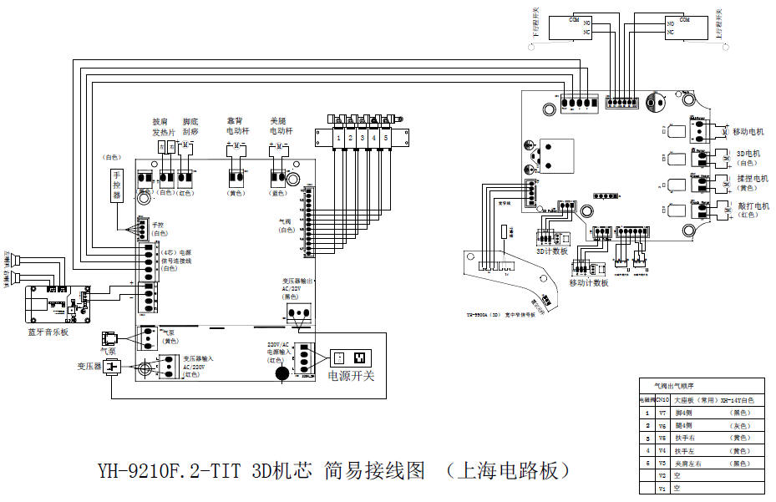

# 4．按摩椅电机 Massage chair motors

Titan Pro Ace II / Commander total 7 motors

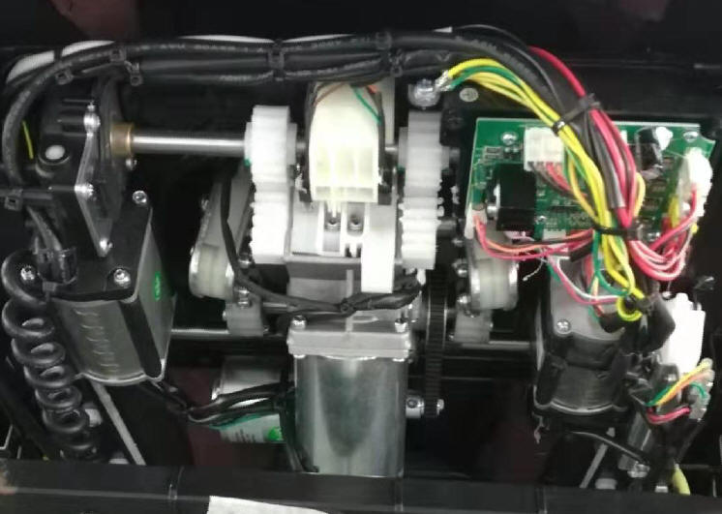

4)3D Motor

2)Moving motor

1)Kneadingmotor

3)Tapping motor

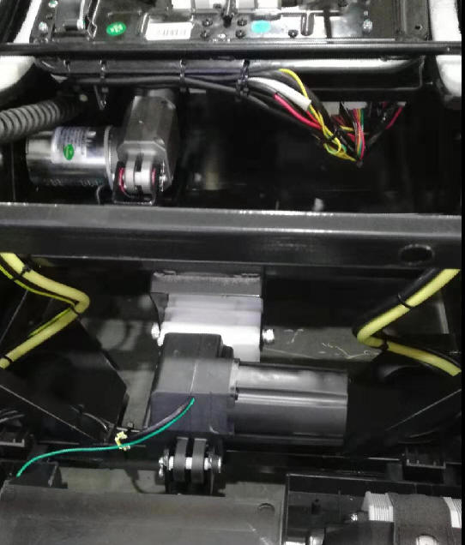

⑥footrest actuator

⑤Backrest actuator

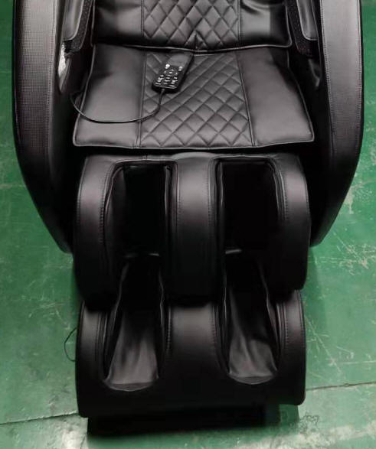

⑦Foot roller motor

**Name of each part**

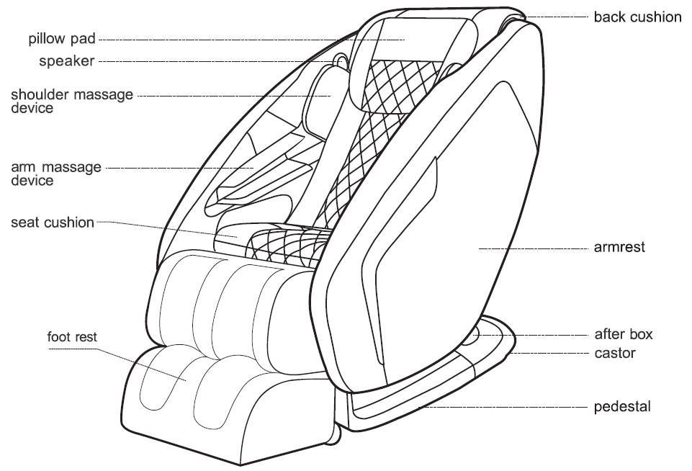

**Remote controller**

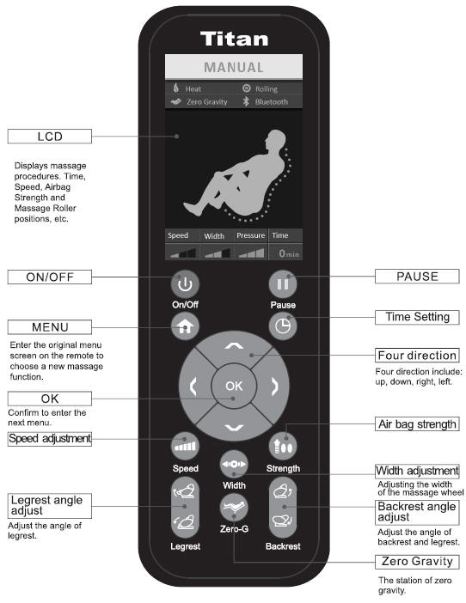

# 5．气压按摩 Air massage

1. 夹肩左右 Shoulder air-Left &right
2. 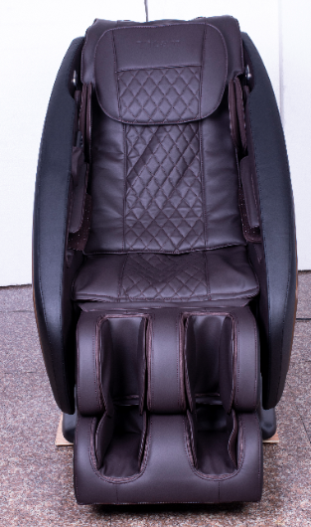扶手右 Arm air -right

③扶手左 Arm air-left

④小腿四侧 Calves air -4 sides

⑤小腿四侧 Foot air-4 sides

# 6．气压气路图解 Air valve diagram

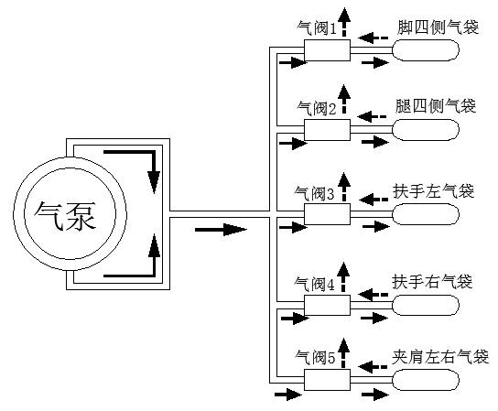

Foot 4 sides

Air valve1

Calves 4 sides

Air valve2

Air valve3

Right arm

Left arm

Air pump 1

Air valve5

Air valve4

Shoulder air left & right

# 7．按摩椅故障检测表 Massage chair trouble lists

**“A” board= Massage mechanism PCB**

**“B” board= Bottom box PCB (Main board)**

|  |  |  |  |
| --- | --- | --- | --- |
| Phenomenon | Fault area | Cause | Maintenance steps and methods |
| The whole machine can't work | 1. fuse  2. switch  3. Transformer plug  4. Hand control plug  5.” B” board (Bottom box PCB) | 1. Fuse bad  2. Power switch is broken  3. Transformer plug, hand control plug are not plugged in or off  4. “B” board damaged | 更换B板  否  是  是  是否正常工作？  否  重新插拔变压器插头  完成  变压器是否有20v输出  亮  更换保险丝或重插电源  不亮  电源开关灯亮  打开电源开关  整机不能工作 |
| The hand controller does not work or cannot be displayed | 1. Hand controller  2. Hand control plug  3. “A” board (Mechanism PCB) | 1. The hand controller is damaged  2. The hand controller plug is not plugged in  3. “A” board damaged | 否  是  是  是  更换手控器或重新插手控器  按键是否可以操作  更换A板  完成  更换手控  是否显示人形符号  否  是否发出嘀嘀声  打开电源开关  手控器不能工作或不能显示 |
| Turn on the power massage chair and start the massage | 1．”A” board (Mechanism PCB) | 1．”A” board broken | Change “A” Board (mechanism PCB) |
| Air pump does not work | 1. air pump  2. B board  3. Air pump cable | 1. Air pump is broken  2. B board damage  3. The air pump cable is not plugged in. | 否  是  否  是  更换气泵  否  重新插好后气泵能工作？  更换B板  用万用表测量气泵阻值是否在550Ω左右  完成  气泵不能工作  检查气泵接线是否插好 |
| Mobile motor does not work | 1. A board  2. Moving motor  3. Mobile motor connection cable | 1. A board damage  2. Mobile motor damage  3. The mobile motor connection is broken or the plug is not connected. | 是  否  否  是  否  是  更换电机  完成  更换A板  检查电机连线及插头是否完好  更换电机连线  测量A板电机插头是否有24V  电机是否正常运转  用手控按机芯上下键  移动电机不能工作 |
| Kneading motor does not work | 1. A board  2. Kneading motor  3. Kneading motor cable connection | 1. A board damage  2. Kneading motor damage  3. Kneading motor connection is broken or the plug is not connected | 是  否  否  是  否  是  更换电机  完成  更换A板  检查电机连线及插头是否完好  更换电机连线  测量A板电机插头是否有24V  电机是否正常运转  用手控开启揉捏功能  揉捏电机不能工作 |
| Tapping motor does not work | 1. A board  2. Tapping motor  3. Tapping motor cable connection | 1. A board damage  2. Tapping motor damage  3. Tapping motor connection is broken or the plug is not connected | 是  否  否  是  否  是  更换电机  完成  更换A板  检查电机连线及插头是否完好  更换电机连线  测量A板电机插头是否有24V  电机是否正常运转  用手控开启捶打功能  捶打电机不能工作 |
| Foot roller does not work | 1．Foot roller motor  2. B board  3．Foot roller motor wire connection | 1．Foot roller motor is broken  2．B board is broken  3．Foot roller motor wire connection loose | 否  是  是  否  否  是  完成  更换B板  更换滚轮电机  重新插好后能工作？  检查滚轮线是否插好  按“滚轮”键时B板是否有24V输出  美腿滚轮不工作 |
| Backrest electric push rod does not work | 1．Backrest actuator  2．B board  3. Actuator connection wire | 1．Actuator is broken  2．B board is broken  3．Actuator connection wire is loose | 否  是  是  否  否  是  完成  更换B板  更换电动推杆  重新插好后能工作？  检查推杆线是否插好  按椅背“起倒”键时B板是否有24V输出  靠背电动推杆不工作 |
| Air pressure massage does not work or abnormal | 1．气管  2．电磁阀  3．B板 | 1．气管折死  2．电磁阀损坏  3．B板损坏 | 是  是  否  否  否  否  是  是  是  否  先检查气泵是否工作  按气泵不工作方法检修  更换B板  完成  重插电磁阀插头  更换电磁阀是否正常工作  整理气管工作正常了吗？  检查电阀插头是否松动  检查气管是否折死  气压按摩异常 |

# 8．更换零部件注意事项Replacement parts notes

## 8.1更换A板注意事项Precautions for Replacing the “A” Board (Massage mechanism PCB)

1）关闭电源开关并拔掉电源插头 Turn off the power switch and unplug the power plug

2）拆后盖: 拆后盖时要先拆下面的螺钉 Remove the backrest rear cover: Remove the screws below when removing the back cover

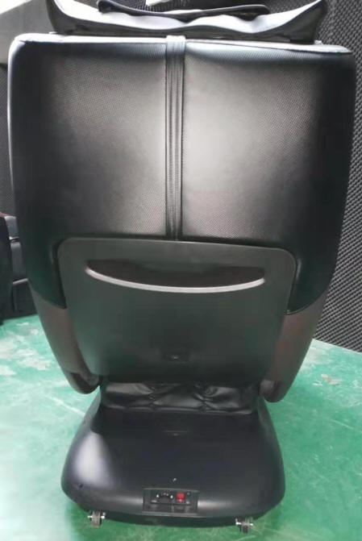

Remove the four screws. Remove the two screws below first.

3）拆后效果 After removing backrest rear cover picture

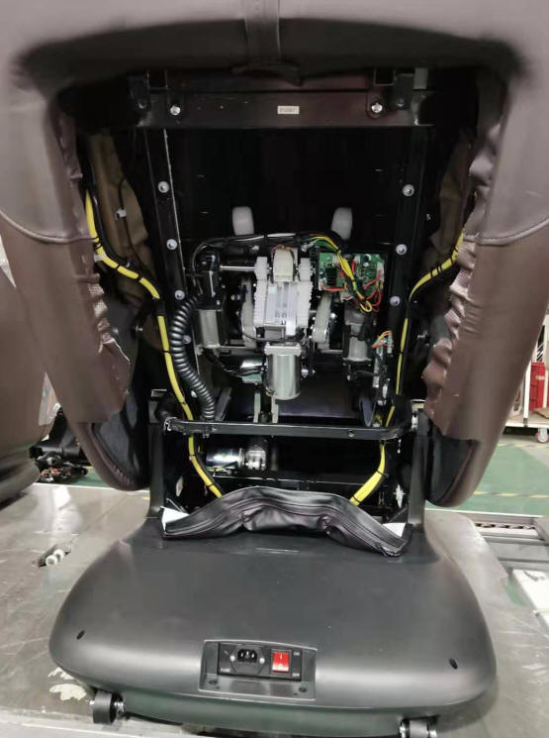

The mechanism PCB box is located on the Mechanism

4）拆电路板盒上盖。Remove the mechanism PCB box

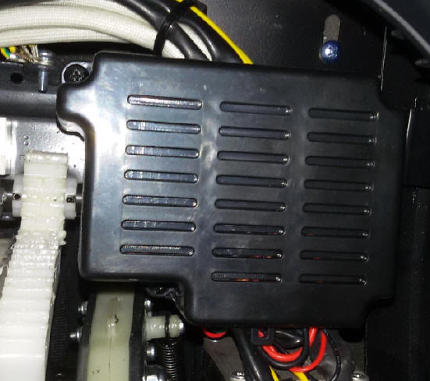

Remove the 4 screws

5）拔下所有电路板插线。Unplug all board strips.

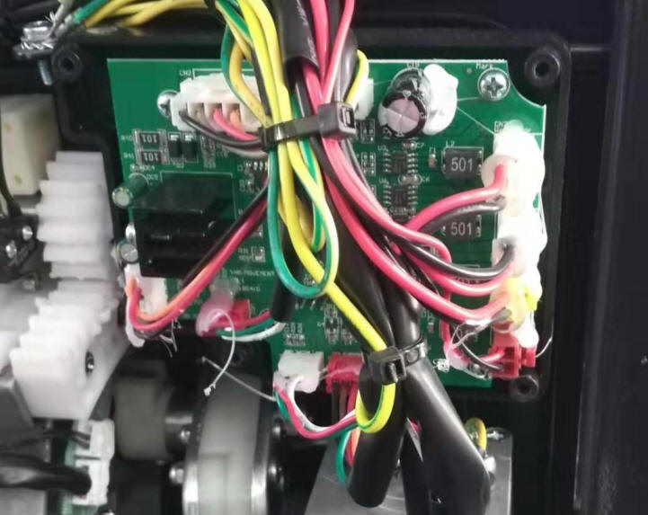

Power signal cable

Moving up/down limit sensor

**Note: When replacing the PCB, please take a photo to record the position of each connectors in case mistake**

Moving motor

3D motor

Width signal board sensor

Kneading motor

Tapping motor

3D limit sensor

Moving up/down counting sensor

3D counting sensor

6）更换新的电路板。Replace the new mechanism PCB.

7）插上电源，开机试一下各个功能是否正常。Power on the chair and try to check if the functions are good.

8）各功能正常后盖上电路板盒和后盖。Close the mechanism PCB box and the backrest rear cover.

## 8.2更换B板注意事项 Precautions for Replacing the “B” Board（Bottom box PCB/Main board）

1）关闭电源开关并拔掉电源插头Turn off the power switch and unplug the power plug

2）拆尾箱上盖 Remove the top cover of power box

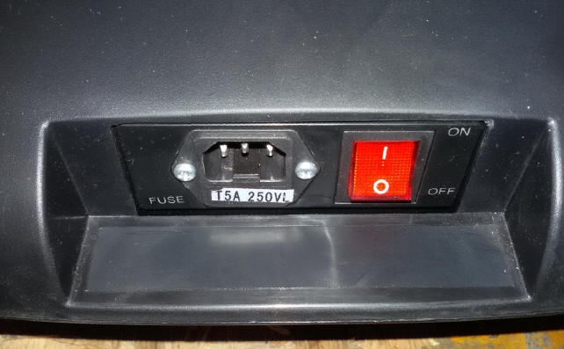

Remove the label and see 2 screws

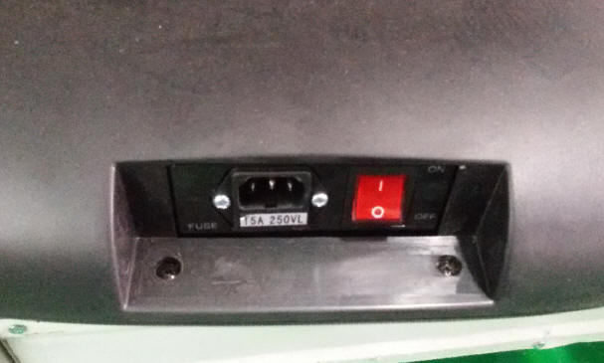

Remove the 2 screws

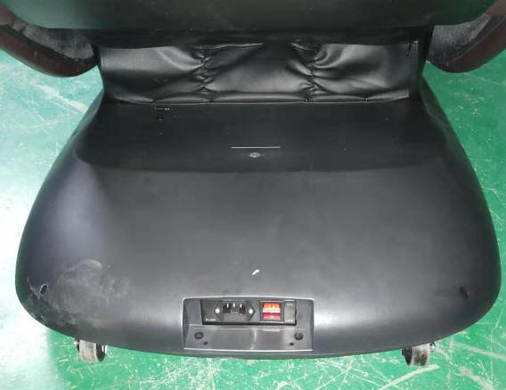

Remove the 6 screws and take off the power box

3）尾箱内部图 Power box inside picture

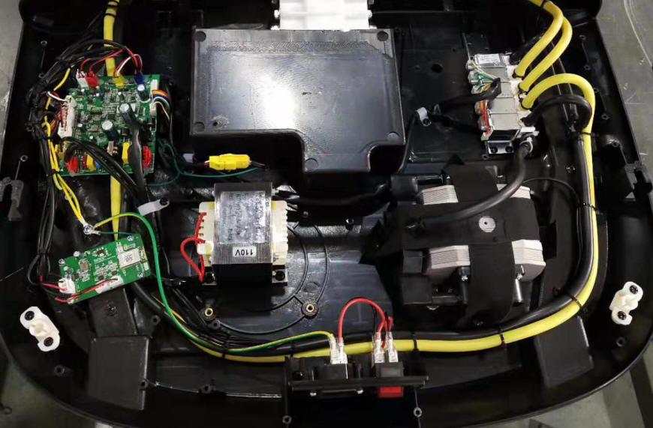

4）拔掉所有连线，拆B板固定螺钉。Unplug all the cables and remove the screws.

Backrest actuator

Footrest actuator

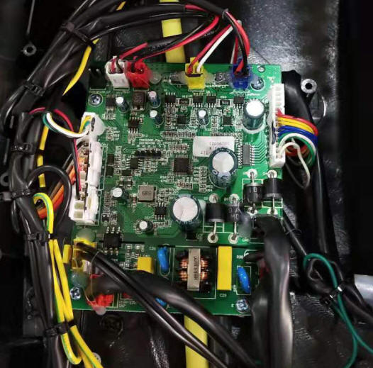

Foot roller

Lumbar heating

Remote

Air valve

**Note: Please take a photo to record the connector’s position before disassemble in case mistake.**

Power signal

Transformer

AC21V/19V

Output

Air pump

Transformer

110V input

AC110V

Input

## 8.3更换手控注意事项 Precaution for remote control replacement

1）掀起手控后背标签，拆下标签下两个螺钉。Remove the back cover sticker and disassemble the two screws.

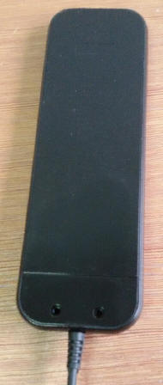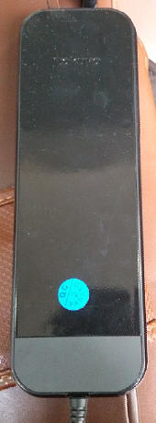

Remove the two screws and open the remote cover.

Label

2）拆手控电路板。Disassemble the remote PCB

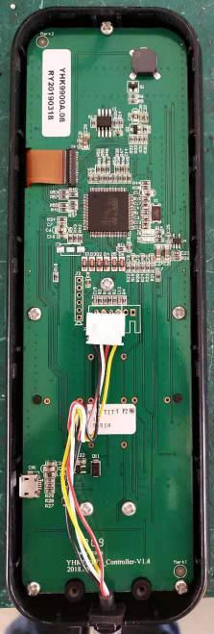

Disassemble the 8 screws.

## 8.4更换气泵注意事项 Precaution for air pump replacement

1）先拆尾箱上盖，方法与更换B板时拆尾箱盖方法一样。Disassemble the power box cover-same steps as above 8.2.2

2）拆气泵固定铁片。Disassemble the 8 screws (4 screws for each pump).

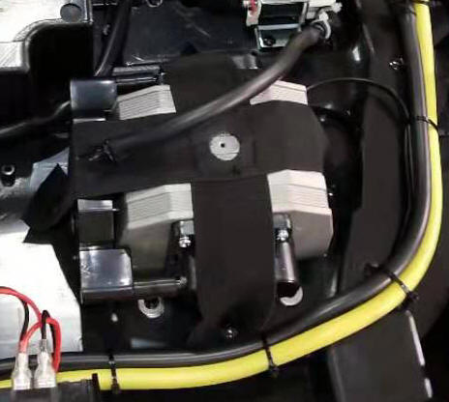

Disassemble the 8 screws to take out the air pump.

3）拆气管及连线插头 Disassemble the air pipes.



Cut off the cable ties and pull out the air pipes.



Air pump connector

4）更换新气泵，以上动作需要确认是否拔掉电源线！必须在无电的情形下操作。

Replace new air pump. All above operation must be done without electricity, please make sure the power cord is disconnected.

## 8.5更换变压器注意事项 Precaution for transformer replacement

1）关闭电源，按下图拆掉固定螺钉。Turn off the power. Disassemble the screws as below picture.

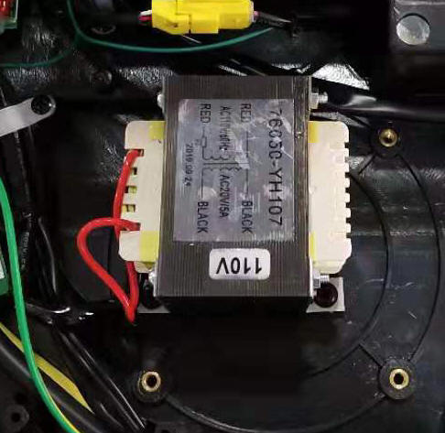

4 screws are here. Please pay attention the transformer input is 110V before reassemble.

2）更换变压器时注意输入与输出不能插反。Please pay attention to the Input and output ports. They can’t be connected in reverse.



Transformer output port in Black.

Transformer input port in red.

## 8.6更换气阀注意事项 Precaution for air valve replacement

1）更换气阀注意气管顺序不能乱。The air pipes order must not be wrong.

2）气阀位于尾箱内 Air valve located inside power box

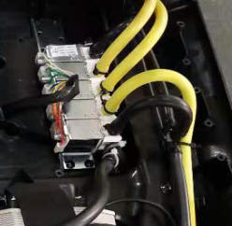

Foot air

Calves air

Right arm air

Left arm air

Shoulder air

## 8.7拆后盖方法 Precaution for backrest rear cover disassemble

1）拆后盖时要先拆下面的螺钉 Disassemble the 4 screws on the backrest rear cover.



Disassemble the 4 screws. Please disassemble the two at below first.

3）拆后效果 Backrest rear cover disassembled picture



## 8.8更换靠背、美腿电动推杆注意事项 Precautions for backrest actuator and footrest actuator.

1）确认是否拔掉电源线，必须在无电的情形下进行以下操作。Please make sure the power cord is disconnected. All operations must be without electricity.

2）拆尾箱盖，方法同更换主板时一样。Disassemble the power box cover, same as 8.2.2

3）拔掉推杆对插线和接地线。Disconnect the backrest actuator wire and grounding wire.



Disconnect backrest actuator wire.

Disconnect the grounding wire.

4）拆下推杆插梢及靠背架的两个固定螺丝。Disconnect the bolt and two screws.

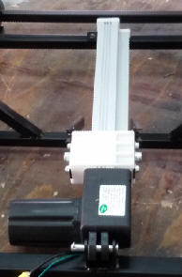

Two screws on backrest frame

Remove the clip pin and pull out the bolt.

5）缷下旧电动推杆。Remove the old backrest actuator

更换时必须有一个人协助扶住按摩靠背，避免因拆除旧推杆后靠背失去支撑使整个靠背架向后或者向前倾斜！

   ATTN:  When remove the backrest actuator, the other person should hold up the backrest in case of the backrest fall down due to the backrest lose support

6）在确保按摩椅靠背有人稳定扶着情形下，先拆座垫下销轴，换上新电动推杆再重新装回销轴及卡销。

Under the condition that someone is holding the back of massage chair stably, then remove the bolt under the seat frame first, replace the new actuators and reinstall the bolt and clip pin.

7）将电动推杆插头插到B板上，插好后注意先不要盖上尾箱盖，先通电检查是否正常，确认无误后再拔掉电源线，扎好线束，再盖上尾箱。

Connect the actuator wire to main PCBA [corresponding](javascript:;) sockets, power on the chair, and check if the function is good or not. Then use cable tie to fasten the cables and close the power box.

8）更换美腿电动推杆 Footrest actuator replacement

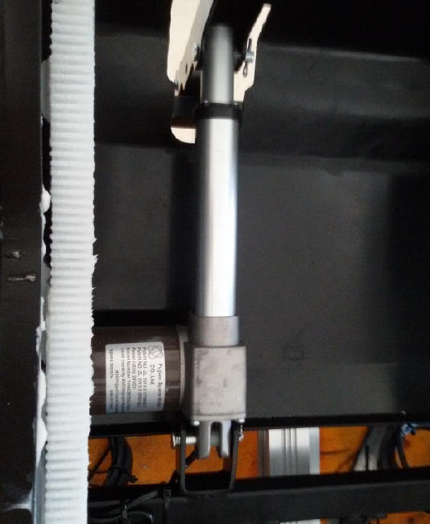

Remove the clip pin and bolt. Replace the new footrest actuator

Footrest actuator



Footrest actuator connector on main board

## 8.9更换美腿注意事项 Legrest (Footrest )replacement precautions

1）缷下美腿固定片。Unzip the cover between the footrest and seat, then disassemble the two screws on both sides of footrest

2）拔下气管及对插线插头。Disconnect the air pipes and wire connection.

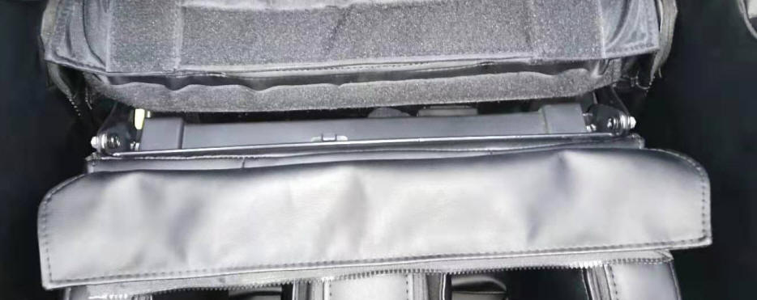

Open the zipper of seat cushion and remove the two screws.

Use [cross](javascript:;) [screwdriver](javascript:;) and [wrench](javascript:;) to disassemble the screw.

3）更换新的美腿。Replace the new footrest (legrest)

## 8.10维修用的工具包 REPAIR KIT

|  |  |  |
| --- | --- | --- |
| Tool name | Specification | Note |
| [Cross](javascript:;) [screwdriver](javascript:;) | 6*150 | Use for disassemble or assemble screws |
| [Cross](javascript:;) [screwdriver](javascript:;) | 5*100 | Use for disassemble or assemble screws |
| [Cross](javascript:;) [screwdriver](javascript:;) | 6*38 | Use for disassemble or assemble side panel cover screws or armrest screws |
| [Cross](javascript:;) [screwdriver](javascript:;) | 2.5*100 | Use for disassemble or assemble screws of speakers and  solenoid valve |
| Slotted screwdriver | 8*150 | Use for disassemble or assemble screws |
| Diagonal pliers | 6’’ | Use to cut cable tie |
| Long nose pliers | 6’’ | Use to disassemble or assemble the snap spring |
| Wrench | 5.5*7 | Use to fix or disassemble M4 Nylon nuts. |
| Adjustable wrench | 4’’ | Use to disassemble the tapping motor screw |
| [Electric](javascript:;) [soldering](javascript:;) [iron](javascript:;) | 50W | Soldering different kinds of bunch |
| Allen wrench | 3mm | Disassemble or assemble M4 [hexagonal](javascript:;) [socket](javascript:;) [nut](javascript:;) &screw |
| Steel ruler | 200mm | Measuring the balance between the belt and the pulley |
| Multimeter |  | Measure the voltage |
| [Slip-joint](javascript:;) [pliers](javascript:;) |  | Disassemble or assemble the snap spring and fasten cable tie. |
| [Scissor](javascript:;) |  | Cut packing belt |

## 8.11工具清单 Tool lists

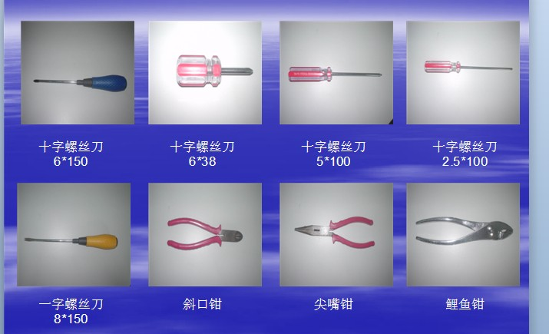

[Cross](javascript:;) [screwdriver](javascript:;)

Slotted screwdriver Diagonal pliers Long nose pliers [Slip-joint](javascript:;) [pliers](javascript:;)

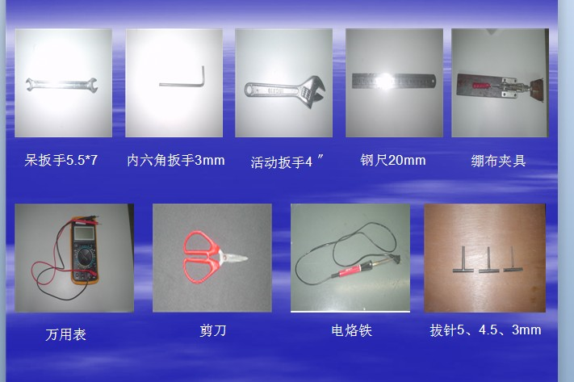

Multimeter [Scissor](javascript:;)  [Electric](javascript:;) [soldering](javascript:;) [iron](javascript:;)  N/A

Wrench Allen wrench Adjustable Wrench Steel ruler N/A