**3D Massage chair RUN test program**

1. Turn off the power and turn on the power

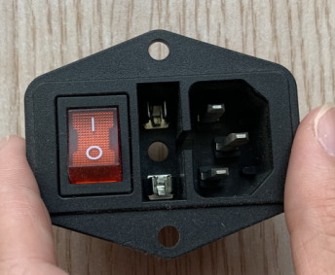

1. Press controller button : UP→DOWN→LEFT→RIGHT→OK→ON/OFF

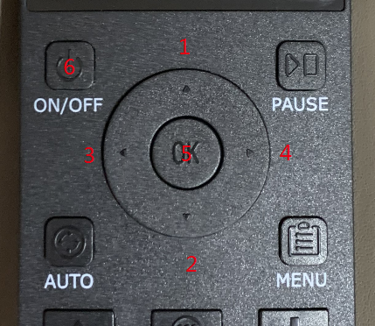

1. SCREEN SHOW.

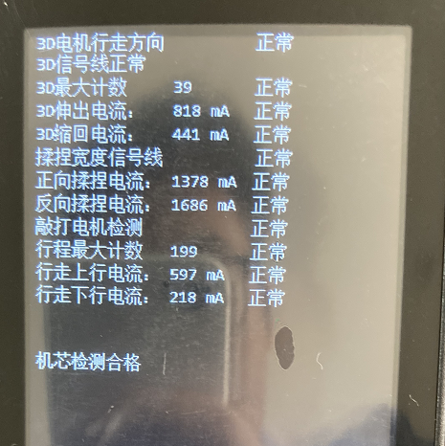

3D机芯检测程序

3D movement detection procedures

测试准备中 。。。

In test preparation...

1）3D电机行走方向 正常/错误

The direction of 3D motor normal/Wrong

显示错误：关闭电源重新检测一次如还是报错，检查行走电机端子是否接触完好，如还不能解决可能需更换机芯板

If Wrong: Turn off the power and test again. If the error is still reported, check whether the terminals of the walking motor are well connected. If the problem cannot be solved, the mechanism board may need to be replaced

2）3D信号检测 正常/故障

3D signal detection normal/Wrong

显示错误：重复检查一次如还是报错，检查推出电机和信号线端子是否接触完好，拔掉重新插一次，如还不能解决可能需更换信号检测组件

If Wrong: Repeat the check once if the error is still reported, check whether the connection between the motor and the signal line terminal is intact, unplug and re-plug it once, if the problem cannot be solved, the signal detection component may need to be replaced

3）3D推出计数检测 正常/故障

3D roll out count detects normal/Wrong

显示错误：重复检查一次如还是报错，检查推出电机和计数线端子是否接触完好，拔掉重新插一次，如还不能解决需更换计数检测组件

If Wrong: Repeat the check once if the error is still reported, check whether the connection between the push-out motor and the terminal of the counting line is intact, unplug and re-plug it once, if it cannot be solved, the counting detection component needs to be replaced

4）3D电机推出电流检测 正常/偏高/偏低

3D Motor introduces current detection Normal/Higher/Lower

显示错误：重复检查一次，如故障仍在，如提示偏低，可能是由于电机组件长时间工作会有磨损，实际工作电流有可能会低于出厂时设定的电流值故会报错，如推出电机可正常工作无异常噪音，可忽略该项。 如提示偏高，先检查推出

If Wrong: check again. If the fault is still present, or if the prompt is low, it may be because the motor assembly will be worn for a long time, and the actual working current may be lower than the current value set at the factory, so the error will be reported. If the motor can work normally without abnormal noise, this item can be ignored.If the prompt is high, check and push out first

5）3D电机缩回电流检测 正常/偏高/偏低

3D motor retraction current detection Normal/Higher/Lower

显示错误：重复检查一次，如故障仍在，如提示偏低，可能是由于电机组件长时间工作会有磨损，实际工作电流有可能会低于出厂时设定的电流值故会报错，如推出电机可正常工作无异常噪音，可忽略该相。 如提示偏高，先检查推出曲臂是否为空载有无障碍物，如均无，且推出电机声音很大，则有可能为电机故障。

If Wrong: Repeat check again,If the fault is still present, or if the prompt is low, it may be because the motor assembly will wear and tear after long time working, and the actual working current may be lower than the current value set at the factory, so the error will be reported. If the motor can work normally without abnormal noise, the phase can be ignored.If the prompt is on the high side, first check whether the push-out arm is empty with or without obstacles. If no, and the push-out motor is loud, it may be the motor fault.

1. 正向揉捏电流检测 正常/偏高/偏低

Forward kneading current detection Normal/Higher/Lower

显示错误：重复检查一次，如故障仍在，如提示偏低，可能是由于电机组件长时间工作会有磨损，实际工作电流有可能会低于出厂时设定的电流值故会报错，如揉捏电机可正常工作无异常噪音，可忽略该相。 如提示偏高，先检查揉捏曲臂是否为空载有无障碍物，如均无，且揉捏电机声音很大，则有可能为电机故障。

If Wrong: Repeat check again, if the fault is still there, if the prompt is low, it may be because the motor components will be worn for a long time, and the actual working current may be lower than the current value set at the factory, so the error will be reported. If the kneading motor can work normally without abnormal noise, the phase can be ignored.If the prompt is on the high side, first check whether the kneading arm is empty with or without obstacles. If there is no, and the kneading motor is very loud, it may be a motor fault.

1. 反向揉捏电流检测 正常/偏高/偏低

Reverse kneading current detection Normal/Higher/Lower

显示错误：重复检查一次，如故障仍在，如提示偏低，可能是由于电机组件长时间工作会有磨损，实际工作电流有可能会低于出厂时设定的电流值故会报错，如揉捏电机可正常工作无异常噪音，可忽略该相。 如提示偏高，先检查揉捏曲臂是否为空载有无障碍物，如均无，且揉捏电机声音很大，则有可能为电机故障。

If Wrong: Repeat check again, if the fault is still there, if the prompt is low, it may be because the motor components will be worn for a long time, and the actual working current may be lower than the current value set at the factory, so the error will be reported. If the kneading motor can work normally without abnormal noise, the phase can be ignored. If the prompt is on the high side, first check whether the kneading arm is empty with or without obstacles. If there is no, and the kneading motor is very loud, it may be a motor fault.

1. 宽度定位信号 正常/故障

Width positioning signal normal/Wrong

显示错误：重复检查一次，如故障仍在，检查宽度信号线是否接触完好，拔掉重插一次，如故障仍在，需更换宽度定位信号板

If Wrong: Repeat check again, if the fault is still present, check whether the width signal wire is in good contact, unplug and replug once, if the fault is still present, need to replace the width positioning signal board

1. 敲打电流检测 正常/故障

Knock current detection normal/Wrong

显示错误：重复检查一次，如故障仍在，如提示偏低，可能是由于电机组件长时间工作会有磨损，实际工作电流有可能会低于出厂时设定的电流值故会报错，如敲打电机可正常工作无异常噪音，可忽略该相。 如提示偏高，先检查敲打曲臂是否为空载有无障碍物，如均无，且敲打电机声音很大，则有可能为电机故障。

If Wrong: Repeat check again,If the fault is still present, or if the prompt is low, it may be because the motor assembly will wear and tear after long time work, and the actual working current may be lower than the current value set at the factory, so the error will be reported. If the knocking motor can work normally without abnormal noise, this phase can be ignored.If the prompt is on the high side, first check whether the knocking arm is empty with or without obstacles. If no, and the knocking motor is loud, it may be the motor fault.

1. 行走上行电流检测 正常/故障

Walking up current detection normal/Wrong

显示错误：重复检查一次，如故障仍在，如提示偏低，可能是由于电机组件长时间工作会有磨损，实际工作电流有可能会低于出厂时设定的电流值故会报错，如行走电机可正常工作无异常噪音，可忽略该相。 如提示偏高，先检查行走组件是否为空载有无障碍物，如均无，且行走电机声音很大，则有可能为电机故障。

If Wrong: Repeat check again,If the fault is still present, or if the prompt is low, it may be because the motor assembly will be worn for a long time, and the actual working current may be lower than the current value set at the factory, so the error will be reported. If the walking motor can work normally without abnormal noise, this phase can be ignored.If the prompt is high, first check whether the walking component is empty and there is no obstacle. If there is no, and the noise of the walking motor is very loud, it may be the motor failure.

1. 行走上行限位开关检测 正常/故障

Detect the uplink limit switch when walking normal/Wrong

显示错误：重复检查一次，如故障仍在，检查下开关线速是否完好，拔掉重新插，故障仍在，检查下两个开关是否完好，且均能很好的接触挡片。

If Wrong: Repeat check again. If the fault is still present, check whether the line speed of the switch is intact. Unplug and replug the switch.

1. 行走下行电流检测 正常/故障

Walking downlink current detection normal/Wrong

显示错误：重复检查一次，如故障仍在，如提示偏低，可能是由于电机组件长时间工作会有磨损，实际工作电流有可能会低于出厂时设定的电流值故会报错，如行走电机可正常工作无异常噪音，可忽略该相。 如提示偏高，先检查行走组件是否为空载有无障碍物，如均无，且行走电机声音很大，则有可能为电机故障。

If Wrong: Repeat check again. If the fault is still present, or if the prompt is low, it may be because the motor assembly will be worn for a long time, and the actual working current may be lower than the current value set at the factory, so the error will be reported. If the walking motor can work normally without abnormal noise, this phase can be ignored.If the prompt is high, first check whether the walking component is empty and there is no obstacle. If there is no, and the noise of the walking motor is very loud, it may be the motor failure.

1. 行走下行限位开关检测 正常/故障

Limit switch detection when walking down normal/Wrong

显示错误：重复检查一次，如故障仍在，检查下开关线速是否完好，拔掉重新插，故障仍在，检查下两个开关是否完好，且均能很好的接触挡片。

If Wrong: Repeat check again.If the fault is still present, check whether the line speed of the switch is intact. Unplug and replug the switch.

1. 行程计数信号 正常/故障

Stroke count signal normal/Wrong

显示错误：重复检查一次如还是报错，检查推出电机和计数线端子是否接触完好，拔掉重新插一次，如还不能解决需更换计数检测组件

If Wrong: Repeat the check once if the error is still reported, check whether the contact between the push-out motor and the terminal of the counting line is intact, unplug and re-plug it once, if it cannot be solved, the counting detection component needs to be replaced

1. 最大行程计数 xxx

Maximum stroke count xxx

机芯检测 合格/异常

Movement detection Good/abnormal