**Atlas XL RK8906**

Maintenance instruction

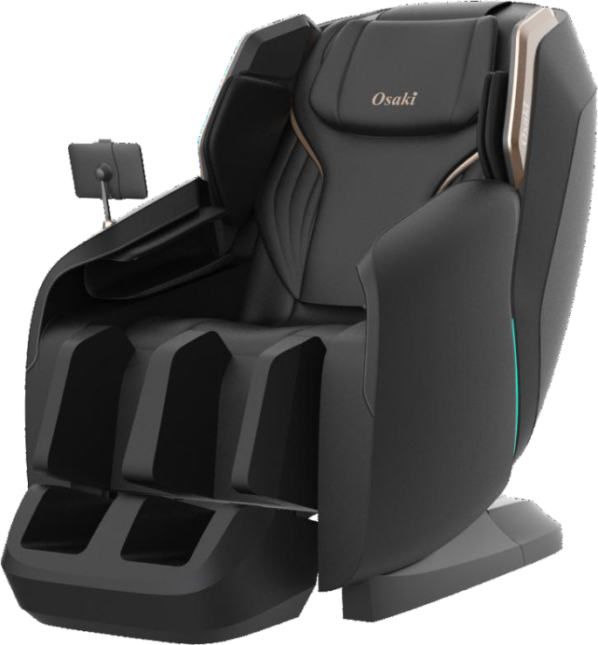

|  |  |  |  |  |  |  |  |
| --- | --- | --- | --- | --- | --- | --- | --- |
| Design: |  | Review: |  | Countersign: |  | Approval: |  |
|  | |  | |  | |  | |

Shandong kangtai intelligence science and technology co., ltd

Thank you for choosing to use Rong Kang massage chair!

It is our greatest honor that you can become a user of Shandong Kangtai Intelligent Technology Co., Ltd.. I sincerely hope that Rong Kang massage chair can be a good helper for your leisure and health care.

In order to make it easier for dealers and customer service personnel to maintain the products on site, some common problems and fault solutions in the use of massage chairs are summarized for professional maintenance personnel to refer to.

**Note: Non-professionals, please do not try.**

|  |  |  |
| --- | --- | --- |
| After-sales Service Center Tel: | (86)400 | -6582511 |
|  | (86)0535 | -8243907 |
|  | (86)0535 | -8243916 |

[http://www.kangtaigroup.com](http://www.kangtaigroup.com/)

Shandong kangtai intelligence science and technology co., ltd

**Catalogue**

**One----Product components** 1

1. RK8906 structure diagram 1

2.Introduction to key components 3

**Two----Common faults and solutions** 5

1.The whole machine of the massage chair does not work, and the

hand control does not display 6

2.The massage machine, the strut, the solenoid valve don’t move,

but the hand control is displayed 7

3.Abnormal lifting of massage machine 8

4.The massage machine kneading abnormally 11

5.Abnormal tapping of massage machine 12

6.The massage machine leans forward abnormally 13

7.The whole machine is uninflated or a certain way is uninflated

15

8.Abnormal back pole movement 16

9.Abnormal leg pole movement 17

10.The feet rollers don’t work 19

11.Foot heating cloths don’t work 19

12.The waist heating cloth don’t work 20

13.Bluetooth music abnormal 20

14.Charging abnormal 21

15.The LED strip light abnormal 22

**Three----Mechanical failures and solutions** 22

1.Replace the massage machine 22

2.Dismantle the shoulder assembly part of the armrest 24

3.Remove the legs and feet 30

4.Replace the circuit board, air pump, and transformer of the whole machine 35

5.Replace the electric struts 36

**Four----Layout diagram of the components of the main circuit**

**board**............................................................................... .........38

**Five----System connection diagram**...........................................39

# One----Product components:

# RK8906 structure diagram

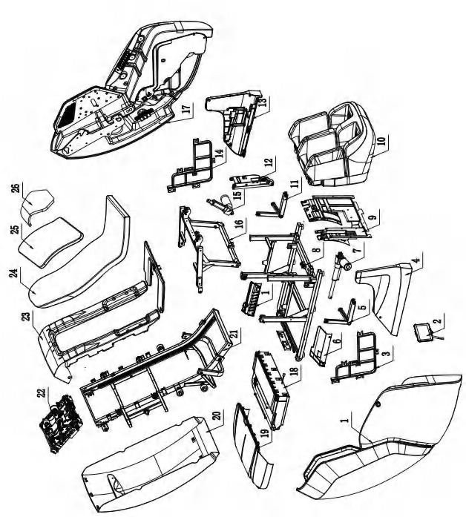

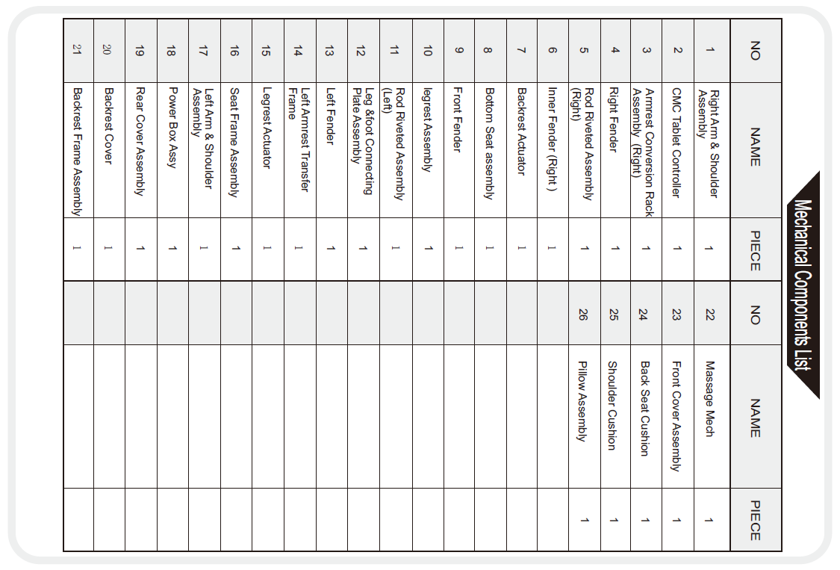

# Introduction of key components

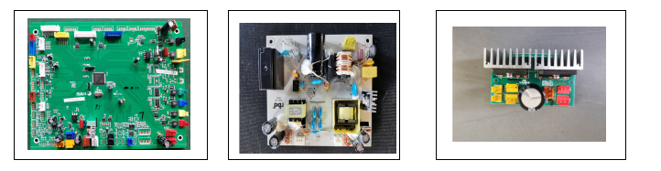 Main circuit board power panel Rectifier plate

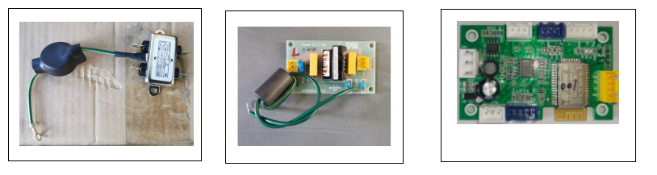

filter Filter plate Bluetooth board

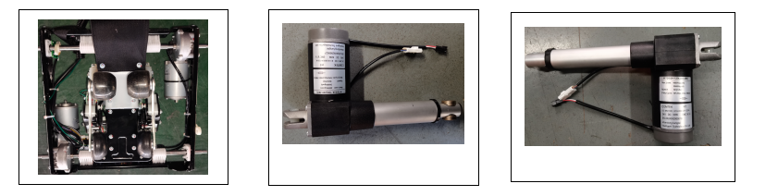

Massage machine assembly Leg brace Back brace

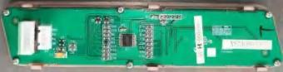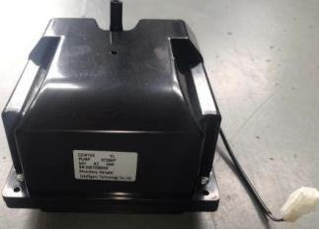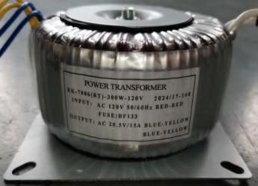

Ring transformer air pump Simple manual control panel assembly

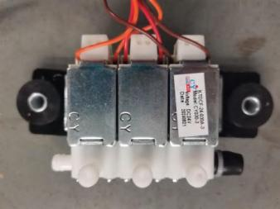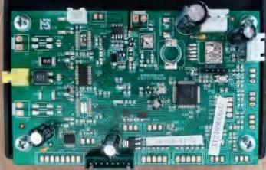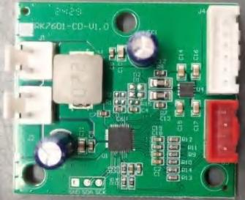

Leg board Charging plate Three-valve solenoid valve

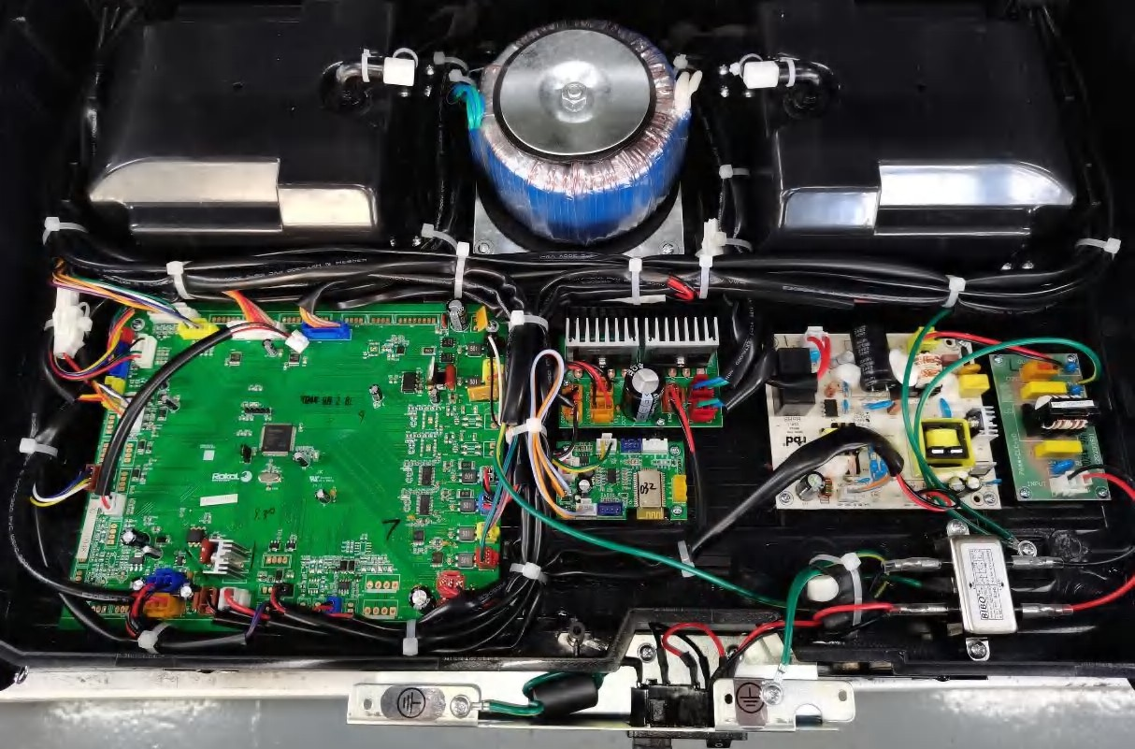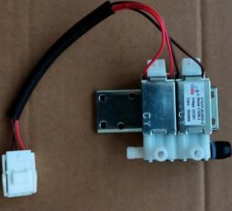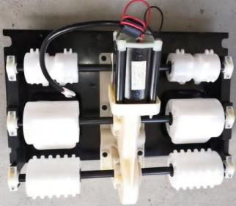

Roller assembly Two-valve solenoid valve Power box assembly

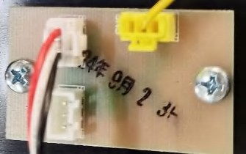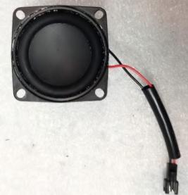

Horn assembly Anti-pinch circuit board assembly

# Second----Common faults and solutions

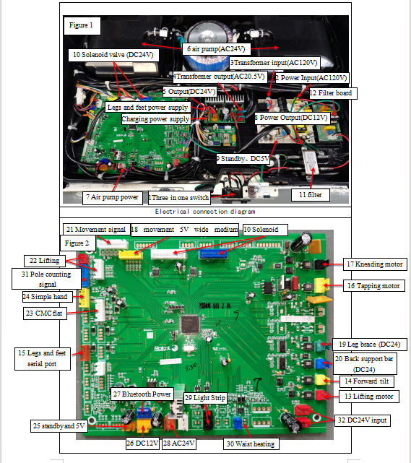

**Electrical connection diagram of leg and leg circuit board**

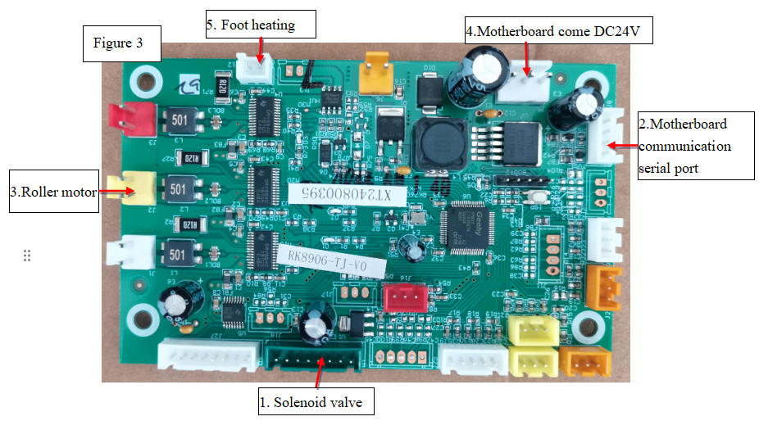

# The massage chair does not work, and the hand controller does not display.

* 1. First, check that there is electricity in the socket. Turn on the switch of the 3-in-1 switch base, and judge whether the fuse of the 1-in-1 switch in Figure 1 is blown. If the fuse is blown, it will be normal after replacement.
  2. Measure the voltage at the power input (AC120V) of the second power supply with an AC voltage range of a multimeter. If the voltage is abnormal, check whether the 11 filter and the 12 filter board are faulty, whether the wiring harness is connected and whether the connector is connected normally. If it is abnormal, replace the corresponding wiring harness. Measure whether the input and output voltages are AC120V V. If it is abnormal, replace it.
  3. Use the multimeter DC voltage range to measure whether the voltage at 25 standby and DC5V(DC5V) is normal. If there is no voltage, check whether the connecting wire between the power board and the motherboard is in good contact. If there is no problem, it should be that the power board is broken and normal after replacement. If 5V is normal, power on and measure whether the standby (white and orange lines) voltage is high (DC5V). If it doesn't change all the time, the motherboard is broken and can be replaced;
  4. Measure 3 transformer input (AC120V) and 4 transformer output with multimeter AC voltage range.(AC20.5V) Two voltages, if 3 voltages are normal and 4 voltages are not, the ring transformer is broken, and it is normal after replacement. Otherwise, replace the power board.
  5. Flat panel does not display. Use a multimeter to measure the DC voltage range, and check whether there is DC5V voltage at both ends of the motherboard 23CMC flat connector. If there is, check whether the docking connector is securely connected and whether the wiring harness is on and off normally. If it is abnormal, replace the extension cord of the flat hand control cord. Otherwise, replace the motherboard.
  6. The simple hand controller does not display and does not work. Measure whether there is DC5V voltage at both ends of the connector of simple hand controller with a multimeter DC voltage range. If there is, replace the assembly of simple hand controller. Check whether the wiring harness between the simple hand controllers on the main board 24 and the connectors are normal. If it is abnormal, replace the corresponding harness assembly. Otherwise, replace the motherboard.

# Massage machine, stay bar and solenoid valve do not act, and

# the hand controller displays.

* 1. Use the multimeter DC voltage range to measure whether the voltage at the DC24V input of the motherboard 32 is normal; if there is no voltage, measure whether the output connector (3.96-3) of the rectifier board 5 has about DC24V output; if so, replace the wiring harness;
  2. If there is no voltage output, measure the transformer output (AC20.5V) with AC equivalent. If there is voltage, the rectifier board is broken and normal after replacement.
  3. Use a multimeter to measure the DC voltage range, and measure the voltages of pins 4, 5 and 6 of the motherboard 23CMC flat panel, pins 2, 3 and 4 of the 24 simple hand controller, and pins 2, 3 and 4 of the simple hand controller board, respectively. If the voltage is kept low or the power is cut off to measure the short circuit, the corresponding port is broken, and the replacement circuit board is normal.

# Abnormal lifting of massage machine

* 1. When the massage machine works in the up-down state, the massage machine does not move up and down;
     1. Turn on the manual control of the tablet hand controller to make the massage machine run the whole process, and use the multimeter DC Measure whether there is voltage output (about DC24V) at 13 connectors on the motherboard in Figure 2. If there is no voltage, the motherboard is bad and normal after replacement.
     2. If the voltage is normal, unplug the connector and use the multimeter buzzer to measure the connection and disconnection of the blue and green wires between the motherboard and the black three-core 450B connector of the lifting motor, and check whether the docking connector is firm, whether the terminals are detached and in good contact. If all connections are normal, it means that the lifting motor is broken and the lifting motor or movement needs to be replaced. If the two wires are not connected, it is necessary to replace the harness assembly of the corresponding massage machine motor;
     3. To judge whether the lifting motor is damaged, put the multimeter in the resistance range, and measure whether the resistance at both ends of the lifting motor connector is 5-30Ω. If it is not, it will be damaged if the resistance is too large.
  2. 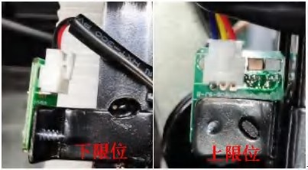When the massage machine works in the up-down state, if there is a phenomenon of top rushing or bottom rushing (over the limit); The up-down limit signal of the lifting motor is faulty.

Low Limit

Up Limit

* + 1. Check the connector of 22 lifting limit in Figure 2 on the motherboard.Whether the connector on the lower limit board falls off and whether the connector terminal falls off, as shown in the above figure.
    2. Measure whether there is DC5V at both ends of the connector shown in the figure on the right. If it is normal, check whether there is any high-low level change in the lifting limit Hall element (use magnetic steel to approach or leave the Hall element, and measure pins 2 and 3 of the upper limit or lower limit connector). If there is no level change in pins 2 and 3, replace the lifting limit plate.
    3. Unplug the connector at 22 in Figure 2, and measure the connection and disconnection of the wiring harness between the main board and the upper and lower limit boards with the buzzer of multimeter. If they are all connected, it means that the main board is broken and can be replaced. If not, replace the lifting limit harness.
  1. If the massage machine does not work in a certain area of the shoulder or back, the massage machine runs.Whole journey; Then the signal at the 21 up-down count of the motherboard in Figure 2 is faulty.
     1. First, measure the wiring harness from the motherboard to the movement adapter board with a multimeter in DC range, and the voltage of DC12V between the red and black wires is normal. Slowly rotate the shaft of the lifting motor by hand, and measure whether there is high or low voltage change between the brown wire 1 and pin 8 of the connector of the motherboard 21. If there is voltage change, replace the motherboard.
     2. If there is no voltage change, unplug the connector, and measure whether the wiring harness between the brown wire of the motherboard and the adapter plate of the movement, the wiring harness between the adapter plate and the lifting motor is normal, whether the connector is firmly connected, whether the terminal is detached, and replace the corresponding wiring harness assembly if it is abnormal.
     3. Check whether the red and black lines from the adapter plate to the lifting motor are normal, and replace them if abnormal. Otherwise, replace the lifting motor count.

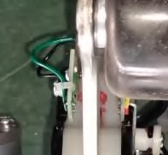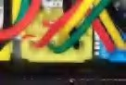

* 1. Boot into a program, the massage machine starts to detect the shoulder height. If the massage machine directly stops at the upper limit or at the back, it means that the shoulder height detection is faulty. As shown on the right.

3.4.1 Measure the voltage between pins 2 and 4 of the yellow connector of the adapter board with a multimeter in DC range. Press and release the rocker arm (with detection element) by hand to measure the voltage.Whether there is high or low level change. If there is no high-low level change, replace the shoulder detection harness assembly.

3.4.2 Unplug the signal connector of the mainboard 21, and measure it with the buzzer of the multimeter. The mainboard 21 Whether there is continuity between the yellow line of the middle 2 foot shoulder height detection and the green line of the shoulder height detection harness, whether the connector is firmly inserted, and whether the terminal is out. Replace the corresponding harness if it is abnormal. Otherwise, replace the motherboard.

# The massage machine is kneading abnormally.

* 1. The massage machine has no kneading action.
     1. Turn on the manual control of the tablet and let the massage machine give kneading instructions. Measure whether there is a voltage output of about DC9-20V at the terminal of the connector at the kneading motor of the main board 17 with a multimeter DC voltage range. If there is no voltage output, the main board is broken and can be replaced.
     2. If there is voltage output, check whether the docking connector of the kneading motor harness at 17 places is firm, whether the terminal is detached and the contact is good. If it is normal, unplug the connector and measure the connection and disconnection of the white and black wires at the main board connector 17 to both ends of the black two-core 396 connector of the adapter board with the buzzer of the multimeter. If they are all connected, it means that the kneading motor is broken and needs to be replaced. If it doesn't work, you need to replace the motor harness assembly of the massage machine; The method for judging whether the kneading motor is damaged is the same as that in 3.1.3 for judging the lifting motor.
  2. As soon as the massage chair is turned on, the kneading function will run. If it can't be turned off through tablet operation, the motherboard will be broken and replaced.

# Abnormal tapping of massage machine.

* 1. The massage machine has no tapping action.
     1. Turn on the manual control of the tablet and let the massage machine tap. Use the DC voltage range of the multimeter to measure whether the voltage at both ends of the connector at the tapping motor of the motherboard 16 has a voltage output of about DC9-20V. If there is no voltage, the motherboard is broken and normal after replacement.
     2. If the motherboard voltage is normal, check whether the docking connector from the motherboard to the rapping motor is secure, whether the terminal is detached and in good contact. If it is normal, unplug the connector, and measure the connection and disconnection of the yellow and red wires from the main board connector 16 to the adapter board's yellow two-core 396 connector with a multimeter buzzer. If they are all connected, it means that the rapping motor is broken and needs to be replaced. If the two wires are not connected, it needs to be replaced. The method of judging whether the rapping motor is damaged is the same as that of 3.1.3 for judging the lifting motor.

5.2 As soon as the massage chair is turned on, the tapping function will run. If it can't be turned off through tablet operation, the motherboard is broken and can be replaced.

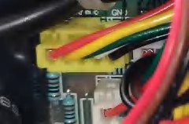5.3 Open the flat plate to make it work in the tapping state. If the width, middle and narrow can't be selected or wrong, the signal of the movement is faulty. As shown on the right.

5.3.1 Measured with a multimeter DC voltage range, the adapter plate is yellow.Is there any height between the yellow, green and white wires and the black wire of the 5-hole connector?If the voltage changes, if there is no change, the kneading counting assembly is broken and the counting assembly or movement is replaced.

5.3.2 Unplug the wide, medium and narrow connectors at 18 places on the main board, and use the multimeter buzzer to measure whether the green, white and blue wires are connected to the adapter board normally, whether the connectors are firmly connected and whether the terminals are detached. If it is abnormal, replace the corresponding massage machine signal harness. Otherwise, replace the motherboard.

# The massage machine leans forward abnormally.

* 1. The massage machine leans forward without action. Turn on the manual control of the tablet and let the massage machine forward.
     1. Put the multimeter in the DC voltage range, and measure whether the voltage output at both ends of the connector at the forward motor of the motherboard 14 is normal. If there is no voltage, the motherboard is bad, and it is normal after replacement.Depend, whether the terminals are in good contact. Then use the buzzer of multimeter to measure the connection and disconnection of the black three-core 450B connector from the brown and purple wires on the motherboard 14 to the wiring harness of the forward tilting motor. If they are all connected, it means that the forward tilting motor is damaged and the forward tilting motor or movement needs to be replaced. If it doesn't work, you need to replace the corresponding massage machine motor harness assembly; The method of judging whether the forward tilting motor is damaged is the same as that of the previous one.

3.1.3 Judgment method of lifting motor.

* 1. The massage machine does not lean forward in place. Explain the forward count fault.
     1. Slowly rotate the shaft of the forward tilting motor by hand, and measure the connection of the main board 21 with a multimeter in DC range.Whether there is high or low voltage change between the 3-pin and 8-pin, if there is voltage change, replace the motherboard.
     2. If there is no voltage change, unplug the connector, and use the multimeter buzzer to measure the connection and disconnection of the wiring harness between the motherboard powder wire and the movement adapter, whether the connector is firmly connected and whether the terminal is detached. If it is abnormal, replace the corresponding massage machine signal wiring harness assembly. Otherwise, replace the lifting motor count.
  2. Lean forward to top or bottom.
     1. Put the multimeter in the DC voltage range, use the magnet to approach and leave the Hall element, and measure whether the voltage output between the connector 4, pin 5 and pin 8 at the signal position of the main board 21 is normal. If there is voltage, the main board is broken and normal after replacement.
     2. If there is no voltage, check whether the wiring harness between the connector 4 orange and 5 purple wires of the motherboard 21 and the wiring harness between the adapter plate and the forward limit plate is on or off, whether the connector is firmly connected and whether the terminal is out. If it is abnormal, replace the corresponding massage machine signal wiring harness assembly or 3D limit wiring harness assembly. Otherwise, replace the 3D limit plate assembly.

# The whole machine is not inflated or one way is not inflated.

* 1. If the whole machine is not inflated, use the multimeter AC voltage range after starting, and measure whether the connector at 7 places on the motherboard has about AC24V voltage. If the connector falls off, check whether there is any problem with the wiring harness. If it is normal, the air pump is broken, and replace the air pump. If there is no voltage output and the voltage at 28AC24V is normal, the motherboard is broken and can be replaced.
  2. Check whether the trachea has fallen off, blocked, broken, poorly inserted, damaged and leaked;
  3. If a certain road is not inflated.
     1. Use a multimeter DC voltage range to measure whether there is a DC24V voltage output at the corresponding port. If there is no output, the corresponding motherboard is broken and can be replaced.
     2. Or shut down, use the multimeter buzzer to measure whether the wiring harness between the main board or leg board and the solenoid valve is abnormal, whether the connector is firmly connected, and replace it if it is abnormal. Ohm with multimeter.Measure the resistance of the corresponding solenoid valve (the resistance of the solenoid valve is 210 10%). If there is no resistance or the resistance is too large or too small, the solenoid valve is broken and can be replaced.
     3. Check whether the trachea between the solenoid valve and the airbag is broken, detached or damaged;
  4. If the inflation is weak. Check whether the trachea, solenoid valve and airbag are blocked, leaked or damaged.
  5. 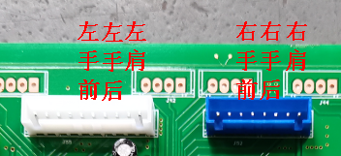When the leg solenoid valve does not work, in addition to checking the DC24V and output, check the motherboard.Whether the wiring harness between the 15-leg serial port and the 2-leg serial port is normal, whether the connector is firmly connected, and whether the terminal is out; Replace the corresponding harness if it is abnormal. Check whether there is any abnormality in the wiring harness of the solenoid valve, and replace it if it is abnormal.The correspond ports of that solenoid valve are as follow: handrail part:

FrontRightHand BackRightHand LeftShoulder

FrontLeftHandBackLeftHand LeftShoulder

Leg and foot parts:

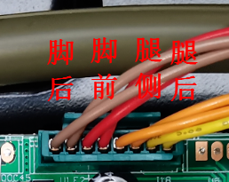

3

4

2

1

1.Back feet

2.Front feet

3.Side leg

4. Back leg

# Abnormal action of back brace

* 1. The electric strut does not move.
     1. Put the multimeter in DC voltage range, insert two probes into the blue connector terminal at the 20-back brace, and operate the backrest lifting button of the flat hand controller to observe whether the multimeter has DC24V output. If there is no voltage, the motherboard is broken and normal after replacement.
     2. Check whether the wiring harness from 20 places to the brace butt connector is plugged in, whether the terminal is out, check whether the wiring harness is on or off, and replace the corresponding wiring harness assembly if it is disconnected. Unplug the brace butt connector, and check the resistance between the two wires of the brace. If the brace is at the upper and lower limit, it is good to conduct it in one direction by diode, positive and negative tests. In other positions, it is normal to conduct it in 3-20Ω. Other conditions prove that the electric brace motor is broken, so replace the electric brace.
  2. The electric stay cannot stop at the initial massage position.
     1. Put the multimeter in the DC voltage range, insert two probes between the green and gray wires of the connector at the counting signal of 31 strut, and operate the lifting button of the backrest of the flat hand controller to observe whether the multimeter has high and low level output. If there is high and low level, the motherboard is broken and normal after replacement.
     2. Check whether the wiring harness between the struts is on and off and whether the connectors are connected securely. If it is normal, the struts are broken, and it is normal after replacement. Otherwise, replace the corresponding harness assembly.

# Abnormal movement of leg brace

* 1. The electric strut does not move.
     1. Put the multimeter in DC voltage range, insert two probes into the terminal of the green connector at the 19-leg strut, and operate the backrest lifting button or leg lifting button of the tablet hand controller to observe whether the multimeter has DC24V output. If there is no voltage, the motherboard is broken and normal after replacement.
     2. Check whether the wiring harness from point 19 to the brace butt connector is plugged in, whether the terminal is out, check whether the wiring harness is on or off, and replace the corresponding wiring harness assembly if it is disconnected. Unplug the brace butt connector, and check the resistance between the two wires of the brace. If the brace is at the upper and lower limit, it is good to conduct it in one direction by measuring with diode, positive and negative tests, and in other positions, it is 3-20Ω. Other conditions prove that the electric brace motor is broken, so replace the electric brace.

9.2 The electric stay cannot stop at the initial massage position.

9.2.1 Put the multimeter in the DC voltage range, insert two probes between the yellow and black wires of the connector at the counting signal of the 31 strut, and operate the lifting button of the backrest of the flat hand controller to observe whether the multimeter has high and low level output. If there is high and low level, the motherboard is broken and normal after replacement.

9.2.2 Check whether the wiring harness between the struts is on and off and whether the connectors are connected securely. If it is normal, the struts are broken, and it is normal after replacement. Otherwise, replace the corresponding harness assembly.

**Electric strut interchange inspection:** when the faulty circuit board is not obviously burned, the legs and back struts are supplied.Electricity and signal (yellow and green) are exchanged at the same time, that is, the faulty strut is replaced with the normal strut circuit, and the strut function is normal. If the strut

is normal, the circuit board is broken. Otherwise, if the electric strut fails, it can be replaced.

# Foot roller does not work.

* 1. Turn on the function of the sole roller (air pressure at the legs and feet) and it won't work. Use the multimeter DC voltage range to measure whether there are DC24V and DC5V in the 4DC24V input and 2-leg board serial connector in Figure 3. If it is abnormal, check whether the connector docking and wiring harness connection between motherboards are normal. If it is abnormal, replace the docking wiring harness.
  2. Put the multimeter in the DC voltage range, and insert two probes into the terminals of the roller motor connector at three places in Figure 3. Is the output voltage normal? If there is no voltage, the legs and legs are broken. If there is voltage output, use a multimeter to measure whether the voltage at both ends of the red and black wires of the 450 connector at the other end of the harness is 24V. If there is no voltage, replace the harness assembly, otherwise the roller motor is broken, and replace it.

# Foot heating cloth does not work.

* 1. Turn on the foot heating function in the tablet. First press 10.1 to check whether there is any problem with the wiring harness between motherboards. Check whether the connectors between the heating cloths are firmly connected and whether the terminals are out.
  2. Measure whether the voltage at the heating point of 5 feet in Figure 3 is DC24V; If there is no voltage output,Then the leg and foot plates are damaged; If there is voltage output, use a multimeter to measure whether the plug-in of the heating wire pair has DC24V; if not, please replace the heating wire; If there is voltage, please replace the heating cloth.

# Waist heating cloth does not work.

* 1. Turn on the waist heating function in the flat panel. Check whether the connectors between the heating cloths are firmly connected and whether the terminals are out.
  2. Measure whether the voltage at the waist heating part of the motherboard 30 is DC24V; If there is no voltage output, the motherboard is damaged; If there is voltage output, use a multimeter to measure whether the DC head of the heating wire has DC24V; if not, replace the heating wire; If there is voltage, replace the heating cloth.

# Abnormal Bluetooth music

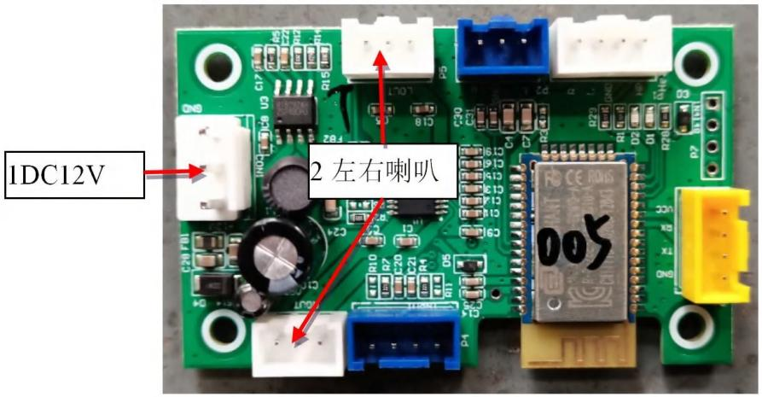

2 Right&left speaker

* 1. When the horn doesn't ring, measure the voltage at the motherboard connector 27, whether it is DC12V; If there is no voltage output, the motherboard is damaged;
  2. Check whether the Bluetooth board 1DC12VCON1 has DC12V voltage; if not, check whether the docking connector is firmly connected and whether the wiring harness is on or off normally; if not, replace the corresponding wiring harness; If there is voltage, the LED of Bluetooth board is on, and the mobile phone is connected to Bluetooth to play music. If it cannot be connected, replace the Bluetooth board.
  3. Use multimeter AC to measure whether the left and right speakers LOUT and ROUT of power amplifier board 2 have jumping voltage output; if not, replace the voice board; If there is voltage, replace the horn after checking that there is no problem with the connection and disconnection of the left and right horn harnesses.

# Abnormal charging

* 1. USB charging is abnormal. Plug in the phone

and don't charge it.

* + 1. Measure whether there is voltage output at the charging power supply of output 5 (DC24V) of the main board with a multimeter in DC range. If the rectifier board is not replaced.
    2. Unplug the connector and measure with the buzzer of multimeter, whether the wiring harness between the rectifier board and the charging board of the left armrest, the wiring harness between the charging board and the Type-C circuit board is normal, whether the connector is plugged in normally, and whether the terminal is out. If it is abnormal, replace the corresponding harness assembly.
    3. Measure with a multimeter in DC range, and the charging board 2DC5V outputs between each port and pin 6.Whether there is voltage output, if not, replace the charging board. Otherwise, replace the Type-C circuit board.

# LED strip anomaly

* 1. Handrail LED is abnormal
     1. Measure with the buzzer of multimeter whether the wiring harness between the lamp belt of the motherboard 29 and the left and right handrails is normal, whether the connector is firmly connected, and whether the terminal is out. If it is abnormal, replace the corresponding harness assembly.
     2. Turn it on. Use a multimeter to measure whether there is DC12V voltage at both ends of the 12LED strip connector of the left and right armrest circuit boards 12. If there is no voltage, replace the armrest circuit board.
     3. Use the multimeter DC voltage range to measure whether there is DC12V at both ends of the docking connector. If there is voltage, LED strip assembly.

# Three----mechanical failures and solutions:

# 1. Replace the massage machine

* 1. Dismantle the rear guard: as shown in the figure, screw 2 pieces of ST4.2*16 combination screws with a cross-groove screwdriver.Remove the nail, and then forcibly disengage the three buckle ball heads on the upper part of the rear cover, and lift the rear cover upward to remove the back cover.

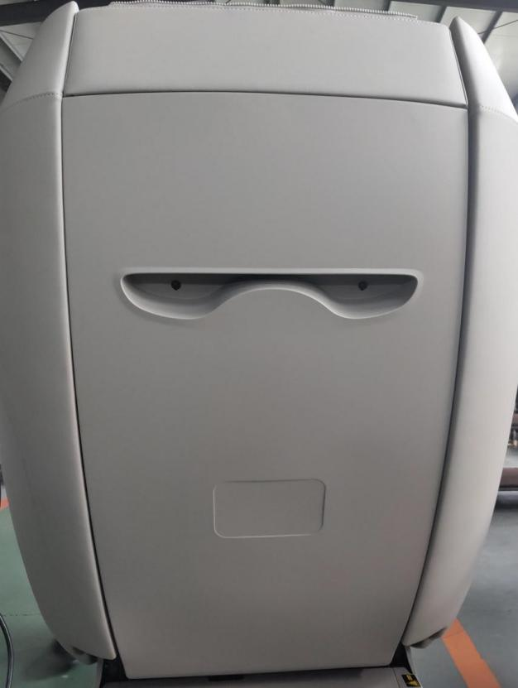

Remove 2 screws.

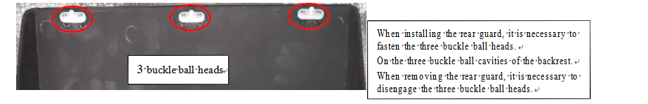

* 1. 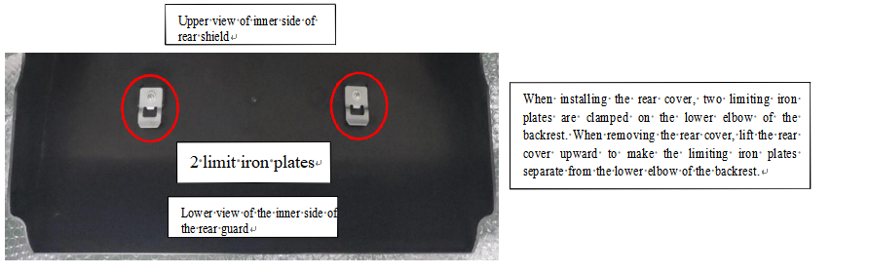Remove the backrest elbow: Remove the screw M6*35, nut M6 and flat washer that fix the backrest elbow, and then take down the backrest elbow.
  2. Dismantling the guide rail connector: Remove the three screws ST4*10 for fixing the left and right guide rail connectors, and then take down the guide rail connector.

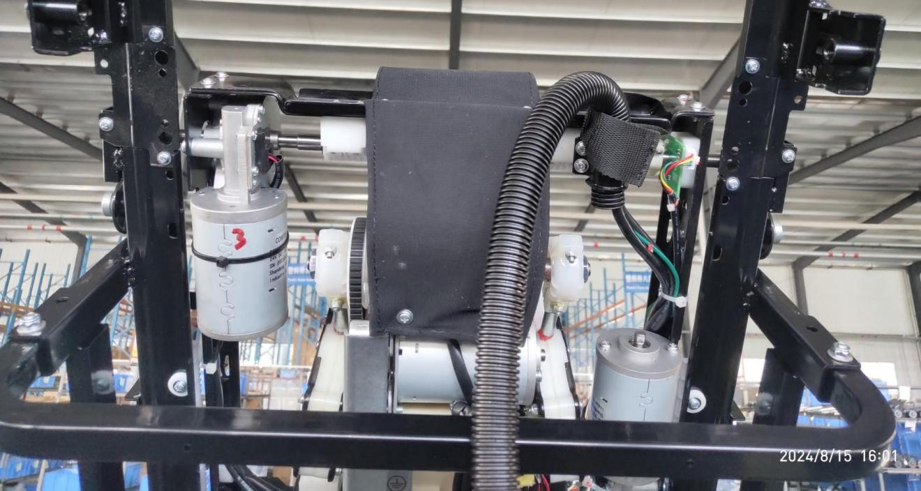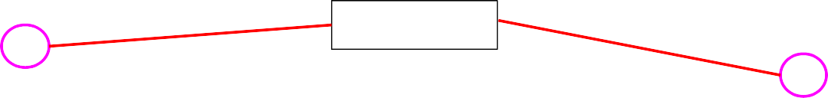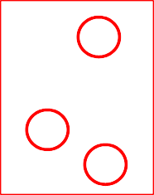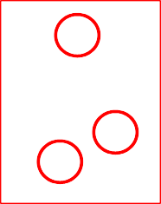

Remove 2 screws.

Upper backrest elbow

Lifting motor, just turn the shaft of lifting motor.

The massage machine rises to the position shown on the upper end of the backrest.

2 pieces of guide rail connectors

Remove 3 screws each.

* 1. Dismantle the massage machine: lift the massage machine to the upper end of the backrest, unplug the two connectors on the harness of the massage machine at the lower left side of the backrest, and remove the screw ST4*10 for fixing the ground wire. You can take down the massage machine and replace it.

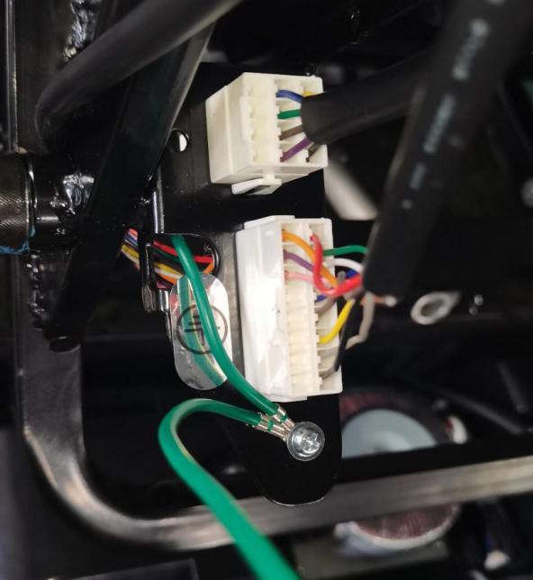

Unplug 2 connectors.

Remove the screw and toothed washer that secure the ground wire.

.

Note: when installing the massage machine, the tooth tips and roots of the lifting gears on the left and right sides should be completely symmetrical, with the tooth tips facing the tooth tips and the tooth roots facing the tooth roots.

**2. Disassemble the armrest shoulder assembly.**

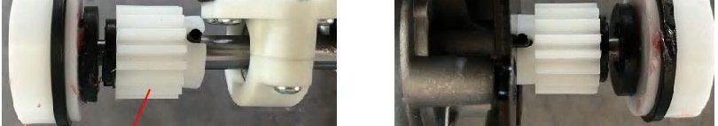

The lifting gears on both sides of the massage machine should be completely symmetrical.

# 2. Dismantle the handrail shoulder assembly.

* 1. Replace the armrest shoulder assembly.
     1. Dismantling the interior trim panel of the handrail: adjust the massage chair to zero gravity, remove the screw ST3.9*12.7 for fixing the interior trim panel of the handrail, and forcibly disengage the three ball cavities of the interior trim panel of the handrail to take down the interior trim panel of the handrail upwards.

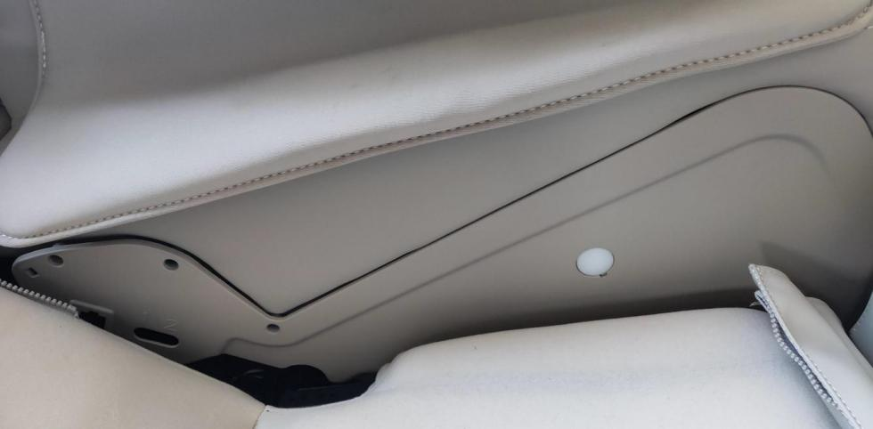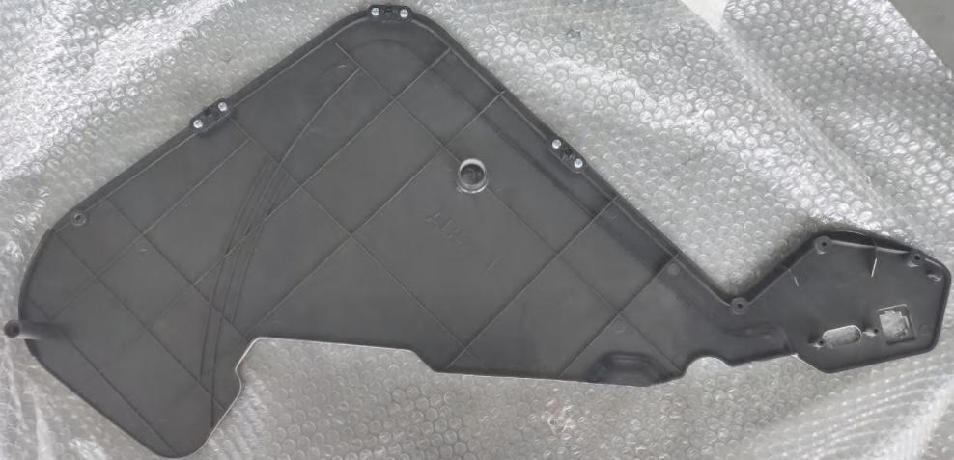

3 buckle ball cavities on the armrest interior trim panel.

And it should be disengaged when it is disassembled.

Remove the armrest interior

.

.

* + 1. Replace the handrail shoulder assembly: unplug the air pipe and connector, remove the mounting screw M6*16 and the flat washer with a hexagon wrench, and lift the handrail to remove the handrail shoulder assembly from the side.

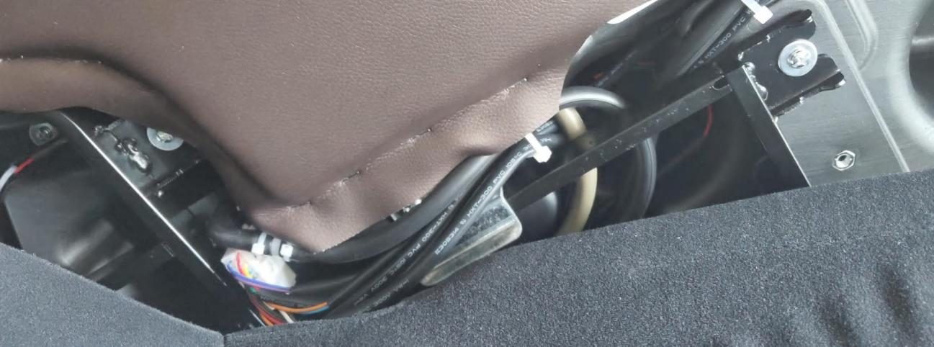

Remove mounting screws and flat washers.

Unplug the trachea and connector.

* 1. Replace the solenoid valve of the armrest shoulder.

First press 2.1.1 and 2.1.2 to remove the handrail shoulder.

* + 1. Unplug the air tube inserted on the solenoid valve (remove the strap that binds the air tube first). The purple air tube is the shoulder air bag air tube, the tan air tube is the rear air bag air tube of the armrest, and the black air tube is the front air bag air tube of the armrest. Then remove the tie strap that binds the solenoid valve harness and unplug the connector of the solenoid valve harness. Remove 2 screws ST4.8*25 and flat washer. Then remove the four screws ST3*10 that fix the solenoid valve to replace it.
  1. Replace the 18W fast charging module.

First press 2.1.1 and 2.1.2 to remove the handrail shoulder.

Unplug the wiring harness plugged on the 18W fast charging module, and remove the three fixing screws ST3.9*9.5 to replace it.

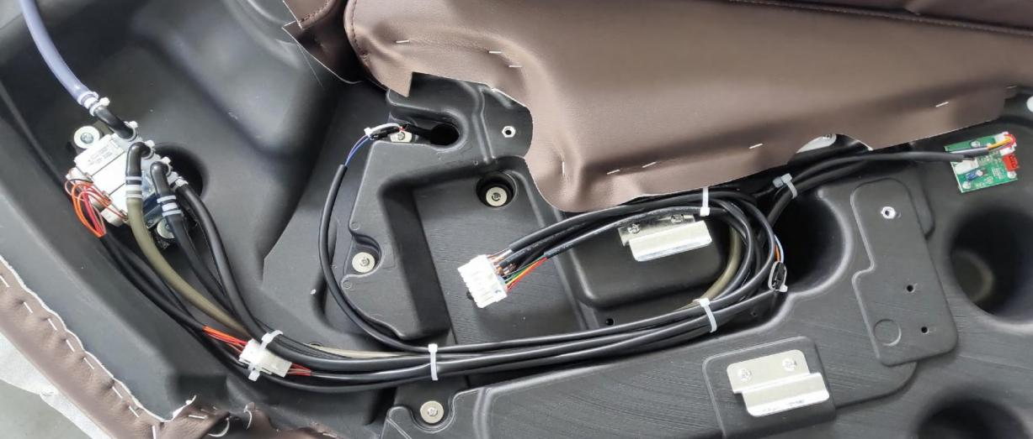

Remove the tie and unplug the connector.

18W fast charging module, remove 3 fixed screws,

Remove the air pipe and 2 screws, and pay attention to the insertion position of the air pipe.

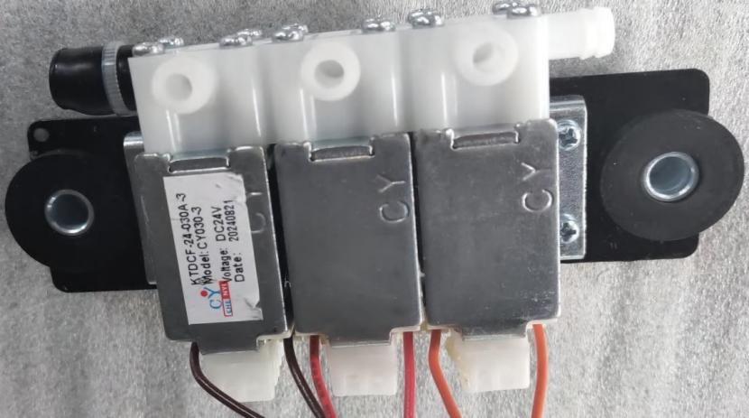

Remove the four screws.

* 1. Replace the simple hand controller of the left armrest: pry up the simple hand controller from two long sides,Unplug two connectors, and the simple hand controller can be replaced. The simple hand controller and the armrest plastic body are of snap structure.

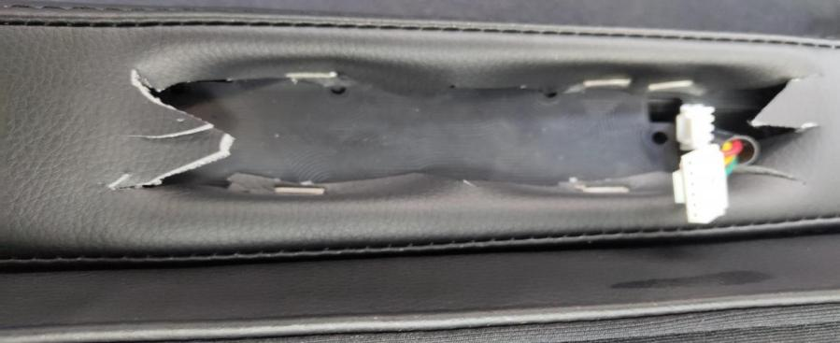

Unplug 2 connectors.

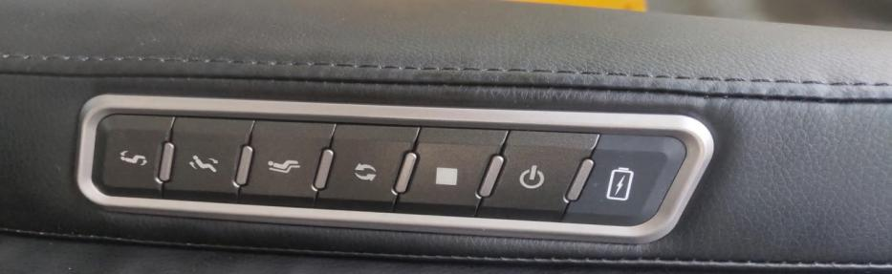

Simple hand controller

* 1. Replace the shoulder airbag: unzip the sewn products of the shoulder airbag to expose the airbag, remove the three combination screws of ST3.9*12.7 and the flat washer for fixing the airbag, and unplug the trachea of the shoulder airbag to replace the shoulder airbag.

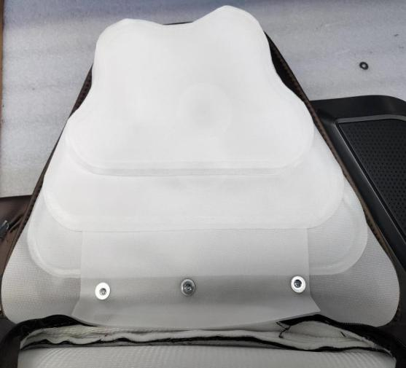

Remove the 3 screws that secure the airbag.

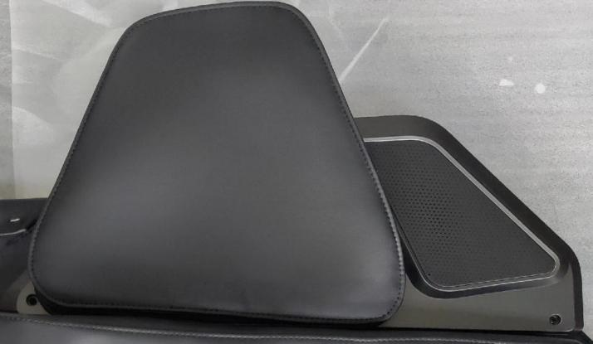

unzip

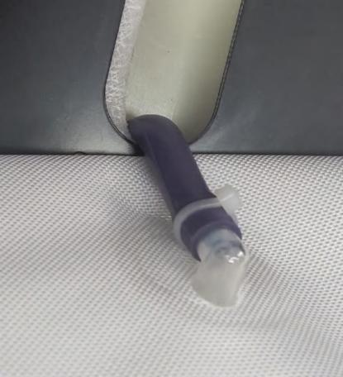

Remove the tie and pull off the air tube on the airbag.

* 1. Replace the shoulder horn

Remove the shoulder airbag according to step 2.5.

* + 1. Remove five combination screws of ST3.9*12.7 for fixing the airbag support plate, take down the airbag support plate and take down the sewn products.

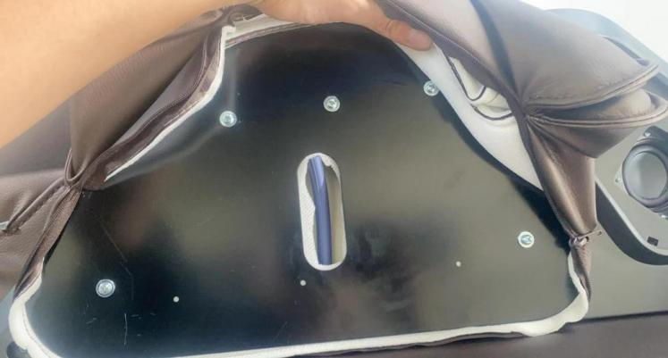

Airbag support plate, remove 5 screws.

* + 1. Remove the horn net, which is installed in a snap structure, and pry off the horn net.

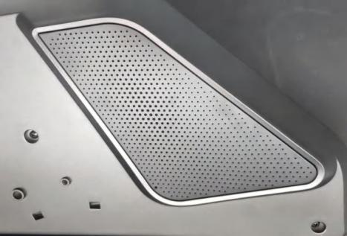

Horn network

* + 1. Remove the horn inner shell, remove the 12 screws ST3.9*9.5 that fix the horn inner shell, remove the tie strap that binds the horn wire harness, and unplug the connector to remove the horn inner shell.

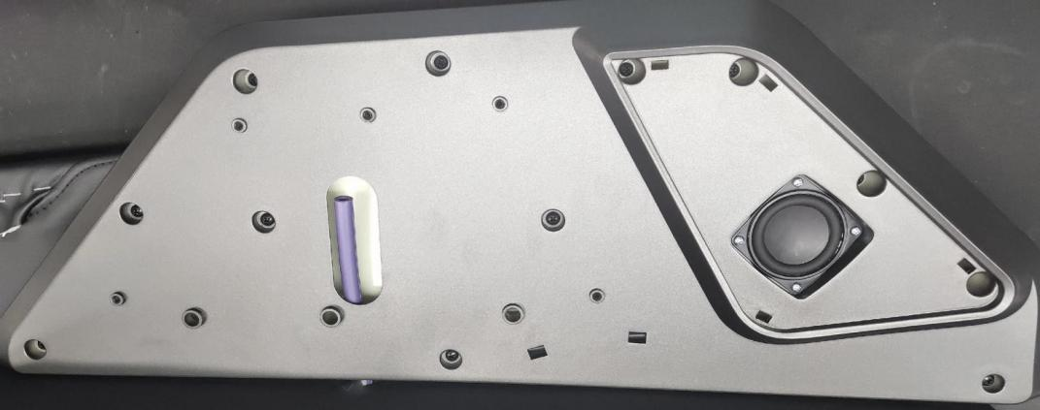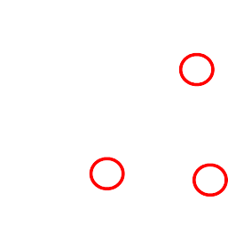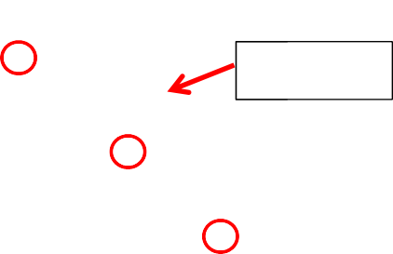

Horn inner shell

* + 1. To replace the horn, remove the four screws ST3*10 for fixing the horn, and pay attention to the position of the horn wire harness.

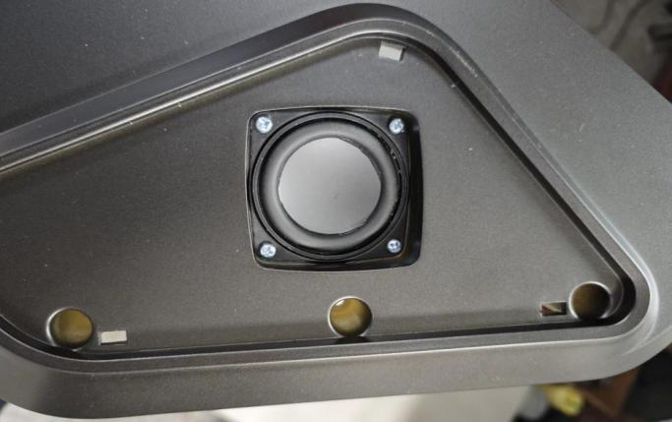

Remove the four screws.

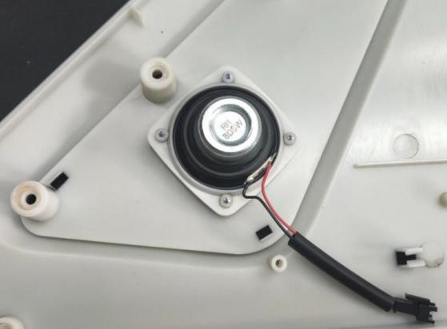

trumpet

* 1. Replace the arm airbag: unzip the sewing product of the arm airbag, remove the four screws for fixing the airbag, remove the tie strap for fixing the trachea, unplug the trachea, and then take the airbag out of the sewing product to replace the arm airbag.

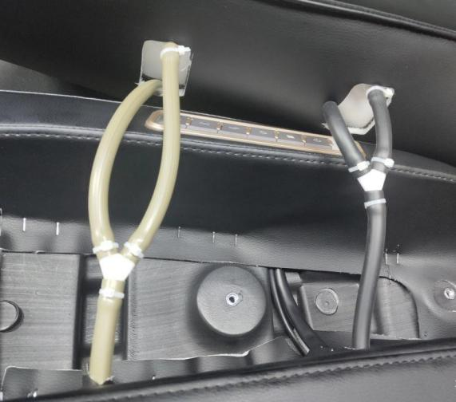

Remove the cable ties in the illustrated circle and unplug the trachea.

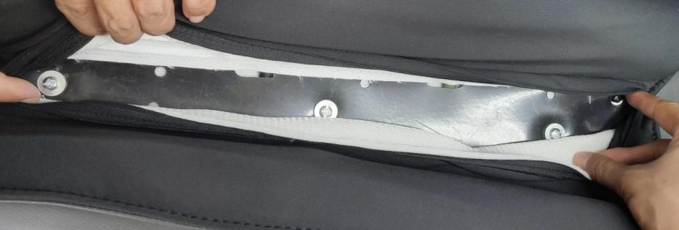

Remove the four screws.

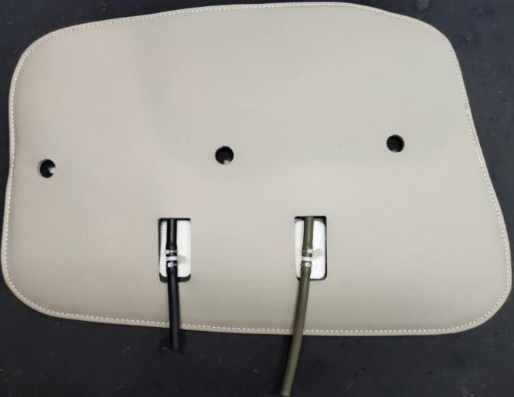

Take the airbag out of the sewn product in the figure, and unplug the trachea on the airbag.

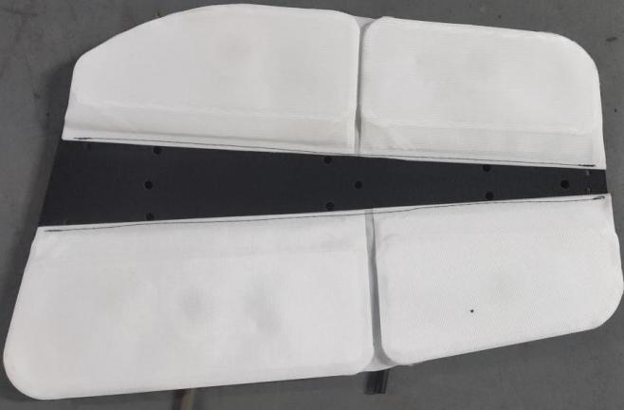

Arm airbag

* 1. Replace the handrail light belt

First press 2.1.1 and 2.1.2 to remove the handrail shoulder.

* + 1. Replace the handrail light belt: firstly, remove the five screws M5*25 and the large flat washer that connect the handrail and the shoulder, remove the tie strap that binds the light belt harness, and unplug the connector.

Remove the four screws ST3.9*12.7 for fixing the lampshade, and expose the lamp strip, so that the lamp strip can be replaced.

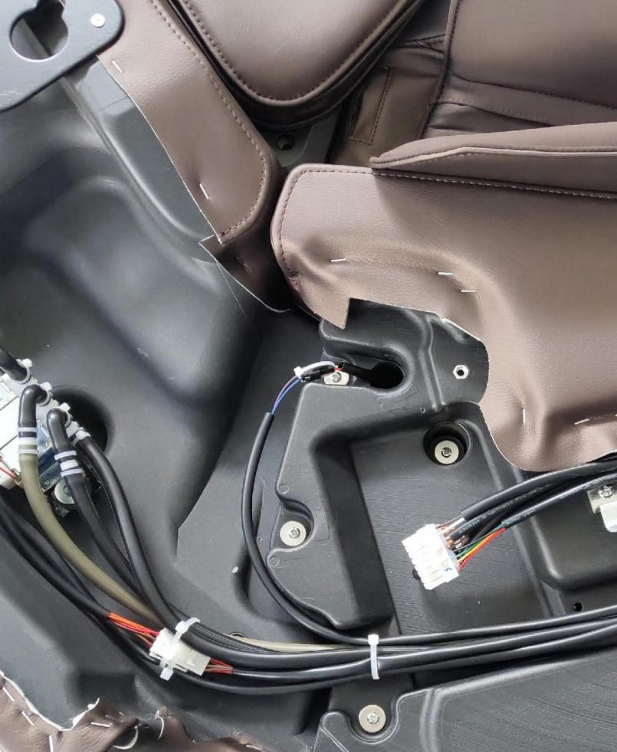

Unplug the harness connector

Remove 5 screws and flat washers in the illustrated ring.

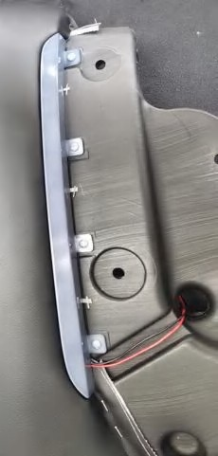

Remove the 4 that holds the lampshade.

Screw, take down the lampshade.

# 3. Dismantle the legs and feet

* 1. Replace the leg circuit board.
     1. Operate the hand controller to raise the legs and feet.
     2. Dismantle the sole shell: remove the screw ST4.2*25 for fixing the sole cover, and take off the sole shell. The sole shell and the foot are in a buckle structure.

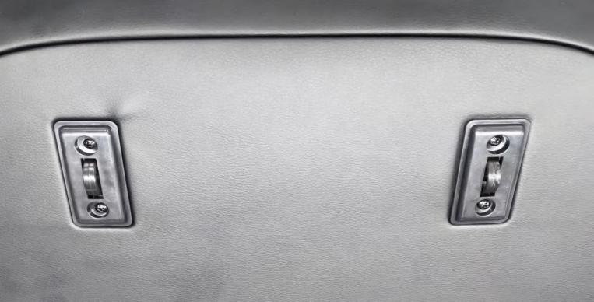

Remove the 4 screws in the illustrated circle.

* + 1. Replace the leg circuit board: unplug the wiring harness plugged into the circuit board, remove the 4 screws ST3.9*9.5 that fix the circuit board, and then replace the leg circuit board.

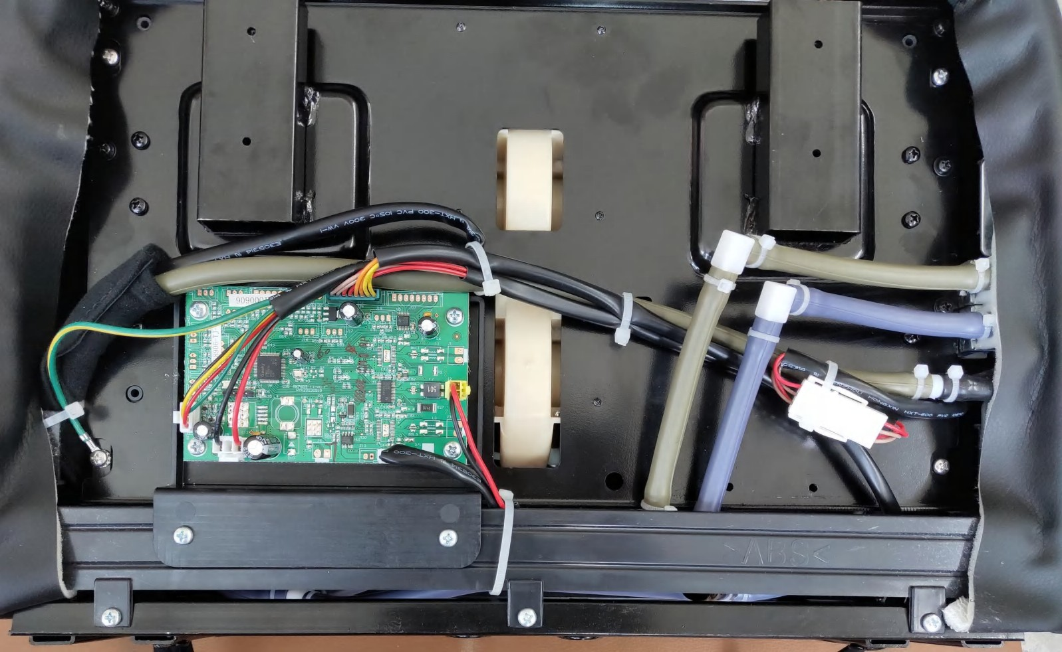

solenoid valve

Remove 4 screws from the leg and leg circuit board.

* + 1. Replace the solenoid valve for legs and feet: Remove the four fixing screws of the feet (ST3.9*9.5), remove the cable tie for binding the air pipe and wiring harness, and unplug the air pipe and wiring harness. Then remove the solenoid valve and the four screws ST3.9*9.5 of the solenoid valve adapter plate to replace the solenoid valve.

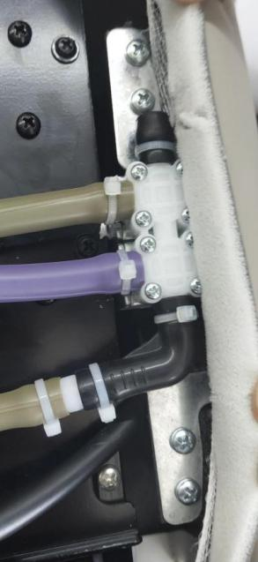

Remove the four screws.

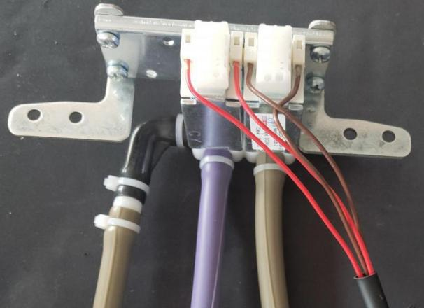

solenoid valve

Remove the four screws.

* 1. Replace the leg and foot assembly: lift the seat cushion upward to expose the upper end of the leg and foot. Remove one screw ST5*16 on the left and right sides, lift up the rotating shaft pressure plate, lift the leg and foot assembly, lift it out and put it down, unplug the trachea and connector behind the leg and foot assembly, and then replace the leg and foot assembly.

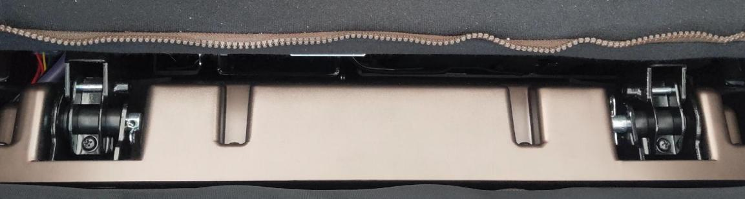

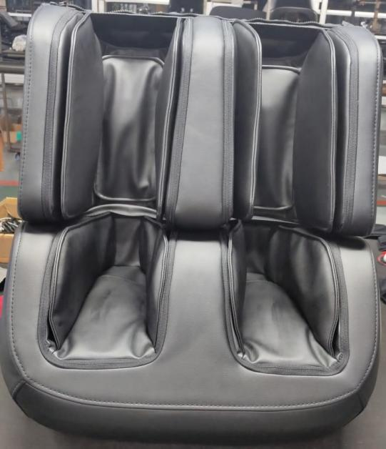

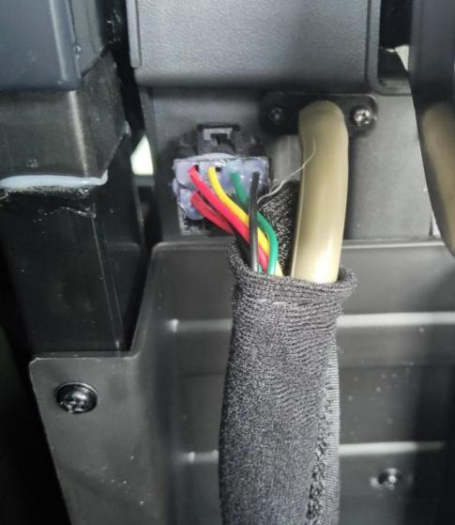

Unplug the trachea and connector.

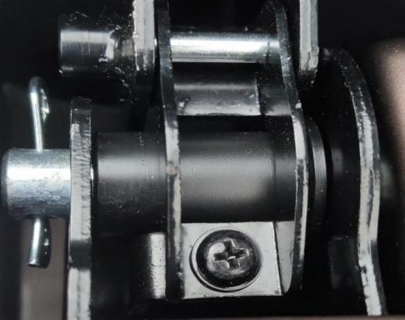

Remove the screws and lift up the rotating shaft pressure plate.

Leg and foot assembly

* 1. Replace the foot massage roller

Remove the leg and foot assembly according to 3.2.

* + 1. Dismantle the upper and lower rear covers on the legs: use a Phillips screwdriver to remove the screws fixing the upper and lower rear covers on the legs. Remove the covers first, and then remove the covers.

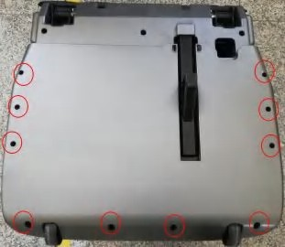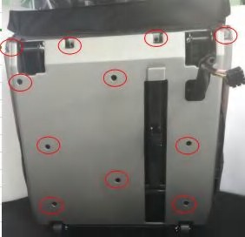

Fixed leg lower cover screw

(10 places)

Fixing leg cover screw

(11 places)

* + 1. Remove the foot assembly:

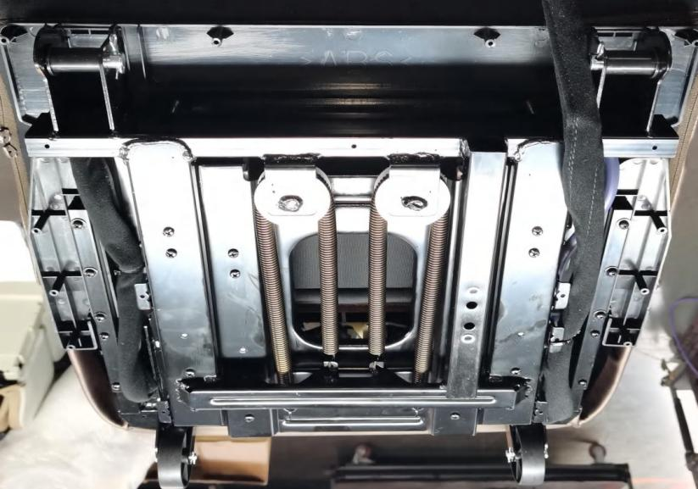

(1) Remove the cable tie that binds the leg harness, separate the connector of the leg and the leg harness, and unplug the purple trachea of the leg.

,

⑵ Remove the screw M6*20 for fixing the foot to remove the foot assembly.

,

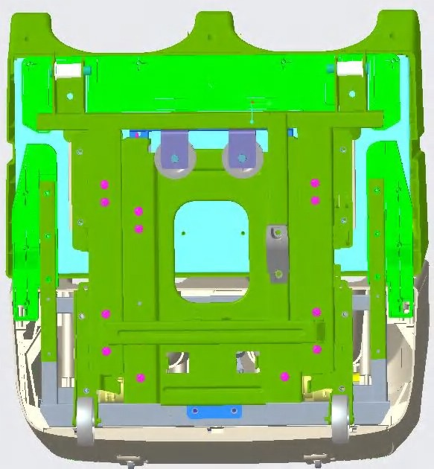

Remove the 6 screws in the illustrated circle.

Press 3.1.2 to remove the sole shell.

* + 1. Remove the screw in the circle shown in the figure, remove the harness strap that binds the foot massage roller, and unplug the harness of the foot massage roller.

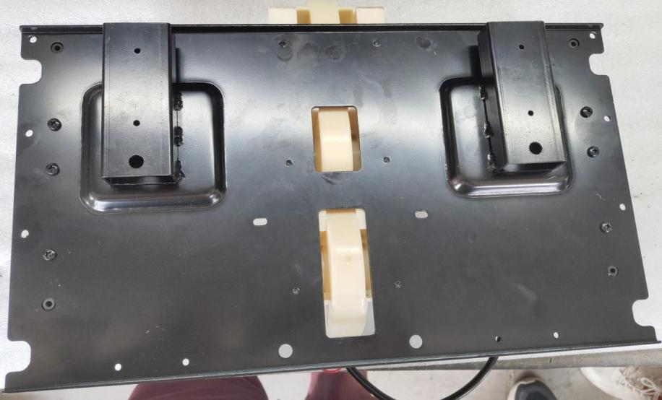

Positioning hole



ST3.9*12.7 self-tapping screw

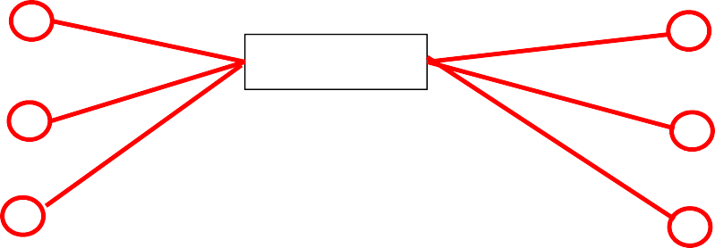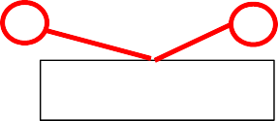

ST4*10 screw

ST4.2*35 screw

+serrated washer

ST3.9*9.5 screw

* + 1. Remove the mounting screw of the foot massage roller to replace the foot massage roller.

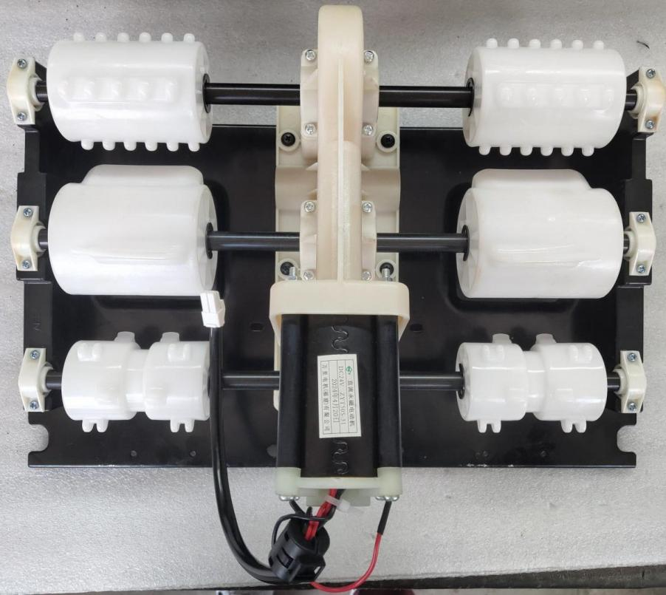

12 pieces of ST3*10 tapping screws



6 Cap Screw ST4*10

# 4. Replace the whole circuit board, air pump and transformer.

* 1. Remove the rear cover: Remove the two screws that fix the rear cover, and force off the ball heads at two places to remove the rear cover.

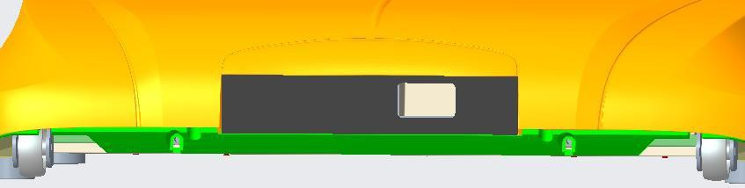

Remove 2 screws ST4*16.

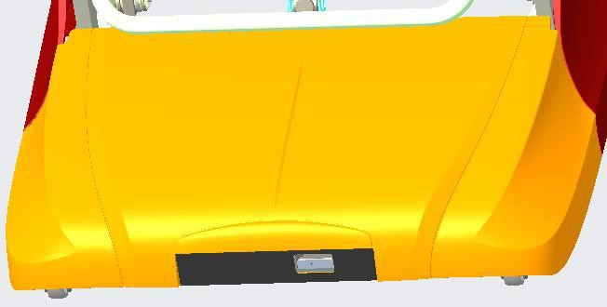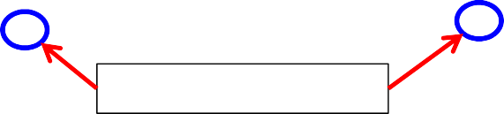

Disengage the buckle ball cavity upward by force.

postoperculum

* 1. Replace the anti-pinch detection plate Remove the screw that fixes the anti-pinch detection plate, and unplug the yellow wire harness to replace the anti-pinch detection plate.

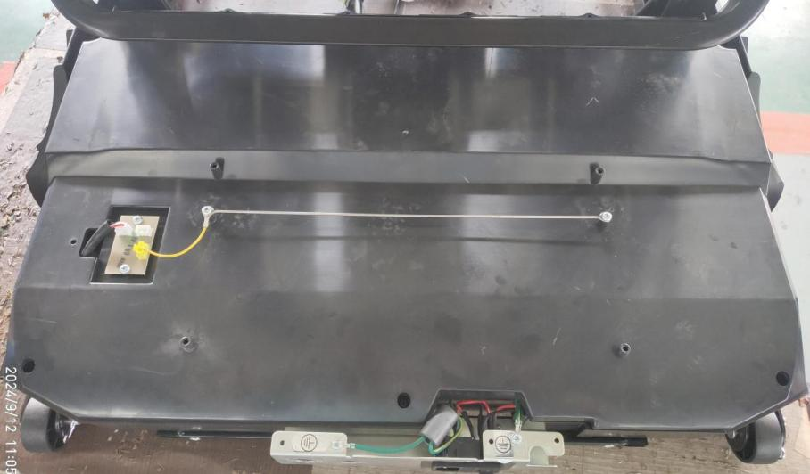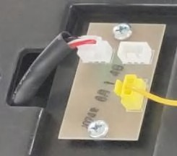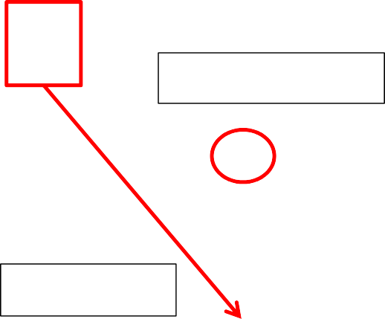

3 ST3.9*12.7 screws

Unplug the white connector

Unplug the yellow wire harness.

Anti-pinch detection plate, 2 ST3.9*9.5 screws

Back cover inner shell

：

Two of them

, namely

* 1. Remove the inner shell of the rear cover: Remove the three screws fixing the inner shell of the rear cover, and unplug the white connector on the anti-pinch switch to remove the inner shell of the rear cover.
  2. Replace the circuit board, air pump and transformer of the whole machine: remove the cable tie, unplug the related wire harness and trachea, and remove the fixing screws to replace it.



Air pump, armrest and shoulder airbag

transformer

Air pump, leg and foot airbag

Filter plate

main control panel

Bluetooth board

Three in one switch

Rectifier plate

power panel

filter

# 5. Replace the electric stay.

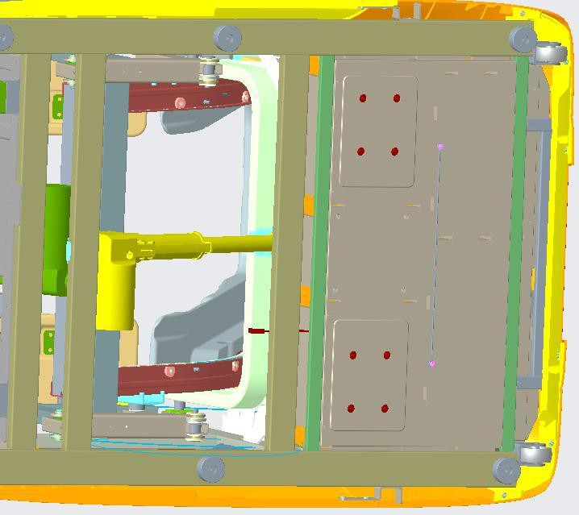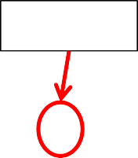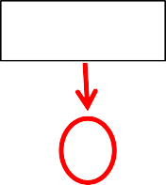

B8*50 pin shaft

B8*55 pin shaft

Backrest electric strut

* 1. Replace the backrest electric strut, put the massage chair sideways, remove the pine leaf pin and pin shaft at both ends of the fixed strut, and unplug the electric strut wire harness to replace the electric strut. Note that the pin shaft should be coated with TE-082 grease.
  2. Replace the leg and foot electric brace.

Remove the leg and foot assembly according to 3.2.

* + 1. Remove the front baffle: remove the 12 screws that fix the front baffle in the circle shown in the figure, and take down the front baffle.

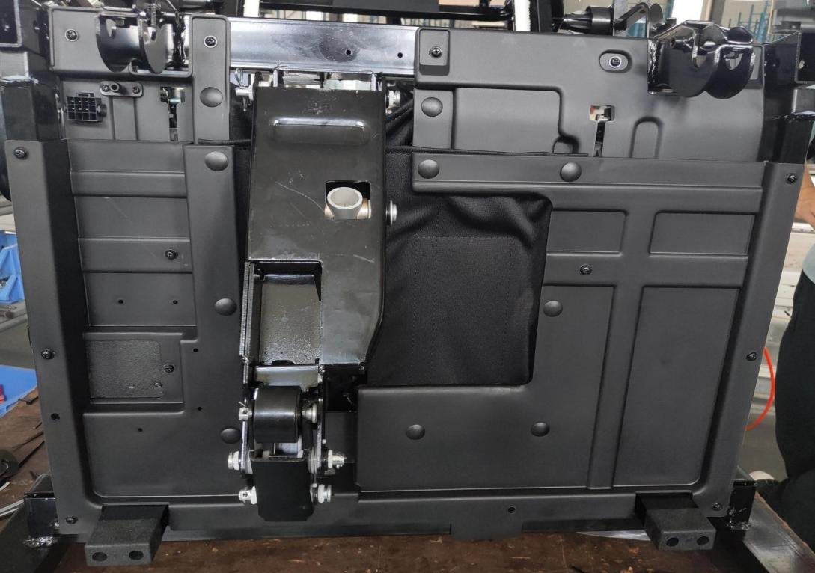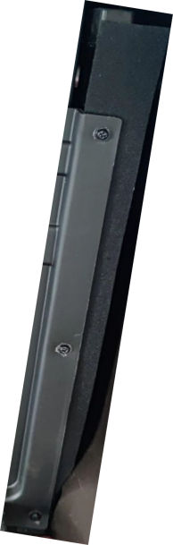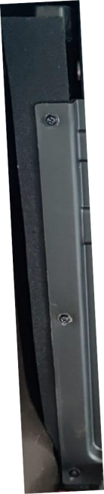

Remove the 12 screws.

ST4*10

* + 1. Replace the electric brace for legs and feet: first remove the pin B8*110, then the pin B10*70, then the pin B8*50, and remove the wire harness of the electric brace to replace the electric brace. Be careful not to miss the gasket when installing the strut.

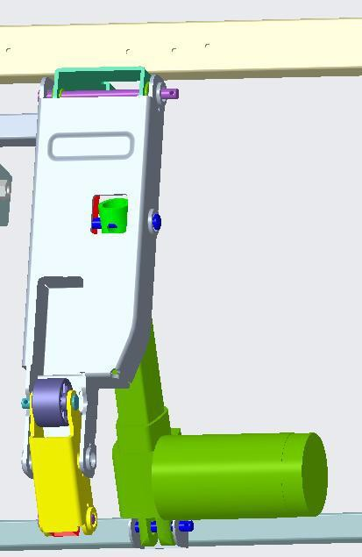

B8*110 pin shaft

B10*70 pin shaft

Leg and foot electric strut

B8*50 pin shaft

Note that the pin shaft should be coated

with TE-082 grease.

# Four----the main circuit board component layout

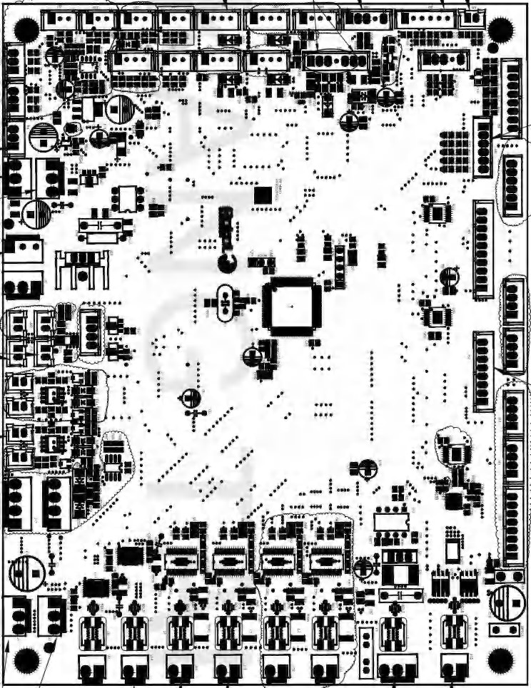

# Five----System Connection Diagram

# mainboard

**Leg board**

